DRAFT BURIAL GROUNDS STRATEGY 2017
1. Overview:
South Dublin County Council maintains seventeen cemeteries within its administrative area at the following locations:

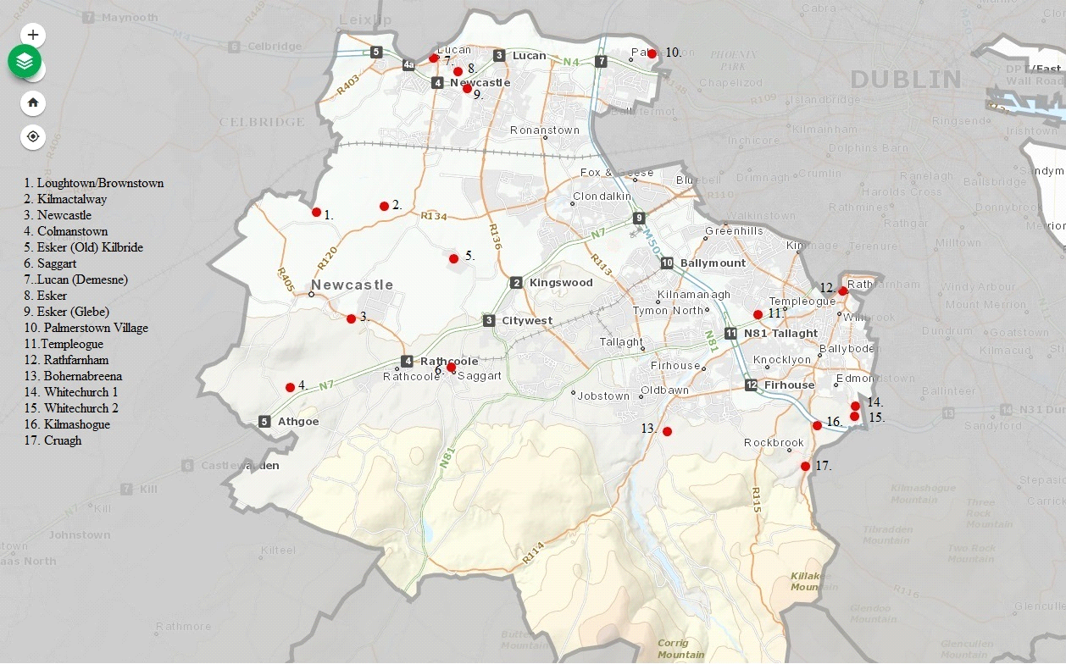

Only eight of these cemeteries are under the control of the Council who holds records for Bohernabreena, Esker, Newcastle, Saggart, Templeogue, Cruagh, Colmanstown and Brownstown, while records in relation to the other Cemeteries are held by the relevant Parish Church Office.

There are grave spaces available for purchase in only the following four burial grounds;
- Bohernabreena
- Saggart
- Newcastle
- Esker

2. Main Cemeteries

2.1 Bohernabreena Cemetery (St. Joseph’s) was established in 1943 and is situated on the edge of the suburban area of Tallaght on the R113 Bohernabreena Road. It is the largest Cemetery under the control of South Dublin County Council. On average 363 burials of all and no denomination take place in this Cemetery annually, with 211 of them involving the re-opening of an existing plot. (Based on figures from 2008 – 2015)

There are Angels Plots and a Lawn Cemetery along with the more traditional kerbed Cemetery Layout.

This Cemetery also has two vehicular entrances, a pedestrian entrance, two car parks laid out in hardcore, a network of concrete roads throughout, a toilet block, several waste disposal bunkers, a small storage building, a storage container, and an undeveloped section to provide for future needs.

There are approximately 2,100 grave spaces available to purchase in Bohernabreena. However, grave spaces cannot be purchased in advance and can only be purchased at the time of death.

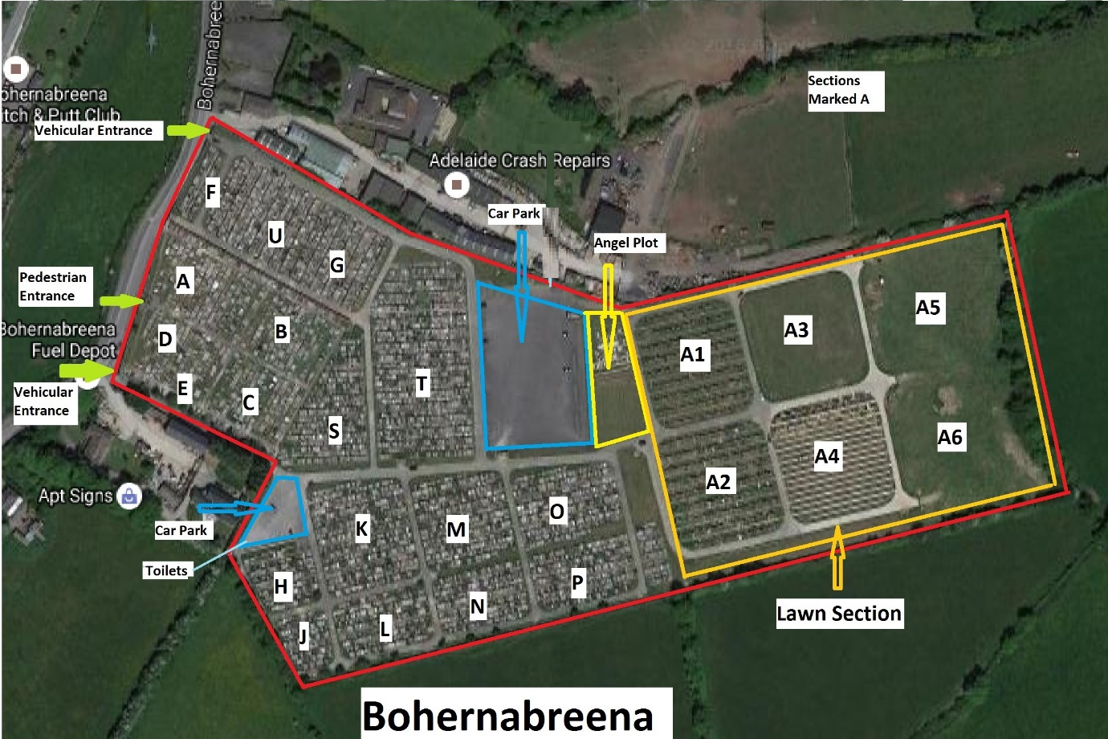

2.2 Saggart Cemetery was established in 1894 and is situated in the centre of Saggart village.

On average 25 burials of all and no denomination take place in this Cemetery annually, with 12 of them involving the re-opening of an existing plot.

This Cemetery consists of an old section where records are poor to non-existent and newer sections where records are complete. The Cemetery is laid out in various fashions with the more recent sections being in the traditional kerbed style, and the newest area being a Lawn Cemetery.

This Cemetery has one entrance.
There are approximately 405 grave spaces available to purchase. However, pre-purchase conditions are in place prioritizing availability for senior citizens and local residents.

There is no undeveloped section in this Cemetery to provide for future needs.

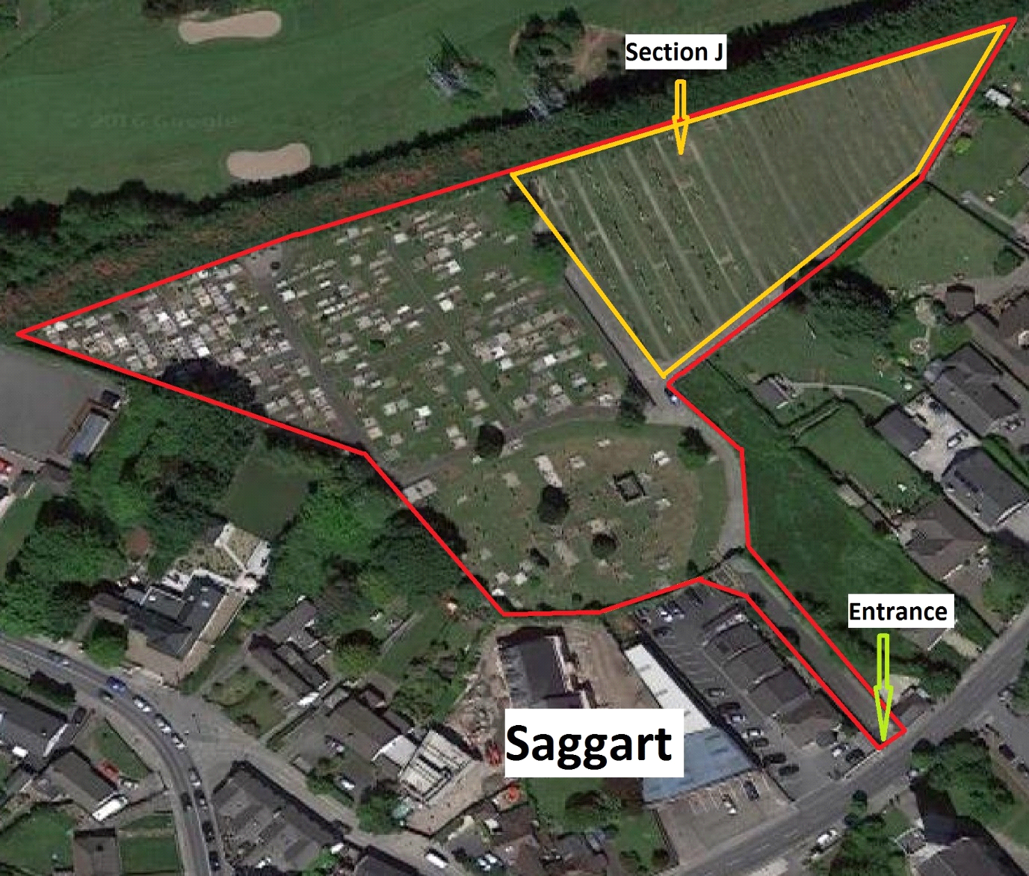

2.3 Newcastle Cemetery was established in 1979 and is situated in Newcastle Village adjacent Greenogue Business Park.
On average 68 burials of all and no denomination take place in this Cemetery annually, with 18 of them involving the re-opening of an existing plot. (Based on figures from 2010 – 2015)

As this Cemetery was established less than 40 years ago, records are complete. The Cemetery is laid out in the traditional kerbed style.

This Cemetery has one entrance and limited parking, and a network of concrete roads throughout.

There is a dedicated Islamic Community burial area.

There are approximately 220 grave spaces available to purchase (incl. 22 in the Islamic community (Infant 12 & Adult 10). However, pre-purchase conditions are in place prioritizing availability for senior citizen.
There is an undeveloped area in this Cemetery to provide for future needs.

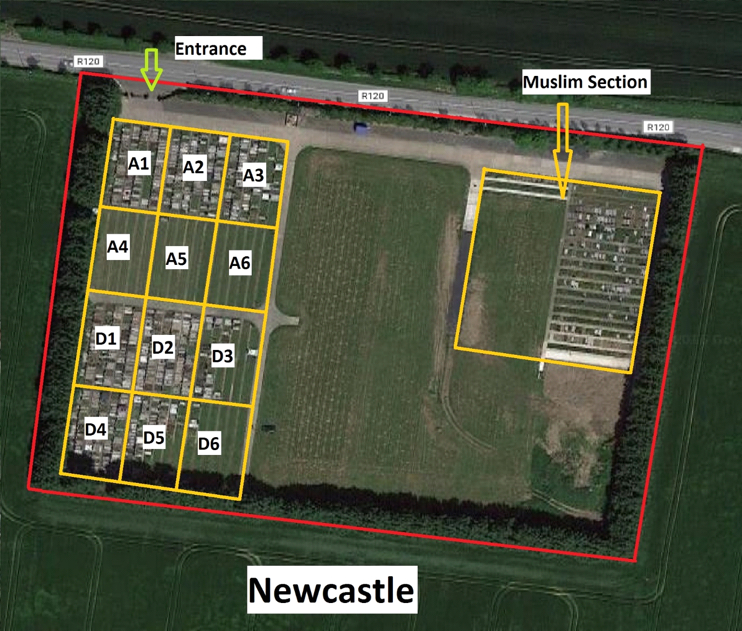

2.4 Esker Cemetery was established in 1890 and is situated in Lucan Village on the Lucan – Newlands Road.

On average 178 burials of all and no denomination take place in this Cemetery annually, with 110 of them involving the re-opening of an existing plot. (Based on figures from 2009 – 2015)

This Cemetery consists of an old section where records are poor and several newer sections where records are complete. The entire Cemetery is laid out in the traditional kerbed style.

This Cemetery has one vehicular entrance, a pedestrian entrance, a car park laid out in hardcore, a network of concrete roads throughout, and several waste disposal bunkers.

There are approximately 88 grave spaces available to purchase. However, grave spaces cannot be purchased in advance and can only be purchased at the time of death.

There is no undeveloped section in this Cemetery to provide for future needs.

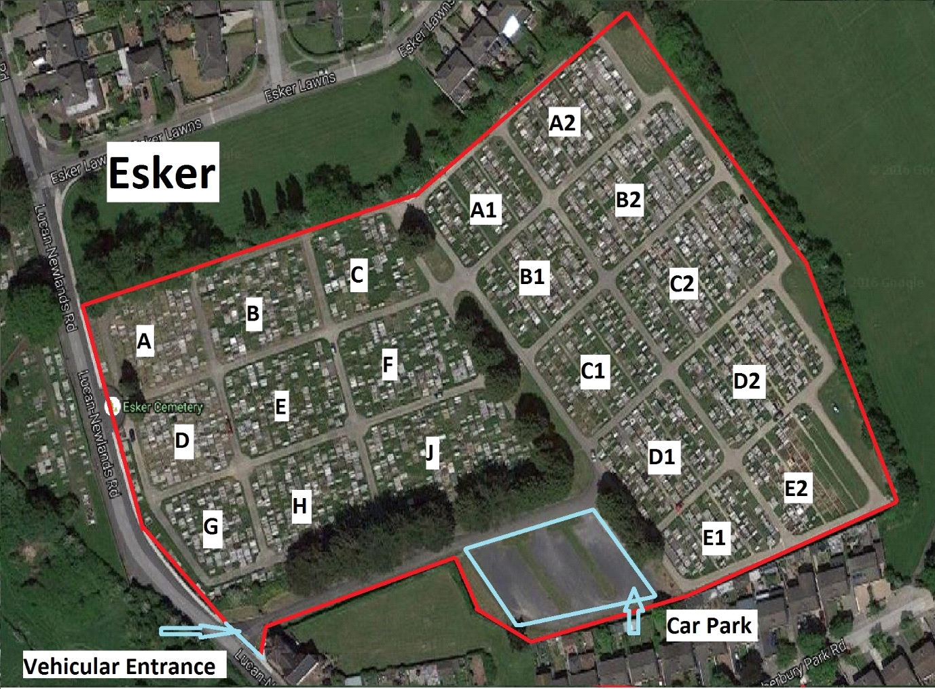

3. Review of management and operations of Burial Ground Services
A comprehensive review of the management of the Council’s Burial Ground services was undertaken in Q4 2016 / Q1 2017 in order to establish the strengths, weaknesses, opportunities and threats associated with this service and to inform the development of a sustainable strategy for the delivery of the Council’s burial ground services.
This review examined capacity, costs, policies and procedures associated with the administration, operations and maintenance of the service.
A comprehensive suite of protocols and procedures exist to ensure that this service is managed and maintained to the standard befitting the memory of all those loved ones buried in the Council’s cemeteries.

4. Objective

The objective of this Burial Grounds Strategy is to clearly set out the Council’s capacity, costs, policies and practices pertaining to the management (administration, operation, and maintenance) of its Burial Grounds, to ensure the effective and efficient delivery of this service within South Dublin County, and to determine the way this service should be developed and improved over the next five (5) years.
5. Overheads
The Council incurs considerable expense annually in the administration and operation of the service, which is offset from income earned through charges levied for services provided.
In the interest of transparency and in line with best practice, charges will be regularly reviewed to ensure that charges and maintenance costs are comparable to the current market, are yielding Value for Money, and cover costs as far as possible.

6. Competitive Analysis / Future Development
The Council is not exclusive in the provision of Burial Ground services within South Dublin County, with a number of private facilities having been developed / in development in recent years.
Given the capacity already identified at the four operational publicly owned burial grounds, and the extent of existing and proposed development by the private sector, it is not presently envisaged that further lands will be acquired by the Council to further extend the capacity of the its public burial grounds when existing available undeveloped land has been exhausted. This will be subject to review.
Income earned in excess of expenditure incurred in the delivery of the service will be transferred to a Development Fund to finance future enhancement and requirements.

7. Evaluation / Key Performance Indicators
The following KPIs which underpin the service provided will be reported annually.
- Number of burials
- Number of plots purchased (single / double / Angel / Islamic / Cremation)
- Number of 1st Openings
- Number of re-opening
- Number of exhumations

