COMHAIRLE CONTAE ÁTHA CLIATH THEAS  
SOUTH DUBLIN COUNTY COUNCIL



MEETING OF LAND USE PLANNING AND TRANSPORTATION SPC

Thursday, May 25, 2017

HEADED ITEM NO. 3

**Architectural Conservation Forum - Capital project (proposed project for 2017/2018)**

**Ballymount Gate House, Ballymount**

**Appraisal**

Under the projects identified by the Architectural Conservation Forum it is now proposed to carry out works to Ballymount Gate House.

It is recommended that due to the nature of the site, the current condition of the site being densely overgrown and the logistical/H&S requirements that works should be phased. Under phase one it is considered that a landscape contractor should be engaged to carry out biocide spraying and cutting back of ivy on the structure and remove areas of dense vegetation and tree growth. This will allow a conservation engineer to carry out a structural assessment of the structure and specify the structural interventions and works required to safeguard the structure.

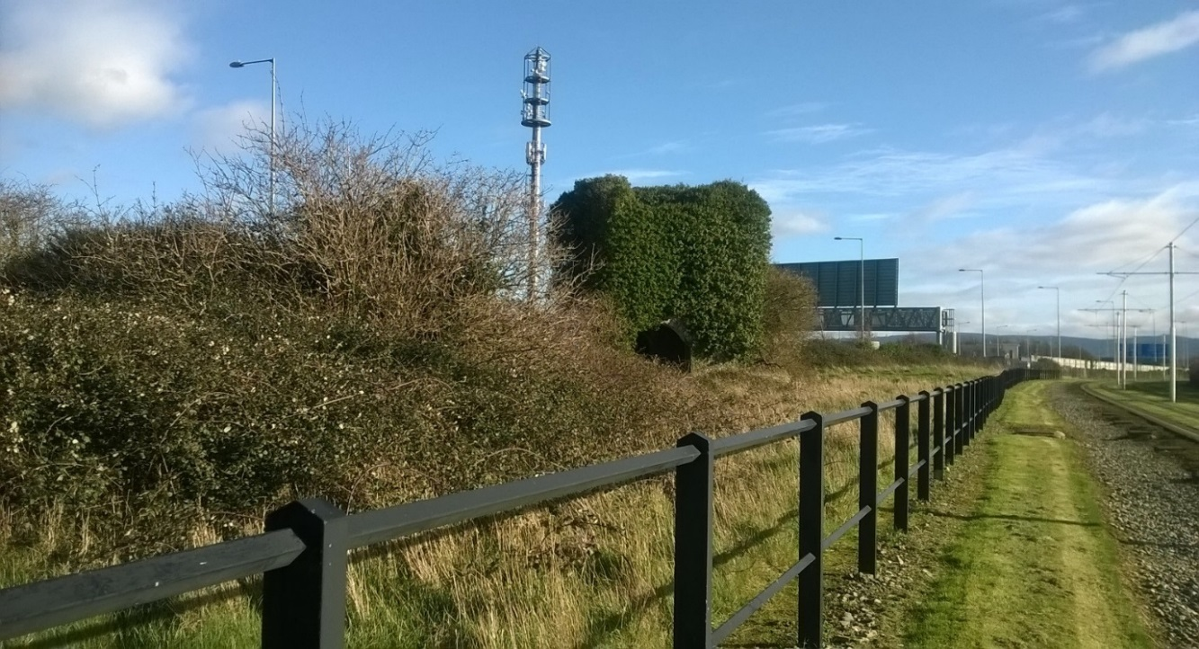View of Gate House and context of site 2016



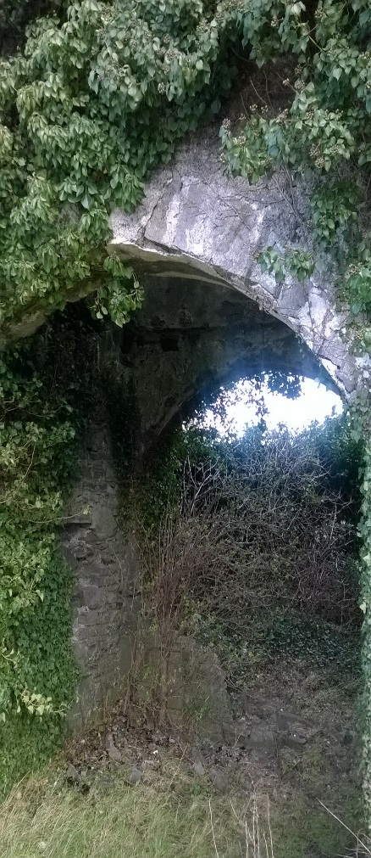 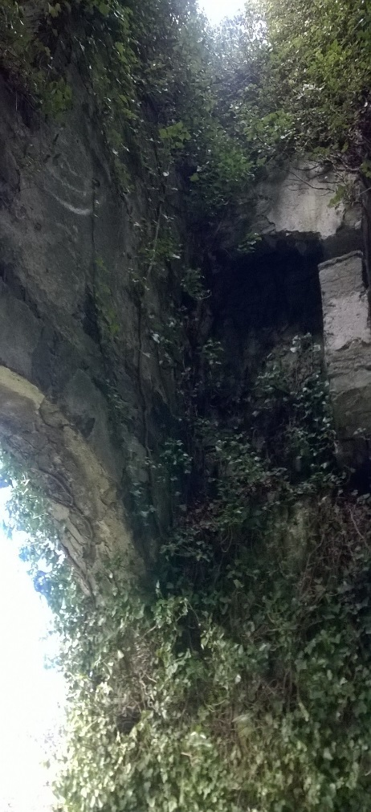 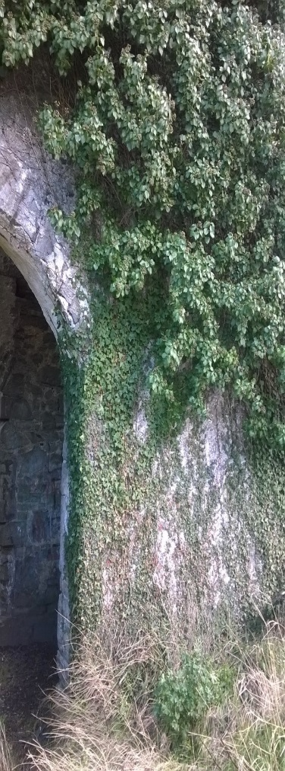External and internal detail

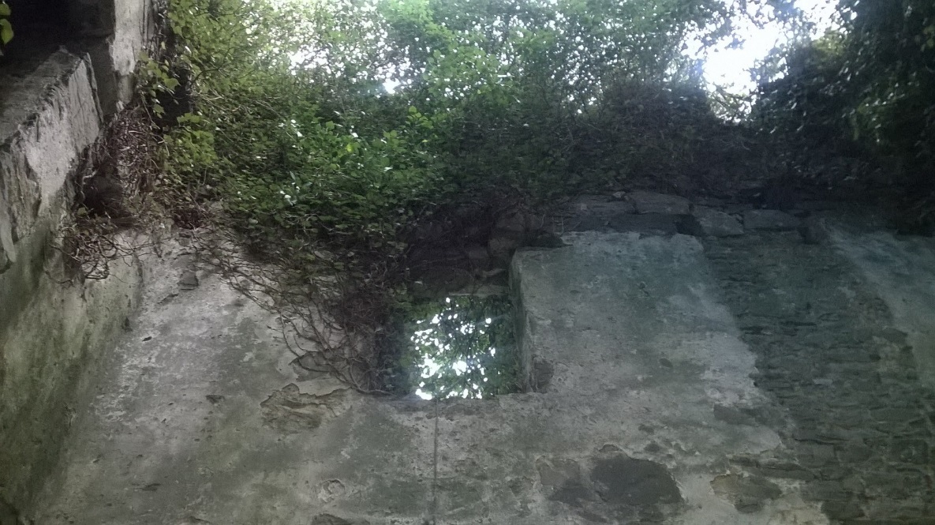Condition of interior 2016 – Note level of vegetation growth on top of walls and damage to masonry.

As part of the overall work programme it is proposed to initiate the necessary works under phase one during 2017 as follows:

* A comprehensive structural assessment of the structure is required in order to ascertain the level of work and full scope of works identified for this project.
* A full survey is required in order that the areas requiring repair and interventions can be identified and survey drawings prepared on this basis.
* Engagement of a Consultant Conservation Engineer to provide above requirements and to co-ordinate the project. The Conservation Engineer will report and liaise with the Councils Architectural Conservation Officer.
* The Conservation Engineer will provide specifications for works under phase two and will provide the necessary drawings and specification for any structural repairs and interventions required as part of the tender documents and requirements.
* The conservation engineer will also assist where required with the engagement of a conservation contractor and will assist with the assessment of tenders received.
* Vegetation clearance of the site will be undertaken as part of phase one works under instruction from the Conservation Engineer.
* Engagement of ecologist and archaeologist when/if required.
* Engagement of masonry contractor may be required to remove any loose masonry and carry out remedial temporary repairs to any damaged areas.

**Irenie McLoughlin**

**Architectural Conservation Officer 16th May 2017**