## COMHAIRLE CONTAE ATHA CLIATH THEAS

## SOUTH DUBLIN COUNTY COUNCIL

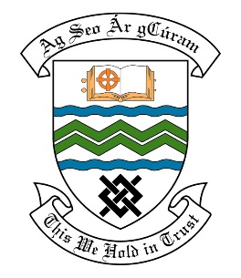

### MEETING OF THE TERENURE / RATHFARNHAM/ TEMPLEOGUE ACM

**Tuesday 9th May 2017**

## HEADED ITEM NO. 15

**Deputations Meeting April 2017**

**Knocklyon United Football Club**

**Deputation** **attendees** – Gary Dent, Donal Skelly, Derek McHugh & Noel Gaughran

**Elected Members** – Cllr. Paul Foley, Cllr. Brian Lawlor, Cllr. Paula O’Donovan, Cllr. Deirdre O’Donovan, Cllr. Enda Fanning & Cllr. Charlie O’Connor.

**Council Officials** – Louise Crofton, Michael McCartan, Michael Hannon, Brian Carroll & Carol McDonnell.

Councillor Paul Foley presided.

**Items discussed**:

1. Playing Pitch Allocations – Castlefield Park pitches 108 & 108A.
2. Future Developments – Castlefield Park.
3. Reinstatement Elkwood Park, Knocklyon.
4. Site request for an Astro Pitch at Kennedy’s field R137 Tallaght Road.
5. Development of pitches at Dodder Valley Park.

**Commitments given**:

Item 1 - Concerns to be brought to attention of Senior Management and The Group will be contacted early May.