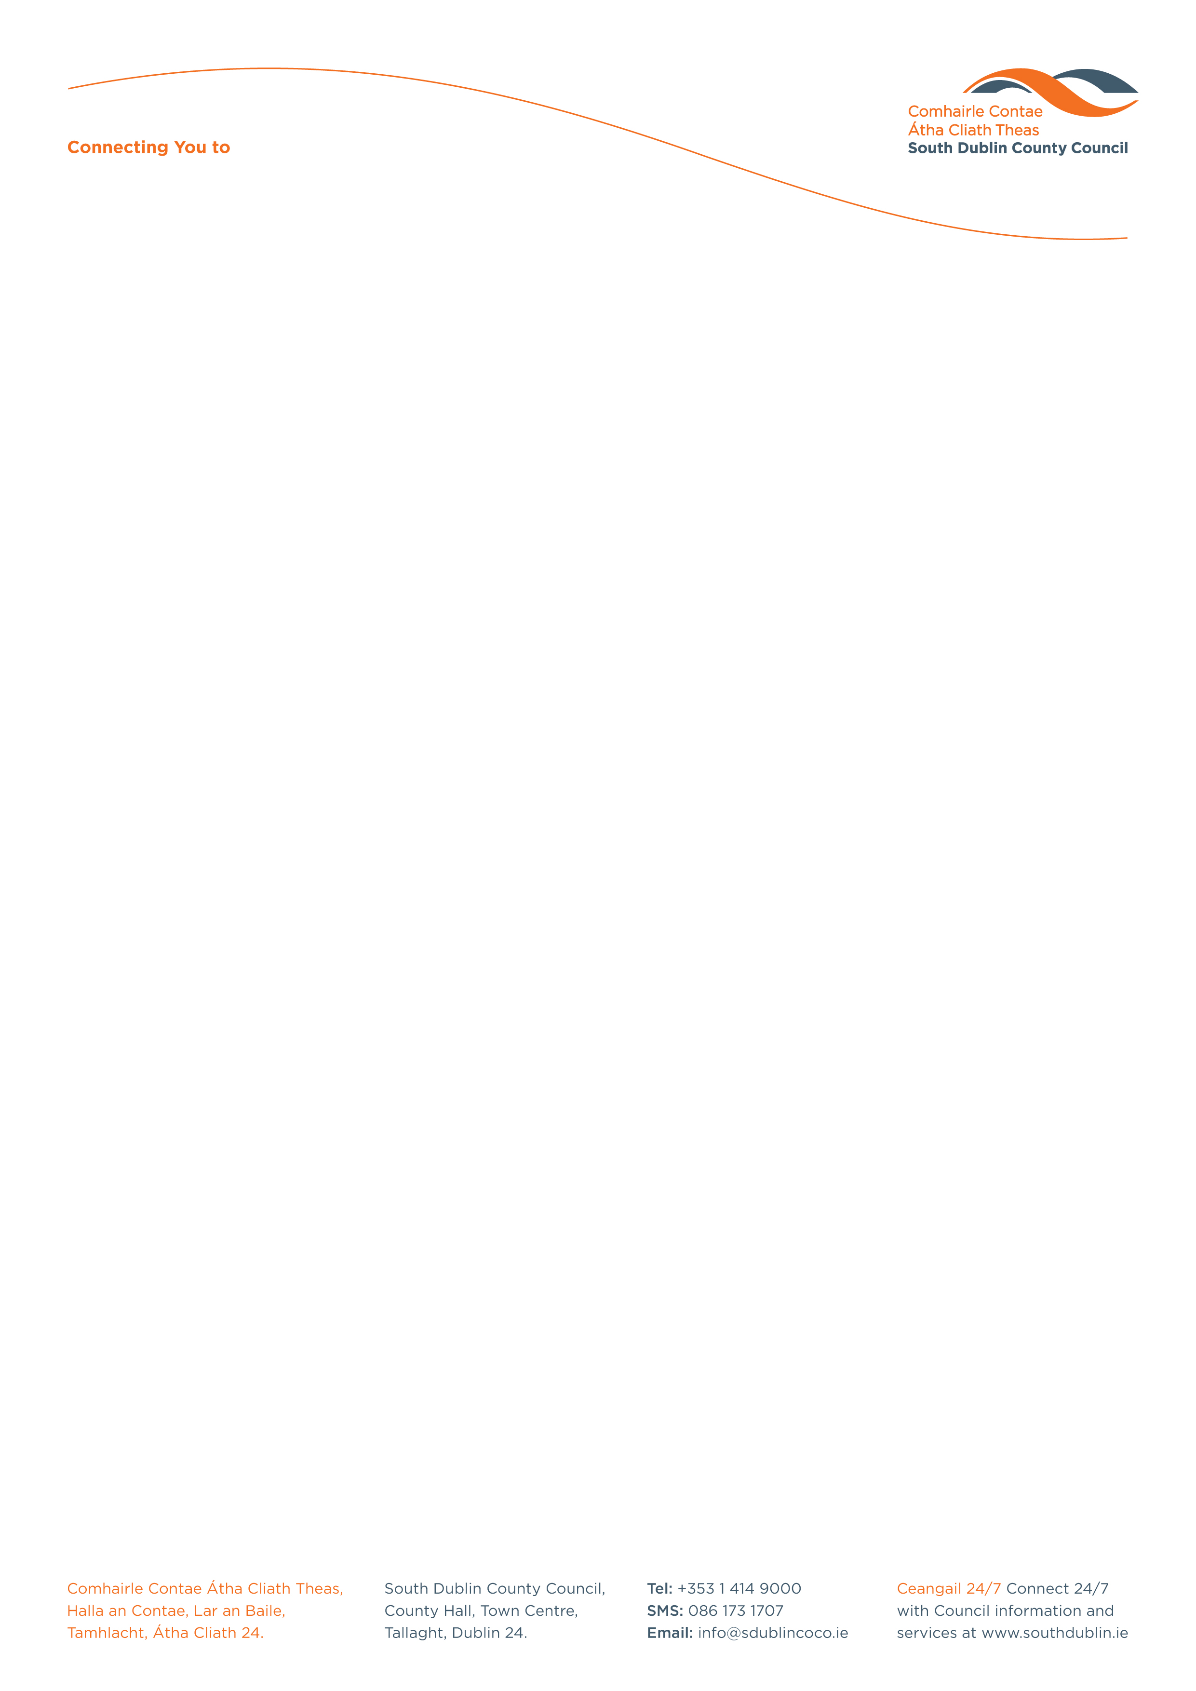

Halla an Chontae, Lár an Bhaile County Hall, Town Centre
Tamhlacht, Baile Átha Cliath 24 Tallaght, Dublin 24
Telefon: 01-4149052 Telephone: 01-4149052

Facs: 01-4149332 Fax: 01-4149042
www.southdublin.ie

Dublin Bus,
59 O’Connell Street,
Dublin 1.

RE: Tallaght Area Committee Meeting – 27th February, 2017

Dear Sir/Madam,

At South Dublin County Council’s Tallaght Area Committee Meeting, held on 27th February, 2017, the following Question was agreed:
"To ask the Chief Executive to contact Dublin Bus and ask for an update on any plans they have for additional bus shelters in the Tallaght area?"
I should be obliged if you would let me have a reply on this matter at your earliest convenience.

Thanking you in anticipation,

Yours sincerely,

__________________
Edwina Leonard,
Staff Officer,
Housing Administration.

Housing Administration

