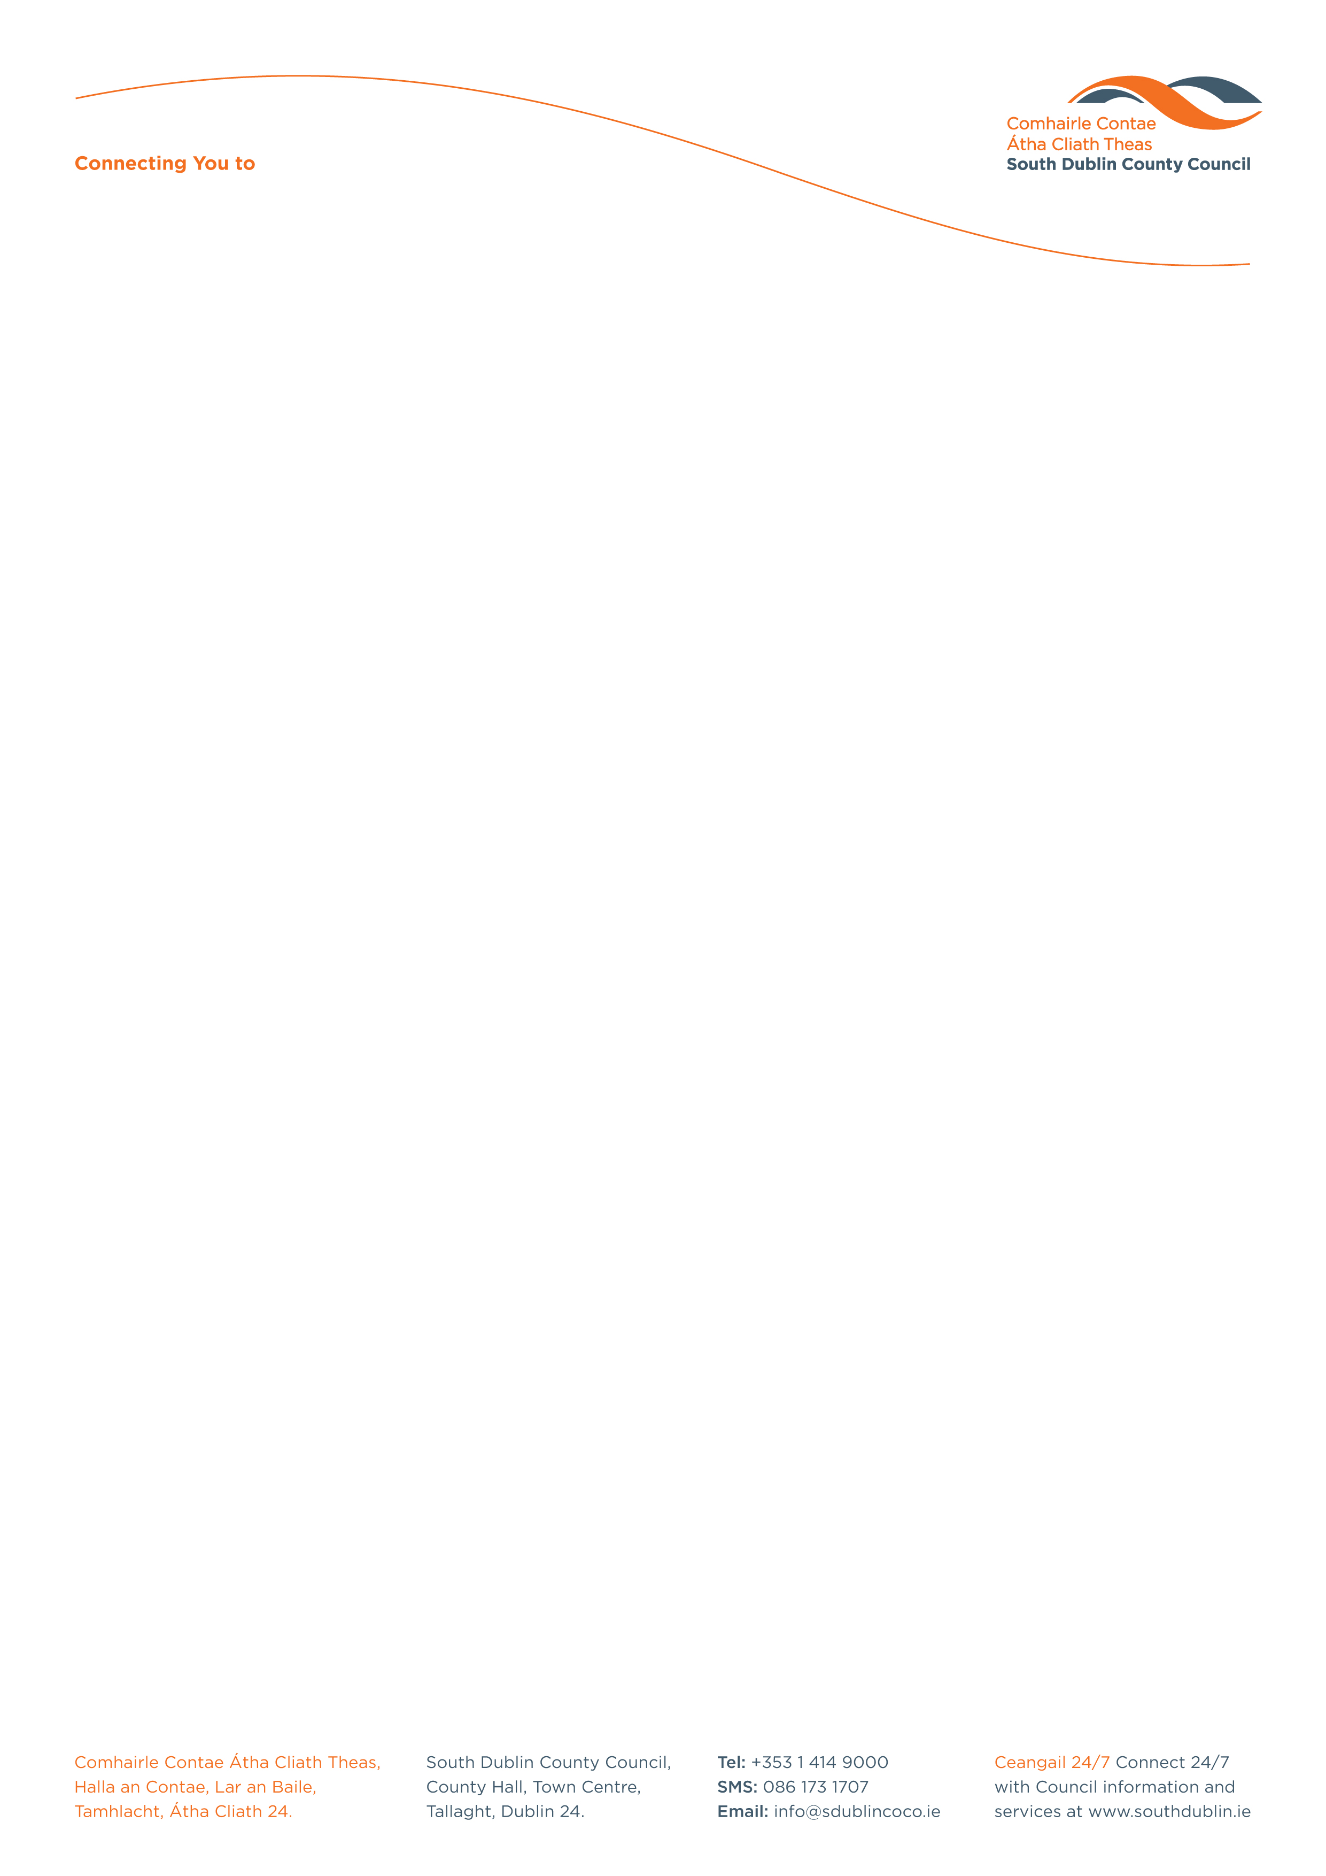

Halla an Chontae, Lár an Bhaile County Hall, Town Centre
Tamhlacht, Baile Átha Cliath 24 Tallaght, Dublin 24
Telefon: 01-4149052 Telephone: 01-4149052

Facs: 01-4149332 Fax: 01-4149042
www.southdublin.ie

Frances Fitzgerald T.D.
Minister for Justice & Equality,
Leinster House,
Kildare Street,
Dublin 2.

RE: Tallaght Area Committee Meeting – 23rd January, 2017

Dear Minister,

At South Dublin County Council’s Tallaght Area Committee Meeting, held on 23rd January, 2017, the following Motion was passed:
“That this Tallaght Area Committee calls on Tanaiste and Minister for Justice, Frances Fitzgerald TD, to discuss with the Garda Commissioner, the clear need for additional personnel, vehicles and resources to be made available to Tallaght Garda Station, to allow for extra attention to be given to issues of crime and particularly to ensure that the Drugs Unit and the Community Garda Unit at Tallaght are properly resourced.”
I should be obliged if you would let me have a reply on this matter at your earliest convenience.

Thanking you in anticipation,

Yours sincerely,

__________________
Edwina Leonard,
Staff Officer,
Housing Administration.

Housing Administration

