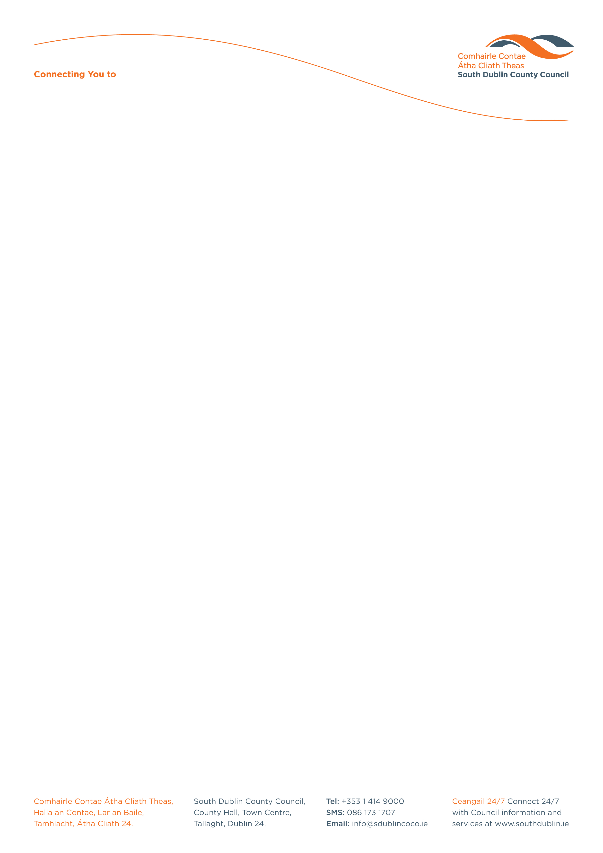

Halla an Chontae, Lár an Bhaile County Hall, Town Centre
Tamhlacht, Baile Átha Cliath 24 Tallaght, Dublin 24
Telefon: 01-4149052 Telephone: 01-4149052

Facs: 01-4149332 Fax: 01-4149042
www.southdublin.ie

Simon Harris, T. D,
Minister for Health,
Department of Health,
Hawkins House
Dublin 2

RE: Tallaght Area Committee Meeting – 27th February, 2017

Dear Minister Harris,

At South Dublin County Council’s Tallaght Area Committee Meeting, held on 27th February, 2017, the following Motion was agreed:

"That this Tallaght Area Committee calls on Simon Harris TD, The Minister for Health, to respond positively to the community campaign to increase the bed capacity in Tallaght hospital, asking him to appreciate the particular demand in that regard and noting that Tallaght hospital has the biggest emergency department in the country and also noting the recent statement from the Hospital Board that a new 72 bed 5 storey unit on the campus is required and will the Chief Executive forward the terms of this motion to the Minister, the CEO of the HSE and also to Tallaght Hospital which is leading the campaign."

I should be obliged if you would let me have a reply on this matter at your earliest convenience.

Thanking you in anticipation,

Yours sincerely,

__________________
Edwina Leonard,
Staff Officer,
Housing Administration.

cc. Tony O’Brien, CEO HSE; David Slevin, CEO, Tallaght Hospital

Housing Administration

