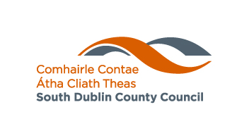

DRAFT ANNUAL REPORT 2016

Our Mission:

To make our county the best possible place in which to live, work and do business

Contents

Mayor’s Foreword 3
Introduction from the Chief Executive 5
Membership of South Dublin County Council 7
Council Meetings 2016 16
Strategic Policy Committees 17
Corporate Awards 2016 19
Corporate Plan Achievements In 2016 20
Economic Enterprise and Tourism Development 20
Land Use Planning and Transportation 23
Housing Social and Community Development 24
Environment Water and Climate Change 27
Organisational Capacity and Accountability 29
Appendix 1- Financial Charts and Graphs 32
Appendix Two - Council Membership of Committees and Other Bodies 36
Appendix Three – Training Conferences Attended by Councillors in 2016 41
Appendix Four- Energy Efficiency Report 2016(Awaiting) 42
Appendix Five- Protected Disclosures 2016 43
Appendix Six- Local Performance Indicators Report 2016 44

MAYOR’S FOREWORD
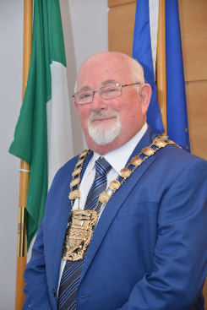
I am delighted as Mayor and First Citizen to be introducing the 2016 Annual Report for South Dublin County Council. This Report represents a snapshot of the County as our reflections on the events of 1916 inspire us for the future.

When honoured by my peers and elected Mayor of this mighty County in June 2016, I said I would focus on ‘Celebrating Community’. Building on the priorities of my two Progressive Alliance predecessors, I determined we focus on community, on the marginalised in our County especially those with a disability, and on those from ethnic minorities and on the needs of older persons.

Judged by the ideals of the 1916 proclamation we have a woefully unequal society in Ireland. Our challenge as a society is, I believe, to give expression to that part of the proclamation that states we must “cherish all of our children equally”. This is not only about persons young in years, yes that’s where it starts, but also about all persons living in our Republic, which in our case means living in our County. We are meant to cherish all, irrespective of creed, colour, ability, orientation or when they settled in Ireland. We can only do this I believe if we embrace a genuine humanitarian approach. The challenge I faced when elected Mayor, and which we all face is to build an inclusive and fair society.We have persons from some 120 different nationalities residing in our County.

That represents a fair diversity. It is a challenge that I believe we as the Councillors, Executive and Citizens of South Dublin County have already risen to as witnessed by this Annual Report. There is a serious commitment evident in our County, as expressed by our very active Social Inclusion Unit, to build an inclusive society. It has become obvious to me since becoming Mayor, having had an opportunity to witness at first-hand what is going on in South Dublin County, that we are not just embracing the type of diversity which is facilitative of the different cultures and traditions but one which positively promotes them. This is most encouraging for the future.

The oldest ethnic minority in our County is the Traveller Community and as the Chairperson of the Local Traveller Accommodation Advisory Committee, I was already very aware and appreciative of the good record of this County in relation to providing accommodation for Travellers. As elected representatives we continue to work with the executive, the Clondalkin and Tallaght Traveller Support Groups, the Traveller Community and the settled community in bringing about a greater understanding and sense of appreciation between the settled community and the Traveller Community. I am very appreciative of the support of my fellow Councillors in my proposal to establish a Traveller Community Forum in our County where Travellers celebrate, promulgate and promote those interests that are special to their heritage, culture and identity.

During my term on office I have endeavored to empower the many voluntary and community based groups and organisations we have in this County and who do such tremendous and valuable work. We have an excellent PPN here in South Dublin which is intended to be the umbrella body for civic society. It does not replace elected democracy and the public can also work through their local Councillor, or both. However the PPN provides an independent forum where the public can have an input into decision making at Local Government level, to engage directly in decision making. The PPN provides a forum where the public can access information and influence decisions of the local authority. I am delighted to get support during my term for a Mayor’s Conference in Tallaght Stadium on “Putting People First” in early 2017. This will allow the respective roles and responsibilities of the three key players PPN, Executive and Elected Councillors to be examined and reflected upon in a manner that I hope will lead to better communication and more effective collaboration between all three stakeholders and consequently a more effective and efficient Local Government service for all citizens.

Similarly, I am delighted also that in 2017 we will launch the “Participative Budgeting” Pilot for one Electoral Area. It is hoped that this ground making initiative will lead to real involvement in future years by the Citizens of South Dublin County on the service and facilities priorities they want for their neighbourhood while also building solidarity across all areas and especially with those most in need.

During 2016 the Local Enterprise Office has been very active in promoting and supporting jobs. In collaboration with the South Dublin Chamber of Commerce it held a hugely successful Enterprise Awards and brought an awareness of the Tourism opportunities in our County to new heights. This includes a five year strategy and a feasibility study that will examine how the flagship Dublin Mountains can be both promoted and conserved for future generations. Also, a Liffey Blueway and restoration of the “Silver Bridge” from Waterstown Park to Farmleigh are being pursued. I also want to focus on the Irish Language and the role of Áras Chrónáin.

When I first entered politics it was to focus on the needs of people and communities; the environment; and balanced planning that puts people first. My slogan then was “People before Party”, and still is. The County has mushroomed over the past 25 years and I continue to campaign for the facilities and services that should have been provided hand-in-hand with the houses. I acknowledge and welcome the commitment in the Councils current Capital and Fiscal budget to addressing this deficit. We are about building communities; especially true given the current housing and homeless crises. I have endeavoured to use every opportunity during my term as Mayor to seriously address the housing crises and I compliment my fellow Councillors and the executive for the huge commitment they have shown in this regard.
Finally, I would like to thank the Chief Executive, Danny McLoughlin and his staff for the dedicated work they do and my fellow Councillors for providing the leadership that will enable our communities to be fully integrated and enjoy the quality of live that they aspire to and deserve. I want to compliment in a special way the Deputy Mayor Councillor Martina Genockey who has done the office proud and brought a real personal contribution to the role of Deputy Mayor.

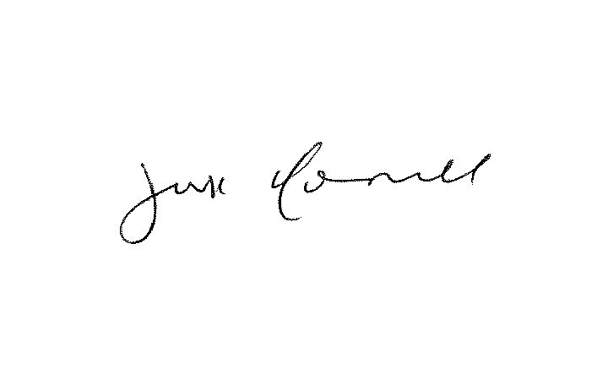
______________________
Mayor Guss O’ Connell

INTRODUCTION FROM THE CHIEF EXECUTIVE

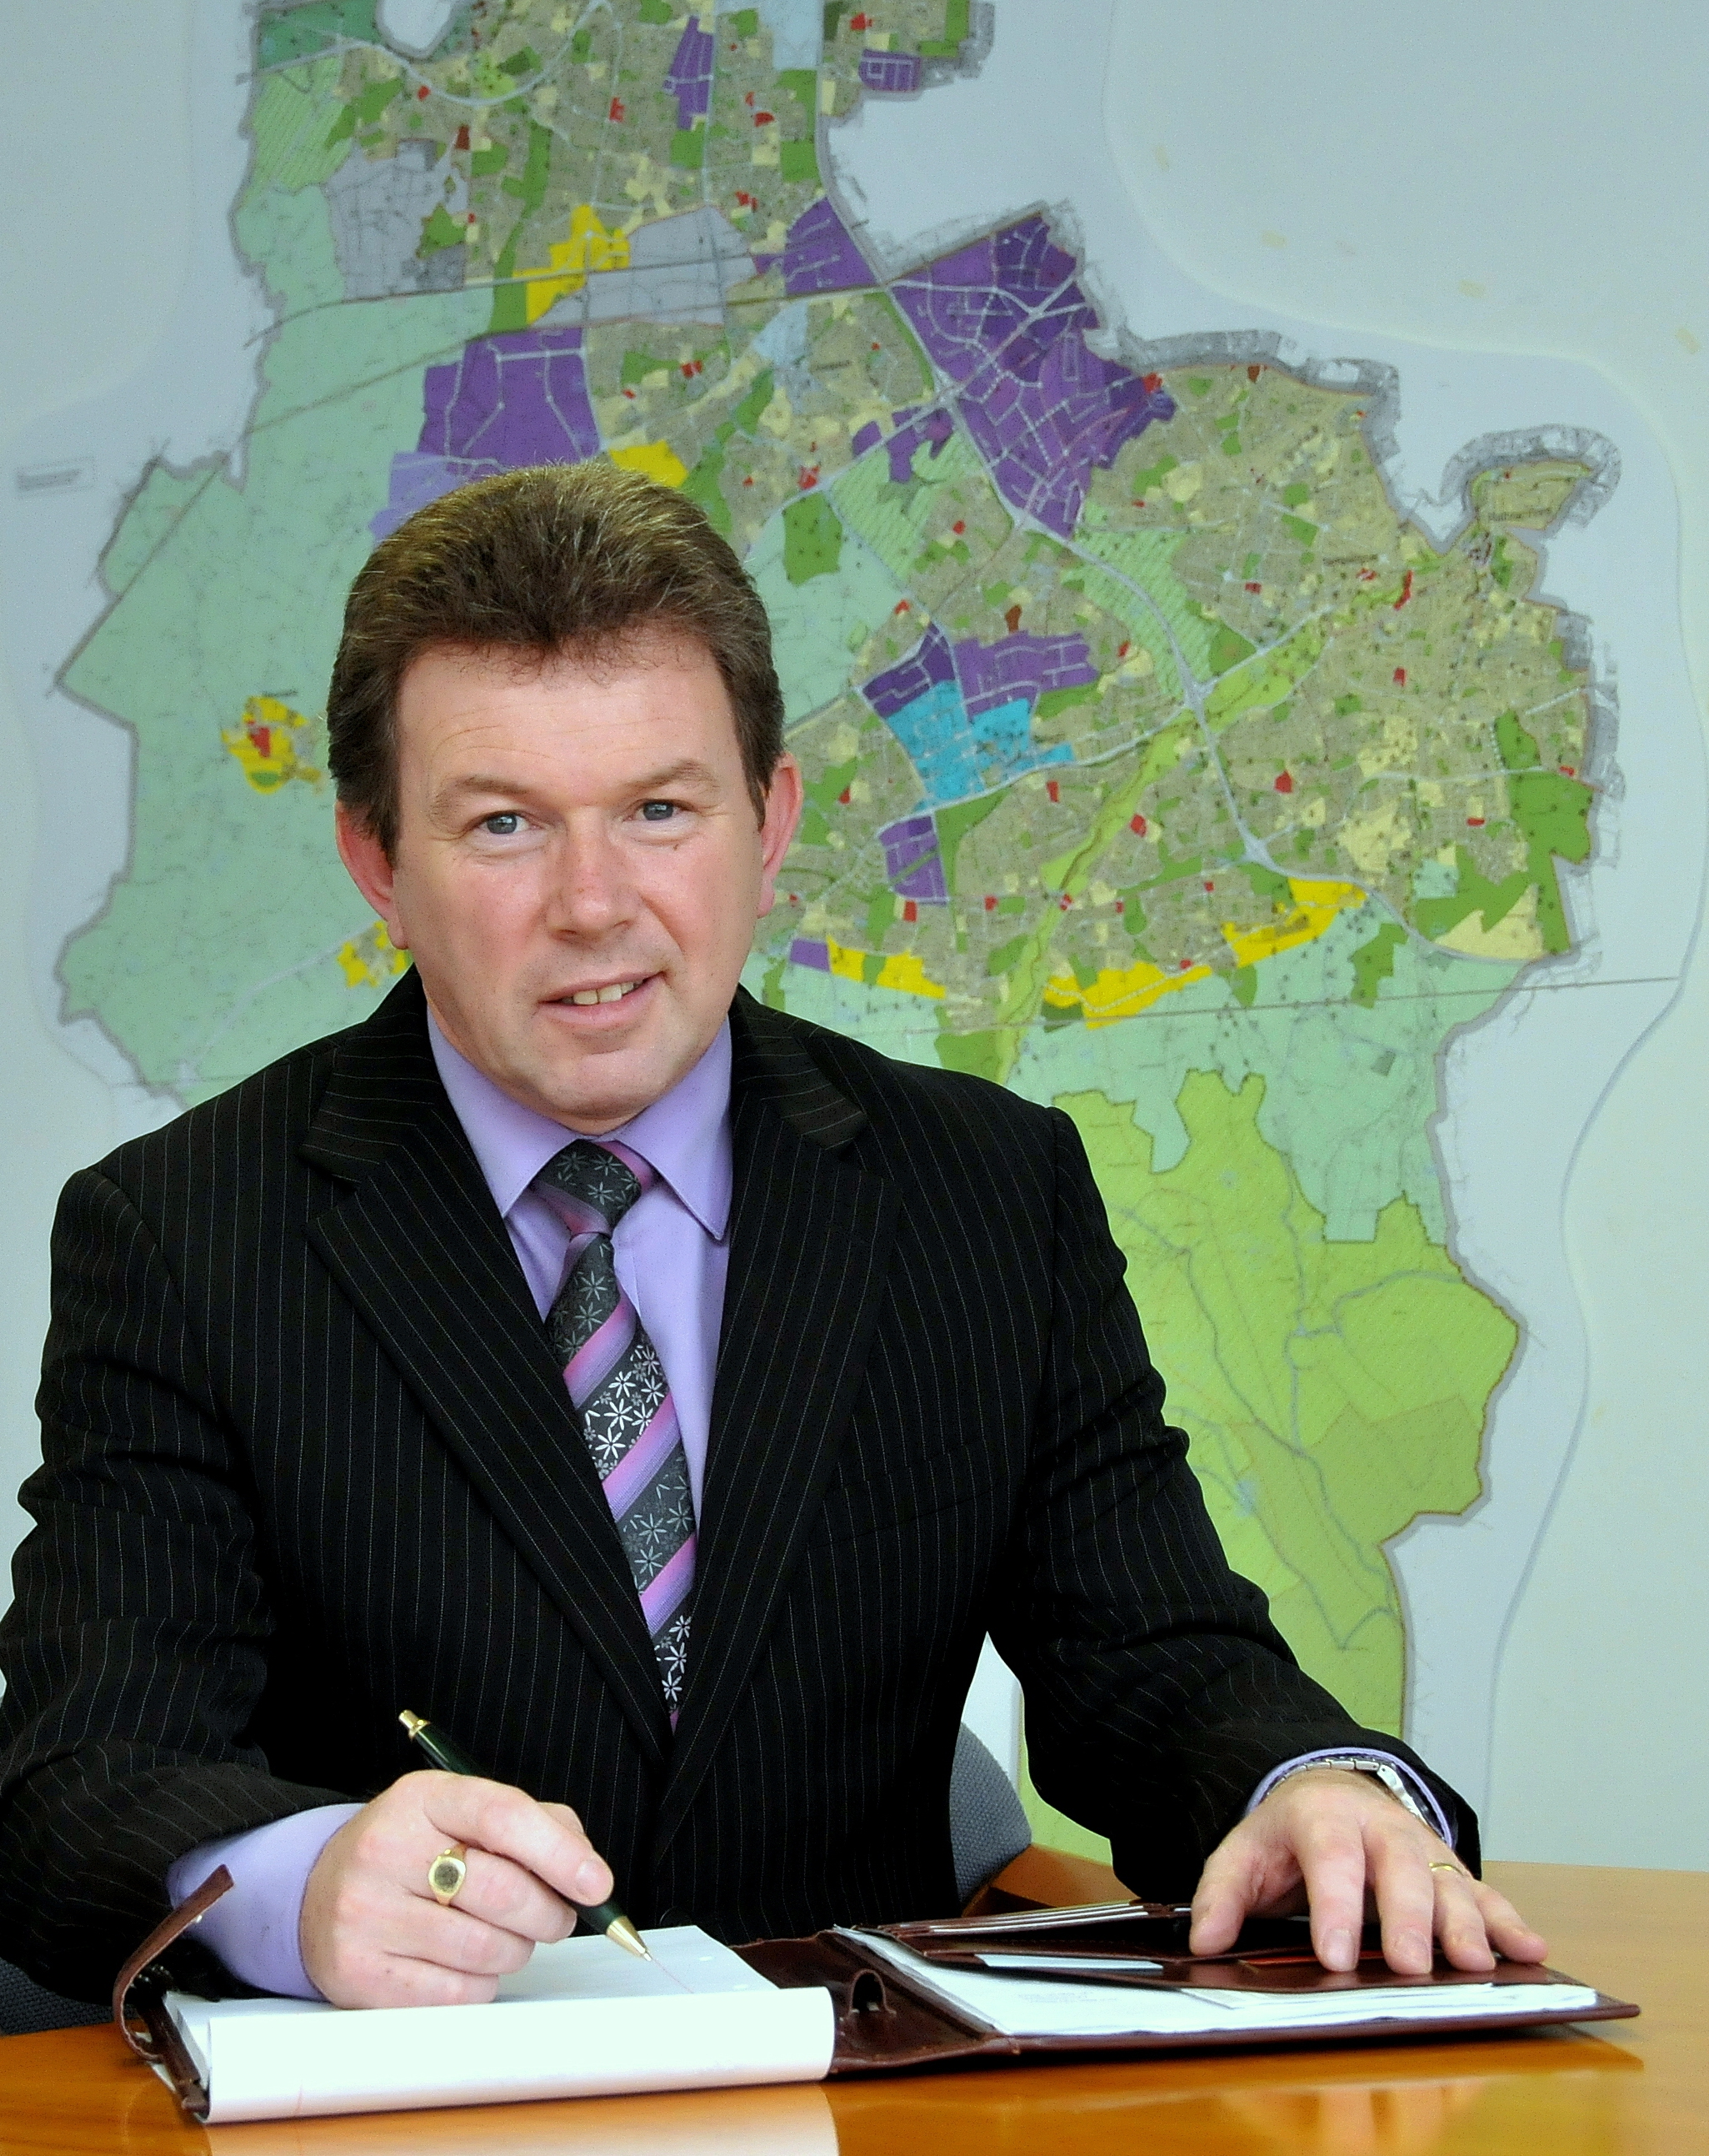
As we approach the mid-point of this Council’s term, it is encouraging to be in a position to report considerable progress across all of our objectives to make our County ‘a better place to live, work and do business’. Before commenting on some of the highlights, I want to also mention the Council’s highly successful 2016 Centenary Programme which facilitated enormous participation in this national celebration.

In general the year marked the midpoint of not just of the council term, but the progression and transition of plans and programmes from concept and planning through to early realization. This is particularly true in relation to our foremost priority of housing. Eight projects with a total yield of 260 units have been progressed through planning, four schemes have been tendered and will commence in March, with the balance being tendered in early 2017 for commencement later in the year. Two further schemes at Old Bawn and St. Cuthberts with the potential of a further 83 units are currently on public display, while a Prior Information Notice has been issued in respect of a joint venture mixed tenure development of up to 900 houses at Kilcarbery, and will be advertised for expressions of interest early in 2017. Private housing supply has started to show a positive trajectory. The review of the County Development Plan and the Clonburris SDZ review now underway will provide further certainty in this regard. An application has been made to the recently announced Infrastructure Support Fund for four of our key development sites at Adamstown, Clonburris, Kilcarbery and Ballycullen. A positive decision is expected in this regard.

Economic, enterprise and tourism development are central to our strategy to grow the local economy and provide opportunities for our citizens. The €1.2m Business Support Fund which represents 1% of commercial rates, is being targeted effectively at supporting the SME, retail and indigenous enterprise sectors. The Marketing Strategy for Grange Castle Business Park has had a positive impact, with the planned expansion of three existing businesses and the development of two additional. The €20m upgrade of the adjacent Nangor and Newcastle roads will commence in summer 2017 which will support the planned expansion westwards of the Park, following the recent completion of strategic land acquisitions for this purpose. The Clondalkin Round Tower Visitor Centre currently under construction will open next summer, while the Dublin Mountain Gateway is now undergoing rigorous environmental assessment. Studies of Corkagh Park and Rathfarnham Castle will explore further tourism attraction investment opportunities for consideration in quarter one of 2017.

Notwithstanding the need for new attractions, the quality of our existing villages and the general presentation of the county are also critically important elements of our offer. The Villages Enhancement Programme saw the completion of Rathcoole and Rathfarnham during the year. Environmental quality and aesthetic presentation are key objectives of our public realm and environment department. The adoption of new Tree and Litter Management Policies during the year has guided additional investment in landscaping, tree pruning and planting, litter management and public realm upgrade. Public and voluntary participation in our Environmental Awareness, Social Credits, Green Schools and Tidy Towns Programmes, all contribute greatly to our sense of pride of place and community.

Annually we invest over €2m in community support programmes including summer projects, arts initiatives, endeavour awards, community grant and initiative schemes, the return on which is enormous in terms of goodwill and volunteerism. Likewise community health and wellbeing is supported through a wide range of wellbeing programmes and infrastructure investments including libraries, playgrounds, sports pavilions and facilities all of which are detailed in this annual update. It is particularly encouraging that South Dublin was awarded “Healthy County” status during the year, a designation we intend to maintain.

The achievements during the year have been facilitated somewhat by a return to recruitment for the first time since 2009. Close to 200 new staff have joined the organisation in 2016, as a result of retirements and the recognition of the need to increase employment to meet increased demand and the gradual return to a more stable economy. The everyday work of our frontline staff is fundamental to public service and expectation. In terms of personal interaction we handled over 500 media queries, engaged with 15,700 followers on social media, processed 90,000 citizen queries and answered 190,000 telephone queries.

In summary progress during the past year has been encouraging and the detail set out in this report reflects positively on the organisation’s efforts to deliver on its Corporate Plan. While there are international considerations to our economic outlook, we can be reasonably sure that the immediate outlook is positive.

Finally, I would like to thank Mayor Guss O’ Connell, Council Members and Staff for their contribution and delivery of the outcomes of this report.

Yours sincerely,

________________
Daniel McLoughlin
Chief Executive

MEMBERSHIP OF SOUTH DUBLIN COUNTY COUNCIL

Clondalkin
Name: Councillor Madeleine Johansson replaced Cllr. Gino Kenny (elected to Dail Eireann)
Party: People before Profit Alliance
C/o South Dublin County Council
Clondalkin Civic Offices
Clondalkin
Dublin 22
0873630242
mjohansson@cllrs.sdublincoco.ie

Name: Councillor Mark Ward replaced Cllr. Eoin O’ Broin (elected to Dail Eireann)
Party: Sinn Fein
C/o South Dublin County Council
Clondalkin Civic Offices
Clondalkin
Dublin 22
086-7038164 or 414 9069
mward@cllrs.sdublincoco.ie

Name: Councillor Breda Bonner
Party: The Labour Party
C/o South Dublin County Council
Clondalkin Civic Offices
Clondalkin
Dublin 22
087 413 2627 or 401 9248
bbonner@cllrs.sdublincoco.ie

Name: Councillor Francis Timmons
Party: Independent
16 Cherrywood Villas
Clondalkin
Dublin 22
087 286 9315 or 4149143
ftimmons@cllrs.sdublincoco.ie

Name: Councillor Emer Higgins
Party: Fine Gael
C/o South Dublin County Council
Clondalkin Civic Offices
Clondalkin
Dublin 24
087 321 7741 or 414 9015
ehiggins@cllrs.sdublincoco.ie

Name: Councillor Trevor Gilligan
Party: Fianna Fail
C/o South Dublin County Council
Clondalkin Civic Offices
Clondalkin
Dublin 22
085 714 5005
www.trevorgilligan.com
tgilligan@cllrs.sdublincoco.ie

Name: Councillor Jonathan Graham
Party: Sinn Féin
C/o South Dublin County Council
Clondalkin Civic Offices
Clondalkin
Dublin 22
087 821 4840 or 414 9141
jgraham@cllrs.sdublincoco.ie

Name: Councillor Kenneth Egan
Party: Fine Gael
C/o South Dublin County Council
Clondalkin Civic Offices
Clondalkin
Dublin 22
087 413 1306 or 414 9140
kegan@cllrs.sdublincoco.ie

Lucan

Name: Councillor Vicki Casserly
Party: Fine Gael
C/o South Dublin County Council
County Hall
Tallaght
Dublin 24
085 831 7982 or 4149144
vcasserly@cllrs.sdublincoco.ie

Name: Councillor Paul Gogarty,
Party: Non Party
C/o South Dublin County Council
Clondalkin Civic Offices
Clondalkin
Dublin 22
087 275 2489 or 4149142
pgogarty@cllrs.sdublincoco.ie

Name: Councillor Ruth Nolan
Party: Non Party
C/o South Dublin County Council
Clondalkin Civic Offices
Clondalkin
Dublin 22
087 854 0030 or 4149145
rnolan@cllrs.sdublincoco.ie

Name: Councillor Guss O'Connell
Party: Non Party
47 Palmerstown Green
Palmerstown
Dublin 20
087 683 8254 or 626 8554
goconnell@cllrs.sdublincoco.ie

Name: Councillor William Lavelle
Party: Fine Gael
36 St. Andrew’s Drive
Lucan
Co. Dublin
087 410 7885 or 414 9050
wlavelle@cllrs.sdublincoco.ie

Name: Councillor Danny O’Brien
Party: Sinn Féin
C/o South Dublin County Council
Clondalkin Civic Offices
Clondalkin
Dublin 22
086 857 0828 or 4149146
dobrien@cllrs.sdublincoco.ie

Name: Councillor Ed O’Brien
Party: Fianna Fáil
C/o South Dublin County Council
Clondalkin Civic Offices
Clondalkin
Dublin 22
087 779 7609 or 6105811
eobrien@cllrs.sdublincoco.ie

Name: Councillor Liona O’Toole
Party: Non Party
C/o South Dublin County Council
Clondalkin Civic Offices
Clondalkin
Dublin 22
087 279 5274 or 4149350
lotoole@cllrs.sdublincoco.ie

Tallaght Central

Name: Councillor Brendan Ferron
Party: Sinn Féin
C/o South Dublin County Council
County Hall
Tallaght
Dublin 24
087 195 6087 or 4149065
bferron@cllrs.sdublincoco.ie

Name: Councillor Kieran Mahon
Party: Anti-Austerity Alliance
C/o South Dublin County Council
County Hall
Tallaght
Dublin 24
085 722 1120 or 4149325
kmahon@cllrs.sdublincoco.ie

Name: Councillor Mick Murphy
Party: Anti-Austerity Alliance
C/o South Dublin County Council
County Hall
Tallaght
Dublin 24
086 968 3814 or 4149327
mmuprhy@cllrs.sdublincoco.ie

Name: Councillor Mick Duff
Party: The Labour Party
C/o South Dublin County Council
County Hall
Tallaght
Dublin 24
087 886 5570 or 414 9031
mduff@cllrs.sdublincoco.ie

Name: Councillor Charlie O’Connor
Party: Fianna Fáil
C/o South Dublin County Council
County Hall
Tallaght
Dublin 24
087 298 2079 or 4149355
coconnor@cllrs.sdublincoco.ie

Name: Councillor Cora McCann replaced Cllr. Maire Devine (elected to Seanad Eireann)
Party: Sinn Fein
C/o South Dublin County Council
County Hall
Tallaght
Dublin 24
0860259078 or 01 4149066
cmccanncllrs@sdublincoco.ie

Tallaght South

Name: Councillor Nicky Coules
Party: People Before Profit
C/o South Dublin County Council
County Hall
Tallaght
Dublin 24
086 853 2326 or 4149356
ncoules@cllrs.sdublincoco.ie

Name: Councillor Cathal King
Party: Sinn Fein
C/o South Dublin County Council
County Hall
Tallaght
Dublin 24
086 318 6098 or 414 9063
cathalking@cllrs.sdublincoco.ie

Name: Councillor Louise Dunne
Party: Sinn Féin
C/o South Dublin County Council
County Hall
Tallaght
Dublin 24
085 785 9177 or 4149353
ldunne@cllrs.sdublincoco.ie

Name: Councillor Martina Genockey
Party: The Labour Party
C/o South Dublin County Council
County Hall
Tallaght
Dublin 24
086 373 5657 or 4149380
mgenockey@cllrs.sdublincoco.ie

Name: Councillor Brian Leech
Party: Anti-Austerity Alliance
C/o South Dublin County Council
County Hall
Tallaght
Dublin 24
085 195 0179 or 4149329
bleech@cllrs.sdublincoco.ie

Name: Councillor Dermot Richardson
Party: Sinn Fein
C/o South Dublin County Council
County Hall
Tallaght
Dublin 24
087 203 6468 or 4149382
drichardson@cllrs.sdublincoco.ie

Rathfarnham

Name: Councillor Anne-Marie Dermody,
Party: Fine Gael
11 Butterfield Avenue
Rathfarnham
Dublin 14
087 367 2030
amdermody@cllrs.sdublincoco.ie

Name: Councillor Paula Donovan
Party: Fine Gael
C/o South Dublin County Council
County Hall
Tallaght
Dublin 24
087 220 0741 or 4149352
podonovan@cllrs.sdublincoco.ie

Name: Councillor Emma Murphy replaced Cllr. John Lahart (elected to Dail Eireann)
Party: Fianna Fail
C/o South Dublin County Council
County Hall
Tallaght
Dublin 24
01-4149061 or 0863462302
emurphy@cllrs.sdublincoco.ie
Name: Councillor Francis Duffy
Party: Green Party
C/o South Dublin County Council
County Hall
Tallaght
Dublin 24
086 066 4762 or 4149323
fduffy@cllrs.sdublincoco.ie

Name: Councillor Sarah Holland
Party: Sinn Féin
C/o South Dublin County Council
County Hall
Tallaght
Dublin 24
086 198 7298 or 4149308
sholland@cllrs.sdublincoco.ie

Name: Councillor Deirdre O’Donovan
Party: Non Party
C/o South Dublin County Council
County Hall
Tallaght
Dublin 24
086 392 4209 or 4149102
dodonovan@cllrs.sdublincoco.ie

Templeogue-Terenure

Name: Councillor Brian Lawlor replaced Cllr Colm Brophy (elected to Dail Eireann)
Party: Fine Gael
C/o South Dublin County Council
County Hall
Tallaght
Dublin 24
01-4149064 or 087 6445472
blawlor@cllrs.sdublincoco.ie

Name: Councillor Dermot Looney
Party: Non Party
1 Temple Manor Close
Greenhills
Dublin 12
085 708 9955 or 414 9073
dlooney@cllrs.sdublincoco.ie

Name: Councillor Pamela Kearns
Party: The Labour Party
203 Orwell Park Heights
Templeogue
Dublin 6.W.
087 775 6718 or 414 9077
pkearns@cllrs.sdublincoco.ie

Name: Councillor Paul Foley
Party: Fianna Fáil
C/o South Dublin County Council
County Hall
Tallaght
Dublin 24
087 669 4177 or 4149331
pfoley@cllrs.sdublincoco.ie

Name: Councillor Ronan McMahon
Party: Renua Ireland
C/o South Dublin County Council
County Hall
Tallaght
Dublin 24
086 814 1498 or 4149354
rmcmahon@cllrs.sdublincoco.ie

Name: Councillor Enda Fanning replaces Cllr. Fintan Warfield (elected to Sennad Eireann)
Party: Sinn Féin
C/o South Dublin County Council
County Hall
Tallaght
Dublin 24
0872561524
efanning@cllrs.sdublincoco.ie

Changes of Members due to the General and Seanad Elections in 2016:

Colm Brophy elected to the Dail replaced by Councillor Brian Lawlor

John Lahart elected to the Dail Replaced by Councillor Emma Murphy

Gino Kenny elected to the Dail replaced by Councillor Madeleine Johannsson

Eoin O ’Broin elected to the Dail replaced by Councillor Mark Ward

Maire Devine elected to Seanad replaced by Councillor Cora Mc Cann

Fintan Warfield elected to Seanad replaced by Councillor Enda Fanning

COUNCIL MEETINGS 2016

There were 21 full meetings of the Council comprising of:

- 11 full Council Meetings including one Budget Meeting
- 6 Organisation Procedure and Finance Committee Meetings including one Budget Meeting
- 1 Annual Meeting
- 3 County Development Plan Meetings

The Corporate Policy Group held 12 meetings including one Budget Meeting

The 4 Area Committees for Clondalkin, Lucan, Rathfarnham/Templeogue-Terenure and Tallaght each met 10 times in 2016.

In addition there was 2 Oireachtas Members Meetings.

STRATEGIC POLICY COMMITTEES (SPCS)

ARTS, CULTURE, GAEILGE, HERITAGE AND LIBRARIES SPC

Chairperson Councillor Dermot Richardson
The Arts, Culture, Gaeilge, Heritage and Libraries SPC met 4 times in 2016 and their work programme included:

- Arts Strategy 2016-2020
- Planning of the 2016 Commemorations
- Tourism Strategy
- Public Art Programme (In context 4)
- Heritage and biodiversity plans.
- Expansion of Red line book festival.



ECONOMIC ENTERPRISE AND TOURISM DEVELOPMENT SPC
Chairperson: Councillor Charlie O’ Connor

The Economic Development, Enterprise and Tourism SPC met 5 times in 2016 and their work programme included:

- Regional Enterprise strategy and local implementation plan.
- Tourism Strategy and Implementation Plan
- Business Support Grant Measures
- LECP updates.

There was a joint meeting of both SPCs in July 2016 to discuss tourism projects and events.

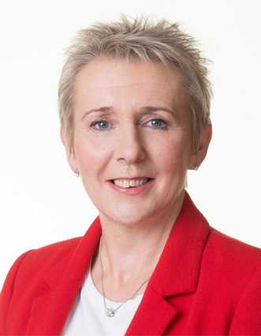

ENVIRONMENT, PUBLIC REALM AND CLIMATE CHANGE SPC
Chairperson: Councillor Pamela Kearns

The Environment, Public Realm and Climate Change SPC met four times in 2016 work programme included:

- Recycling Strategy
- Review of Litter Management Plan 2015-2019
- Preparation of Bio Diversity Plan and update of Heritage Plan
- Abandoned Cars
- Consideration of Climate Change Adaptation Strategy and Adaptation Guidelines
- Flood Alleviation Schemes
- National Climate Change Adaptation Framework
- Casual Trading Bye-Laws
- Review of Litter Bins
- Burial Ground Review and Strategy



HOUSING SPC
Chairperson: Councillor Cathal King

During 2016, the Housing SPC met 4 times and a number of reports and issues were discussed and considered including:

- Incremental Tenant Purchase Scheme
- Rent Policy and Debt Management
- Kilcarbery The Grange Masterplan
- Agreed Approved Housing Bodies Protocol
- Housing for Older People – Future Perspectives and Proposals

SOCIAL AND COMMUNITY SPC
Chairperson: Councillor Dermot Looney

The Sports, Recreation and Community Affairs (Including Parks) SPC met four times in 2016 work programme included:

- Sports Disability Programmes
- Review and progress 2016 Community Initiative Fund and Endeavour Awards
- Pride of Place Programme
- Intercultural Food Festival Initiative
- Festivals and Summer Projects 2016

LAND USE, PLANNING AND TRANSPORTATION SPC
Chairperson: Councillor William Lavelle

The Land Use, Planning and Transportation SPC met four times in 2016 discussed and considered the following matters:

- N4/N7 Corridor Study
- Policy on Infrastructure Naming, provision of Memorials & Plaques
- Speed Limit Review & Road Safety Strategy
- Cycling Forum / Strategy
- Vacant Sites Register
Details on the full membership of the SPCs are available in Appendix 2

CORPORATE AWARDS 2016

South Dublin County Council received recognition for excellence in the following areas:

Chambers Ireland Local Government Awards
South Dublin County Council took the ‘Healthy and Wellbeing Award ‘for Healthy Ireland - South Dublin County Initiative’. South Dublin County Council was also shortlisted in the following categories:
Category | Project Title
Supporting Active Communities | The Community Initiative Fund
Best Practice in Citizen Engagement | “Where does your money go"
Supporting Tourism | Dublin Mountain Partnership
Local Authority Innovation | Building the Lean Six Sigma Organisation
Disability Services Provision | Learn to Cycle Programme
Best Library Service | South Dublin Libraries- Heritage Publications and Bookstore
Sustainable Environment | Social Credits
Commerations and Centenaries | Part 8 - Construction of Grange Road Cycle and Walking Scheme and Enhancement of the Streetscape along Grange Road ,Rathfarnham, Dublin 14 and 16

CORPORATE PLAN ACHIEVEMENTS IN 2016

Economic Enterprise and Tourism Development

Objective 1: Maintain A Supportive Business Environment With Job Creation And Retention At Its Heart
- The Dublin Regional Enterprise Strategy 2017-2019 was approved by the Council in November 2016.
- South Dublin County Council sponsored the inaugural South Dublin Chamber Business Awards held on 21st October in Citywest Hotel.
- A survey of Exporting Businesses in the County was conducted by South Dublin Chamber on behalf of the Council. This will form the basis of a 2017 Action Plan for Local Exporters.
- LEO launched the Network of Enterprising Women in South Dublin on December 15th, 2016.
- The Evaluation and Approvals Committee of the Local Enterprise Office has approved €583,250 for 35 projects, creating 42 new jobs immediately and with the potential to create a total of 167 new jobs.
- 553 people have attended LEO training courses.
- 298 clients have availed of in-house / outreach mentoring services from LEO.
- 94 people have attended Trading Online seminars with 34 vouchers approved this year.
- 1,040 valid applications received for the Business Support Grant with an additional 41 applications being progressed for improvement / development support schemes.
- Business Support Fund Area Improvement works completed in Cookstown Enterprise Park, Old Belgard Road, JFK with further projects progressing in Ballymount and Merrywell.
- 168 attendees attended Business Support Fund training programmes based on 2015 training needs survey completed in conjunction with Chamber.
- Business Support Fund approved for continuation in 2017 as part of Budget process.

Objective 2: Work With Enterprise Support Agencies To Increase Foreign Direct Investment In South Dublin County
Grange Castle
- Interxion: Build 80% by year end 2016. Entrance road has been completed by SDCC.
- Pfizer: Submitted planning application for production expansion and permission was granted SD16A/0236. Enabling works were ongoing to Dec 2016. Pfizer have announced the expansion is not to happen because a decision has been made to discontinue the development of the drug bococizumab, a drug for reducing cholesterol which was to be manufactured at Grange Castle.
- Grifols: Submitted planning application for production expansion and permission granted SD16A/0250. Works are ongoing.
- Microsoft: Planning permission in place for extensive future decvelopment. Construction is ongoing.
- Eirgrid: S.I. Application for 220KV substation granted by ABP 28/06/16. Was the subject of Judicial Review.
- Capital Programme - Nangor Road / R120: CPO approved.
- Archaeological – GC South: Archaeological work ongoing.
- Google: Official Opening was in June 2016.
- Edgeconnex: Application for new Datacentre approved directly adjacent to the Business Park. Access to datacentre will be via Grange Castle Business Park, subject to finalisation of terms.
- Takeda: Announcement in Dec 2016 regarding proposal for new production facility in 2017.
- Office Brief: 2 expressions of interest were received however on further examination of feasibility, it was considered premature to build significant speculative office accomodation in Grange Castle. This will be reviewed going forward.
- Delegations: Dutch delegation visited the Business Park in October 2016. A number of IDA meeting and delegations were hosted in 2016.
- IDA are kept fully informed of status of available lands: SDCC actively seeking new clients.
- Preliminary Conservation works were carried out on the Castle in preparation for a ‘pocket park’ in 2017.
- Grange Castle supported in excess of 3150 jobs at end 2016.

Objective 3: Manage The Assets Of South Dublin County Council In A Way That Supports Economic Development
- GCFM Ltd Continue to maintain, operate and manage the Business Park. 2016 saw the Landscape and Security contracts renewed through full tender process in accordance with procurement requirements. CCTV contract maintenance ongoing. Tender for professional services will be issued late 2016 / early 2017.
- Assessment of future requirements of industrial land bank under constant review and property acquired. Latest acquisition Strategic Land Bank has been acquired West of Grange Castle Business with following CDP objective ET3 SLO 1:To conduct a review of the zoning of lands south of the Grand Canal and west and north of the R120, including lands adjoining Peamount Healthcare, with a view to preparing a long term plan for the expansion of the Grange Castle Economic and Enterprise Zone to this area, to accommodate strategic investment in the future, while also seeking to provide public open space along the Canal, including a natural heritage area in the vicinity of the historic canal quarries at Gollierstown.
- CPOs process for the R120 / Nangor Road upgrade approved by ABP, which will increase road and service accessibility to Grange Castle Business Park and wider area.
- Development/review of property management procedures commenced in 2016 as well as development of a new property management system and involvement in OPW national working group on protocols for public lands.
- Tallaght Stadium played host to a number of independent events such as Nitro Circus, and Fossetts Circus as well as American Football, Rugby, Womens International Soccer matches and Dundalk’s UEFA matches.

Objective 4: Maximise The Contribution Of Arts, Libraries, Heritage And The Irish Language To Quality Of Life And Our Tourism Experience
- Plans for North Clondalkin library and funding for same at an advanced stage.
- Lease arrangements at the Digital hub in Palmerstown is well advanced and fit-out will soon be commenced.
- New mobile library in service.
- Part 8 approval for Castletymon Library agreed.
- Successful delivery of 1916/2016 commemorations events in all branch libraries.
- Libraries won 1st prize for the YAPS blog and 3rd prize for the Ballyroan reads blog at the Littlewoods Art and Culture Blogs.
- Arts Strategy 2016-2020 agreed.
- Libraries’ programme of events successfully delivered throughout the branch network including the Summer Stars Reading Programme, Science Week events and Craft Fairs at Tallaght, Ballyroan and Lucan libraries.
- Red Line Book Festival delivered 39 events across 12 venues throughout the county.
- Science Partnership initiative between South Dublin County Libraries, IT Tallaght and Foróige to engage young people and their families with STEM subjects.
- Local Studies/history section of Libraries identified and catalogued materials for the Round Tower and Dublin Mountain projects.

Objective 5: Put In Place A Tourism Strategy Focused On New Product And Brand Development
- Continued focus on implementation of the South Dublin Tourism Strategy 2015-2020 approved by Council and launched in April 2015.
- Memoranda of Understanding completed with Coillte for Dublin Mountains Gateway project. Feasibility and master plans presented to the Council in March. Consultant project team appointed to progress EIA preparation for lodgment of a planning application to An Bord Pleanala in 2017. A capital grant funding application has also been made to Failte Ireland for this project.
- Tourism marketing strategy and implementation plan ongoing – this will include launch of marketing campaign, logo, website and collaterals in Q1 2017.
- Construction commenced on the Round Tower Visitor Centre in Clondalkin- open in May 2016.
- Red Line Festival in October 2016 included a broader range of venues, events and a wider marketing focus delivering increased visitor numbers.
- Plans ongoing for Gael Force Dublin in February 2017 - opportunity to showcase the Dublin Mountains. This industry led festival proposal from the Tourism Working Group and Economic Enterprise & Tourism Development SPC is underpinned by the Council’s support.
- Feasibility studies progressed in 2016 for the Liffey Blueway Study, Corkagh Park plan and a condition survey of Heritage out-buildings at Rathfarnham Castle.
- EU Funding secured to progress the Dodder Greenway project.
- €26,500 was paid to nine events under the Community (Diaspora) Tourism Events Scheme.
- 13 Shop Front Grants approved in 2016 to complement ongoing village improvement works.

Land Use Planning And Transportation

Objective 1: Implement An Annual Road Works Programme Of Maintenance And Improvements
- A total of 50 schemes, costing €4.5m were carried out on Regional and Local Roads. In addition Footpath replacement schemes were carried out at 82 locations throughout the County.
- On the N81 resurfacing works were carried from the Crooksling to Brittas Village. TII also funded 2 Safety Improvement Schemes on the N81, resurfacing and drainage works at Lisheen bends south of Brittas and also repairs and improvements to the boundary wall at Kiltalown.
- Bridge repairs and routine maintenance works were carried out on 17 Regional and local Road bridges.
- The footpath maintenance programme replaced 30,000m² of public footpath.
- A new Public Lighting Maintenance contract was tendered and awarded during 2016 and 3,000 lights were upgraded to low energy LED’s throughout the County at a cost of €900,000.

Objective 2: Maintain A Professional Planning And Development Management Structure And Processes
- During 2016 the new County Development Plan 2016-2022 was adopted by the Council and came into effect on 12th June 2016.
- 2016 again saw an increase in planning applications received, with 800 expected to be received by year end. In addition over 240 pre-planning consultations were held throughout the year.
- 2016 saw the recommencement of construction activity in Adamstown SDZ. Significant residential development proposals are now at various stages in the planning process which should lead to significant construction activity in 2017.
- The Planning Section also made applications for the funding of residential development related infrastructure under the Governments Local Infrastructure Housing Activation Fund (LIHAF) for Adamstown and Clonburris SDZ’s, Ballycullen-Oldcourt LAP and The Grange Mixed Tenure Scheme.
- The Planning Department continued to expand its role in the Area of Active Land Management and completed a review of all potential vacant zoned lands in the County for inclusion on the new Vacant Site Register as well as ongoing monitoring of residential construction activity throughout the County.

Objective 3: Promote All Modes Of Transport Including Walking And Cycling To Improve The Movement Of People Within And Beyond The County
- Works continued in 2016 on the Sustainable Transport Measures programme, funded by the NTA and €5m was invested in the County on the following schemes:-
- Works were completed on Cycle lanes from Tallaght village towards Templeogue and pedestrian and cycle improvements at Knocklyon Road/Idrone Junction, Pedestrian Crossings on the N81 at Jobstown and Avonmore and works on Monastery Road in Clondalkin.
- Works were also commenced on the Willsbrook Road, Outer Ring Road Junction in Lucan and pedestrian improvement works around the Green Schools Cluster in Ballyroan.
- All speed limits within the County were reviewed and a statutory public consultation process held for the introduction of a new 30kph speed limit in all residential areas. Subject to Council approval these new residential speed limits will come into effect in early 2017.
- The Council expanded its programme of cycle awareness training and provided certified training to 1,838 school children during the year.

Objective 4: Invest In Sustainable Communities And Quality Of Life Initiatives
- The Council formulated and adopted a New Road Safety Strategy for the County, covering the period 2016-2020 and established a Road Safety Together Working Group to oversee its implementation.
- The Village Enhancement Programme continued in 2016 and works were completed in Rathcoole and Rathfarnham. Improvements schemes were also designed and agreed for Saggart, Tallaght, Belgard Square and Newcastle and these will be implemented in early 2017.

Housing Social and Community Development

Objective 1: Put In Place A Three Year Programme To Supply Social Housing In The Context Of The Social Housing Strategy 2020
- 15 units completed in 2016.
- One Rapid Build Project for 85 units approved through Part 8 in 2016 – cost plans and CBA submitted to DECLG. Two other Rapid Build projects progressing through Part 8 process. A total of 220 Rapid Build units to be progressed through 2017.
- Four Projects through tendering process providing a total of 71 units to start early 2017 – and three projects approved for tender stage - a total of 105 units.
- 65 Acquisitions completed in 2016.
- Current Social Housing Stock – 9,124, 1,501 RAS and 773 Leased Units.
- 1,434 live accounts on HAP at 31st December 2016.
- 235 Allocations in 2016 including 87 Homeless Allocations.
- Re-let turnaround average time is 9 weeks.
- Agreed process between Dublin LAs and ICSH re protocols to be followed in dealings with LA / Developers in acquisitions, leasing, new build and purchases in operation.
- The new incremental tenant purchase scheme approved and came into operation on in 2016.
- 203 Private Disability Grants issued in 2016.
- 75 units benefitted for Grants for void management at cost of €1.473M.
- 790 Units benefitted from Energy Efficiency programme with grant aid of €847,000.
- Housing Need Assessment carried out for all those applicants on housing list at 21/9/2015 and returned completed forms and/or online assessed.

Objective 2: Take A Leadership Role In Social Inclusion And Interagency Co-Operation
- SICAP funding delivery by the Implementer reviewed by LCDC and a POBAL parallel review carried out on delivery and targets met in areas of Targeting Geographical Disadvantage and Targeting Disadvantaged Groups in 2016.
- New ‘LAG’ (Local Action Group) for Dublin Rural areas established made up of the Fingal LCDC and representatives from SDC and DDL LCDC. The LAG is made up of the 19 Fingal LCDC members plus 8 additional members from LCDCs of the administrative areas of South Dublin County Council and Dun Laoghaire Rathdown County Council. The role of this group is to oversee the creation and rollout of the Local Development Strategy (LDS) following a consultation process. The Local Development Strategy (LDS) for the Dublin Rural Area was approved by the Department and calls for expressions of interest begun following animation meetings at local levels.
- LECP 6 year plan -Community and Economic pillars of plan agreed by LCDC and Economic SPC progressing. Review of the 2016 Workplan through public consultation process completed.
- Successful Bealtaine Festival and Social Inclusion Week in 2016 with full attendance at many events. Over 170 free events organised between both.
- South Dublin Age Friendly County Alliance continues to support and lead in initiatives for the active aged in the county such as including provision of a Public Transport Report, NALA Health Literacy Courses, Trusted Tradesmen piloted in Newcastle, Housing Research project through IT Tallaght, Support for the development of men’s sheds – 5 new in 2016 and a new initiative on Home Security for doors or Patios -500 installations to be completed by end 2016.
- 32 Joint Policing and Local Policing Fora meetings held in 2016 including public meetings at Tallaght, South West Clondalkin and North Clondalkin.

Objective 3: Promote Health, Wellbeing, Recreation And Activity To Improve Quality Of Life
- The Steering Group established in conjunction with the HSE, Trinity Research, DDLETB and Local Development Company on the South Dublin Healthy County initiative to achieve “Healthy County” status progressed a number of projects in 2016 including 2 successful programmes of We Quit Campaign for Women, development of Alcohol Strategy with Tallaght Drugs Task Force. Full accreditation as member of the Healthy City/Counties Network awarded in November 2016. Main themes Physical Activity and Alcohol Strategy. Work continues to reduce health inequalities and Health and Wellbeing embedded in policies with Key focus areas of promoting Physical Activity and Active Lifestyles.
- The HANA Work plan arising from the recommendations of the HANA report being implemented. The Council is proactive and leading on 3 of the 12 actions with focus on positive aspects of Tallaght area, greater awareness of available facilities and services and promotion of their use and finally develop an evidence based approach to community led initiatives to tackle petty crime which is being developed by the Healthy County Steering Committee.
- SPORTIVATE the Councils new Sports Development Programme agreed in partnership with DDLETB and with DSP as partner 18 participants completing the programme with accreditation and 5 participants achieving full awards. The second programme started in 2016. The programme is based in Brookfield Youth and Family Centre. It caters for participants primarily between the ages of 18 and 25 years of age who are interested in breaking into the sports industry in some capacity or furthering their educational opportunities. The programme designed to broaden the participant’s education and help them get back into the workforce.
- 83,489 Sports Programmes participants in 2016 over 1,612 events.
- SDCC Schools Cross Country finals held on 12th May 2016 at Corkagh Park - 2,950 participants from 59 schools.
- SDCC Disability Accommodation revised Strategy signed off by the Disability Accommodation Steering Committee at December 2016 meeting.
- Successful Health and Wellbeing Week in September.
- 322 Community events attracting 63,019 participants.
- 563,787 visitors to Councils Leisure Facilities
- 26 Summer Projects/Camps supported in 2016 facilitating over 6,000 children.
- 9 Local Village Festivals supported.
- Successful 2016 Late Nite Leagues with FAI and Gardai – up to 120 participants during the programme at 4 venues during November with the County Finals involving 80 youths held on 3rd December 2016.
- The swimming pool project for Lucan secured funding from the Department of Transport Tourism and Sport and the School Sports Hall incorporating a Community facility for Adamstown progressed in 2016.

Objective 4: Facilitate Community Leadership And Development Through Community Engagement And Empowerment
- The second successful Endeavour Awards progressed during 2016 and Awards made on 2nd December 2016. The Awards has the objective of recognising and rewarding particular categories of endeavor and to promote and support the Community of South Dublin.
- The Community Initiative Fund approved by the Council in 2015 was again run in 2016. The Initiative allowed Community Groups to bid for funding support which is not available from other resources. It is designed to fund/provide an opportunity for access to funds for significant community and Cultural/heritage enhancement or neighbourhood projects. There were 69 applications with 18 successful entries.
- The Community Grants Scheme opened for applications twice during 2016 - in February and September.
- The PPN continues to grow its membership The DECLG provided additional funding to support PPN’s nationally. The PPN is utilised for all notifications from Council. PPN Membership/registration now stands at 430 communications to other groups is being broadened. New PPN Member Directory Launched and Training Programme announced during 2016.
- 9 Tidy Town Groups Active as of start of the year (Clondalkin, Lucan, Newcastle, Palmerstown, Templeogue, Woodstown, North Clondalkin, Griffeen and Oldbawn) with 2 new groups identified and capacity building work during the year. All the Tidy Town Groups improved on their results in this year’s SuperValu National Tidy Towns Competition announced 26th September 2016.
- Council supported the Pride of Place Entrants 2016 with 5 entrants. SDCC submitted Glenasmole Community Association, RAMS, Re-Create, St Dominic’s CC and SDCC PPN WITH St Dominics crowned Urban Neighbourhood Centre for 2016.

Environment Water and Climate Change

Objective 1: Improve The Appearance Of Our County In The Interest Of Economic Development
- Park land and open space maintained including a fortnightly grass cutting schedule for March to October resulting in over 6,000 hectares of grass cut in the period.
- Action Plan for the implementation of the Litter Management Plan for 2016 appended: 3850 complaints were investigated, 434 Litter Fines were issued, with 56 Court Appearances during 2016.
- Living with Trees - SDCC’s Tree Management Policy: In the period January to November 2016, 4469 trees were inspected; 424 trees were planted with a further 700 to be planted as part of the ongoing winter 2016/spring 2017 tree planting programme; 1417 trees were pruned; 642 trees were removed and 522 tree stumps were removed.
- N81 Landscape Improvement Scheme: The preliminary design of the N81 improvement scheme progressed during 2016. The Part 8 drawings and documents went to public consultation from November 2016 to the 20th of January 2017. Provision has been made to deliver the project in 2017 and 2018.
- Roundabout Sponsorship Scheme: In April 2016, tenders were invited from interested parties for the Roundabout Sponsorship Scheme. Tender submissions were received for five of the 16 roundabouts advertised. Improvement works and upgrades are being carried out on the following roundabouts: Belgard Square/ITT; Ballymount Industrial Estate at junction Ballymount Road/Turnpike Road; Orwell roundabout; Ballyboden Road/Taylors Lane and at Scholarstown/Templeroan.
- Derelict Sites Register maintained with 371 Dangerous Buildings/ Derelict Sites inspected during the year, 16 sites on the Register at end of 2016, 5 properties vested and an additional site pending appeal with An Bord Pleanála following an objection from the owner.
- Environmental monitoring initiatives including Litter/waste CCTV and Programmable Audio Devices to help combat graffiti, litter, illegal dumping and dog fouling installed in various locations which resulted in an average reduction of 82.5% in illegal dumping occurrences. Two parks prone to dog fouling being monitoring following trial of provision of dog bag dispensers.
- A total of 383 tonnes of waste was collected from 675 bins (increase of 90) serviced on 5 dedicated routes, 4995 tonnes of illegally dumped material was collected and 5312 tonnes of road sweeping/ gully cleaning waste collected and disposed in 2016.

Objective 2: Incorporate Environmental Sustainability In All Policy-Making And Implementation Programmes
- 2016 Annual Service Plan agreed with Irish Water and service provided under a Service Level Agreement.
- 1,500km of water mains and 4 large storage reservoirs were maintained
- 73 ML of water was supplied per day, with an Unaccounted for Water (UFW) of 33.75%.
- 1,200km of foul and surface water sewers were maintained.
- 545 Water bursts and leaks were repaired.
- Water Quality was maintained at an average of 99.9% throughout the year, with 70 Water Pollution Incidents dealt with during the year.
- River clearing and Flood Alleviation Schemes: A programme of river clearing was carried out during 2016. The rivers and streams cleared were the Poddle, the Camac, the Jobstown stream and the Oldcourt stream. Ballycullen Flood Alleviation Scheme - Tenders assessment completed and contractor appointed in December. Poddle FAS - the brief for this scheme is finalised and agreed with the OPW. The procurement of consultants is progressing using a Framework in Dublin City Council.
- Surface Water Schemes: Monastery Road and New Road Clondalkin surface water schemes were completed in 2016. Preparation for works at Tay Lane Rathcoole and Chapel Hill Lucan commenced.
- Climate Change: Following a public consultation process, the revised strategy, 'A Draft Strategy towards Climate Change’ Action Plans for the Dublin Local Authorities' has been completed and will be considered at the next Environment SPC Meeting in February 2017. Climate Change Mitigation and Adaptation Action Plans will be developed and adopted in 2017.

Objective 3: Manage our regulatory, licensing and enforcement roles together with the Environmental Protection Agency
- 2016 Service Plan agreed with Food Safety Authority of Ireland.
- Continued active enforcement of the provisions of all environmental legislation and regulations with 208 enforcement procedures commenced and 100 Enforcement Notices issued in 2016. 2,568 Scheduled and Unscheduled Inspections were carried out including 927 Waste Enforcement Officers Inspections, 1,035 FOG inspections and 606 Water Pollution Inspector inspections. 38 permitted facilities (permits & CORs).
- Delivered 185 Environmental Awareness workshops/information sessions for schools, communities and businesses.
- 131 Schools registered in the Green Schools Programme
- 2332 Social Credits actions took place (Jan- Nov 2016 )
- 74 recycling Bring Banks and 2 Recycling Centres provided.Community recycling strategy updated and agreed through Env SPC in Feb 16. As part of the recycling message is promoted on an ongoing basis as part of the Environmental awareness programme
- Control of Animals legislation actively enforced. 581 dogs and 266 horses were impounded during the year. Regular inspections of horse pound and dog pound have also been carried out, with ongoing monitoring of contractual performance and recoupment of monies.
- Delivery of Equine Facility at Ballyowen Park consisting of 20 Equine Stalls, ancillary facilities, education space, exercise paddocks, and car parking.
- Casual Trading Bye Laws reviewed and new Bye Laws for control and regulation of casual trading made.
- Contract for Dog Pound: Service extended to April 2017 and contract for Provision and Operation of Horse Seizure & Pound Service extended March 2017. At the end of 2016 - 9582 dog licences were in force in the County.
- Working with the Eastern Midlands Regional Waste Office, SDCC is implementing actions and goals under the eight strategic objectives of the Waste Management Plan 2015 – 2021. www.emwr.ie
- The Waste Enforcement Regional Lead Authorities (WERLAs) were established to co-ordinate waste enforcement actions within local authorities - a work plan for the 2016/17 period has been agreed by the 12 Eastern Local Authorities. www.emwr.ie
- Burial Grounds: Internal Review conducted which will inform development (in 2017) of Burial Grounds Strategy

Objective 4: Maintain and improve our parks and recreation areas to enhance our quality of life
- Maintenance of and detailed audit carried out of 163 pitches provided by Council.
- Allotments: Design of a new extension with a capacity for 100 plots and car parking to the allotments at Tymon Park was progressed in 2016. The tender for this project will issue in 2017.
- 2016 Play-space Programme: 14 play spaces progressing through planning / design stage at end of 2016, 8 in consultation, 5 completed and opened during 2016 and 1 to be completed in early 2017.
- Sports Capital Grants: Progression of designs and tender documentation in relation to Tymon Park pitches and athletics track at Lucan in 2016. Planning granted in relation to an all-weather pitch at Lucan and discussions between the Club and local residents is on-going with facilitation from the council.
- Pitch development / enhancement: The design for sports facilities at Mt Carmel, Dodder Park was progressed in 2016 with the Ecological Impact Assessment report completed. The design and tender for replacement pitches at Firhouse Park to facilitate new school construction was also progressed.
- Pavilion Construction Programme: The Part 8 Public Consultation Proposals concluded. The initial tender process was unsuccessful and failed to result in an award. Documents being prepared currently for re-tendering.
- Collaboration on Council’s Tourism Strategy including contributing to the options and feasibility report for the further development of the tourism visitor potential at Corkagh Park, the commencement of the feasibility study for the Liffey Valley Blueway and the tender for the preliminary design and progression of the Dublin Mountains tourism facility.

Organisational Capacity and Accountability

Objective 1: Support local democracy including the policy making and representation role of our Elected Members
- The Council's 2016 Centenary Programme attracted a large number of participants to our events and exhibitions during the year and we were delighted with how the year progressed to and the level of community engagement. Some of the highlights of the year included:
- Proclamation Day
- Paths to Freedom Conference in Tallaght Stadium
- Flag Raising Ceremony at County Hall, Tallaght
- Official Opening of Commemorative Garden at Newlands Cross
- Concert to Remember in Clondalkin Library
- State Ceremonial Event attended by President Higgins in the Pearse Museum
- Dublin Fire Brigade 1916 Exhibition
- South Dublin County and 1916 Rising Exhibition
- South Dublin County and Battle of the Somme Exhibition

- Freedom of the County was awarded to Jim Gavin, Dublin Senior Football Team Manager in February, and in June 2016, a Civic Reception was held for Ballyboden St. Enda’s All- Ireland Football Champions 2016. A revised Civic Honours Protocol was adopted by the elected members at the November Organisational, Procedure and Finance Committee Meeting.
- The Electoral Register for 2017/2018 has been brought to draft stage on time with the final register will be published in February 2017. Planning has begun on the introduction of an online register Voter.ie.in collaboration with the three other Dublin local authorities.

Objective 2: Provide robust financial management, risk management, audit and corporate governance systems
- In 2016 the financial welfare and effective financial management of the council was achieved and supported through a combination of measures. Budgets were actively monitored and controlled with quarterly reports in revenue and capital issued to Council and the Department of Housing, Planning, Community and Local Government. Commercial rate bills totaling €117m were issued in January. Income was tracked through the production and review of monthly billing and collection statements to ensure income maximisation. The 3 year capital programme incorporating projects of €289m was produced for 2017-2019 while council adopted a 2017 revenue budget of €228m on November 3rd. The 2015 AFS was prepared by 31st March 2015 with subsequent audited accounts and audit report submitted to council and audit committee.
- The Audit Committee met four times during the year and delivered on their work programme as presented to the December 2015 County Council meeting. The Chair of the Audit Committee attended the March Council meeting and presented the Committee’s 2015 annual report. The Chair also attended the October Council meeting and presented the Committee’s report on their findings of the audit of the Annual Financial Statement and Auditor’s report 2015. Audits were conducted during the year across the organisation and recommendations made assisted in strengthening the control environment on a continual improvement basis.
- The Ethics Declaration and preparation of the Ethics Register was completed in February 2016 and a new Ethics Registrar was appointed for the period 1st December 2016 – 31st November 2018.
- Implementation of the Corporate Procurement Plan 2015 – 2017 continued with the dedicated Procurement Unit providing ongoing support and training to all staff as required in procurement policy, on individual tender processes and on contract management.
- The Public Spending Code was published and submitted to National Oversight and Audit Commission on 31st May 2016.
- The Publication Scheme required under the Freedom of Information Act 2014 was developed and implemented within the statutory timeframe.
- A report on the Corporate Plan Achievements for 2015 was published in January 2016.
- The Annual Service Delivery Plan (ASDP) with performance targets was published in February 2016.
- An infographic promoting the ASDP was published in the Citizen Newsletter and issued to every household in the county in June 2016.
- The Annual Report for 2015 was published in June 2016.
- The Monthly Management Report to Council reported on all activity in 2016 under the Corporate Plan and included the provision of local monthly performance indicators.
- Completion of South Dublin’s return for the National Performance Indicators for 2015 was submitted to NOAC within the timeframe and a report was presented to the Audit Committee on our performance in December 2016.

Objective 3: Exploit advances in information and communications technology (ICT) to become more efficient and to improve services for local people
- New Systems and Upgrades Implemented: Planning Bonds and Contributions system, Tree Management System implemented, Statutory Inspections system, NetConsent, on line Consultation Portal, House Survey system implemented, Community Endeavour Awards, Public Realm Scheduler system
Public Wi-Fi facilities upgraded at various locations. These include at the Civic Theatre and extensive upgrade and new deployments across the library branch network expanding this coverage into the villages Wi-Fi project.
- Development of an athlete orientated self-awareness online facility delivered which acts as a self-critique and facilitating goal eight of the LECP – “Empower our communities to improve their health and wellbeing and quality of life by providing relevant information and accessibility to quality services”.
- GIS accomplishments: Delivery of online Maps Gallery incorporating community facilities, general election 2016, playing pitches, burial grounds, allotments, playgrounds, derelict sites and retail GIS projects. Community mapping incorporates; Parks, Playing Pitches, Playgrounds, Adult Exercise Equipment, Pavilions, Allotments, Burial Grounds, Churches, Electoral Boundaries, CSO data, Bring Banks, Accessible Parking, RSA Road Collisions, myPlan and “Fitwalk” routes. Rates Vacancy GIS and Property Register GIS upgraded.

Objective 4: Develop and maintain appropriate communication channels that enable proactive citizen engagement
- Over 400 media queries were responded to in 2016
- The number of social media followers increased by over 2,000 with 15,700 followers now on our various social media channels
- Over 90,000 queries were processed through customer services with an average response time of 4 days across the year.
- Over 190,000 telephone calls were handled by customer services, of which 82% were answered within 20 seconds
- South Dublin County Council’s 3rd Irish Language Scheme approved by the Minister in October 2016
- A Summer and Winter edition of the Citizen’s Newsletter was published
- Unwrapped 2016 programme of Christmas Festivities in South Dublin
- Community Endeavour Awards on 2nd December 2016
- Thirteen consultations were initiated through the new online Consultation Portal receiving a total of 123 submissions and 233 observations

Objective 5: Support staff and organisational development and performance through the implementation of best practice in Human Resource Management
- Support continued for the Graduate Programme and Labour Activation Schemes throughout the year including Gateway, Community Employment and Job Initiative.
- The Performance Management and Development System is fully linked to incremental credits since 2015, is the core mechanism for managing staff performance in the organization and is accompanied with the 2016 Training and Development Plan which delivered training to 3745 participants.
- Occupational Health Programme: A health screening programme for staff was carried out in 2016 with 564 staff participating. The results of the health check informed the Council’s subsequent action plan on health and wellbeing.
- 31 staff members were trained to Lean Six Sigma yellow belt standard with 6 project teams established with project proposal approved by the Steering Group. A Lean Six Sigma Black Belt project delivered significant efficiencies to the Housing Needs Assessment process.

APPENDIX 1- FINANCIAL CHARTS AND GRAPHS

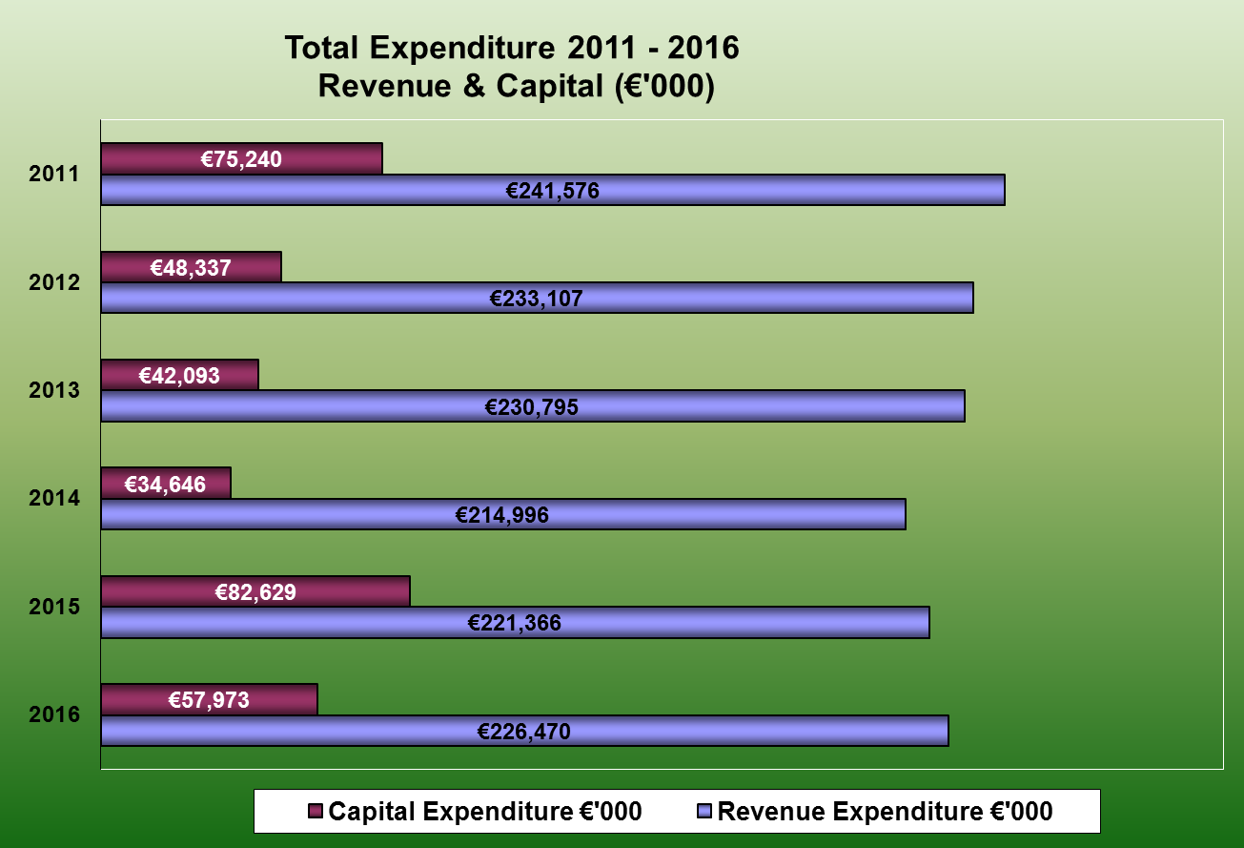
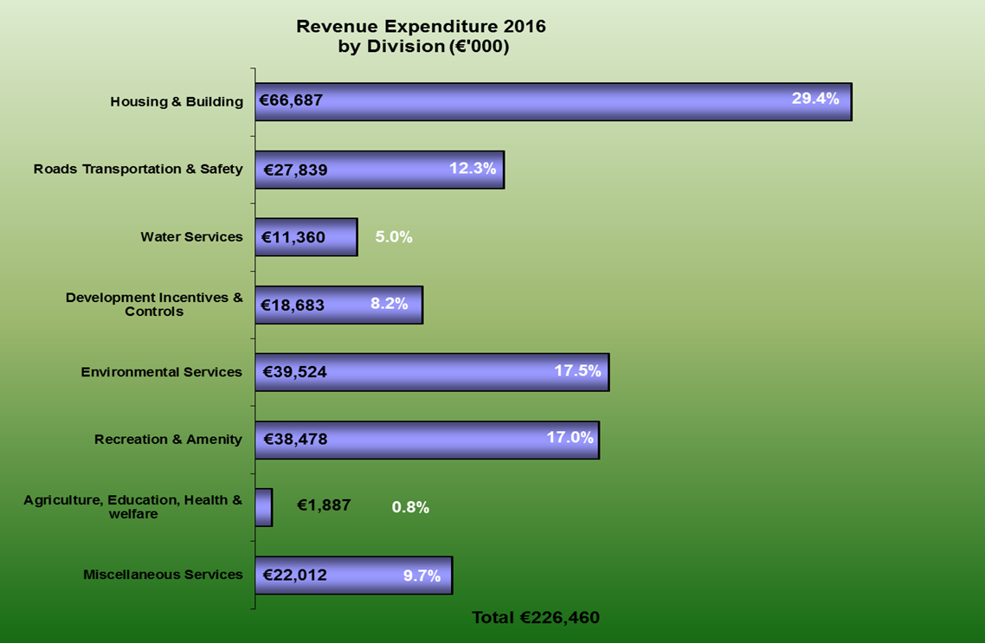

APPENDIX TWO - COUNCIL MEMBERSHIP OF COMMITTEES AND OTHER BODIES

Area Committees Chairs

Councillor Jonathan Graham was unanimously elected Chair of the Clondalkin Area Committee.

Councillor Liona O’ Toole was unanimously elected Chair of the Lucan Area Committee.

Councillor Brendan Ferron was unanimously elected Chair of the Tallaght Area Committee.

Councillor Paul Foley was unanimously elected Chair of the Rathfarnham/Templeogue-Terenure Area Committee

Strategic Policy Committees

Arts, Culture, Gaeilge, Education and Libraries SPC

Council Members
Councillor Dermot Richardson - Chairperson
Councillor Breeda Bonner
Councillor Brian Leech
Councillor Madeleine Johansson
Councillor Cora Mc Cann
Councillor Dermot Looney

Sectoral Members
Deirdre Mooney
Peadar Ó Caomhánaigh

Economic Development, Enterprise and Tourism SPC

Council Members
Councillor Charlie O’ Connor - Chairperson
Councillor Guss O’ Connell
Councillor Ronan Mc Mahon
Councillor Francis Duffy
Councillor Paul Foley
Councillor Anne-Marie Dermody
Councillor Emer Higgins
Councillor Brendan Ferron
Sectoral Members
Sean Reid
Garrett Robinson
Tara de Buitlear
Damien Roche

Environment, Public Realm and Climate Change SPC

Council Members
Councillor Pamela Kearns - Chairperson
Councillor Danny O’Brien
Councillor Ed O’ Brien
Councillor Brian Lawlor
Councillor Enda Fanning
Councillor Francis Timmons

Sectoral Members
Donal Anderson
John O’Farrell
Connie Kiernan

Housing SPC
Council Members
Councillor Cathal King - Chairperson
Councillor Louise Dunne
Councillor Kieron Mahon
Councillor Mick Duff
Councillor Martina Genockey
Councillor Trevor Gilligan
Councillor Mark Ward
Councillor Nicky Coules

Sectoral Members
Betty Tyrrell Collard
Tricia Nolan
Brendan MacPhiarais

Social and Community SPC

Council Members
Councillor Dermot Looney - Chairperson
Councillor Jonathan Graham
Councillor Vicki Casserly
Councillor Charlie O’ Connor
Councillor Sarah Holland
Councillor Kenneth Egan

Sectoral Members
Gráinne Ní Mhuirí
Layton Kelly

Land Use, Transportation and Planning SPC

Council Members

Councillor William Lavelle - Chairperson
Councillor Mick Murphy
Councillor Ruth Nolan
Councillor Paul Gogarty
Councillor Liona O’ Toole
Councillor Paula Donovan

Sectoral Members
Neil Durkan
Denis Sherwin
Siobhán Butler

South Dublin County Council Commemorations Committee Members

Councillor Ruth Nolan
Councillor Liona O’ Toole
Councillor Colm Brophy*
Councillor Martina Genockey
Councillor Eoin O Broin*
Councillor Ed O’Brien

South Dublin County Council- Audit Committee Members

George Kennington - Chair
Dermot Carter
Ann Horan
Eilis Quinlan
Councillor Dermot Richardson
Councillor Gus O’Connell
Councillor Martina Genockey
Councillor John Lahart – Resigned Jan 2016

South Dublin County Joint Policing Committee Membership 2016
South Dublin Councillors (14) plus Mayor
Cllr. Deirdre O’Donovan (Chair )
Cllr. Paula Donovan
Cllr. Louise Dunne
Cllr. Cathal King
Cllr. Sarah Holland
Cllr. Ed. O’Brien
Cllr. Paul Foley
Cllr. Pamela Kearns
Cllr. Kieran Mahon
Cllr. Nicky Coules
Cllr. Liona O’Toole
Cllr. Kenneth Egan
Cllr. Paul Gogarty
Cllr. Brian Lawlor
Cllr. Brendan Ferron
Mayor Guss O’ Connell
Oireachtas (5)
Sean Crowe T.D.
John Curran T.D.
John Lahart T.D
Vacant
Vacant
SDCC (1)
Billy Coman
Garda Síochána (2)
Chief Superintendent Orla McPartlin Crumlin (DMR South)
Chief Superintendent Lorraine Wheately Blanchardstown (DMR West)
Community (7) (PPN (4) other (3))
Ann Corrigan (PPN)
Tara Deasy (PPN)
Jim Lawlor (PPN)
Michael Noonan (PPN)
Eamon Dolan (D&ATF)
Ray McGrath (D&ATF)
Gemma Carton (Garda Diversion)

Local Community Development Committee Membership 2016

Name | Organisation
Private
Anna Lee | Community
Mary Corcoran | Community
Joe Barry | Community
Larry O’Neill | South Dublin County Partnership
Peter Byrne | South Dublin Chamber
Justin Byrne | PPN
Doreen Carpenter | PPN
Ronan Leydon | PPN
Stephen Dunne | PPN
Maurice Walsh | PPN
Greg Tierney | Youth Services
Public
Cllr Eoin O Broin | Councillor
Cllr Ciaran Mahon | Councillor
Cllr Paula Donovan | Councillor
Padraig Rehill | HSE
Paddy Lavelle/Deirdre McKeon | DDLETB
Fiona Ward | Department of Social Protection
Loman O’Byrne/ Emer O’Gorman/Colin Ward | LEO
Billy Coman | SDCC

APPENDIX THREE – TRAINING CONFERENCES ATTENDED BY COUNCILLORS IN 2016

- AILG Third Annual Conference, Buncrana, 5th -6th May 2016

- AILG Training (Cultural Services), Killarney, 20th May 2016

- AILG Training (Planning & Development), Dundalk, 18th June 2016

- AILG Training (Housing Action Plan), Longford, 15th September 2016

- AILG Autumn Conference, Gorey, 13th -14th October 2016

- AILG Training (Regional Assemblies and their Role with Local Authorities (Red Cow Hotel), 19th November 2016

- LAMA Spring Training Seminar (Planning and Flood Plains Insurance and Finding Solutions) Sligo Park Hotel 1st -2nd April 2016

- Planning Conference (Implementation and Engagement Planning for a New Era) Athlone, 14th -15th April 2016

- Autism Conference (Empowering Potential), Dublin, 16th April 2016

- Transport Ireland, Dublin, 21st April 2016
- Road Safety Authority iSafer Conference, Dublin, 28th April 2016.
- Regional Studies Association -Planning For Regional Development: The National Planning Framework as a Roadmap for Ireland's Future , Galway, 9th September 2016

- Parnell Summer School (Embers of Easter), Wicklow,-11th August 2016.

- LAMA Autumn Seminar (Brexit) Bantry, 29th September -1st October 2016

- Irish Council for Social Housing (for Delivery and Management) Kilkenny, 20th 21st October 2016

- National Youth Council of Ireland Seminar (How to Secure Investment and Funding to Enhance the Delivering Of Quality Youth Work in a Changing Public Policy Context),Dublin,13th December 2016

- Community Development – (Achieving Social Inclusion, Reconciliation and Equality) Galway- 16th -17th 2016

Total Amount Spent on Training Conferences in 2016- €20,919.53

APPENDIX FOUR- ENERGY EFFICIENCY REPORT 2016(AWAITING)

APPENDIX FIVE- PROTECTED DISCLOSURES 2016

Section 22 of the Protected Disclosures Act 2014 requires the publication of an annual report relative to Protected Disclosures received.

Pursuant to this requirement, South Dublin County Council hereby confirms that no reports were received in 2016.

APPENDIX SIX- LOCAL PERFORMANCE INDICATORS REPORT 2016

Corporate Performance and Change Management
Statistic Name | Total
Customer Contacts processed through CMS | 90,209
Average CMS response time | 4 days
Members reps processed | 7,676
Members reps Av. Response time (days) | 10 days
Telephone calls answered | 182,499
Answered within 20 seconds (%) | 83%
Media queries responded to | 438
Fix your street queries responded to | 6,000
Web pages opened | 2,536,814
Social media followers | 15,789
Staff employed - WTE | 1,216
Apprenticeships/graduates | 1
No. of Gateway participants | 60
% of Gateway participants allocated | 60%
No. of CE participants | 97
% of CE participants allocated | 78%
Training programme - No of participants | 3,778
Economic, Enterprise and Tourism Development
Statistic Name | Totals
LEO - jobs supported | 41.5
LEO - projects approved | 34
LEO - training participants | 710
LEO - mentoring sessions | 338
Business support grants spend | 120201
Business support grant spend (projects) | 83545
Business initiative with Chamber meetings held | 207
Shopfront grants paid | 19
Grange Castle jobs sustained | 2162
Library - visitors actual | 994914
Library - visitors online | 436273
Library - items borrowed | 1039222
Library - computer sessions | 229416
Libraries - events hosted | 4611
Library wi-fi users | 63060
Arts grants paid | 17
Arts events hosted | 53
Visitors civic theatre | 178835
Visitors Rua Red | 144775
GC Jobs (Construction) | 1301
Environment, Water & Climate Change
Statistic Name | Totals
Grass cut - Hectares | 6181.47
Trees inspected | 4651
Trees pruned | 1616
Trees removed | 706
Trees planted | 426
No. of stumps removed | 565
No. of locations of hedge cuts | 90
Hectares of park land maintained | 1750
No of allotments provided | 433
Playing pitches provided/Maintained | 163
Playgrounds provided/maintained | 29
Tonnage of waste collected - street bins | 383.54
Tonnage of waste collected - litter/illegal dumping | 4995.31
Tonnage of waste collected - road sweeping/gullies | 5312.96
No. of bring banks provided | 74
No. of recycling centres | 2
No. of green flag schools | 131
Km. of roads swept monthly | 925
Derelict site/Dangerous building inspections | 371
No. of sites on derelict sites register | 16
No. of environmnent inspections | 989
Environment enforcement procedures commenced | 204
Environment enforcement - cases closed | 179
Litter - fines issued | 433
Litter - court appearances | 50
Litter - cases closed | 3303
Total number of waste permits in force | 33
No. of waste enforcement notices issued | 96
Water Quality (%) | 99.9
% of unaccounted for water | 33.75
Water maintainence repairs completed | 545
Water pollution incidents dealt with | 66
No. of dogs impounded | 580
Number of dog licences in force | 9624
DFB fire incidents mobilised | 2056
DFB Ambulance incidents mobilised | 13470
Number of horses impounded | 266
Housing, Social & Community Development
Statistic Name | Totals
Total housing stock | 9124
Construction starts | 0
Construction completions | 15
Total housing needs assessed | 7895
Allocations - Homeless/Other | 242
No. of voids | 47
Time taken to re-let dwellings (weeks) | 9
Total RAS units | 1489
Total HAP units | 1434
Total units leased | 792
No. of housing grants approved | 202
Housing Maintainence requests received | 18882
Housing Maintainence requests completed | 13201
Planned Maintenance - units completed | 147
Total PPN registrations | 105
No. of community grants issued | 110
No. of sports programmes | 1612
No. of sports programme participants | 83489
No. of community events | 322
No. of community event participants | 63019
Visitors to leisure facilities | 565983
Visitors to Community halls
PRTB inspections | 832
PRTB called no access | 480
BER inspections | 16
BER Certs published | 220
Mechanical Inspections | 2590
Energy upgrades completed | 249
Electricial inspections completed | 2358
No of anti-social incidents reported | 752
No of actions taken in response to reports | 7394
JPC and Policing Fora meetings held | 35
No of Local Festivals supported | 9
Land Use Planning & Transportation
Statistic Name | Totals
Planning applications received - new housing | 144
Planning applications received - new housing (units) | 2841
Planning granted new houses - applications | 65
Planning granted new houses - applications (units) | 905
Planning applications housing - applications | 144
Planning applications housing - applications (units) | 2841
Planning Refused - no of houses | 807
Planning applications - other | 762
Planning other - no granted | 569
Planning other - no. refused | 50
Additional information requests - all classes | 193
% decisions upheld by ABP | 78%
Pre planning meetings held | 231
Planning enforcements initiated | 92
Enforcement files closed | 170
Building control inspections | 245
Commencement notices received | 541
TIC requests received | 3
TIC completions | 0
Area of footpath repaired in m2 | 38722
Area of road repaired in m2 | 126467
No of public lights in charge | 29269
No of public lights repaired | 8097
Traffic lights repaired | 1001

