**LUCAN ACM FEBRUARY**

BOOKS BORROWED 2015 AND 2016

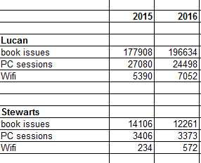

ONLINE LOANS 2015 AND 2016

(It is not possible to distinguish what the homebranch of the borrower is for online services)  
Note that our eBook provider and our online languages package changed in 2016 in line with LGMA shared service tender. Tumblebooks introduced authentication per South Dublin library card in 2016 which restricted loan to South Dublin Library members only. Previously library members outside our library area could use Tumblebooks.

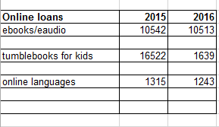

Universal Class is on online service offering courses with live Tutors, which includes English language grammar, spelling and comprehension. The usage figure for 2016 was 33,933 nationally. We cannot get a breakdown of statistics for South Dublin County Library Service on its own. This service is in addition to figures for online languages listed above.

SPECIFIC CATEGORY OF ITEMS BORROWED (art and music)  
We no longer loan pictures/prints.

In 2015 we changed library systems and it is not possible to interrogate the old system  
but for figures kept up to the changeover:

**2015** Approx. 16% of loans were non book material for Lucan (DVD, CDs, language courses, multimedia sets).   
 Approx. 19% of loans were non book material in Stewarts

**2016**  
Approx. 12% loans were non book material in Lucan  
Approx. 16% loans were non book material in Stewarts.