COMHAIRLE CONTAE ÁTHA CLIATH THEAS  
SOUTH DUBLIN COUNTY COUNCIL



MEETING OF LAND USE PLANNING AND TRANSPORTATION SPC

Thursday, February 16, 2017

HEADED ITEM NO. 4

**Planning Enforcement** is a statutory process under the Planning and Development legislation relating to unauthorised development.

**Development** is defined in legislation as;

*the carrying out of any works on, in, over or under land or the making of any material change in the use of any structures or other land.*

Planning permission is required to carry out development defined above, unless there is a provision in the legislation or regulations to exempt this requirement.

Development is **unauthorised** when:-

* Planning Permission is required and has not been obtained.
* Planning Permission has been obtained but the development has not been carried out in accordance with the approved plans and/or conditions attached to the Permission.
* It does not comply with all of the conditions and limitations to qualify as exempt development.

**Exempted development** is development for which the Planning Legislation or Regulations deem that Planning Permission is not required. It generally relates to developments of a minor nature such as:-

* Works of improvement, maintenance or other alterations that affect only the interior of a structure
* Works that do not materially affect the external appearance of a structure
* Building of an extension, shed, garage, boiler house, boundary walls, etc. within the curtilage of a house subject to conditions and limitations
* Certain changes of use of commercial premises

Statutory provisions relating to exempted development may be found in Section 4 of the Planning & Development Act 2000, Articles 6 – 10 and Schedule 2 of the Planning & Development Regulations, 2001.

Most exemptions do not apply to structures that are included on the Council's **Register of Protected Structures**, or are situated in an **Architectural Conservation Area**, or which would have a significant impact on a site designated under any EU Directive.

Planning Enforcement complaints must in writing (letter, fax or e-mail) to the Planning Enforcement Section and must include the complainant’s name & address. The complaint should include the exact location of the site, details of the suspected breach, details (where known) of the property owner/occupier/developer, the date the development began. The complainant’s details are treated with the greatest confidence, are not included in the Council’s Planning Register and are not released to any third party unless the Council is required to do so under statutory requirements.

Planning Enforcement legislation sets time limits within which alleged unauthorised development must be investigated. It establishes a common procedure for all type of planning offence – issue of a Warning Letter, service of an Enforcement Notice, institution of legal proceedings etc.

Upon receipt of a complaint the Planning Authority endeavours to establish all owners, occupiers or other interests in the development before issuing a Warning Letter. It might be possible to establish at this stage from evidence available to the Planning Authority that no action is possible e.g. statute barred. The Planning Authority may also examine whether the complaint is trivial or vexatious.

The **Warning Letter**, which must be served within six weeks of receiving the complaint, allows an owner / occupier or developer up to four weeks to rectify the offence or to make a submission. A submission to the Planning Authority may include evidence that may preclude taking further action.

Regard must be had to any submission received when deciding whether or not to serve an Enforcement Notice. An **Enforcement Notice** sets out the requirements of the Council to rectify the offence and also contains a timeframe within which the work must be completed. Non-compliance with an Enforcement Notice is an offence.

Should any person served with an Enforcement Notice fail to comply with its requirements, the Council may institute legal proceedings and prosecute the matter in the District Court. This requires that all the necessary evidence is compiled and that such evidence can withstand scrutiny and cross-examination in a criminal court of law.

In urgent cases, the Council may alternatively apply to the Circuit or High Court for an Order directing that particular actions take place or cease, as the case may be.

Even if the development is outside the time frame for prosecuting enforcement action, it remains unauthorised and could have a negative impact on the value of a property. In addition, further works that may normally be considered exempt (such as alteration, repair or renewal) may not be carried out to an unauthorised structure or a structure whose use is unauthorised. It is in the interest of every property owner to ensure that any unauthorised development is regularised.

The Planning Enforcement process can be summarised as follows

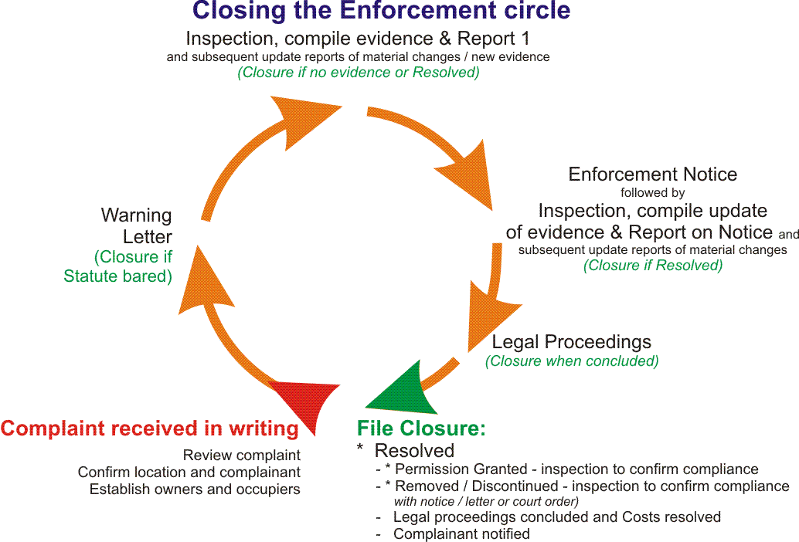

The following is a summary of Planning Enforcement activity for 2016

|  |  |
| --- | --- |
| Total number of cases subject to complaints that were investigated | 92 |
| Total number of cases subject to complaints that were dismissed | 112 |
| Total number of cases subject to complaints that were resolved through negotiations | 58 |
| Number of enforcement procedures taken through warning letters | 94 |
| Number of enforcement procedures taken through enforcement notices | 40 |
| Number of prosecutions | 9 |