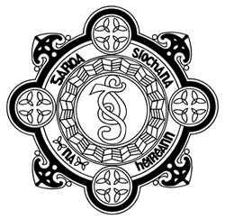 | South Dublin County  Joint Policing Committee
Friday 27th January 2017
3.00 p.m.
Council Chamber, County Hall, Tallaght, Dublin 24

AGENDA

- Report of Meeting held on the 25th November 2016

- Matters arising

- Garda Síochána Report
  - Garda Reports

- Issues
  - Scramblers
  - Halloween
  - Horses
  - JPC's and Local Authorities and consequences of recreational drug use

- Local Policing Fora Report
  - Clondalkin
  - D12
  - North Clondalkin
  - Tallaght

- JPC Subgroups
  - Drug Subcommittee

- Any Other Business

- Schedule of Meetings for 2017
  - 26th May
  - 22nd September
  - 24th November

- Issues for May 2017
  - 6 Year Workplan
  - JPC Annual Report 2016

