
Architectural Services Department

COUNTY ARCHITECT’S REPORT ON COMPLETION OF PART 8 DISPLAY DECEMBER 2016

Project Title | NEW SPECTATOR STAND TALLAGHT STADIUM, WHITESTOWN WAY TALLAGHT, DUBLIN 24
County Architect:  Senior Exec Architect:  Architects: | Eddie Conroy FRIAI  Máire O’Sullivan MRIAI  Martin Noone Architects MRIAI
Part 8 Process
Brief  explanation of  Part 8 Process  carried out  under Part 8 of  the Planning  and  Development  Regulations  2001 | Part 8 (Public Consultation Schemes)  Developments by a local authority are subject to a public consultation process as set out in the Planning & Development Regulations, 2001 - 2015. This procedure requires that notice of the proposed development be given in the public press and that a site notice be erected. If any submissions or observations are received, a report is presented to the members of the Council. This report contains a list of the objector's names along with a summary of the points made by them and the Local Authority's response.  Arising from consideration of the representations, the report sets out whether or not it is proposed to proceed as originally planned or to proceed with a modified proposal.  Development by a Local Authority: 'Part 8 Process'  From time to time the Local Authority may carry out development within its  administrative area, such as the construction of houses, roads, swimming pools, public toilets etc.  Development carried out by a Local Authority is often referred to as a 'Part 8’: - this is reference to Part 8 of the Planning and Development Regulations 2001 which sets out the procedure for carrying out such developments.  Public consultation is an intrinsic part of the 'Part 8' process. This is achieved by public notices, public display of the proposal, observations by members of the public, reportage on observations received and a recommendation that considers all internal and public observations. The consultation may extend to advisory consultation meetings with local community and interest groups dependant on the particular circumstances and impact of the proposal, though such meetings are not proscribed under the legislation. The primary purpose of the process is to notify the public of the proposal and incorporate any observations validly submitted into a report to inform the Council on its decision to recommend the proposal.  Comments and observations on Proposed Developments by a Local Authority can only be received in writing between certain dates. The public notices should be referred to in this regard to ascertain the final date of receipt for observations.  Part 8 of the Planning and Development Act 2000 refers to requirements in respect of specified development by, on behalf of, or in  partnership with Local Authorities. Part 8 applications are generally lodged by the proposing department within the Council. Article 80 of the Planning and Development Regulations 2001 sets out a list of the types of development prescribed for the purposes of the act.  The process is as follows:  Public Notices of the proposed development must be placed in an approved newspaper. A site notice (or notices) must be erected on the land on which the proposed development is situated – Article 81(1)(a)(b) of the Planning and Development Regulations 2001 provides guidance on the requirements.  The application, which must be submitted on the same date as the Newspaper notice, must include a cover letter / report, a copy of the newspaper and site notice and public display of the proposal in a designated public area accessible to the public during normal office hours – normally County Hall. Drawings can be made available to the public on request.  There is no fee payable on a Part 8 application.  The application is referred to internal works Departments in the City Council – (Roads, Water, Drainage).  In the case of protected structures, the application is referred to the Conservation Section, An Taisce, DEHLG and the Heritage Council.  The timeframe for third party Observations/Submissions on the Part 8 application is eight weeks from the date of lodgement. This date is specified in the public notices.  There is no fee charged for observations/submissions on a Part 8.  The proposing Department completes a report for the attention of the Executive Manager of the Planning Department. The Executive Manager will make a recommendation to the proposing department on foot of this report.  A report will then be compiled for a meeting of the Council. Following consideration of this report by the Council, the proposed development may be recommended, unless the local authority, by resolution, decides to vary or modify the development, otherwise than as recommended in the report, or decides not to proceed with the development’ – as per Section 179(4)(b) of the Planning and Development Act 2000.  For a Part 8 application the period for observations/submissions is 8 weeks.  There are 5 weeks allowed for a planning application submitted by private Individuals / companies under the standard planning process.  The making of a decision on a Part 8 application is a reserved function of Council, while a standard planning application is determined by the Planning Department as an executive function.  The above is a summary of the Part 8 requirement for consultation. It is intended for guidance only. The Planning Acts set out the requirements in full.
Description of  Proposed  Development  Details of Display & Submission of  Observations | SOUTH DUBLIN COUNTY COUNCIL  SITE NOTICE/PUBLIC NOTICE  Notice under Planning and Development Act 2000 to 2011  Public Consultation Procedure under Part 8 of the Local Government  (Planning and Development) Regulations 2001 - 2013  Pursuant to the requirements of the above, notice is hereby given by South Dublin County Council of the proposal to construct the following scheme:  A New Spectator Stand  in Tallaght Stadium on Whitestown Way Tallaght, Dublin 24  The Proposed Works include:  The construction of a single tier 2,195 seat Spectator Stand, including associated ancillary and welfare facilities, within in the boundaries of Tallaght Stadium to the south of the existing spectator stands and pitch. The New Stand will occupy an area of 1004SqM with a roof height of 13.6M. A new access/egress will be formed in the existing southern boundary wall.  Drawings and particulars of the proposed development will be available for inspection or purchase at a fee not exceeding the reasonable cost of making a copy at the following location during the period from Thursday 20th October to Thursday 1st December 2016:  South Dublin County Council, County Hall, Tallaght, Dublin 24  (between the hours of 9:00am – 5:00pm Monday to Thursday and 9.00am - 4.30pm on Friday).  The plans and particulars can also be viewed in Tallaght Stadium during opening hours and on South Dublin County Council’s website – www.sdcc.ie and the Public Consultation Portal http://consult.sdublincoco.ie  Written submissions or observations with respect to this matter dealing with the proper planning and sustainable development of the area in which the development would be situated may be made in writing to:  The Senior Executive Officer  Economic Development Department  South Dublin County Council  County Hall  Tallaght  Dublin 24  The latest date for the receipt of written submissions shall be 4.00pm on Thursday 15th December 2016.  DATE SITE NOTICE ERECTED: - Thursday 20th October 2016  It should be noted that the Freedom of Information Act applies to all records  held by South Dublin County Council.  All advertised information, maps and drawings in relation to South Dublin County  Council is available on our website 24 hours a day seven day a week.  Visit www.sdcc.ie for all your information needs
Context  Site Location  Site conditions, Services and Utilities | Tallaght Stadium is located in the northwest corner of Sean Walsh Memorial Park and is bounded to the north by the N81, to the south by SDCC Park Depot and Bungalow, to the east by Sean Walsh Memorial Park and Old Bawn Community School and to the west by Whitestown Way.  The proposed development is wholly contained within the boundaries of Tallaght Stadium and associated carpark. The proposed Stand will be located to the south of the existing spectator stands and pitch and within the existing walls of the stadium.  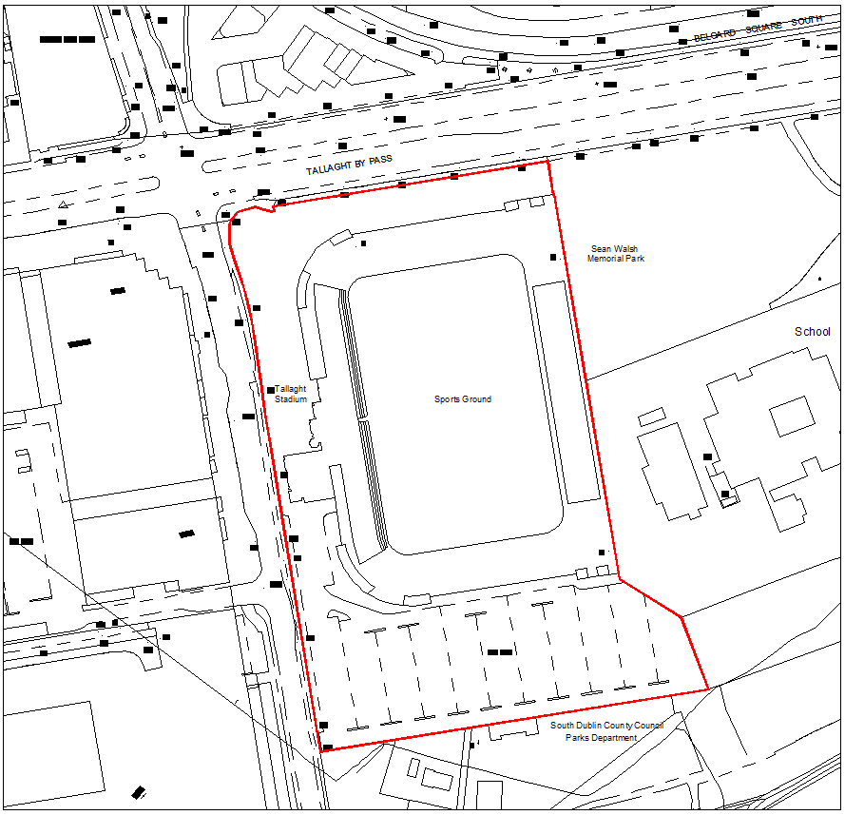  Figure 1 Site Location Map  Proposed Stand  Figure 2 Aerial View of the Proposed Development Site.  (Source: Screen shot from the website “googlemaps.com” September 2016)  The proposed development site is generally flat with a slight fall of from north to south (circa 250mm). There are no public services or utilities traversing the site. There is no history of flooding on the site and so no unusual problems are anticipated regarding the topography or existing utilities which will service the New Stand.  Tallaght Stadium is well served by public transport including the Red Line Luas, (Tallaght Stop) and Dublin Bus numbers 27, 49, 56a, 65, 76, 76a & 77a. Both Luas and buses stop/pass through Tallaght at The Square Shopping Centre. The Stadium is located within a 5-minute walk east of The Square via Cookstown Way.  It is noted that there will be no alteration to the parking provisions currently available at Tallaght Stadium resulting from the proposed development.  The majority of users of the stadium arrive on foot or by public transport. There is a wide range of car parking available within a five minute walk in Tallaght Town Centre including the Arena Centre, the Square and Tallaght Cross Centre. It should also be noted that on a number of occasions temporary stands have increased the stadium capacity to over 8,000 seats without creating vehicle congestion or parking difficulties.  Utilities  - Water Supply: A review of the existing water supply determined it adequate for the proposed development.  - Foul drainage: A review of the existing foul drainage capacity determined it adequate for the proposed development.  - Surface water: ‘Refer to Infrastructure & Environmental Quality of Surface & Ground Water’  - Electrical Supply: A review of the load requirements associated with the New Stand determined that the capacity of both the existing substation and the existing emergency generator are adequate for the proposed development.
Planning History  Planning Context | February 10th 1997 South Dublin County Council passed a resolution to lease land comprising approximately 12.18 acres (49,300 m2) at Whitestown Way for the construction of a Stadium for Shamrock Rovers F.C.  On January 14th 1998 planning permission was granted for a 10,000 seat stadium with ancillary buildings/services.  On March 24th 2000 a lease was granted to Mulden International Limited. This lease was subsequently transferred to Slonepark Company Limited on October 20th 2000. Work on the new Stadium commenced in October 2000.  Work ceased on site in November 2001 with the Stadium at various stages of completion.  Shamrock Rovers FC applied for and was granted permission to extent the duration of the existing planning permission to 31st October 2004.  Following a prolonged period where no work was carried out at the stadium in December 2004 SDCC refused to extend Slonepark Company Ltd. lease which was subsequently terminated on January 4th 2004.  A public consultation process began on July 18th 2005 to complete the stadium. A county Managers report presented to the Council on December 12th 2005 provided for the increase of the playing area to accommodate Senior Gaelic games and other uses subject to allocation of funds from the Department of Arts, Sports and Tourism. The Departments response on January 24th 2006 stated that funding would not be made available for the modified development. Acting on the Ministers response the Council voted in favour of proceeding with the original plans on February 13th 2006.  Thomas Davis GAA club instituted judicial review proceedings in the High Court in May 2006. The judicial review began April 20th 2007 and concluded on December 14th 2007. In the High Court decision Mr. Justice Roderick Murphy found in favour of South Dublin Co. Council and Shamrock Rovers. An application by Thomas Davis for leave to appeal this decision to the Supreme court was refused by Judge Murphy on January 25th 2008.  Construction commenced on the stadium on May 6th 2008.  The South Dublin County Development Plan 2016-2020 carries a ‘OS’ zoning objective for the site which is:  ‘To preserve and provide for open space and recreational amenities’.  Tallaght Stadium  Figure 3. Development Plan Zoning Objective.  (Extract of Development Plan 2016 – 2022: Map 9)  The zoning objective of the site supports the construction of a Third Stand in Tallaght Stadium. The proposed development complies in principle with the relevant Development plan policy namely,  COMMUNITY INFRASTRUCTURE (C) Policy 7 – Sports Facilities & Centres.  C7 Objective 1:  To support the provision of new or improved sports and leisure facilities in the County.  C7 Objective 3:  To support and provide a framework for the improvement, maintenance, upgrade and refurbishment of existing community based facilities, within the County, to meet current and future needs.  C7 Objective 6:  To support the provision of permanent space for well-established sports and leisure clubs, including amateur boxing clubs and scout’s clubs, in the County.
  Tallaght Stadium Planning Permission Chronology
  Applicant | Application Ref. | Date | Application Type | Description | Planning Authority | Decision | Date
  Shamrock Rovers FC | D97A/0063 | 12/01/1997 | Permission | 10,000 seat Football Stadium with ancillary buildings/ services. | SDCC | Grant | 10/04/  1997
   |  |  |  |  | An Bord Pleanala | Grant | 14/01/  1998
  Shamrock Rovers FC | D97A/0063  /EP | 24/07/2003 | Extension of Duration of Permission to 31/10/04 | 10,000 seat Football Stadium with ancillary buildings/ services. | SDCC | Grant | 17/09/  2003
  SDCC | SD058/0016 | 01/09/2005 | Part 8 | Completion of 6,000 seat Football Stadium in two Phases with ancillary buildings/ services. | SDCC | Council Vote in favour of proceeding with the original plans. | 13/02/  2006
  Use Classes Related to Zoning Objective OS
  Permitted in Principle | Allotments, Community Centre, Cultural Use, Open Space, Recreational Facility, Sports Club/Facility.
  Open for Consideration | Agriculture, Bed & Breakfasta, Camp Site, Carparkh, Cemeterye, Childcare Facilities, Crematorium, Education, Garden Centre, Guest Housea, Home Based Economic Activitiesa, Hotel/Hostel, Housing for Older People, Outdoor Entertainment Park, Place of Worshipa, Public Services, Recycling Facility, Residential, Restaurant/Café, Shop-Local, Stadium, Traveller Accommodation.
  Not Permitted | Abattoir, Advertisements and Advertising Structures, Aerodrome/ Airfield, Betting Office, Boarding Kennels, Caravan Park-Residential, Concrete/Asphalt Plant in or adjacent to a Quarry, Conference Centre, Doctor/Dentist, Embassy, Enterprise Centre, Fuel Depot, Funeral Home, Health Centre, Heavy Vehicle Park, Hospital, Industry-Extractive, Industry-General, Industry- Light, Industry-Special, Live-Work Units, Motor Sales Outlet, Nightclub, Nursing Home, Office-Based Industry, Offices less than 100 sq.m, Offices 100 sq.m -1,000 sq.m, Offices over 1,000 sq.m, Off-Licence, Petrol Station, Primary Health Care Centre, Public House, Refuse Landfill/Tip, Refuse Transfer Station, Residential Institution, Retail Warehouse, Retirement Home, Rural Industry-Food, Science and Technology Based Enterprise, Scrap Yard, Service Garage, Shop-Major Sales Outlet, Shop Neighbourhood, Social Club, Transport Depot, Veterinary Surgery, Warehousing, Wholesale Outlet, Wind Farm.
Project Description | The proposal consists of:  The construction of a single tier 2,195 seat Spectator Stand, including associated ancillary and welfare facilities, within in the curtilage of Tallaght Stadium to the south of the existing stands and pitch.  The new stand will occupy an area of 1004sqM with a roof height of 13.6M. A new access/egress will be formed in the existing southern boundary wall.  The proposed stand will be made of specialist precast concrete frame and panel elements with a coloured metal profile roof to match existing stands.  Seats and other fittings will match the existing.  The under croft of the stand will be used for sanitary and ancillary facilities for the stand.
Infrastructure & Environmental Quality of Surface & Ground Water | The New Stands Surface Water drainage system will be designed to meet the objectives stated in South Dublin County Council Development Plan 2016 – 2022. The development proposal will provide suitable drainage measures in compliance with the Greater Dublin Strategic Drainage Study (GDSDS) and Greater Dublin Regional Code of Practice for Drainage Works. Surface water run-off will be harvested and used to supply new welfare facilities and when possible to irrigate the existing football pitch. Any surplus surface water run-off will be attenuated through the use of a Proprietary Surface Water attenuation system. This system will be designed to attenuate the additional Surface Water runoff generated from the construction of the New Stand.
Project Partners | The development will be funded by South Dublin County Council and managed by Economic Development Department of South Dublin County Council.
Project Budget Estimate | The budget estimate for the construction of the proposed New Stand including ancillary utilities/services is €1,910,000 excluding VAT.
Habitats Directive  Assessment | Summary results of screening of Ecological Survey and Screening of a proposed development at Tallaght Stadium Whitestown Way, Dublin 24.  It is noted that the site does not affect watercourses or adjacent park land.  Visual Inspection  There are no trees present on the site that offer potential for roosting bats. The existing stands do not offer an appropriate habitat due to noise / human activity.  Conclusion  A bat derogation licence is therefore not required for the proposed development as part of the Part 8 Approval.  Badger Survey  There was no evidence of badgers using the site – The site is open and offers no cover for Badger/Badger Setts.  This report finds that the project will not give rise to significant effects on the integrity of any Natura 2000 site.  The Appropriate Assessment procedure for this proposed Part 8 is therefore concluded at this Screening Stage.
Part 8 Submissions  & Commentary | One formal submission was received on the Part VIII display as follows:  From SDCC Arts Officer - that consideration be given to the inclusion of a public art commission in the proposed works.  The submission states that:  Currently there are 60-80,000 people per annum visiting and using Tallaght Stadium including Youth and Community programmes. This is set to increase with the addition of the new stand, and through promotion via the County’s tourism and business development strategies. It is a singular place where people living in Tallaght and visitors gather en masse. Tallaght Stadium is a success story and a powerful representation of progressive development for people living in Tallaght and those from outside.  This is an opportunity to commission a signature/iconic sculptural artwork that matches in scale the presence and visibility of Tallaght Stadium which has become an inherent part of the identity of Tallaght and the County. It also sits with the ongoing development of Tallaght as a cultural hub in the county.  The scale of a Public Art commission for this site would be in the region of €150,000 - €200,000. This commission would add significant cultural value to the project and the Tallaght area.  Response:  The County Architect agrees in principal with this submission, however he recommends that given the time pressure to deliver this stand before the EUFA season in June 2018, the commissioning of this piece of public art be postponed until after the completion of the third stand.

