New Speed Limit Sign for Minor Local Roads
A Speed Limit is the maximum legal speed, but not necessarily the safe speed at which a vehicle should be driven. It is the responsibility of a driver to obey a Speed Limit and to ensure that the vehicle speed is appropriate for the prevailing circumstances, even if that speed is lower than the Speed Limit applying.
Ireland’s road network is extensive and inconsistent, which means that a ‘one size fits all’ solution for Speed Limits for the 99,100km of road network is not possible. Additionally, Local Authorities (in conjunction with the National Roads Authority in respect of National Roads) are able to amend and set Speed Limits as appropriate and in accordance with Guidelines on Special Speed Limits for different sections of the road network as required.
Arising from the recent Speed Limit Review the Working Group recommended the introduction of a new ‘Rural Speed Limit’ sign for Local Roads, a generic sign that does not display a numeral value, to replace the 80 km/h signs on minor local roads (boreens). This new sign is a ‘black circle with diagonal which is in use internationally under the Vienna signage convention and which was used in Ireland prior to 2004. The new sign means that drivers must use their own judgement but must never exceed 80km/h in any case.
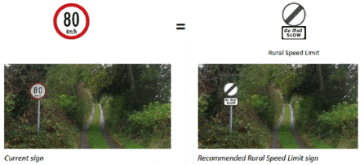
The Minister for Transport, Tourism and Sport launched the new sign on 19 March 2015.
The Road Safety Authority (RSA) has launched a new campaign to raise awareness of the new speed limit signs for minor local roads.
The campaign focuses on the fact that the new ‘Rural Speed Limit’ signs are being placed on minor local roads across the country and that motorists must use their own judgement and choose an appropriate speed for the conditions and environment, but must never exceed 80kmh.

