PLAYSPACE PROGRAMME 2014-2018 INTERIM REPORT
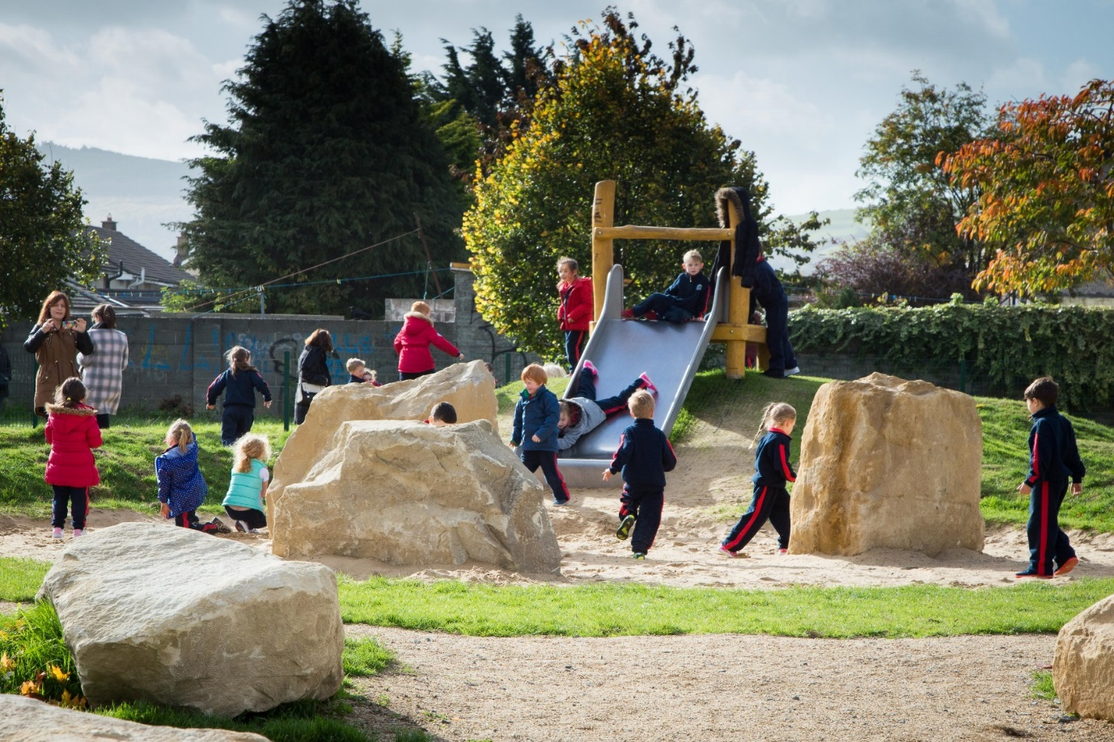Avonbeg, Tallaght
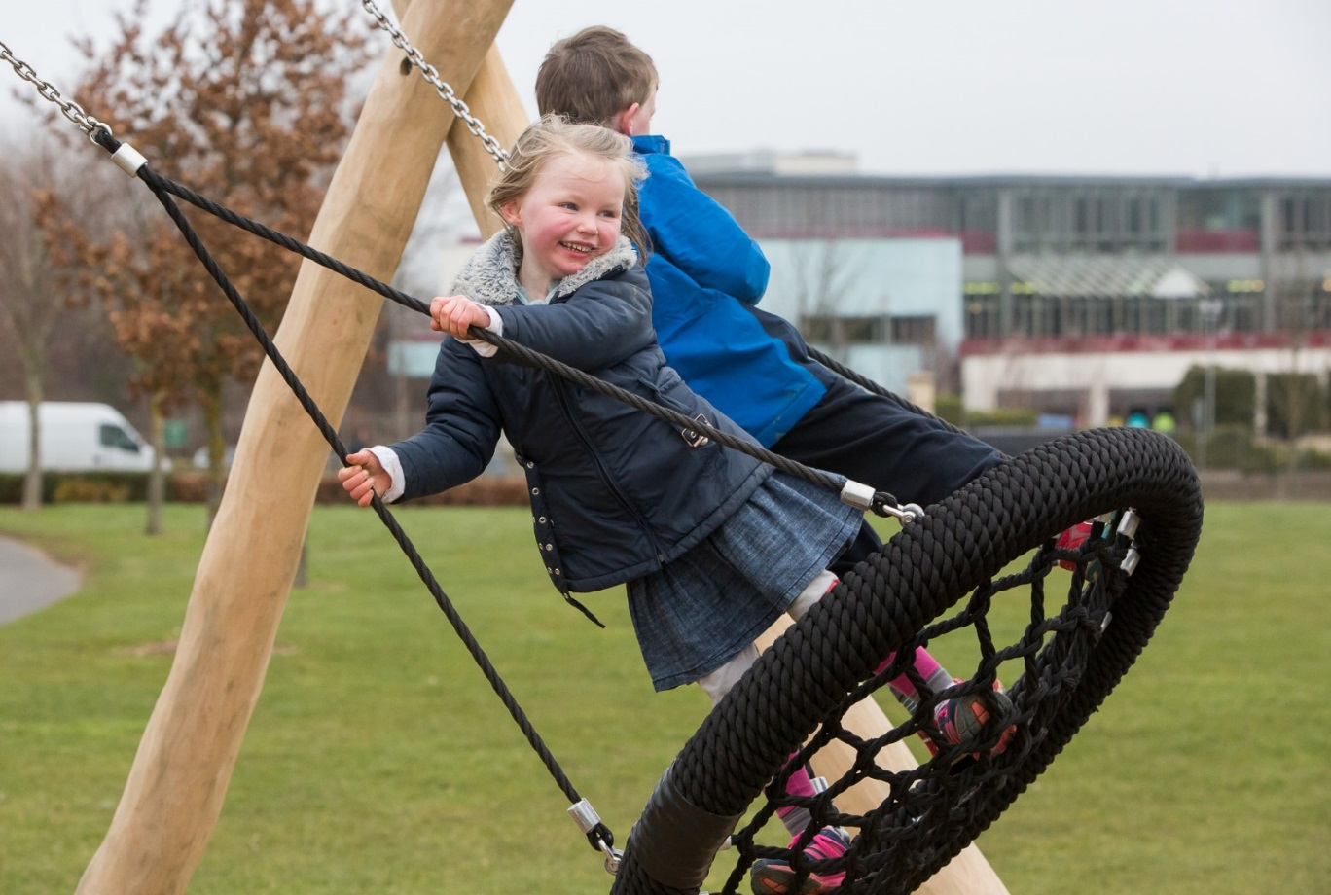
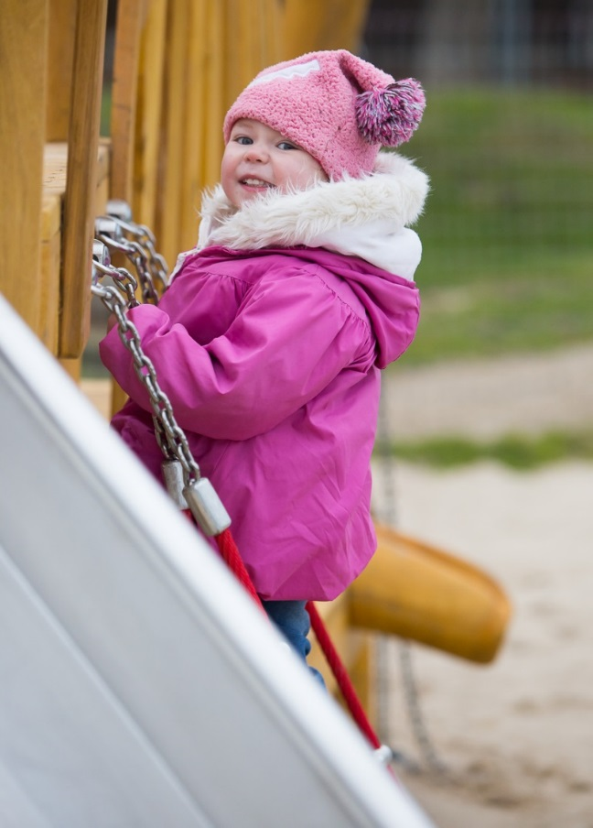
NOVEMBER 2016
Interim Report
The Playspace programme in South Dublin County Council is a five year programme that commenced in 2014. The programme is now half-way through its proposed time-line and this report is intended to review and establish the progress and value of the work done to date versus the original objectives for the programme, suggest improvements or changes to the programme where warranted and plan for completion of the construction phase of the programme
Introduction to the programme: What is it?
The play space programme was proposed as a five year programme aimed to address the deficiency of play opportunities in the immediate environment of children’s homes. It is an innovative programme based on encouraging imaginative, constructive and social play. The playspaces are designed to adapt to the particular place where they are implemented. They provide a space and a setting for play (rather than equipment for children to play with); are located where children live, with the emphasis on natural playspaces; which focus on the type of play that is most important to younger children.
The spaces incorporate an element of risk (or replicate natural experiences) and encourage contact with nature. The playspaces tend to be small pockets located within a larger open space, at a scale easily relatable to children and encourage social interaction by accompanying adults. Highly manicured and defined open space discourages play that children can create themselves and the play space programme seeks to re-dress the balance by providing spaces in the immediate vicinity or very close to where children live.
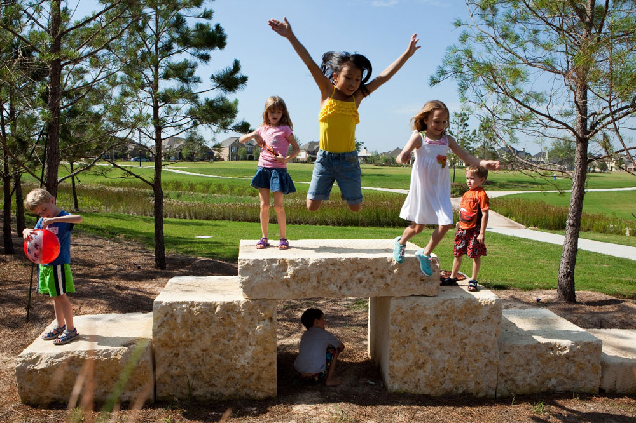
Example of robust materials
The spaces also add to the attractiveness of the areas in which they are placed; they are robust; being made of mostly naturally found material, earth mounding etc. and are thus less susceptible to vandalism.
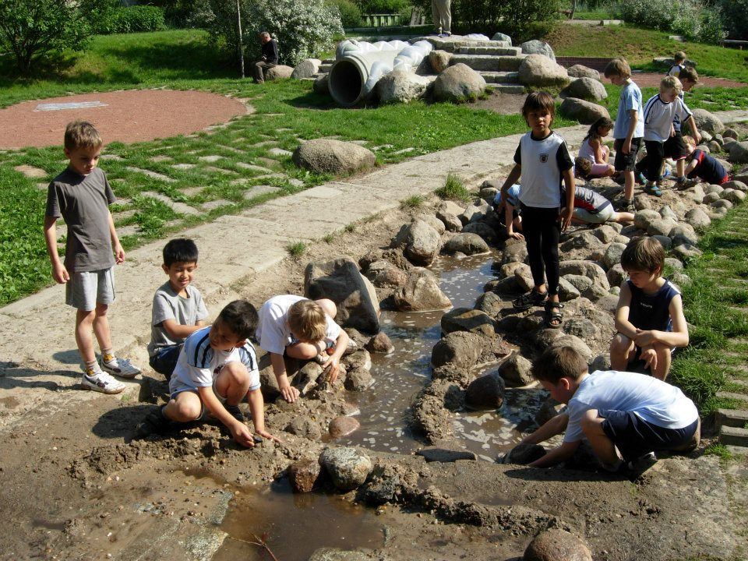
Example of natural materials
The provision of playgrounds in the recent past concentrated on large, formally equipped and defined playgrounds with highly specialised equipment. This type of playground is easily recognised by bright colours and play equipment. It is a place that children are brought to play and then are brought home again. The playspace programme is different; it aims to provide opportunities to play. These playspaces are instantly recognisable to people who were brought up when access to formal playgrounds was not as available and children made their own play based on what was available and adaptable in their environment e.g. a mound of gravel became a mountain for children to scale or a muddy pond was an ocean to sail on. This type of play allows children to develop their imagination, challenge their abilities, deal with risk and, critically, adapt their own environment.
Why it was done?
The Play Space programme was established following the identification of a deficit of play areas for children in this county. This was documented in the policy document ‘Developing Play in South Dublin 2006-2009’ adopted by the Council in June 2006. However the development of play areas / playgrounds did not result in the immediate aftermath, due to the economic downturn and lack of development generally.
In recent years there has been an emphasis on the physical and mental well-being of children. Over the past 20 years there has been a significant rise in levels of obesity, childhood diabetes, high levels of stress and increasing sedentary lifestyles. A report by the National Taskforce on Obesity estimates that 300,000 children in Ireland are now obese.
Due to a variety of factors children are less likely to wander far from their own homes. A study in the UK documented the distance children travelled from home for play; the results showed that the distance children roam from home on their own has shrunk by 90% since the 70s; 43% of adults think a child shouldn't play outdoors unsupervised until the age of 14. So children are increasingly confined to the immediate environs of their homes. This results in children’s activity being dependant on the immediate environment of their homes being conducive to a wide variety of play opportunities and social interaction; which is not so readily available in sterile landscapes of mown grass.
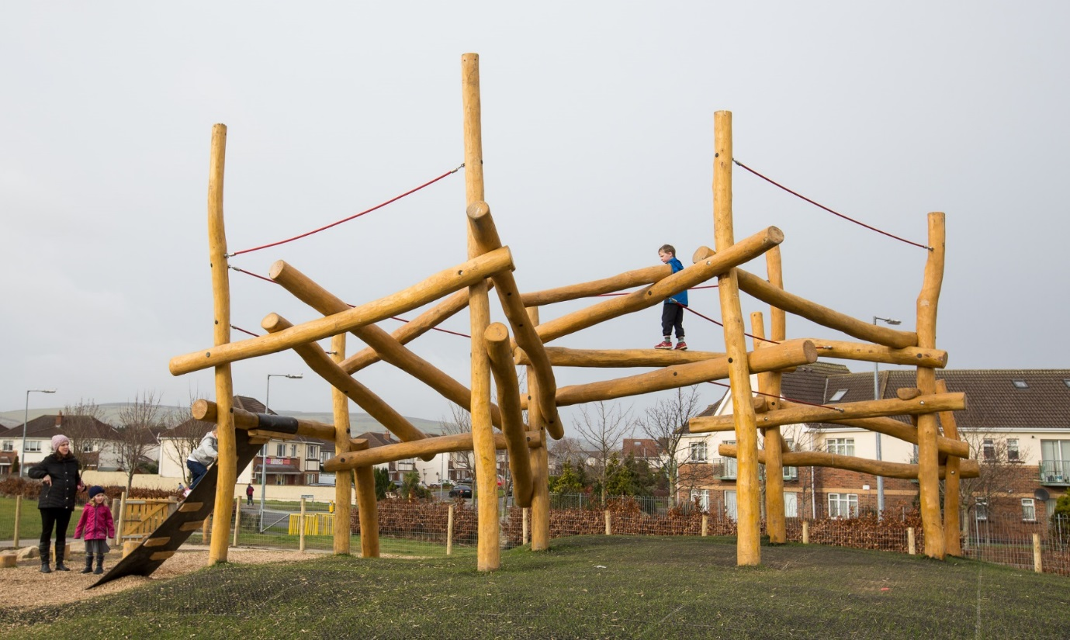
Ballycragh, Firhouse: Example of risk replication
The recent increased access to sedentary activities compounds the problems of inactivity and a recent report from the Kaiser Family Foundation in the US found that the average eight-to-18-year-old American now spends more than 53 hours a week "using entertainment media".
The physical environments in which children grow up have a significant impact on their health, their enjoyment of childhood and their levels of activity. Recent advice from the NHS in the UK advocates 3 -4 hours per day of strenuous activity for children under 5, and 60 minutes of strenuous activity per day per child over the age of 8. For that to be sustainable; activity needs to be readily available and easily incorporated into the child’s lifestyle; ideally it should be self-directed; (i.e. not dependant on an adult bringing a child to an activity). High levels of play and activity as a child translates nearly directly into higher academic achievement, lower levels of stress, more robust mental health and transmits to healthier activity patterns as an adult.
Creating better play environments outside people’s houses will incur benefits for the physical and mental health of children as they grow up. In addition these spaces also confer benefits on communities, parents interact with each other through their children’s friendship with other children. In residential areas it leads to less social isolation and more social cohesion.
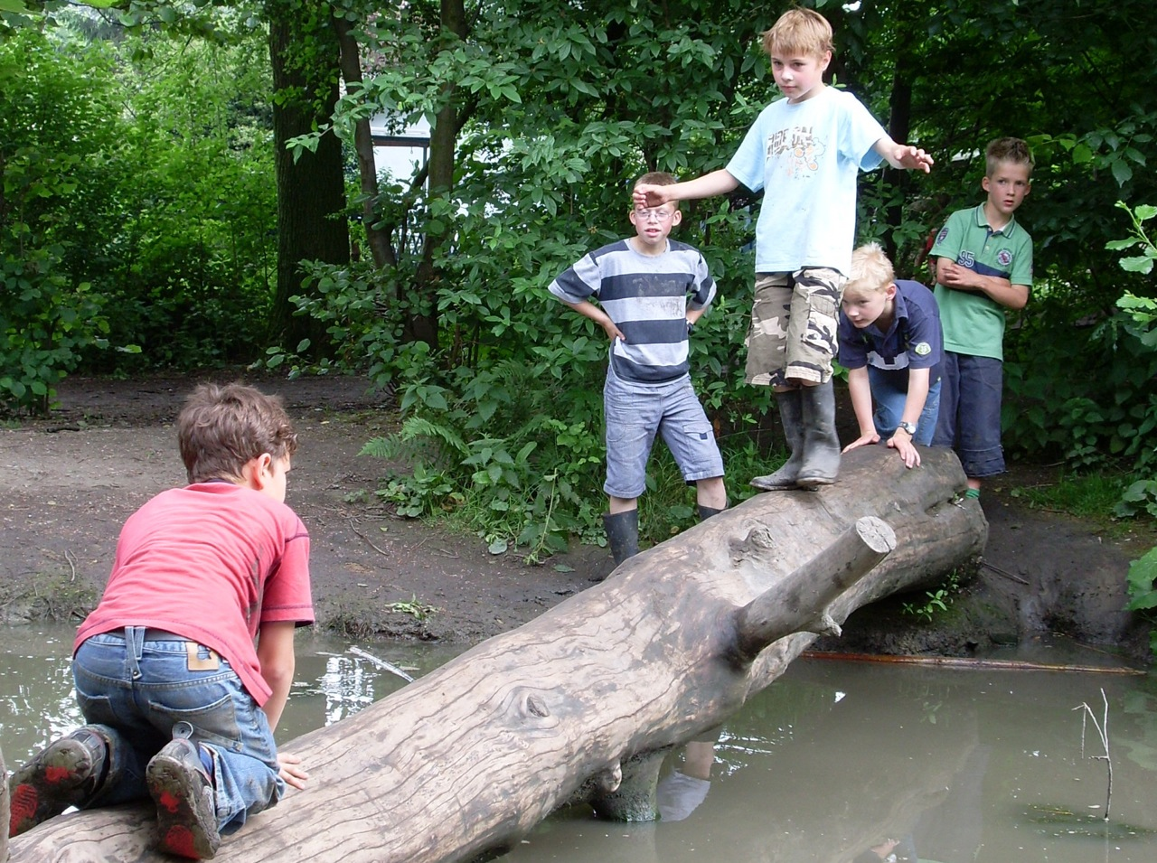
Example of risk and daring
In South Dublin, in order to provide play spaces within the areas in which children live, and allow them to be easily and independently accessed by children, proposals for the development of playspaces over a five years period were presented to Area Committees in South Dublin. Proposed locations and an implementation programme were developed. The concept of playspaces as set out above was agreed and image boards and possible layouts were presented to each committee to inform the discussion.
The resulting programme was presented and approved by the Council in February 2014. The playspace programme proceeded to consultation with local organisations, local residents groups, Comhairle na nÓg, adjacent community groups and schools with a view to commencing construction in early Summer 2014.

Initial Proposals from February 2014:
The Proposed Five Year Play Space Programme as presented to the meeting of South Dublin County Council in February 2014:
Local Play Space Programme presented to Council
Map of existing playgrounds and proposed play spaces as on February 2014

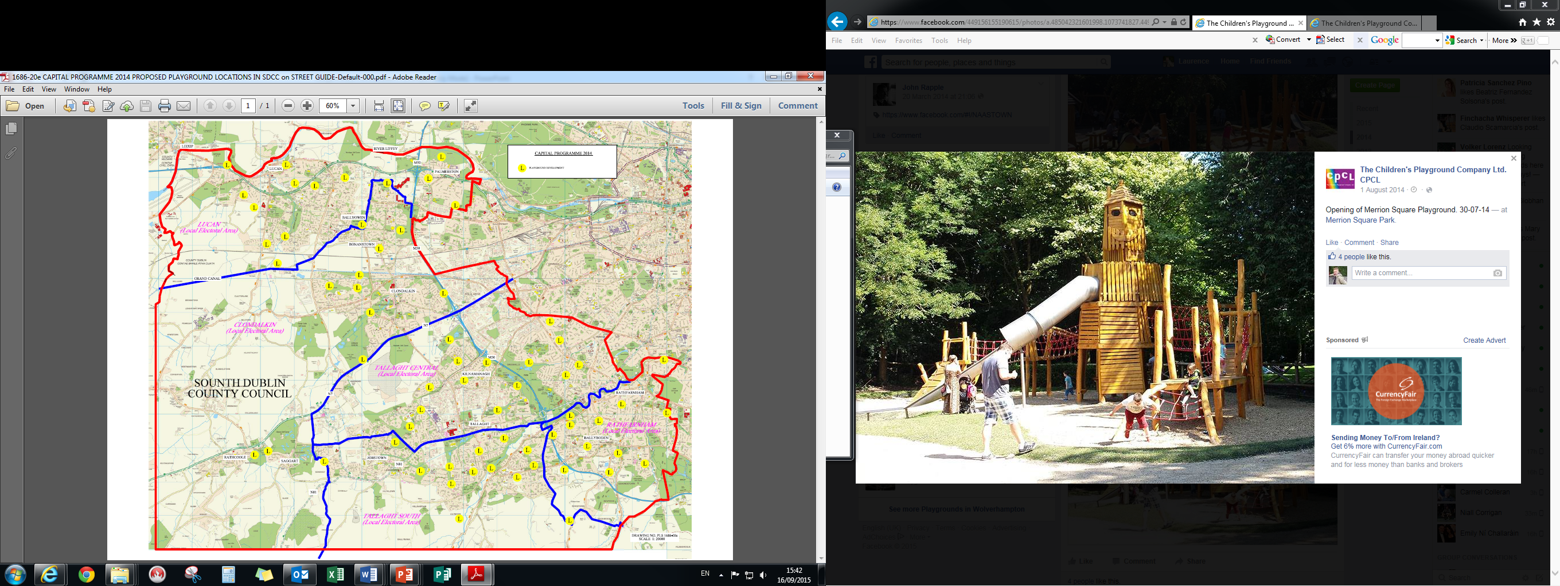
Fig 1: Playspace programme September 2016

The objectives for the programme are as follows:
- Delivery of play settings for children; that provide opportunities for play in ways that develop their imaginations.
- Delivery of the play spaces in the immediate vicinity of where children live.
- The play spaces will increase the attractiveness of the local area in which they reside.
- The delivery of robust play areas that are less susceptible to vandalism.

Delivery of the Programme to date:
The programme proposed to deliver 64 playspaces over 5 years. It was estimated at the time that it was likely that 50 would be achieved. (The initial proposals comprised a high level study and it was envisaged that some would not be deliverable for various reasons).
During the delivery of the programme some amendments were made to the proposed scheme and two additional play spaces were added to the list; (Ballycragh and Hermitage).
The table and graph below illustrate progress to date:
 | 2014 | 2015 | 2016 | 2017 | 2018 | TOTALS
Total proposed in 2014 | 10 | 12 | 14 | 13 | 15 | 64
Total commenced currently underway | 0 | 6 | 13 |  |  | 19
Total commenced and did not progress | 2 | 3 | 0 |  |  | 5
Total Completed | 10 | 3 | 0 |  |  | 13
Notes: | 2 new playspaces added to list and completed. |  | 3 playspaces currently underway are from proposed 2018 list.
Table 1: Progress of the programme at September 2016

Table 2: Delivery per annum

Table 3: Overall progress
The following table shows the list of proposed playspaces and progress to date:
No. | Original Proposed Year | Electoral Area | Location | Status as at September 2016
1. | 2014 | Clondalkin | Rathcoole Park | Completed. Rathcoole Park Local
2. | 2014 | Clondalkin | Knockmitten Park | Completed. Knockmitten Park Neighbourhood
3. | 2014 | Lucan | Woodfarm Acres | Completed. Riversdale substituted for Woodfarm. Local
4. | 2014 | Lucan | Griffeen Avenue | Completed. Griffeen Avenue Local
5. | 2014 | Rathfarnham, Templeogue, Terenure | Woodstown, Knocklyon | Did not progress. Woodstown, Knocklyon Local
6. | 2014 | Rathfarnham, Templeogue, Terenure | Whitechurch open space | Did not progress. Whitechurch open space Local
7. | 2014 | Rathfarnham, Templeogue, Terenure | Beechfield Park, Walkinstown | Completed. Beechfield Park, Walkinstown Local
8. | 2014 | Tallaght | Belgard Heights | Completed. Brookview- substituted for Belgard Heights Local
9. | 2014 | Tallaght | Avonbeg | Completed. Avonbeg Local
10. | 2014 | Tallaght | Killinarden Community Centre | Completed. Killinarden Community Centre Local
11. | 2015 | Clondalkin | Letts Field, Neilstown | Consultation on-going. Neilstown Local
12. | 2015 | Clondalkin | Quarryvale Park | Completed. Quarryvale Park Local
13. | 2015 | Clondalkin | Newcastle | Has not progressed to date. Sites being actively sought. Newcastle Neighbourhood
14. | 2015 | Lucan | Sarsfield Park, Lucan | Completed. Sarsfield Park, Lucan Local
15. | 2015 | Rathfarnham,  Templeogue,  Terenure | Marian Road | Consultation Plan being developed. Marian Road Local
16. | 2015 | Rathfarnham, Templeogue, Terenure | Dargle Wood | Did not progress. Dargle Wood Local
17. | 2015 | Rathfarnham,  Templeogue,  Terenure | Longwood/Stonepark Abbey Rathfarnham | Consultation Stage. Longwood/Stonepark Abbey Rathfarnham Local
18. | 2015 | Tallaght | Ambervale | Did not progress. Ambervale Local
19. | 2015 | Tallaght | Kilnamanagh Parkhill Rd | Contractor appointed. Kilnamanagh Parkhill Rd Local
20. | 2015 | Tallaght | Aylesbury | Completed. Aylesbury Local
21. | 2015 | Tallaght | Jobstown Park | Design being progressed. Jobstown Park Neighbourhood
22. | 2015 | Rathfarnham,  Templeogue,  Terenure | Kiltipper Park | Glendoher Park (substitute for Kiltipper Park)  Glendoher Park Contractor appointed.
23. | 2016 | Clondalkin | Ashwood estate | Consultation Plan being developed. Bawnogue area substituted for Ashwood Local
24. | 2016 | Tallaght | Springbank Cottages Saggart | Consultation Plan being developed. Springbank Cottages Saggart Local
25. | 2016 | Clondalkin | Collinstown Park | Consultation Plan being developed. Collinstown Park Local
26. | 2016 | Lucan | Ballyowen Park | Ballyowen Park Neighbourhood
27. | 2016 | Lucan | Lucan Demesne | Consultation Plan being developed. Lucan Demesne
28. | 2016 | Lucan | Newcastle Road area | Consultation Plan being developed. Newcastle Rd area Local
29. | 2016 | Rathfarnham, Templeogue, Terenure | Elkwood | Consultation Plan being developed. Elkwood Local
30. | 2016 | Rathfarnham, Templeogue, Terenure | Delaford | Consultation Plan being developed. Delaford Local
31. | 2016 | Tallaght | Kingswood open space | Contractor appointed. Kingswood open space Local
32. | 2016 | Rathfarnham, Templeogue, Terenure | Tymon Park Limekiln | Tymon Park Limekiln Neighbourhood
33. | 2016 | Rathfarnham, Templeogue, Terenure | Glendown Park | Consultation Plan being developed. Glendown Park Local
34. | 2016 | Tallaght | McGee Park | Design being progressed. McGee Park Neighbourhood
35. | 2016 | Tallaght | Marlfield | Sean Walsh Upgrade Local. Contractor appointed.
36. | 2016 | Rathfarnham, Templeogue, Terenure | Firhouse Park | Consultation Plan being developed. Firhouse Park Local
37. | 2017 | Clondalkin | Grand Canal Park | Consultation Plan being developed. Grand Canal Park Local
38. | 2017 | Clondalkin | Clondalkin Park | Clondalkin Local
39. | 2017 | Lucan | Willsbrook Park | Willsbrook Park Neighbourhood
40. | 2017 | Lucan | Hillcrest Estate Lucan | Hillcrest Estate Lucan Local
41. | 2017 | Lucan | Glenaulin Park, Palmerstown | Glenaulin Park, Palmerstown Neighbourhood
42. | 2017 | Rathfarnham, Templeogue, Terenure | Westbourne Lodge | Westbourne Lodge Local
43. | 2017 | Rathfarnham, Templeogue, Terenure | Boden Park | Boden Park Local
44. | 2017 | Rathfarnham, Templeogue, Terenure | Idrone, Knocklyon | Idrone, Knocklyon Local
45. | 2017 | Tallaght | Ballymount Park | Ballymount Park Neighbourhood
46. | 2017 | Tallaght | Bancroft Park | Bancroft Park Neighbourhood
47. | 2017 | Rathfarnham, Templeogue, Terenure | Greenhills Park | Greenhills Park Neighbourhood
48. | 2017 | Tallaght | Old Bawn Park | Old Bawn Park Neighbourhood
49. | 2017 | Rathfarnham, Templeogue, Terenure | Mount Carmel | Mount Carmel Neighbourhood
50. | 2018 | Clondalkin | Cherrywood Park | Cherrywood Park Local
51. | 2018 | Clondalkin | St Cuthberts Park | Consultation Plan being developed. St Cuthberts Park Local
52. | 2018 | Lucan | Beechpark | Beechpark Local
53. | 2018 | Lucan | Hillcrest Estate Lucan | Hillcrest Estate Lucan Local
54. | 2018 | Lucan | Esker Park | Esker Park Neighbourhood
55. | 2018 | Lucan | Grange Park | Grange Park Neighbourhood
56. | 2018 | Rathfarnham, Templeogue, Terenure | Cherryfield Park | Cherryfield Park Neighbourhood
57. | 2018 | Rathfarnham, Templeogue, Terenure | Prospect Manor, Stocking Lane | Prospect Manor, Stocking Lane Local
58. | 2018 | Rathfarnham, Templeogue, Terenure | Orwell Park | Orwell Park Local
59. | 2018 | Rathfarnham, Templeogue, Terenure | Perrystown | Consultation Plan being developed. Perrystown Local
60. | 2018 | Tallaght | Kilnamanagh Treepark Rd | Contractor appointed. Kilnamanagh Treepark Rd Local
61. | 2018 | Rathfarnham, Templeogue, Terenure | Carrigwood | Carrigwood Local
62. | 2018 | Rathfarnham, Templeogue, Terenure | Hunterswood | Hunterswood Local
63. | 2018 | Tallaght | Killinardan Park | Killinardan Park Neighbourhood
64. | 2018 | Rathfarnham, Templeogue, Terenure | Dodder Park Road | Dodder Park Road Local
64. +1 |  | Rathfarnham, Templeogue, Terenure | Ballycragh | Completed. Ballycragh Community Centre Local
64 + 2 |  | Lucan | Hermitage Park | Completed. Hermitage Park. Local Lucan.
Table 4: Playspace programme; individual projects
Delivery on objectives:

• Delivery of play settings for children; that provide opportunities for play in ways that develop their imaginations.
To date the programme has delivered 13 playspaces, 5 have not progressed and 19 are underway; at various stages of delivery. There is on-going progression of the programme. The playspaces have been well received to date and feedback has been overwhelmingly positive; the playspaces are very well used in a variety of ways especially by smaller children.
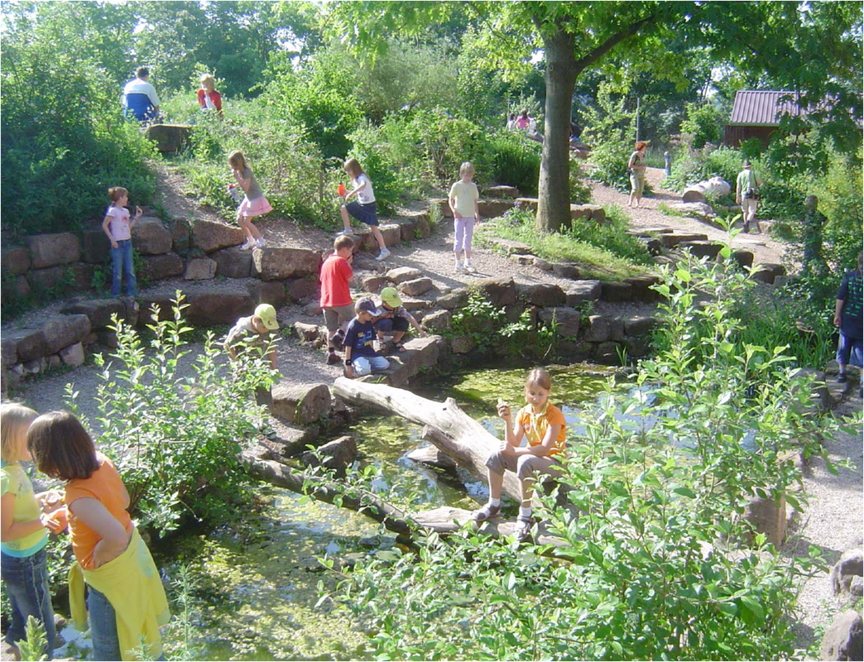
Example of natural play area

• Delivery of the play spaces in the immediate vicinity of where children live.
The completed playspaces have provided play opportunities for children in the vicinity in which they live. Visits to the spaces have shown them to be well used and busy.

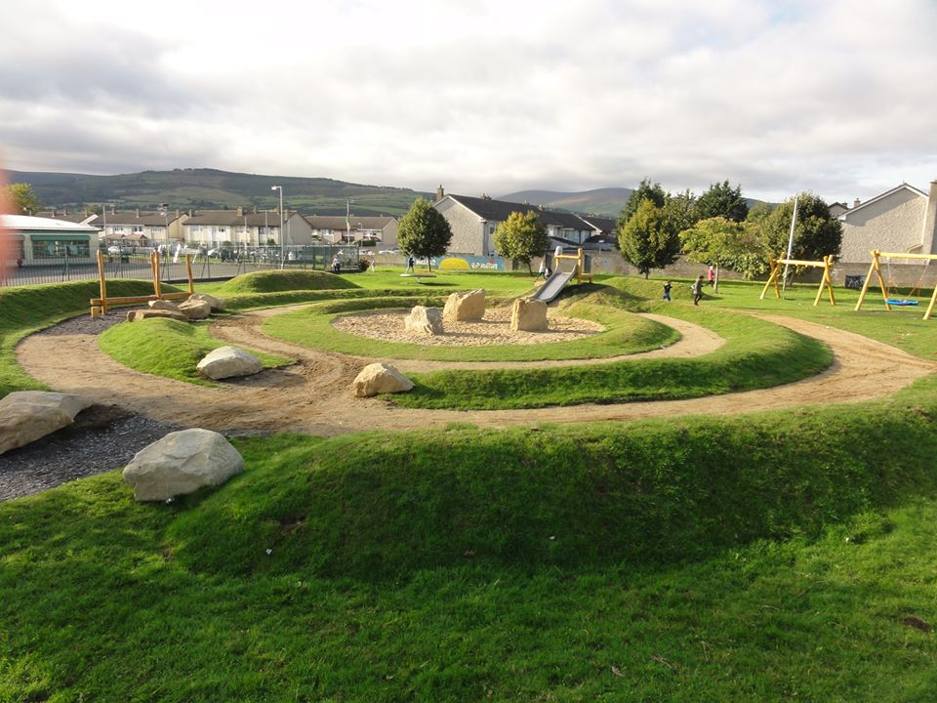
Avonbeg, Tallaght

• The play spaces will increase the attractiveness of the local area in which they reside
Most complaints arise during the construction stage and local residents are usually satisfied with the finished playspaces.
Attitudes to meadow grass are an issue at some locations; Griffeen Park playspace is a meadow type playspace that allows children access to nature. Meadowland is highly rich in species such as bees and butterflies, though the decreased use of this type of grass land maintenance in recent years has led to an under-appreciation of meadowland in its appropriate setting. As the meadow develops wildflower species will naturally enter it further adding to the biodiversity and attractiveness of the space, while also allowing children to mark seasonal changes.
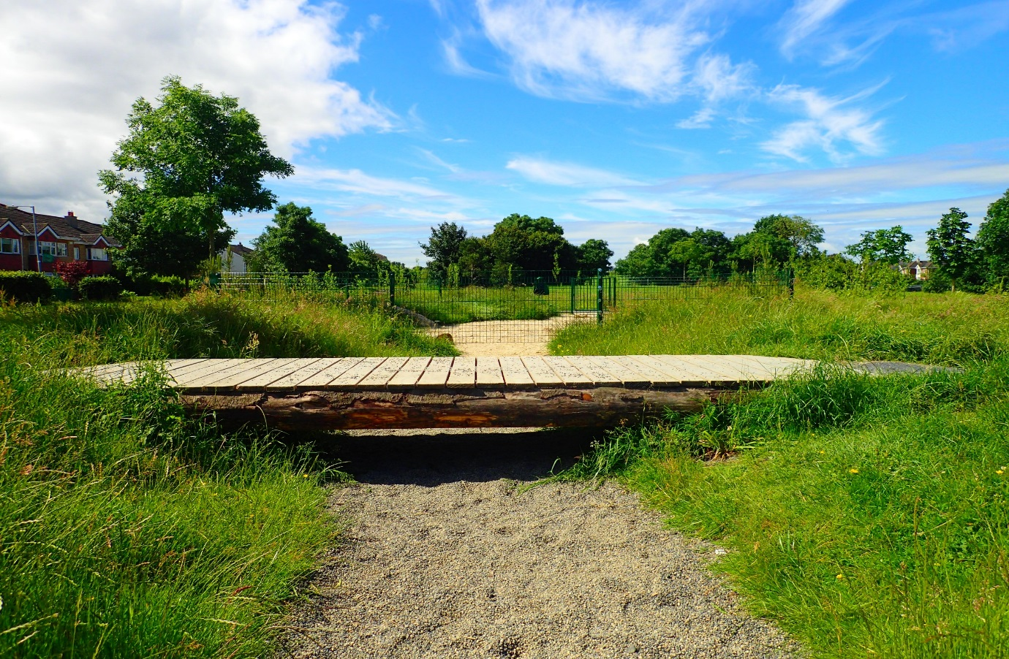
Griffeen Park, Lucan
Positive community benefits have been reported unrelated to play; e.g. at Knockmitten. The initial consultation connected with grandparents who were becoming socially isolated while caring for grandchildren. The neighbourhood playspace that was installed emphasised community cohesion as well as a place for children to play. It has become a community gathering spot where children play while the adults relax. There is no time limit to the visit to the ‘playground’ as this is where the adults go to socialise. The playspace was located in a previously existing and underutilised community garden. The community garden was renovated, a men’s shed project (a pizza oven) was integrated into the garden; the local youth club were involved, and the play space was imbedded into the garden; it has become the social hub of the community.
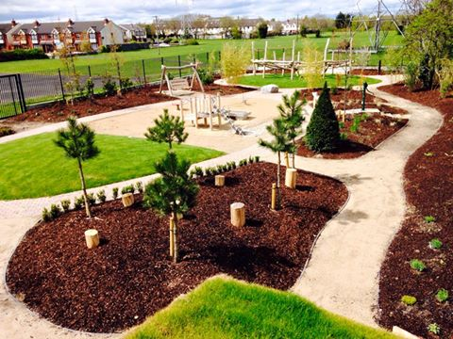
Knockmitten 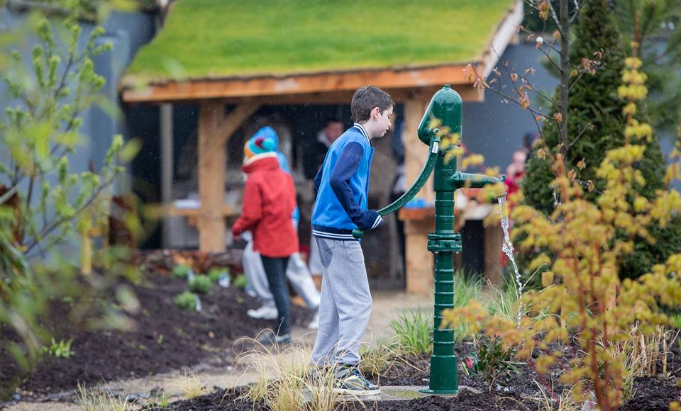
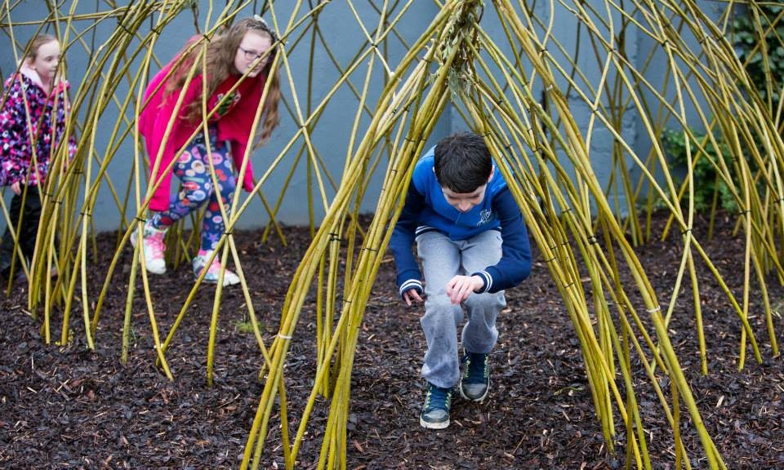
Knockmitten, Clondalkin
• The delivery of robust play areas that are less susceptible to vandalism
The playspaces are robust and have not suffered much vandalism. Indeed in some areas it has moved anti-social activity away e.g. Avonbeg: (the intensive and interactive consultation process included mediation. The consultation was prolonged and addressed sincerely held concerns). It resulted in the in-depth involvement of the community in the design process and resulted in the residents taking ownership of the playspace; and, by use of passive surveillance techniques, ensured damage did not occur to their playspace.
To date there has been little or no complaints about night time activity; much of this is resolved at the design stage by careful siting and careful choice of surfacing (soft finishes versus hard surfaces).
Litter is a constant issue and in many cases two bins have been installed and emptied twice per week, on Saturdays and Mondays.
The longer grass and the use of features within grass require a more individualised maintenance approach. The playspaces are specialised features and specific maintenance requirements are integral to ensuring they remain a valuable part of the community. However as the playspace programme rolls out this will add to the maintenance requirement.

Avonbeg, Tallaght

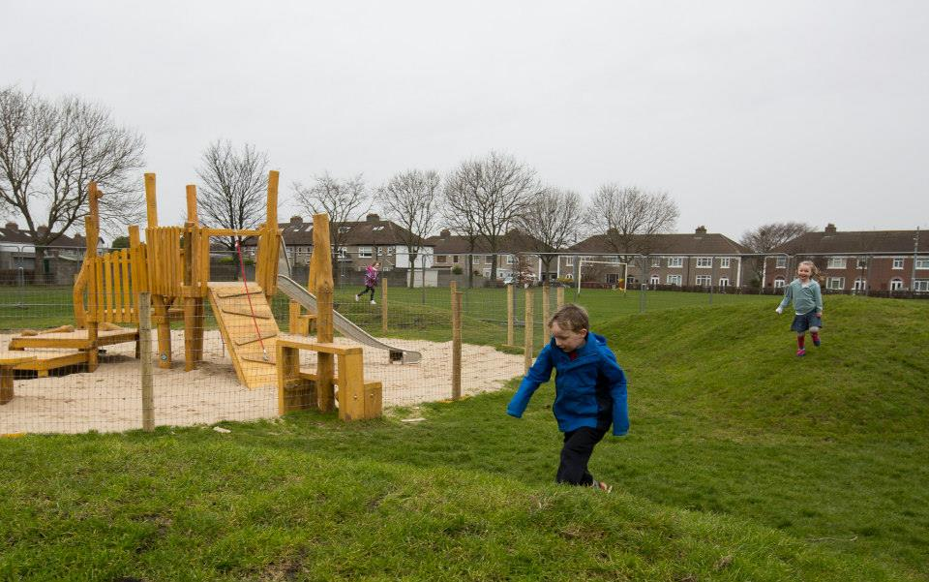
Beechfield Walkinstown

The Consultation process:
Challenges:
- Mistrust of proposals in general
- History of play provision and previous bad experiences.
- Major concern about what happens in playgrounds at night- Anti social behaviours
- Concerns over maintenance
- Lack of understanding of playspaces vs playgrounds.
- Fear of change- nothing broken; why fix it
- Difficulty in reaching people
- Aggressive behaviour during consultation processes
- Building relationships and trust
Once the proposal was adopted by the council in 2014 there was an initial attempt to move quickly through the programme; with one consultation per playspace envisaged. However this was found to be ineffective. The challenges associated with playspaces outlined above, meant that in some cases, people were reluctant to consider, or actively opposed to, the concept of ‘playgrounds’. It takes some time and resources to explain the concept of playspaces as a new departure in play provision. The early stages of the programme resulted in the non-progression of several proposed playspaces (listed above).
Swiftly the consultation process evolved from town hall style meetings; where a complete proposal was presented for consideration, to a more intensive engagement process where local people meet with council officials and talk about play. This allows for an exchange of ideas on what is required in a local area. Children are involved in the playspace design as central to the design of the final space.
A consultation process has developed and, as each area is completely different, new learning occurs at each, which allows the playspace programme consultation process to develop and evolve.
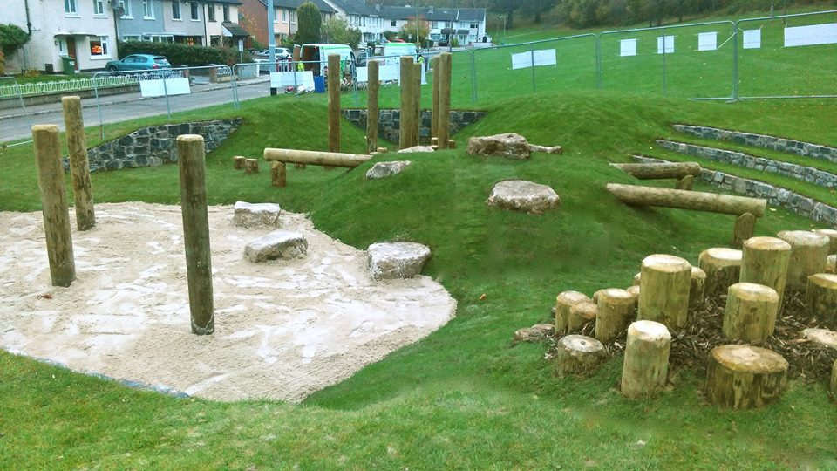
Sarsfield Park Lucan
So far consultation has involved the following groups:
- Community Groups, Residents Associations, Elected Representatives, Large Community Meetings
- Consulting directly with children and teenagers.
- Other partners have also being involved as well as other sections of the Council such as the community department.
The processes through which consultation occurs also vary:
- Workshops, pop up play days; (allow the children to develop their play ideas while the playspace providers talk to the parents) and a combination of all above

Some Consultation examples:
Foróige won a national award for organising the consultation for Kingswood playspace. 80 drawings from primary school children of their ideal playspace were reviewed to get ideas to incorporate into the play area. Foróige presented the resulting pictures to the children, carried out surveys and held a workshop for teenagers. Barnardos also won an award for the ‘Amplifying Voices’ initiative for their work in the design and consultation during the proposals for the playspace at Avonbeg.
The intensive consultation process ensures the playspaces are specifically designed for the needs of the community; each is different and each conveys a sense of ownership to the community
The innovative and progressive engagement process has garnered much praise. The locally elected councillors were brought on a tour of the playspaces and were much impressed by the results. It is felt that the intensive involvement of the local community in the design and development of the playspaces are one of the factors influencing the low rates of vandalism thus far.
Typically the consultation process has increased from 1 meeting per playspace to on average 7-10 meetings.

Possible Risks associated with the programme and associated controls:
- Perceived risk of injuries: The playspaces are purposely designed in order to present the concept of risk to children without any physical danger. Each playspace is assessed by RoSPA prior to its opening to ensure it is fit for purpose.
- Higher / different maintenance obligations: Regular maintenance and inspections are required to ensure the playspaces are safe and attractive. In some cases there is a misunderstanding of the level of maintenance required as in many cases a low intensity meadowland regime is intended and preferable.
- Ongoing costs: On-going costs do not include just maintenance but also on-going repair and refurbishment. The playspaces get heavy use and will need ‘refreshing’ at intervals.
- Disapproval of nearby residents: The consultation process (outlined further above) is designed to collate all concerns early in the process of play space development; in this way concerns of nearby residents are addressed at the design stage. This can be by equipment selection, by careful siting and so on. Or sometimes the explanation of how the playspace programme differs from the previous playground provision is enough to allay concerns. As the programme is rolled out the ability to provide people with a site to visit where they can see an example for theirselves has been very helpful in allaying concerns.
- Anti-social activity and / or vandalism:
  - Prevention:
Anti-social activity and vandalism are combatted as much as possible at the design stage by effective and robust design, careful siting, use of passive surveillance and involvement of the local community in the development of the playspace. (Outlined further above).
  - Proactive measures once issues arise:

Case study: A particular case of persistent anti-social problems developed after one playspace was installed. The playspace equipment was removed to prevent the escalation of anti-social behaviours and to protect the equipment. However, the close relationship that had developed between the local community and the council at the design stage has meant that a community -led agreement has been reached to plan for the playspace return.

A community meeting was held soon after the playspace removal to discuss the problems and formulate a solution and, despite the problems, it was agreed at the meeting that the playspace was the most positive thing that has ever happened in the estate and the community did not want to lose it. The buy in by everyone at the start of the playspace process was spoken of and how much it mattered to local children and families. There was an acceptance that the solution lay within the community and the following list of actions were agreed:
- The Residents Association will work together to identify those responsible for the problem and talk to parents
- Local Youth workers will confront the children responsible and get them to understand the impacts of their behaviour
- The travellers association will work with Youth Workers where possible.
- The Council will use CCTV to identify those causing problems and issue warnings
- The local school will start an education and awareness programme and ask the local teenagers to be involved in developing a code of conduct for the playspace, including a night time cut off time for use of the playspace.
- Local councillors will continue to make representations to the Gardai for additional support
- A new tree will be replanted at a Tree of Hope ceremony. The youth workers, travellers representatives and school will organise local youths to be involved with the planting and help them to understand its significance to their community.
The community dept has agreed to coordinate all these actions and report back on their progress. At the end of the meeting attendees confirmed the meeting was a success and that the community was going to fight back to protect its playspace and ensure its return.

Further Recommendations:
Survey work: There is a need for a greater assessment of the delivery; both qualitative and quantitative. The programme is currently relying on anecdotal evidence, feedback from elected members and observed reactions. There is a need for number surveys and assessment of attitudes of users and close residents. Feedback can be integrated into playspace programme development.
Promotion: The playspace programme is an innovative and special programme, it exists in other countries but it is ground-breaking in Ireland. We need to promote its use and increase its profile nationally and with other play providers. If resources permit learning opportunities / CPD could be provided for other playspace providers
Consultation: The consultative processes that have developed are individualised and intensive. It would be worthwhile to detail and assess the consultation process that has developed.

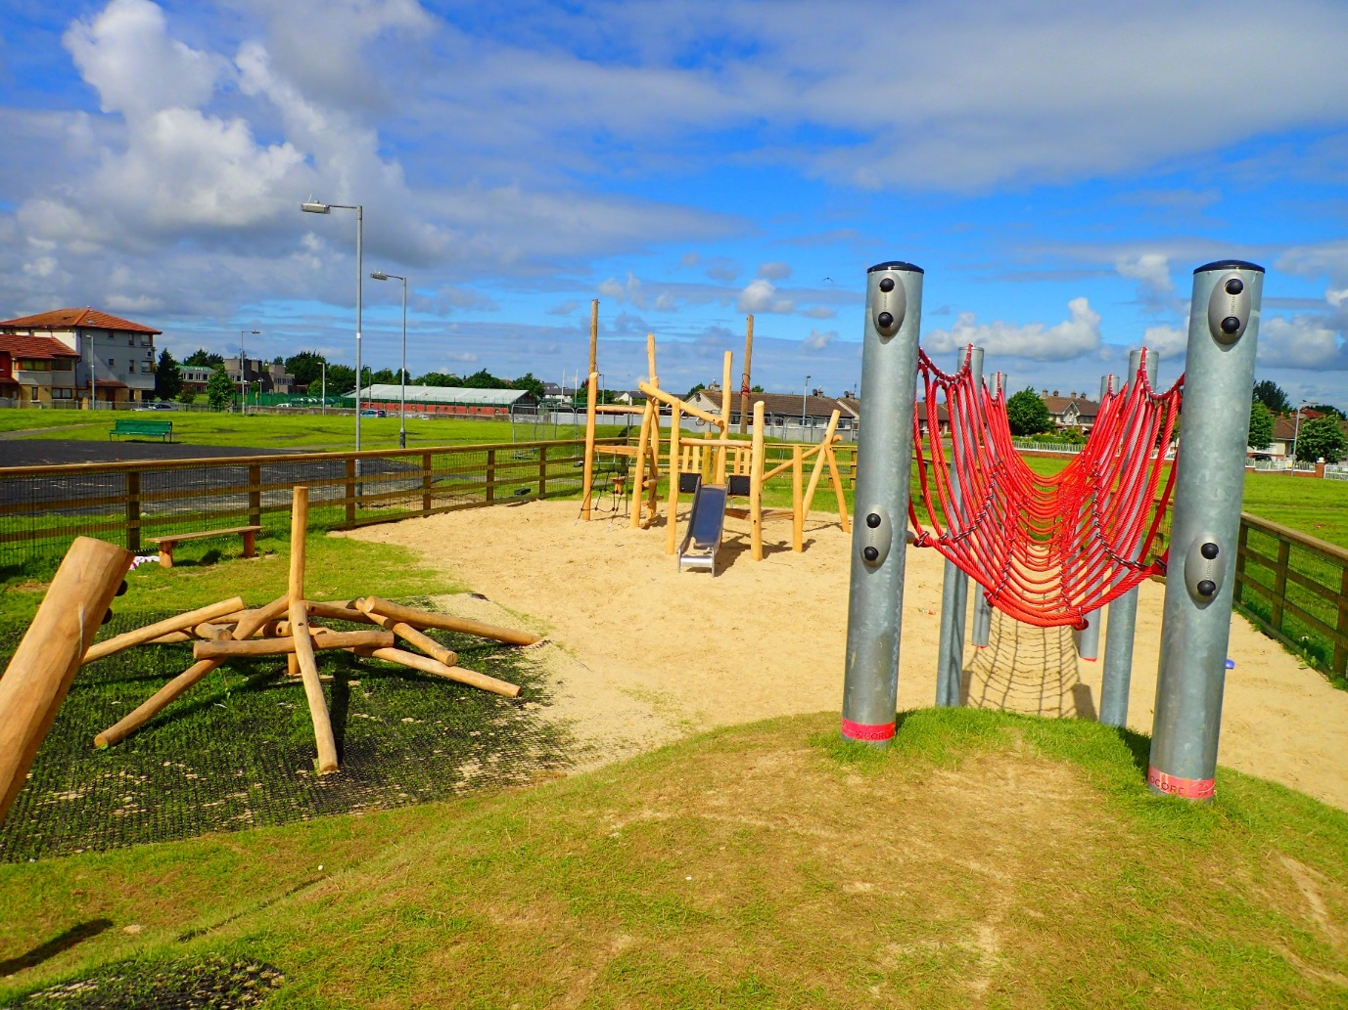
Brookview, Tallaght. A community led plan has been agreed for its reinstatement.

Plan to complete the programme:
Consultation: As discussed above the consultation process has evolved from town hall style meeting where the proposal was presented: (1 playspace: 1 meeting), to a more intensive engagement process where local people meet with council officials to talk about play. This allows for an exchange of ideas on what is required in a local area. Children are involved in the playspace design as central to the proposed provision.
The more intensive consultation (from 1 meeting to 7-10 engagements (on average)), has a knock-on effect, in terms of resource commitment and delivery time; it is a process that requires time. But it is felt that the resulting delivery, the reported satisfaction rates and the decrease in vandalism is a worthwhile payback.
This increase in consultation requirements (in one recent case the consultation process took 1 year), has meant that the playspaces have a longer delivery arc. It may be that an acceleration in terms of delivery may occur now the programme is ‘up and running’ but this will have to be monitored. Each playspace is unique and it is difficult to estimate the time each will take. This issue will have to be monitored and an assessment made of the best way to complete the programme in a timely fashion. This will be discussed further with elected members.
Delivery to date: To date the cost of each playspace approx. €65,000.
13 playspaces have been completed, at an overall cost of €680,000 in the 2.5 years to date;

The following 13 playspaces have been constructed:
- Quarryvale Park, Clondalkin
- Griffeen Avenue, Lucan
- Sarsfield Park, Lucan
- Hermitage Park, Lucan
- Aylesbury Park, Tallaght
- Rathcoole Park, Rathcoole
- Ballycragh, Firhouse
- Knockmitten, Clondalkin
- Riversdale Estate, Lucan
- Killinarden, Tallaght
- Avonbeg Park, Tallaght
- Beechfield Park, Walkinstown
- Brookview Estate, Tallaght

The following playspaces have not progressed and it is proposed to remove them from the scheme:
- Woodstown, Knocklyon
- Dargle Wood, Rathfarnham
- Ambervale, Tallaght.

The following playspaces are planned for completion in 2016:
- Glendoher: Construction stage
- Kilnamanagh Tree Park and Park Hill, amalgamated into a line of connected play spaces: Construction Stage
- Kingswood: Construction Stage
- Tymon Park: Construction Stage

It is proposed to proceed with the following programme to complete the playspace programme based on the years originally proposed, preliminary consultation indicates that in some cases amalgamation may be favourable but each will be assessed on a case by case basis:
RATHFARNHAM / TEMPLEOGUE / TERENURE
2016
- Marian Road: Consultation on-going.
- Longwood / Stonepark Abbey: Consultation on-going incorporating Aranleigh.
- Elkwood: Consultation plan
- Delaford: Consultation plan
- Perrystown: Consultation plan
- Glendown Park: Consultation plan
- Firhouse Park: Consultation plan
2017
- Tymon Park, Limekiln
- Greenhills Park
- Mount Camel
- Westbourne Lodge
- Boden Park
2018
- Cherryfield Park
- Prospect Manor, Stocking Lane
- Dodder Park Road
- Idrone Knocklyon
- Orwell Park
- Whitechurch, Rathfarnham
- Carrigwood
- Hunterswood

LUCAN
2016
- Newcastle Road area / Esker Park, commence consultation, possible amalgamation
2017
- Willsbrook Park
- Hillcrest Estate (x 2)
- Glenaulin Park, Palmerstown
- Lucan Demense
2018
- Move Ballyowen Park to 2018 due to Horse Project currently under construction
- Beechpark
- Grange Park

TALLAGHT
2016
- Brookview: ongoing consultation regarding management of playspace
- Jobstown Park: Design Stage
- McGee Park: Design Stage
- Springbank Cottages, Saggart: Consultation Plan
2017
- Old Bawn Park
- Ballymount Park
- Bancroft Park
2018
- Killinarden Park

CLONDALKIN
2016
- Newcastle: continue to progress site options
- Neilstown: Consultation plan being progressed
- Collinstown Park: Consultation plan being progressed
- Bawnogue area: combine with St, Cuthberts and Grand Canal Park: preparing consultation plan
2017
- Boot Road
2018
- Cherrywood Park

Refinement / Development of the Scheme
Teenager Facilities: During the roll out of the playspace programme requests have been made for a similar programme for teenagers.
Provision of teenage facilities is a vital requirement that is very much needed in the county. The provision for teenagers will be different and will needs to be diverse; from active play (such as MUGAs. Parkour, fitness equipment), to more passive areas such as hang out areas etc. The assessment of requirement, the best location, the likely increased budgetary requirements, the likelihood of elevated concerns from local residents; would make the provision of a programme for older children best deliverable by a county-wide assessment and roll out of a specific programme with an allocated budget. The public realm section intend carrying out an initial scoping exercise on types of facilities that can be provided for teenagers. It is proposed to complete the current playspace programme while carrying out a feasibility / scoping exercise on teenager facilities, and roll out a teenager programme subsequent to the playspace programme.
Adult Equipment: Fitness equipment for active retired people is currently provided at 14 locations in 12 different parks. During the roll out of the playspace programme requests have arisen for additional equipment for adults. It is felt that the existing usage needs to be surveyed and assessed (South Dublin Sports partnership are involved in this). It is felt that location need to be assessed versus best practice here and elsewhere prior to the commencement of a new programme for delivery. Fitness Parks in use in other jurisdictions could also be considered at the same time (more focused towards younger adults).
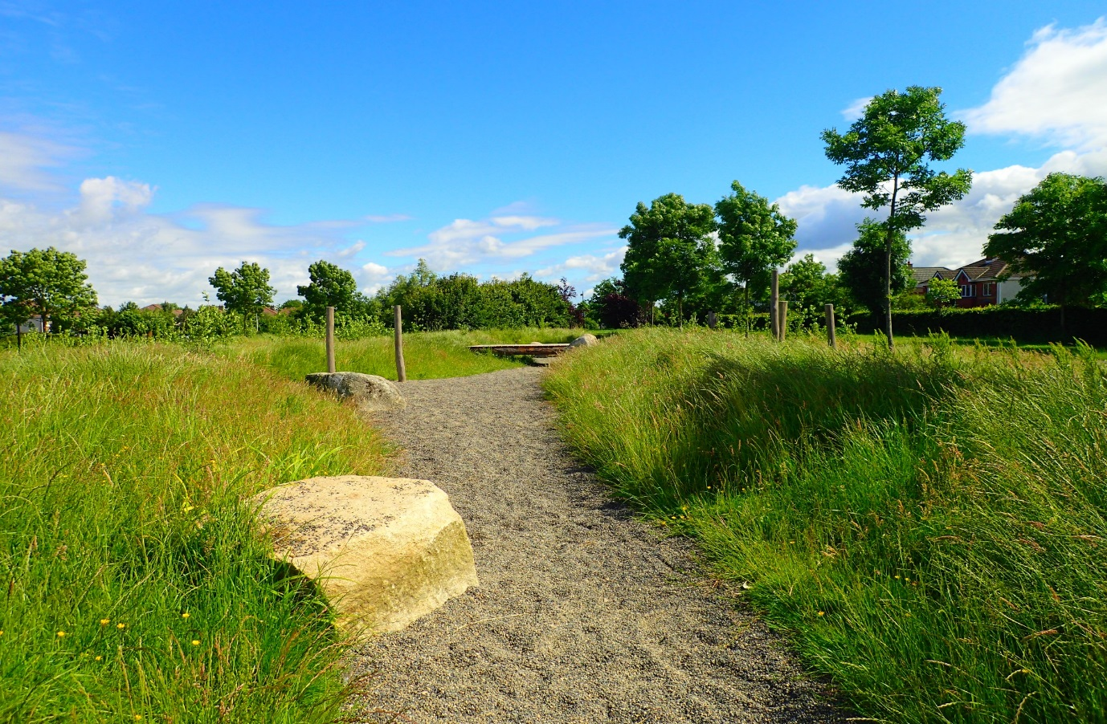
Griffeen Valley Park, playspace.

