Completion Plan for the Playspace Programme 2014-2018
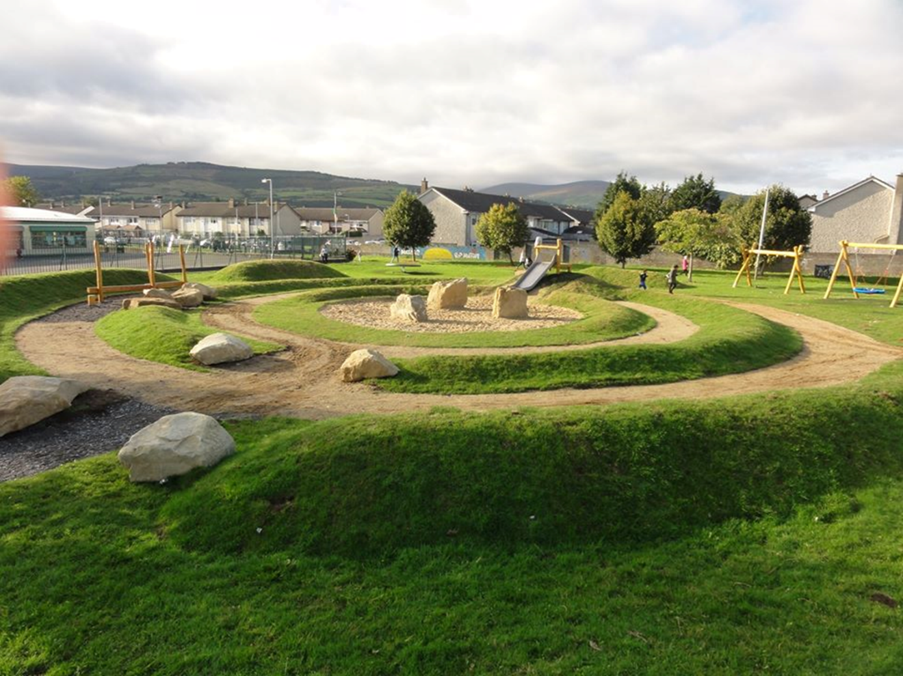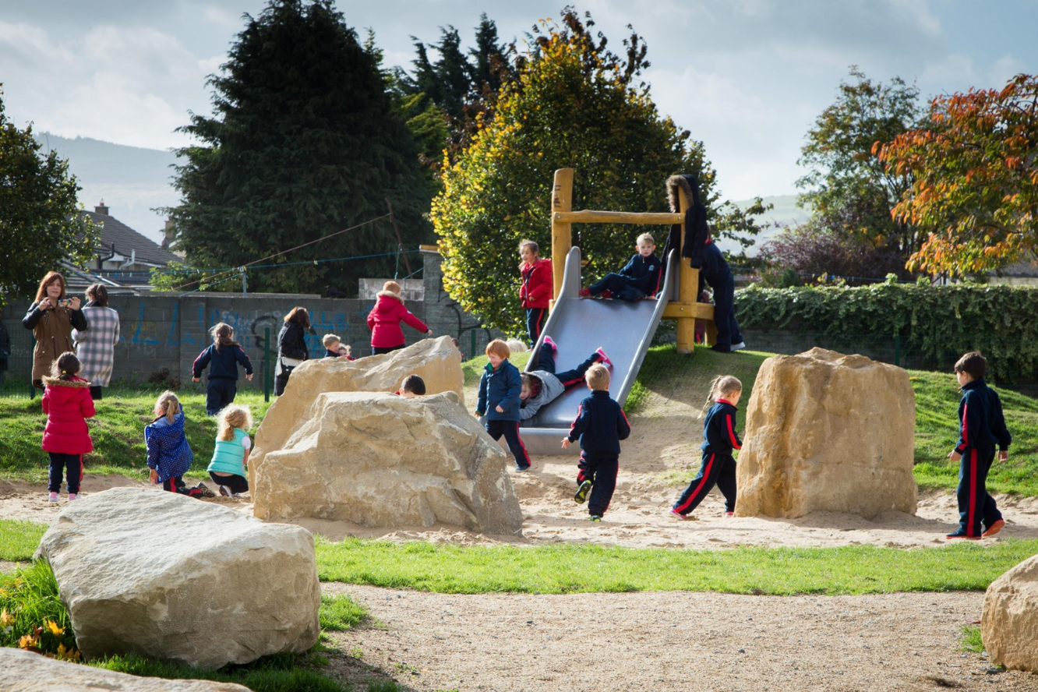
Avonbeg
(Extract from Playspace Programme Interim Report November 2016)
Consultation: The consultation process for the delivery of the playspace programme has evolved from ‘town hall style meeting’ where the proposal was presented: (1 playspace: 1 meeting), to a more intensive engagement process where local people meet with council officials to talk about play; allowing for an exchange of ideas on what is required in each local area. Children are involved in the playspace design as central to the proposed provision.
The more intensive consultation (from 1 meeting to 7-10 engagements (on average)), has a knock-on effect, in terms of resource commitment and delivery time; it is a process that requires time. But it is felt that the resulting delivery, the reported satisfaction rates and the decrease in vandalism is a worthwhile payback.
This increase in consultation requirements (in one recent case the consultation process took 1 year), has meant that the playspaces have a longer delivery arc. It may be that an acceleration in terms of delivery may occur now the programme is ‘up and running’ but this will have to be monitored. Each playspace is unique and it is difficult to estimate the time each will take. This issue will have to be monitored and an assessment made of the best way to complete the programme in a timely fashion. This will be discussed further with elected members.

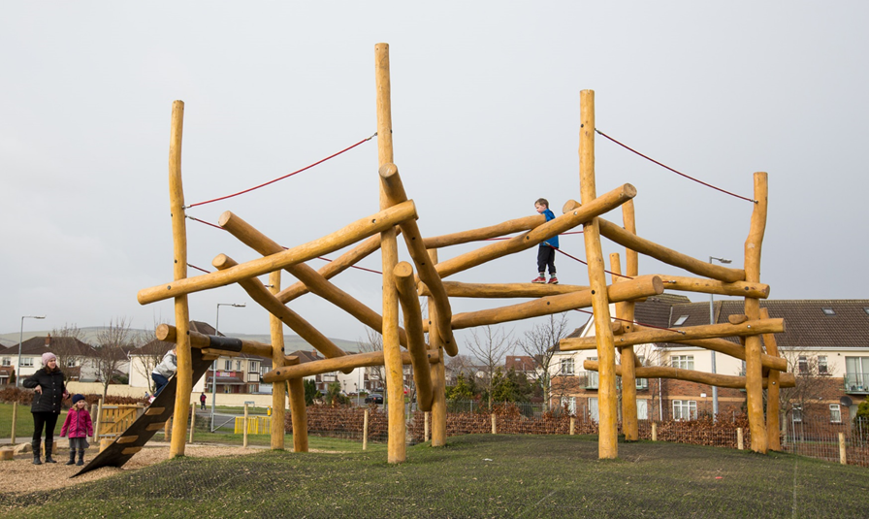Ballycragh

Delivery to date: To date the cost of each playspace approx. €65,000.
13 playspaces have been completed, at an overall cost of €680,000 in the 2.5 years to date.

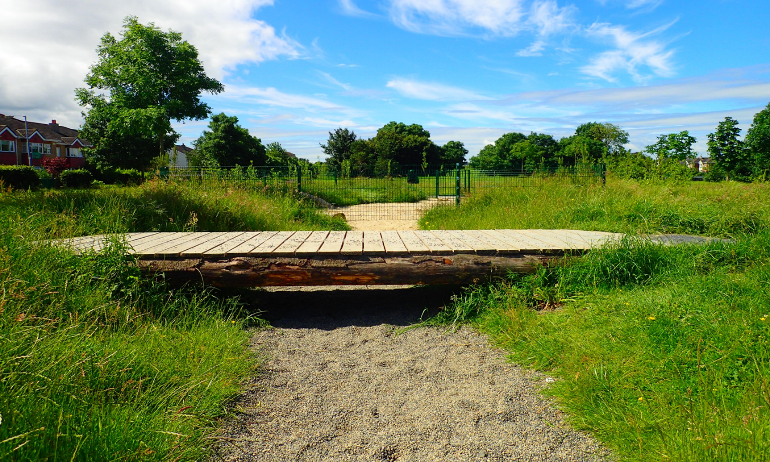
Griffeen Avenue

The following 13 playspaces have been constructed:
- Quarryvale Park, Clondalkin
- Griffeen Avenue, Lucan
- Sarsfield Park, Lucan
- Hermitage Park, Lucan
- Aylesbury Park, Tallaght
- Rathcoole Park, Rathcoole
- Ballycragh, Firhouse
- Knockmitten, Clondalkin
- Riversdale Estate, Lucan
- Killinarden, Tallaght
- Avonbeg Park, Tallaght
- Beechfield Park, Walkinstown
- Brookview Estate, Tallaght
The following playspaces have not progressed and it is proposed to remove them from the scheme:
- Woodstown, Knocklyon
- Dargle Wood, Rathfarnham
- Ambervale, Tallaght.

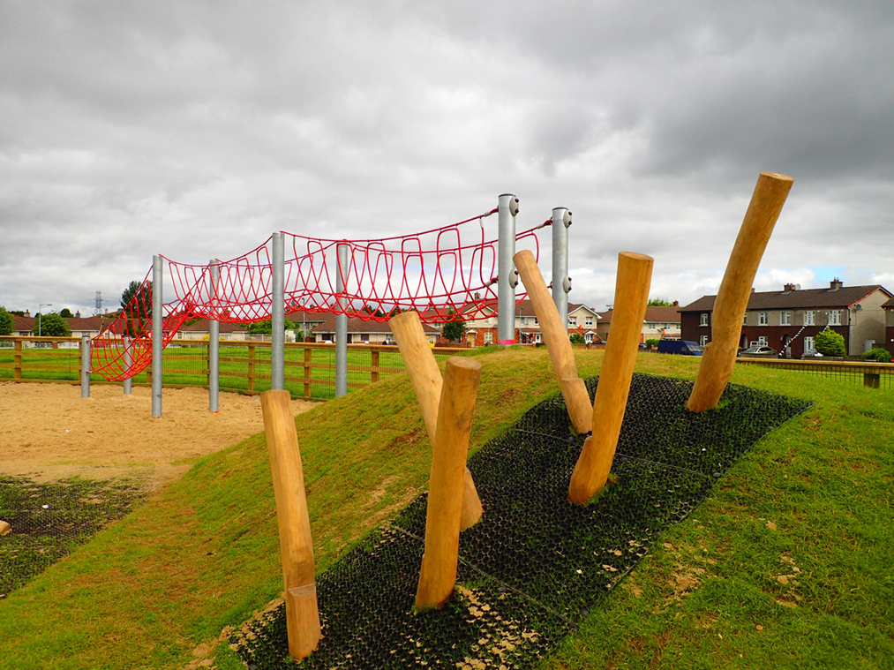
Brookview

The following playspaces are planned for completion in 2016:
- Glendoher: Construction stage
- Kilnamanagh (Tree Park and Park Hill, amalgamated into a line of connected play spaces): Construction Stage
- Kingswood: Construction Stage

It is proposed to proceed with the following programme to complete the playspace programme; preliminary consultation in some cases indicates that amalgamation at some locations may be favourable but each will be assessed on a case by case basis:
RATHFARNHAM / TEMPLEOGUE / TERENURE
2016
- Marian Road: Consultation on-going.
- Longwood / Stonepark Abbey: Consultation on-going incorporating Aranleigh.
- Elkwood: Consultation plan
- Delaford: Consultation plan
- Perrystown: Consultation plan
- Glendown Park: Consultation plan
- Firhouse Park: Consultation plan
2017
- Tymon Park, Limekiln
- Greenhills Park
- Mount Camel
- Westbourne Lodge
- Boden Park
2018
- Cherryfield Park
- Prospect Manor, Stocking Lane
- Dodder Park Road
- Idrone Knocklyon
- Orwell Park
- Whitechurch, Rathfarnham
- Carrigwood
- Hunterswood

LUCAN
2016
- Newcastle Road area / Esker Park, commence consultation, possible amalgamation
2017
- Willsbrook Park
- Hillcrest Estate (x 2)
- Glenaulin Park, Palmerstown
- Lucan Demense
2018
- Move Ballyowen Park to 2018 (due to Horse Project currently under construction)
- Beechpark
- Grange Park

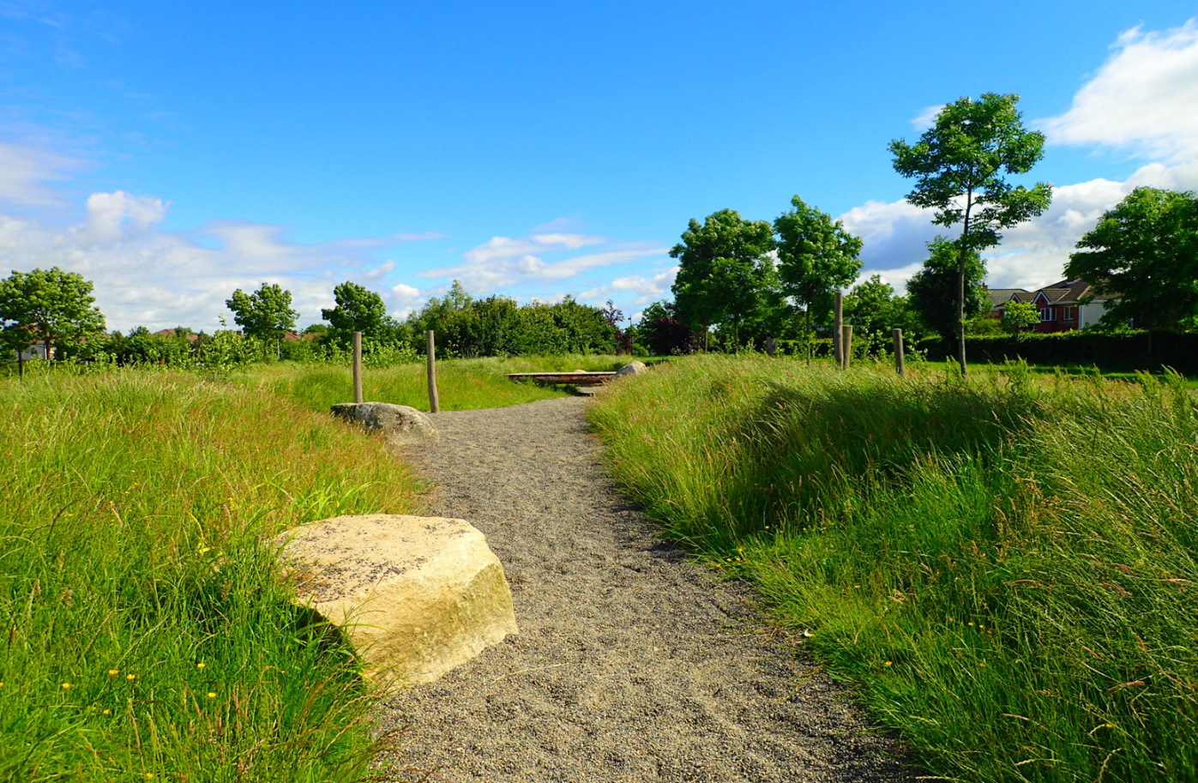
Griffeen Avenue

TALLAGHT
2016
- Brookview: Ongoing consultation regarding management of playspace
- Jobstown Park: Design Stage
- McGee Park: Design Stage
- Springbank Cottages, Saggart: consultation plan
2017
- Old Bawn Park
- Ballymount Park
- Bancroft Park
2018
- Killinarden Park

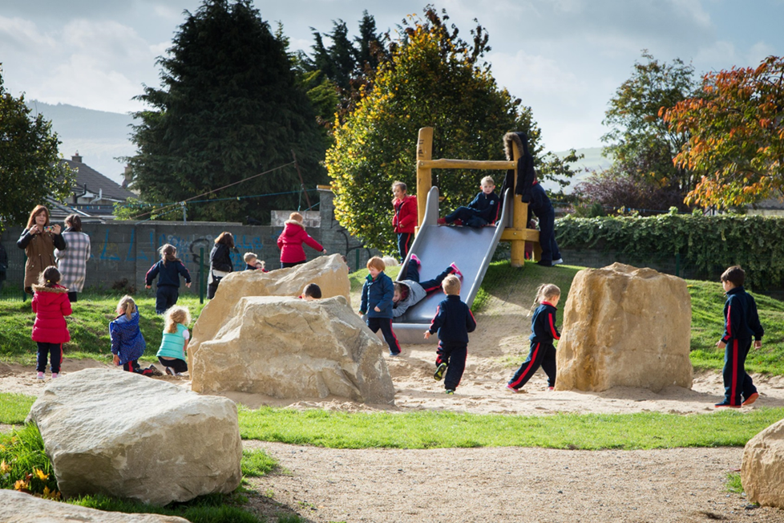
Avonbeg

CLONDALKIN
2016
- Newcastle: continue to progress alternative site options
- Neilstown: consultation plan being progressed
- Collinstown Park: consultation plan being progressed
- Bawnogue area: combine with St. Cuthberts and Grand Canal Park: preparing consultation plan
2017
- Boot Road
2018
- Cherrywood Park

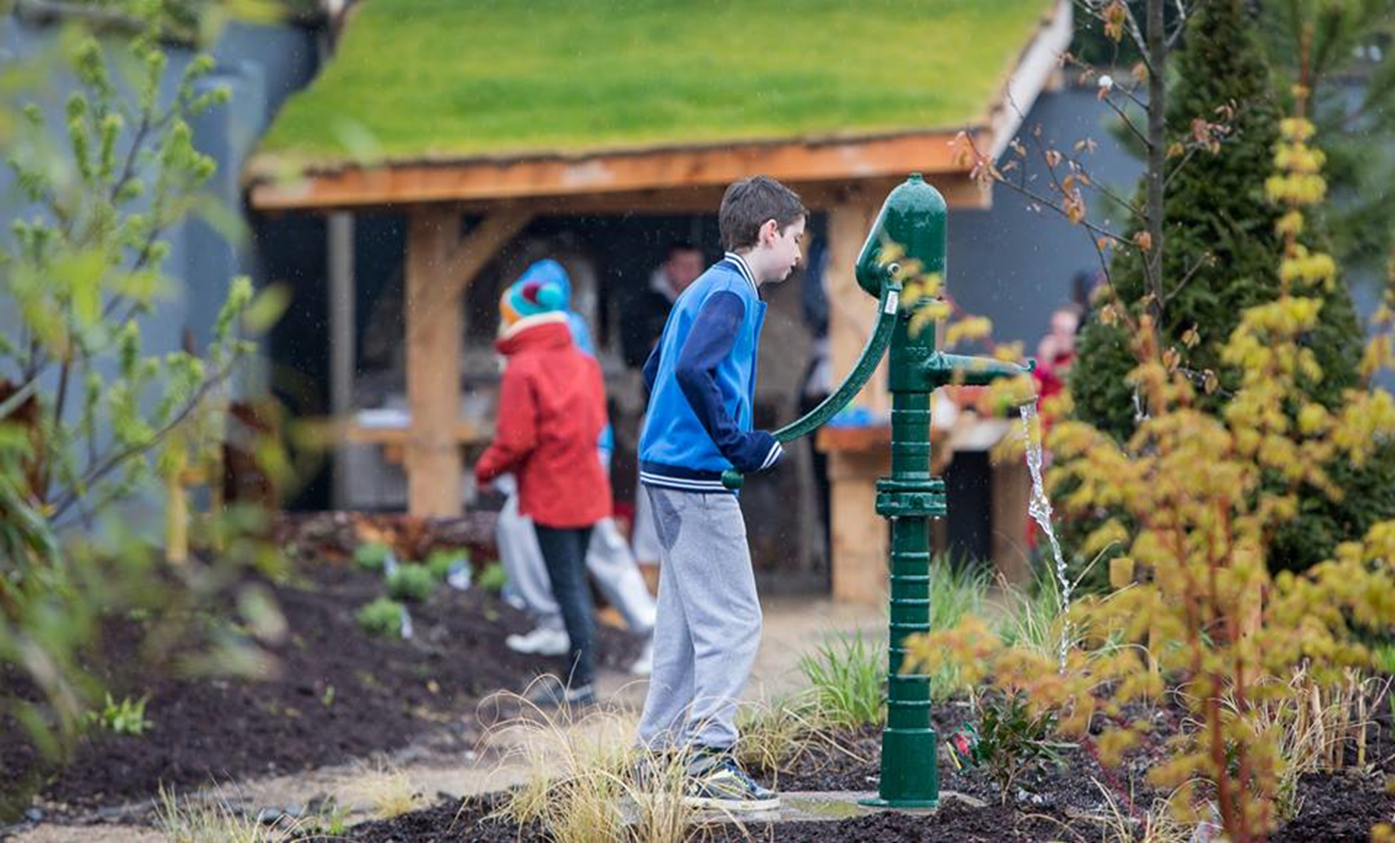
Knockmitten

Refinement / Development of the Scheme

Teenager Facilities: Requests have been made for facilities for teenagers (playspaces focus on play provision for younger children).
Provision of teenage facilities is a vital requirement that is very much needed in the county. The provision for teenagers will be different and will need to be diverse; ranging from active play (such as MUGAs. Parkour, fitness equipment), to more passive areas such as hang out areas etc. The assessment of requirements, the best locations, the likely increased budgetary requirements and the likelihood of elevated concerns from local residents etc.; would make the provision of a programme for older children best deliverable by a county-wide assessment and roll out of a specific programme with an allocated budget. The public realm section intend carrying out an initial scoping exercise on types of facilities that can be provided for teenagers. It is proposed to progress the current playspace programme as outlined above while carrying out a feasibility / scoping exercise on teenager facilities. A programme for teenager facilities will be agreed prior to completion of the playspace programme and a teenager programme will be ready to progress subsequent to the playspace programme.
Adult Equipment: Fitness equipment for active retired people is currently provided at 14 locations in 12 different parks. During the roll out of the playspace programme requests have arisen for additional equipment for adults. It is felt that the existing usage needs to be surveyed and assessed (in conjunction with South Dublin Sports Partnership). It is felt that locations need to be assessed versus best practice, both here and elsewhere, prior to the commencement of a new programme for delivery. Fitness Parks (in use in other jurisdictions) could also be considered at the same time (more focused towards younger adults).
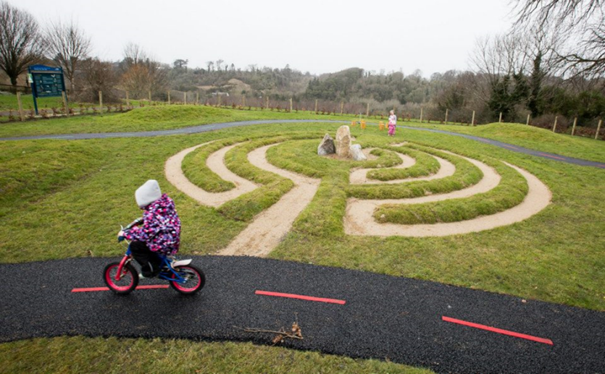
Riversdale

