Playspace Programme 2014-2018
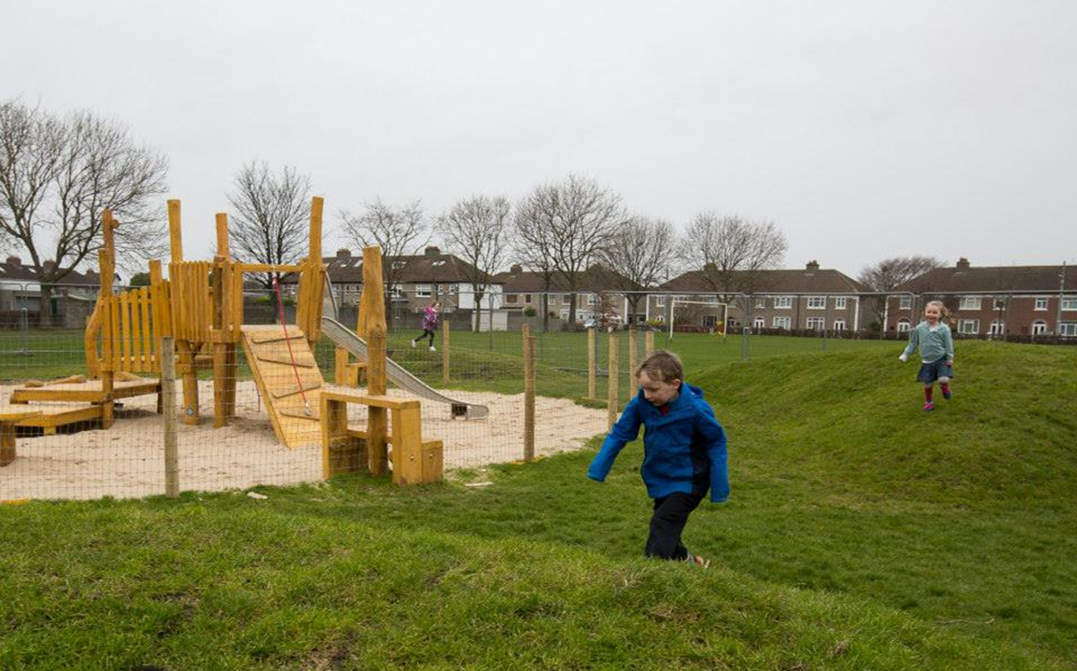
Beechfield.

Consultation: The consultation process for the delivery of the playspace programme has evolved from ‘town hall style meeting’ where the proposal was presented: (1 playspace: 1 meeting), to a more intensive engagement process where local people meet with council officials to talk about play; allowing for an exchange of ideas on what is required in each local area. Children are involved in the playspace design as central to the proposed provision.
The more intensive consultation (from 1 meeting to 7-10 engagements (on average)), has a knock-on effect, in terms of resource commitment and delivery time; it is a process that requires time. But it is felt that the resulting delivery, the reported satisfaction rates and the decrease in vandalism is a worthwhile payback.
This increase in consultation requirements (in one recent case the consultation process took 1 year), has meant that the playspaces have a longer delivery arc. It may be that an acceleration in terms of delivery may occur now the programme is ‘up and running’ but this will have to be monitored. Each playspace is unique and it is difficult to estimate the time each will take. This issue will have to be monitored and an assessment made of the best way to complete the programme in a timely fashion. This will be discussed further with elected members.

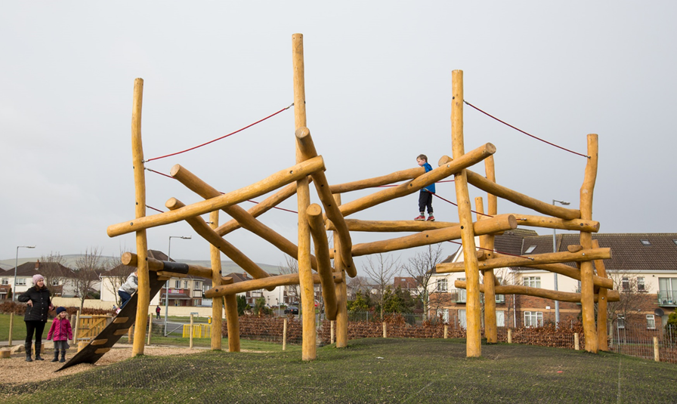Ballycragh

Delivery to date: To date the cost of each playspace approx. €65,000.
13 playspaces have been completed, at an overall cost of €680,000 in the 2.5 years to date.

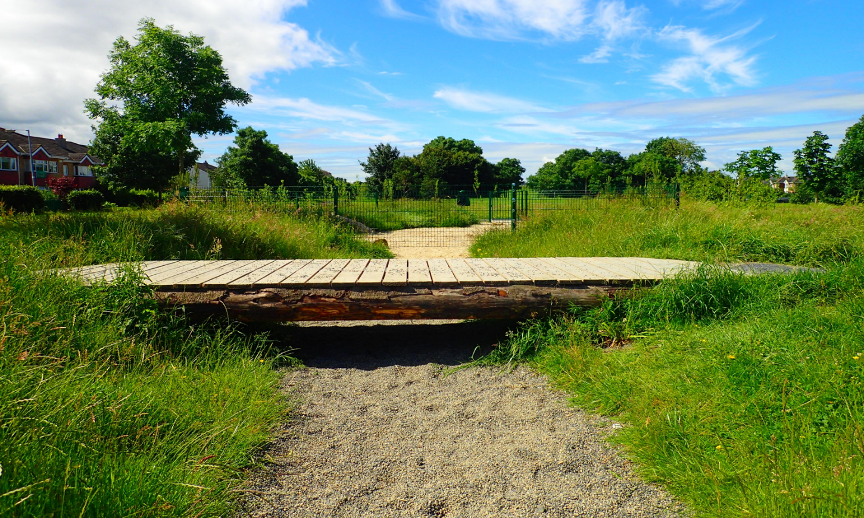
Griffeen Avenue

The following 13 playspaces have been constructed:
- Quarryvale Park, Clondalkin
- Griffeen Avenue, Lucan
- Sarsfield Park, Lucan
- Hermitage Park, Lucan
- Aylesbury Park, Tallaght
- Rathcoole Park, Rathcoole
- Ballycragh, Firhouse
- Knockmitten, Clondalkin
- Riversdale Estate, Lucan
- Killinarden, Tallaght
- Avonbeg Park, Tallaght
- Beechfield Park, Walkinstown
- Brookview Estate, Tallaght
The following playspaces have not progressed and it is proposed to remove them from the scheme:
- Woodstown, Knocklyon
- Dargle Wood, Rathfarnham
- Ambervale, Tallaght.

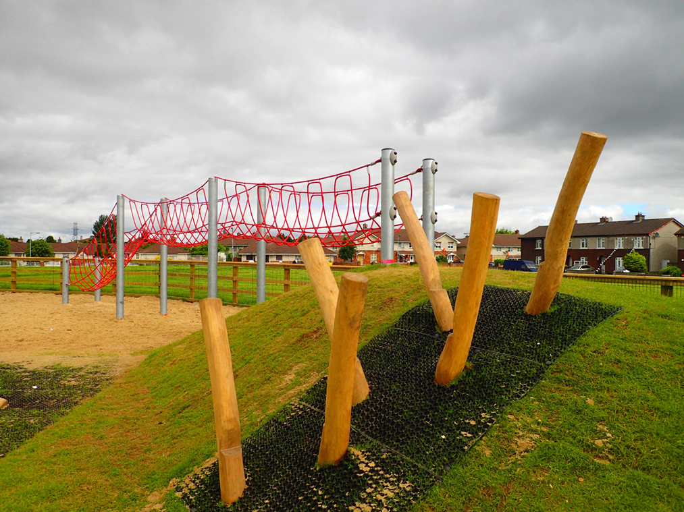
Brookview

The following playspaces are planned for completion in 2016:
- Glendoher: Construction stage
- Sean Walsh: Construction Stage
- Kilnamanagh (Tree Park and Park Hill, amalgamated into a line of connected play spaces): Construction Stage
- Kingswood: Construction Stage

It is proposed to proceed with the following programme to complete the playspace programme; preliminary consultation in some cases indicates that amalgamation at some locations may be favourable but each will be assessed on a case by case basis:
RATHFARNHAM / TEMPLEOGUE / TERENURE
2016
- Marian Road: Consultation on-going.
- Longwood / Stonepark Abbey: Consultation on-going incorporating Aranleigh.
- Elkwood: Consultation plan
- Delaford: Consultation plan
- Perrystown: Consultation plan
- Glendown Park: Consultation plan
- Firhouse Park: Consultation plan
2017
- Tymon Park, Limekiln
- Greenhills Park
- Mount Camel
- Westbourne Lodge
- Boden Park
2018
- Cherryfield Park
- Prospect Manor, Stocking Lane
- Dodder Park Road
- Idrone Knocklyon
- Orwell Park
- Whitechurch,
- Carrigwood
- Hunterswood

