**AL51007B.NTS**

**South Dublin County**

**Joint Policing Committee (JPC)**

**Strategic Plan**

**2016-2022**

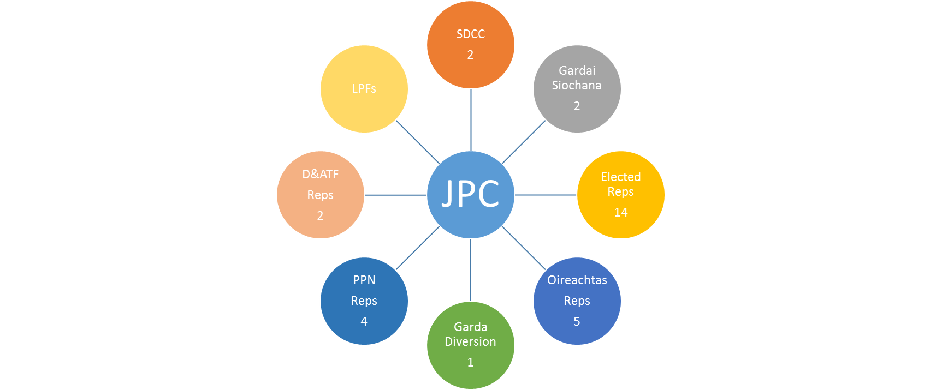

**Draft 1.3**

**Updated 15th September 2015**

 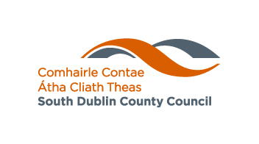

1. **Introduction** 
   1. The Garda Síochána Act 2005 introduced the establishment of Joint Policing Committees (JPCs)
   2. The function of the JPCs is set out in section 36(2) of the Garda Síochána Act, which states:

*“The Joint Policing Committee’s function is to serve as a forum for consultations, discussions and recommendations on matters affecting the policing of the local authority’s administrative area, and in particular to –*

1. *keep under review –* 
   1. *the levels and patterns of crime, disorder and anti-social behaviour in that area (including the patterns and levels of misuse of alcohol and drugs), and*
   2. *the factors underlying and contributing to the levels of crime, disorder and anti-social behaviour in the area,*
2. *advise the local authority concerned and the Garda Síochána on how they might best perform their functions having regard to the need to do everything feasible to improve the safety and quality of life and to prevent crime, disorder and anti-social behaviour within the area,*
3. *arrange and host public meetings concerning matters affecting the policing of the local authority’s administrative area,*
4. *establish, in consultation with the local Garda superintendent, as the committee considers necessary within specific neighbourhoods of the area, local policing fora to discuss and make recommendations to the committee concerning matters that it is to keep under review under paragraph (a) or on which it is to advise under paragraph (b), in so far as those matters affect their neighbourhoods, and*
5. *co-ordinate the activities of local policing fora under paragraph (d) or otherwise.”*
   1. **South Dublin County JPC**

1.3.1 The South Dublin County JPC has the following structure:



1.3.2 It has the following membership:

|  |  |
| --- | --- |
| **South Dublin Councillors (14) plus Mayor** | **Area Committee** |
| Cllr. Deirdre O’Donovan (Chair) | Rathfarnham |
| Cllr. Paula Donovan | Rathfarnham |
| Cllr Louise Dunne | Tallaght South |
| Cllr. Brian Lawlor | Templeogue- Terenure |
| Cllr. Cathal King | Tallaght South |
| Cllr. Brendan Ferron | Tallaght Central |
| Cllr. Ed. O’Brien | Lucan |
| Cllr. Paul Foley | Templeogue- Terenure |
| Cllr. Pamela Kearns | Templeogue- Terenure |
| Cllr. Kieran Mahon | Tallaght Central |
| Cllr. Nicky Coules | Tallaght South |
| Cllr. Liona O’Toole | Lucan |
| Cllr. Kenneth Egan | Clondalkin |
| Cllr. Paul Gogarty | Lucan |
| Cllr. Sarah Holland | Rathfarnham |
| Mayor Cllr Guss O’Connell | Lucan |
| **Oireachtas (5)** |  |
| Sean Crowe T.D. (TBC) | Dublin South West |
| John Curran T.D. (TBC) | Dublin West |
| John Lahart T.D (TBC) | Dublin South West |
| Vacant |  |
| Vacant |  |
| **SDCC (2)** |  |
| Danny McLoughlin | Chief Executive |
| Billy Coman | Director of Housing & Community |
| **Garda Síochána (2)** | **Division** |
| Chief Superintendent Orla McPartlin | Crumlin (DMR South) |
| Chief Superintendent Lorraine Wheatfield | Blanchardstown (DMR West) |
| **Community (7) (PPN (4) other (3))** |  |
| Ann Corrigan | PPN |
| Tara Deasy | PPN |
| Jim Lawlor | PPN |
| Michael Noonan | PPN |
| Eamon Dolan | Tallaght D&ATF |
| Ray McGrath | Clondalkin D&ATF |
| Gemma Carton | Garda Diversion Programme |

* 1. This is the first six year South Dublin Joint Policing Committee Strategic Plan it was developed in 2016 and agreed at the JPC meeting held on………..

**2 Links to other Plans**

2.1 The Links to the following plans have been considered (See Appendix 1)

* An Garda Síochána Annual Policing Plan
* South Dublin County Local Economic & Community Plan (LECP) 2016-2021

2.2 Other Plans considered are:

* A Safer Community: South Dublin County Council Road Safety Plan 2016-2020 (published August 2016 yet to be considered by the JPC)
* Clondalkin Drug and Alcohol Task Force Plan
* Tallaght Drug and Alcohol Task Force Plan (Copy to be received)

2.3 It should be noted that the current National Drugs Strategy comes to an end in December 2016 and work is underway to develop a New National Drugs Strategy for the period from 2017 onwards. Clondalkin Drugs and Alcohol Task Force are in the process of preparing a tender brief for the development of a new three year Local Drugs Strategy and a Local Alcohol Strategy 2017 – 2020 which will be finalised in 2017.

**3 Demographic information**

**3.1 Garda Districts**

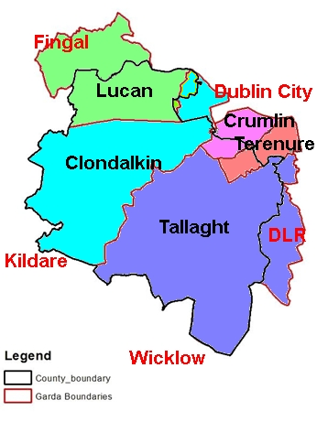

3.1.1 Garda Sub Districts

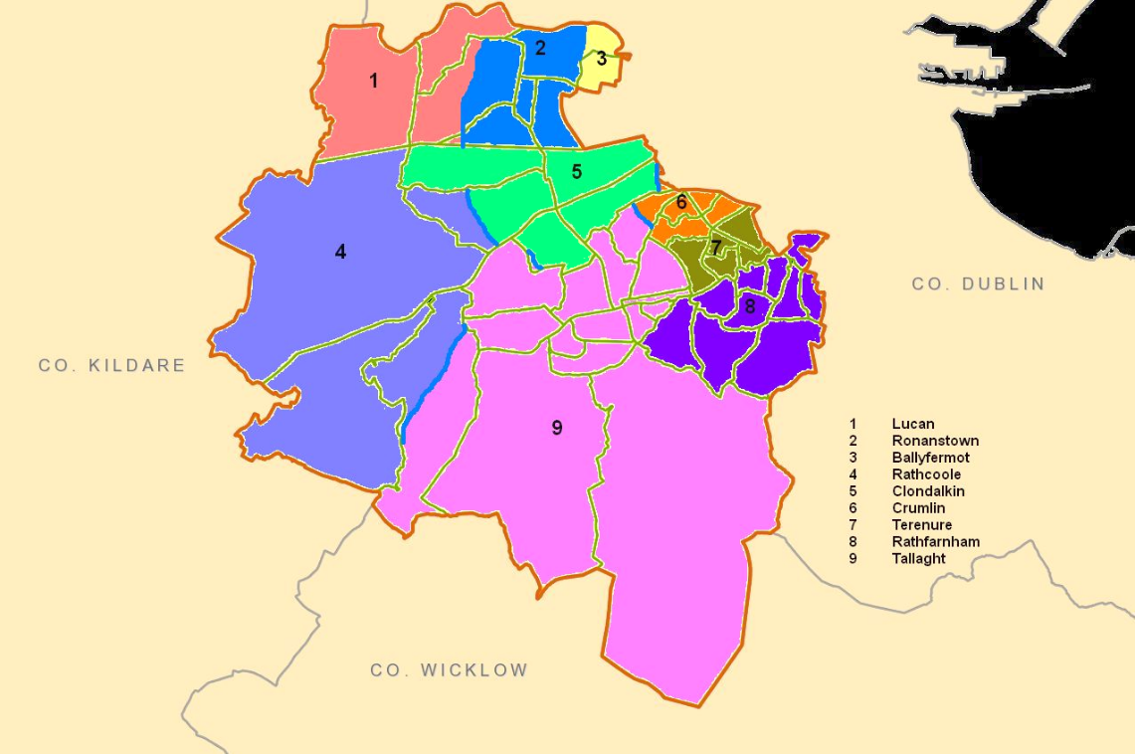

**3.2 Population (2016 Census)**

3.2.1 The 2016 Census statistics for population have been released.

The population of the state has risen from 4,588,252 in 2011 to 4,757976 in 2016 an increase of 169,724 and a 3.7% increase and the population of South Dublin County has risen from 265,205 in 2011 to 278,749 in 2016 an increase of 13,544 and a 5.1% increase

3.2.2 The following table gives an estimate of the change in population relating to Garda sub districts (Note some of the EDs are divided between two sub districts)

|  |  |  |  |  |  |  |
| --- | --- | --- | --- | --- | --- | --- |
| **Garda Sub District** | **Pop 2011** | **Pop 2016** | **Males 2016** | **Females 2016** | **Change 2011-16** | **% Change 2011-16** |
| State | 4,588,252 | 4,757,976 | 2,352,240 | 2,405,736 | 169,724 | 3.7 |
| Leinster | 2,504,814 | 2,630,720 | 1295533 | 1,335,187 | 125,906 | 5 |
|  |  |  |  |  |  |  |
| Ballyfermot | 11,216 | 11,130 | 5,377 | 5,753 | -86 | -1% |
| Clondalkin | 33,882 | 35,556 | 17,526 | 18,030 | 1,674 | 5% |
| Crumlin | 11,089 | 11,197 | 5,338 | 5,859 | 108 | 1% |
| Lucan | 44,487 | 47,800 | 23,628 | 24,172 | 3,313 | 7% |
| Rathcoole | 11,549 | 13,891 | 6,970 | 6,921 | 2,342 | 20% |
| Rathfarnham | 50,959 | 52,263 | 25,270 | 26,993 | 1,304 | 3% |
| Ronanstown | 12,914 | 12,944 | 6,232 | 6,712 | 30 | 0% |
| Tallaght | 75,206 | 80,022 | 39,150 | 40,872 | 4,816 | 6% |
| Terenure | 13,903 | 13,946 | 6,784 | 7,162 | 43 | 0% |
| South Dublin | 265,205 | 278,749 | 136,275 | 142,474 | 13,544 | 5.1% |

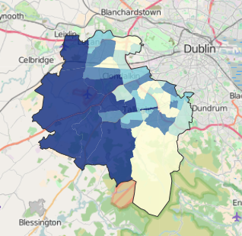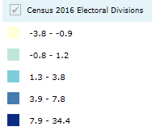

3.2.3 The greatest percentage population increase EDs are as follows:

|  |  |  |
| --- | --- | --- |
| **ED** | **Garda Sub District** | **Percentage Population Change (2011-2016)** |
| 027 Saggart | Rathcoole/Tallaght | 34 |
| 039 Tallaght-Springfield | Tallaght | 21 |
| 001 Ballinascorney | Tallaght | 16 |
| 021 Rathcoole | Rathcoole | 16 |
| 018 Newcastle | Rathcoole | 14 |
| 017 Lucan-St. Helen's | Lucan | 10 |
| 030 Tallaght-Fettercairn | Tallaght | 9 |
| 010 Clondalkin Village | Clondalkin | 8 |
| 015 Lucan-Esker | Lucan/Ronanstown | 8 |

3.2.4 The greatest percentage population decrease EDs are as follows:

|  |  |  |
| --- | --- | --- |
| **ED** | **Garda Sub District** | **Percentage Population Change (2011-2016)** |
| 044 Templeogue-Orwell | Terenure | -4 |
| 034 Tallaght-Kilnamanagh | Tallaght/Crumlin | -3 |
| 041 Templeogue-Cypress | Terenure | -3 |
| 045 Templeogue-Osprey | Terenure | -3 |
| 002 Ballyboden | Rathfarnham | -2 |
| 005 Clondalkin-Cappaghmore | Ronanstown | -2 |
| 013 Firhouse-Knocklyon | Rathfarnham | -2 |
| 049 Terenure-St. James | Crumlin | -2 |
| 003 Bohernabreena | Tallaght | -1 |
| 020 Palmerston West | Ballyfermot/Ronanstown | -1 |

**3.3 Deprivation (2011 Census)**

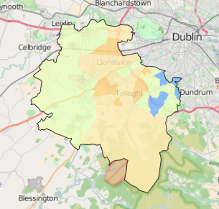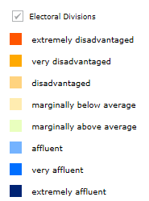

3.3.1 The disadvantaged EDs are as follows:

|  |  |  |
| --- | --- | --- |
| **ED** | **Garda Sub District** | **Relative Deprivation Score (2011)** |
| 005 Clondalkin-Cappaghmore | Ronanstown | -15 |
| 008 Clondalkin-Moorfield | Ronanstown | -11 |
| 009 Clondalkin-Rowlagh | Ronanstown | -17 |
| 028 Tallaght-Avonbeg, | Tallaght | -17 |
| 030 Tallaght-Fettercairn | Tallaght | -14 |
| 033 Tallaght-Killinardan | Tallaght | -19 |
| 037 Tallaght-Millbrook | Tallaght | -11 |
| 040 Tallaght-Tymon | Tallaght | -11 |
| 049 Terenure-St. James | Crumlin | -13 |

3.3.2 The affluent EDs are as follows

|  |  |  |
| --- | --- | --- |
| **ED** | **Garda Sub District** | **Relative Deprivation Score (2011)** |
| 002 Ballyboden | Rathfarnham | 11 |
| 012 Firhouse-Ballycullen | Rathfarnham | 13 |
| 024 Rathfarnham-Hermitage | Rathfarnham | 15 |
| 026 Rathfarnham Village | Rathfarnham | 14 |
| 042 Templeogue-Kimmage Manor | Terenure | 14 |
| 046 Templeogue Village | Terenure | 12 |

**4 JPC Six Year Strategic Plan**

|  |  |  |  |
| --- | --- | --- | --- |
| JPC Six Year Strategic Plan Strategic Objectives (derived from the Local Economic and Community Plan and which the JPC considers that it can add significantly to collective efforts to achieve the objectives)  List these in order of priority with at least three High Priority objectives | Summary of strategy to be pursued in relation to each objective | Lead /agency key partners  Name of JPC subcommittee where relevant | Anticipated outcomes |
| High Priority Objectives (at least 3 of these) |  |  |  |
|  |  |  |  |
|  |  |  |  |
|  |  |  |  |
| Other Objectives |  |  |  |
|  |  |  |  |
| **Potential Objectives** |  |  |  |
| **CCTV** | Community Based CCTV: To support the following Community CCTV schemes:   * Jobstown * Fettercairn * Brookfield * Killinarden * North Clondalkin | * Gardaí * SDCC | Ongoing |
| **Community Safety:**  To promote positive crime prevention and community safety initiatives | **Information:** To develop and produce information on community safety initiatives/projects through the media and the JPC web page of South Dublin County Council web site | * JPC Executive (Supported by SDCC) | Ongoing |
| **Events:** To plan for events attracting large crowds and ensure they are a safe and enjoyable experience. To build on the good working relationship between the Gardaí, South Dublin County Council, the Community and other stakeholders co-ordinating events | * SDCC * Gardaí * Public Transport providers * Local Communities * Local Businesses | Ongoing |
| **Road safety:** To consider elements within the SDCC Road Safety Plan 2016-2020 |  |  |
| **Older People:** Support South Dublin County as an Age Friendly County which is a safe place for older people and continue to work on any safety issues identified by the Age Friendly Alliance. To work with the Network and any other partners on the proposed Text Alert Scheme | * SDCC * Gardaí * Age Friendly Network | Ongoing |
| **Consultation & Involvement:**  To improve the process of engagement and interaction between local community reps. An Garda Síochána, Elected Representatives, South Dublin County Council, Local Drug & Alcohol Task Forces on matters concerning community safety. | **Local Policing Forums:** Support the work of the four local policing fora in the County by:   * Each local policing forums will report to each JPC meeting * Consider recommendations of the Local Policing Forums * Support for public and other meetings organised by the Local Policing Forums | * JPC * LPFs | Ongoing |
| **Young People:** Continue consultation with young people through Comhairle na nÓg and other services. Support the Comhairle na nÓg charter to prevent Cyber Bullying | * Comhairle na Nog * Gardaí * JPC * SDCC | Ongoing |
| **Crime:**  To support actions that address crime and the fear of crime | **Parks:** Deter crime and anti- social behaviour in public parks (See Appendix 4) through the implementation of the recommendations included in “Reclaiming our Parks.” Reports to be prepared for each JPC meeting | * JPC * SDCC * Gardaí | Ongoing |
| **Intimidation:** Support the work of the Intimidation Sub-group of the JPC (See Appendix 3) and develop further the working group and support any recommendations identified | * JPC Intimidation Sub-committee * JPC * Gardaí * SDCC * Local Drug & Alcohol Task Forces | Ongoing |
| **Integration** | **Integration Strategy:** Support the implementation of the South Dublin County Integration Strategy and work on any actions identified that can improve the quality of life and safety of residents in the County | * SDCC * Gardaí * Community | Begin middle 2014 |
| **Pro-social initiatives:**  To provide continued support for Pro-social initiatives in the County and to support inter agency projects | To develop a close liaison between the JPC, its members and inter agency projects in the County, To support pro-social projects by improved coordination between Gardaí, SDCC and Community Representatives | * JPC * Children & Young People’s Services Committee (CYPSC), * Childhood Development Initiative (CDI) Safety Initiative, * Local Partnerships * Community/Voluntary Sector * Local Drug & Alcohol Task Forces * FAI (Football night leagues) | Ongoing |
| **Restorative Justice:** | Support the recommendations contained in the National Commission on Restorative Justice by strengthening relations with the Restorative Justice Service in Tallaght and continue to promote restorative practice in the Community. Consider services which will look at tackling anti-social behaviour using restorative practices. Continue to support the work of Restorative Practice promoters where necessary | * Gardaí * SDCC * Restorative Justice and Practice Programmes * Community Mediation * Community Groups * CDI | Ongoing |

**5 JPC Annual Work Plan Template**

|  |  |  |  |  |
| --- | --- | --- | --- | --- |
| Strategic Objectives  List these in order of priority with at least three High Priority objectives | Origin (Garda Policing Plan, local authority plan, JPC members) | Summary of actions to be taken | Lead person /agency key partners Name of JPC s subcommittee where relevant | Timescale for action |
| High Priority Objectives (at least 3 of these) |  |  |  |  |
|  |  |  |  |  |
|  |  |  |  |  |
|  |  |  |  |  |
| Other Objectives |  |  |  |  |
|  |  |  |  |  |

**Appendices**

**Appendix 1 Links to other Strategic Plans**

**1 An Garda Síochána Annual Policing Plan**

1.1 The An Garda Síochána Annual Policing Plan 2016 sets out the policing commitments of the service for the coming year.

1.2 The Plan encompasses the priorities for An Garda Síochána as determined by the Minister for Justice and Equality under section 20 of the Garda Síochána Act 2005. The Minister has determined the following matters as priorities for An Garda Síochána for 2016:

* **Security:** To protect the State and the people against terrorism in all its forms.
* **Tackling Crime:** To combat serious and violent crime in all its forms, in particular organised and cross-border crime including human trafficking, as well as burglary, drug related crime, white collar crime and crimes against businesses and agriculture.
* **Policing Communities:** To provide a visible, mobile and responsive policing service which meets the needs of both rural and urban communities.
* **Public Safety:** To provide effective policing that ensures the public safety of our town and city centres, supports a safe and vibrant night-time economy, and tackles anti-social behaviour.
* **Supporting Victims of Crime:** To support the needs of victims of crime in a manner which treats them with dignity and keeps them informed about the progress of cases relevant to them; and to generally support measures aimed at implementing the EU Directive on Victims’ Rights and the Criminal Justice (Rights of Victims) legislation.
* **Reduce Re-Offending:** To support a targeted, inter-agency approach to reduce recidivism; tackle serial offenders; including continued development of the Diversion Programme for young offenders.
* **Roads Policing:** To reduce the number of deaths and serious injuries on our roads arising from collisions and from pedestrians failing to take appropriate care and to continue to implement the recommendations of the Garda Inspectorate Report on the Fixed Charge Processing System.
* **Domestic and Sexual Violence:** To vigorously work to prevent domestic, sexual and gender-based violence, and to effectively tackle such violence when it occurs; with a view to ensuring timely responses in all cases.
* **Innovation and Efficiency:** To continue to maximise the efficient and effective use of personnel and other resources; to oversee the implementation of reforms and the development of new ICT systems taking into account the recommendations of the Garda Inspectorate and to adhere, in so far as is possible, to budgetary targets across the organisation.
* **Justice Reform:** To implement the policing and security elements of the Government Justice Reform Programme including support for the work of the new Independent Policing Authority.

1.3 The priorities relating to tackling crime, policing communities, public safety, reduce re-offending and roads policing are reflected in the JPC’s Strategic Plan.

1.4 The An Garda Síochána Annual Policing Plan sets out its priorities for 2016 which are:

1. **National Security & intelligence:** protect our national interest, mitigate the threat posed by terrorism and contribute to international security
2. **National Policing:** deliver a policing service focused on crime prevention, victim orientation and professional investigations
3. **Community Safety:** improve public safety through enhanced community engagement and high visibility roads policing
4. **Cross Organisation Services:** deliver a professional policing and security service using resources effectively and efficiently

1.5 A number of objectives and initiatives within the Plan would be reflected in the JPC’s Strategic Plan including:

2.1. Tackle serious and violent crime in all its forms

2.2. Focus on the prevention and detection of crime in our communities

* Build upon our national anti-crime strategies including Operation Thor.

2.6. Inter-agency offender management systems to tackle repeat offenders

* Work in partnership to tackle repeat offenders including continued development of our Juvenile Diversion Programme.

3.1. Collaborate more closely with our communities to address crime, public safety and the fear of crime

* Maximise the use of local policing fora and Joint Policing Committees.
* Continue to reach out to, engage with and develop positive collaborative partnerships with diverse, vulnerable and hard to reach groups in the community.

3.2 Provide greater Garda visibility and create better opportunities to proactively prevent crime and offending in our communities

* Promote high visibility policing
* Continue to tackle public disorder and antisocial behaviour
* Target the illegal consumption of alcohol in public places.

**2 South Dublin County Local Economic & Community Plan (LECP) 2016-2021**

2.1 Under the Local Government Reform Act (2014) each local authority is required to establish a Local Community Development Committee (LCDC) and that each LCDC produce a 6 year Local Economic and Community Plan (LECP) in partnership with the Economic Development Strategic Policy Committee. The LECP was approved by both partner committees on the 22nd October 2015.

2.2 The LECP has 14 goals:

1. Maintain and develop existing enterprise to support and improve the economic infrastructure of South Dublin County
2. Transform older industrial areas into high quality centres for enterprise
3. Strengthen the economic fabric of our towns and villages
4. Develop new and existing enterprises with significant employment, capital, income or growth potential
5. Improve the quality and diversity of employment in the County
6. Actively engage with other Authorities and Agencies in the continued economic development of the Dublin region.
7. Develop micro enterprise, community economic development and start-ups.
8. Empower our communities to improve their health and wellbeing and quality of life by providing relevant information and accessibility to quality services
9. Protect and enhance our environment by providing information that is accessible to all and applying the principles of sustainable development
10. Reduce poverty, social exclusion and disadvantage, and improve levels of income for disadvantaged communities, including children and families
11. Continue to improve opportunities for our people to participate in life-long learning opportunities
12. Develop and empower our local workforce through improving skills and increasing the accessibility of further educational opportunities
13. Support our communities to influence decisions that matter in their areas and lives and
14. Strengthen connections, cooperation and coordination between service providers and between service providers and communities

2.3 Within each goal there are a number of objectives and actions, some of these would be reflected in the JPC’s Strategic Plan including:

8.2 Ensure high quality services are provided by increasing cooperation and collaboration

* Develop an agreed protocol for engagement between the LCDC and existing interagency committees and collaborative groups
* Continue to support projects which demonstrate collaboration and cooperation
  1. Develop new methods of enabling service providers to share information, develop collaborative relationships and improve cooperation
* Explore the development of a protocol for engagement for all LECP collaborators

**3 Clondalkin Drug and Alcohol Task Force Plan**

3.1 Clondalkin Drug & Alcohol Task Force has a Strategic Plan for the period 2009-2016. The strategy in the Plan has a number of programmes, objectives and goals some of the goals would be reflected in the JPC Strategic Plan including:

Programme 1: Strategy for operational and organisational development

Objective 2: Continue to work effectively and in collaboration with all key stakeholders

* + Develop frameworks and protocols with statutory and other agencies for effective collaboration and interagency working

Programme 2: Prevention

Programme 3: Treatment & rehabilitation: Continuum of Care

Programme 4 Supply reduction

Objective 1: To create opportunities for safe dialogue between the community and the Gardaí to explore options to address drug related crime

* + To work in partnership with key agencies including the Gardaí to reduce the level of drug dealing in the area
  + To create a safe environment to discuss ways of addressing drug supply and control issues
  + To identify barriers and solutions to addressing drug related crime in order to inform national policy
  + To highlight the links between local drug economics, underage crime and social exclusion

**4 Tallaght Drug and Alcohol Task Force Plan**

4.1

**5 A Safer Community: South Dublin County Council Road Safety Plan 2016-2020**

5.1 The Road Safety Plan 2016- 2020 identifies the key stakeholders for implementing the Plan as:

* South Dublin County Council
* Transport Infrastructure Ireland
* Road Safety Authority
* An Garda Síochána
* Dublin Fire Brigade
* National Transport Authority

5.2 The Plan is based on the four E’s of road safety:

* Education
* Engineering
* Enforcement
* Evaluation

**Appendix 2**

**Demographics**

|  |  |  |  |  |  |  |  |
| --- | --- | --- | --- | --- | --- | --- | --- |
| ED | Garda Sub District | Pop 2011 | Pop 2016 | Males 2016 | Females 2016 | Change 2011-16 | % change 2011-16 |
|  |  |  |  |  |  |  |  |
| State |  | 4588252 | 4757976 | 2352240 | 2405736 | 169724 | 3.7 |
| Leinster |  | 2504814 | 2630720 | 1295533 | 1335187 | 125906 | 5 |
|  |  |  |  |  |  |  |  |
| 019 Palmerston Village | Ballyfermot | 3623 | 3638 | 1735 | 1903 | 15 | 0.4 |
| 020 Palmerston West | Ballyfermot/Ronanstown | 7593 | 7492 | 3642 | 3850 | -101 | -1.3 |
| 004 Clondalkin-Ballymount | Clondalkin | 1915 | 2036 | 1032 | 1004 | 121 | 6.3 |
| 006 Clondalkin-Dunawley | Clondalkin | 10877 | 11358 | 5488 | 5870 | 481 | 4.4 |
| 007 Clondalkin-Monastery | Clondalkin | 10904 | 11322 | 5605 | 5717 | 418 | 3.8 |
| 010 Clondalkin Village | Clondalkin | 8492 | 9153 | 4528 | 4625 | 661 | 7.8 |
| 029 Tallaght-Belgard | Clondalkin | 1694 | 1687 | 873 | 814 | -7 | -0.4 |
| 043 Templeogue-Limekiln | Crumlin | 3501 | 3542 | 1716 | 1826 | 41 | 1.2 |
| 047 Terenure-Cherryfield | Crumlin | 2174 | 2157 | 1036 | 1121 | -17 | -0.8 |
| 048 Terenure-Greentrees | Crumlin | 2791 | 2927 | 1359 | 1568 | 136 | 4.9 |
| 049 Terenure-St. James | Crumlin | 2623 | 2571 | 1227 | 1344 | -52 | -2 |
| 016 Lucan Heights | Lucan | 5217 | 5294 | 2582 | 2712 | 77 | 1.5 |
| 017 Lucan-St. Helen's | Lucan | 9450 | 10372 | 5145 | 5227 | 922 | 9.8 |
| 015 Lucan-Esker | Lucan/Ronanstown | 29820 | 32134 | 15901 | 16233 | 2314 | 7.8 |
| 018 Newcastle | Rathcoole | 3749 | 4258 | 2145 | 2113 | 509 | 13.6 |
| 021 Rathcoole | Rathcoole | 4740 | 5520 | 2790 | 2730 | 780 | 16.5 |
| 027 Saggart | Rathcoole/Tallaght | 3060 | 4113 | 2035 | 2078 | 1053 | 34.4 |
| 002 Ballyboden | Rathfarnham | 5085 | 4959 | 2384 | 2575 | -126 | -2.5 |
| 011 Edmondstown | Rathfarnham | 5712 | 5764 | 2833 | 2931 | 52 | 0.9 |
| 012 Firhouse-Ballycullen | Rathfarnham | 7773 | 8280 | 4078 | 4202 | 507 | 6.5 |
| 013 Firhouse-Knocklyon | Rathfarnham | 3602 | 3514 | 1719 | 1795 | -88 | -2.4 |
| 014 Firhouse Village | Rathfarnham | 11648 | 12199 | 5930 | 6269 | 551 | 4.7 |
| 022 Rathfarnham-Ballyroan | Rathfarnham | 2493 | 2678 | 1275 | 1403 | 185 | 7.4 |
| 023 Rathfarnham-Butterfield | Rathfarnham | 3206 | 3296 | 1547 | 1749 | 90 | 2.8 |
| 024 Rathfarnham-Hermitage | Rathfarnham | 4604 | 4610 | 2207 | 2403 | 6 | 0.1 |
| 025 Rathfarnham-St. Enda's | Rathfarnham | 3843 | 3865 | 1845 | 2020 | 22 | 0.6 |
| 026 Rathfarnham Village | Rathfarnham | 2993 | 3098 | 1452 | 1646 | 105 | 3.5 |
| 005 Clondalkin-Cappaghmore | Ronanstown | 2605 | 2558 | 1195 | 1363 | -47 | -1.8 |
| 008 Clondalkin-Moorfield | Ronanstown | 6251 | 6313 | 3080 | 3233 | 62 | 1 |
| 009 Clondalkin-Rowlagh | Ronanstown | 4058 | 4073 | 1957 | 2116 | 15 | 0.4 |
| 001 Ballinascorney | Tallaght | 804 | 931 | 493 | 438 | 127 | 15.8 |
| 003 Bohernabreena | Tallaght | 4592 | 4552 | 2263 | 2289 | -40 | -0.9 |
| 028 Tallaght-Avonbeg, | Tallaght | 1613 | 1643 | 787 | 856 | 30 | 1.9 |
| 030 Tallaght-Fettercairn | Tallaght | 7607 | 8318 | 3977 | 4341 | 711 | 9.3 |
| 031 Tallaght-Glenview | Tallaght | 1723 | 1929 | 975 | 954 | 206 | 12 |
| 032 Tallaght-Jobstown | Tallaght | 16630 | 17788 | 8585 | 9203 | 1158 | 7 |
| 033 Tallaght-Killinardan | Tallaght | 3915 | 3987 | 1935 | 2052 | 72 | 1.8 |
| 035 Tallaght-Kiltipper | Tallaght | 8068 | 8562 | 4136 | 4426 | 494 | 6.1 |
| 036 Tallaght-Kingswood | Tallaght | 3974 | 4060 | 1985 | 2075 | 86 | 2.2 |
| 037 Tallaght-Millbrook | Tallaght | 3290 | 3297 | 1585 | 1712 | 7 | 0.2 |
| 038 Tallaght-Oldbawn | Tallaght | 4527 | 4595 | 2316 | 2279 | 68 | 1.5 |
| 039 Tallaght-Springfield | Tallaght | 9123 | 11068 | 5514 | 5554 | 1945 | 21.3 |
| 040 Tallaght-Tymon | Tallaght | 4888 | 4967 | 2407 | 2560 | 79 | 1.6 |
| 034 Tallaght-Kilnamanagh | Tallaght/Crumlin | 4452 | 4325 | 2192 | 2133 | -127 | -2.9 |
| 041 Templeogue-Cypress | Terenure | 2800 | 2717 | 1309 | 1408 | -83 | -3 |
| 042 Templeogue-Kimmage Manor | Terenure | 4637 | 4844 | 2374 | 2470 | 207 | 4.5 |
| 044 Templeogue-Orwell | Terenure | 2138 | 2056 | 1019 | 1037 | -82 | -3.8 |
| 045 Templeogue-Osprey | Terenure | 2334 | 2262 | 1099 | 1163 | -72 | -3.1 |
| 046 Templeogue Village | Terenure | 1994 | 2067 | 983 | 1084 | 73 | 3.7 |
| South Dublin |  | 265205 | 278749 | 136275 | 142474 | 13544 | 5.1 |

**Appendix 3**

**Intimidation Sub Committee**

**1 Intimidation Sub-committee**

1.1 The Intimidation sub-committee was formed in 2011 as a sub-committee of the JPC to look at intimidation of families in this county and report back to the Joint Policing Committee. The JPC agreed that it should keep meeting and its work is named in the annual JPC Workplans as “Support the work of the Intimidation Sub-group of the JPC to develop further the working group and support any recommendations identified.”

1.2 **Membership:**

* JPC Community Members (Anne Corrigan PPN, Tara Deasy PPN)
* JPC Elected Members (Cllr Cathal King)
* Clondalkin Drug Task Force (Sandra Mullen/Rosie McGlone)
* Tallaght Drug Task Force (Grace Hill)
* South Dublin County Council (Andy Lane)
* An Garda Síochána (Inspectors Ray Blake & Patrick O’Sullivan)

1.3 **Terms of Reference:**

1. That the JPC Intimidation Working Group consider how best to deal with intimidation and put in place measures that will reduce intimidation and its effect on local people in their own communities.
2. The role of the JPC Intimidation Working Group will be to develop alternative innovative methods that will support a cohesive approach when addressing intimidation.
3. This should be done through measurable actions with clear performance indicators.

**1.4 Current Work**

1.4.1 **Training:** Joint intimidation training (Drug Related Intimidation Reporting) facilitated by the Family Support Network.

1.4.2 **Seminar:** A follow up seminar was held in May 2016 at this seminar a number of suggestions were made including:

* The need for “mini CABs” to address the wealth generated by drug suppliers
* That the impact of poverty and unemployment within disadvantaged and Traveller communities is linked to the problem of drug misuse and then drug related intimidation
* That the impact of intimidation on people’s mental health be recognised and that GPs have a role to play here
* That there is a need to address the “normalisation” of drugs where recreational drug use has a huge impact on communities
* That mothers/women are often the victims of intimidation and that drug related intimidation has similarities to the impact of domestic violence

**Appendix 4**

**Parks Sub Committee**

**1 Parks Sub-committee**

* 1. The Joint Policing Committee established the Parks Working Group in November 2009 under Priority Area 3 of the Annual Work Programme. The purpose of the group was to review the causes and effects of antisocial behaviour in public parks and open spaces and to bring forward proposals to deter crime and anti-social behaviour.
  2. The Working Group presented their report “Reclaiming our Parks” (which listed 52 actions) to the Joint Policing Committee on the 10th September 2010. The report was based around three themes:

1. Policing our Parks- how to enhance the policing of our parks and enforcement of laws and bye-laws
2. Managing our Parks- how to reduce opportunities for anti-social behaviour
3. Activating our Parks- how to increase positive use of our parks
   1. The Parks Working Group in 2010 comprised

* Councillor William Lavelle (Chairman)
* Michael Hannon, Senior Executive Parks Superintendent
* Michelle Kearns, The Dolcain Project,
* Inspector Mel Smyth, Clondalkin Garda Station
* Inspector Raymond Blake, Tallaght Garda Station
  1. South Dublin County Council Bye Laws for Parks and Open Spaces 2011 came into force on the 1st August 2011
  2. In May 2016 it was agreed to discontinue with the Sub-committee but to monitor progress on the 52 actions regularly at the JPC.