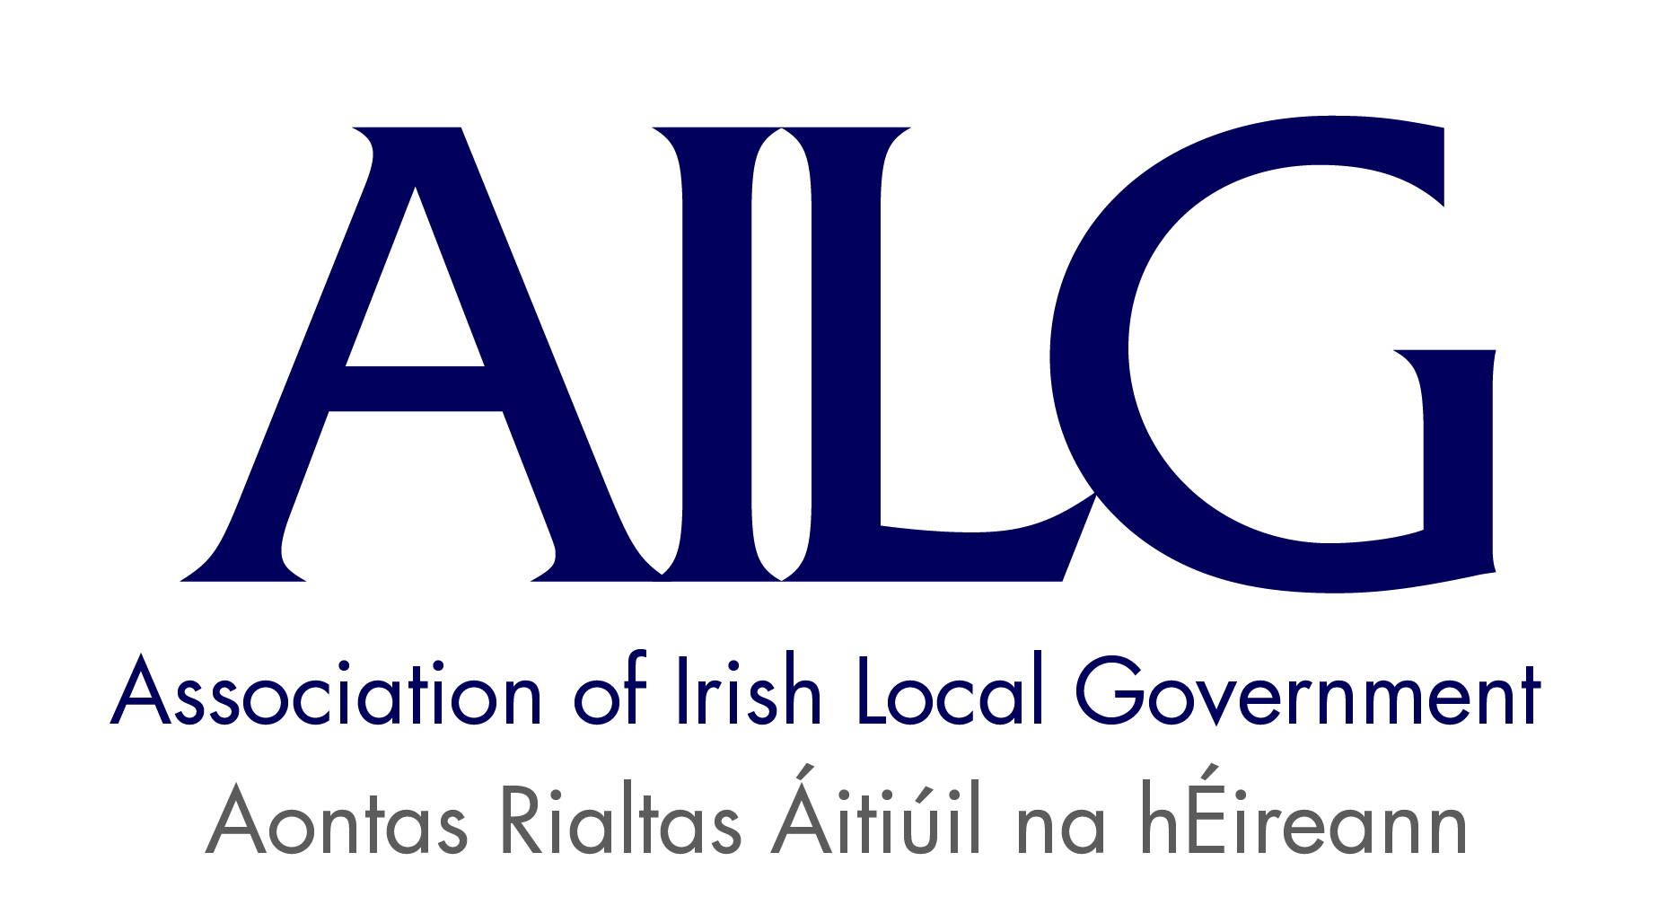
Induction Training for Co-opted Elected Members
14th July 2016, Moran’s Red Cow Hotel, Dublin
Training Day Programme
9:30am – 10:00am | Registration & Tea/Coffee
10:00am – 10.15am | Introduction & Welcome  Speaker: Cllr. John Crowe, President AILG  Overview including context for Co-opted Members.  Speaker: Liam Kenny, Director AILG
10:15am – 10:50am | Councillors & Committees  Speaker: Constance Hanniffy, Former Elected Member Offaly County Council and member of National Oversight & Audit Committee (NOAC)
10:50am – 11:15am | Role of the Elected Member – Formal & Informal  Speaker: Cllr. Dermot Lacey, Dublin City Council & Executive Member AILG
11:15am – 11:30am | Questions & Answers
11:30am – 11:45am | Tea & Coffee
11.45am – 12:15pm | Local Authority Finance and Budgeting & the New Councillor  Speaker: Cllr. Pat Fitzpatrick, Kilkenny Co. Co. & Executive Member AILG
12.15pm – 12.30pm | Briefing on Elected Member Financial Terms and other Supports  Speaker: Tom Moylan, Co-Director AILG
12.30pm – 1.00pm | Questions & Answers
1.00pm – 1.15pm | Local Government – Issues to 2019 including briefing AILG Member Training  Speaker: Liam Kenny, Director AILG
1:15pm | Close & Lunch

