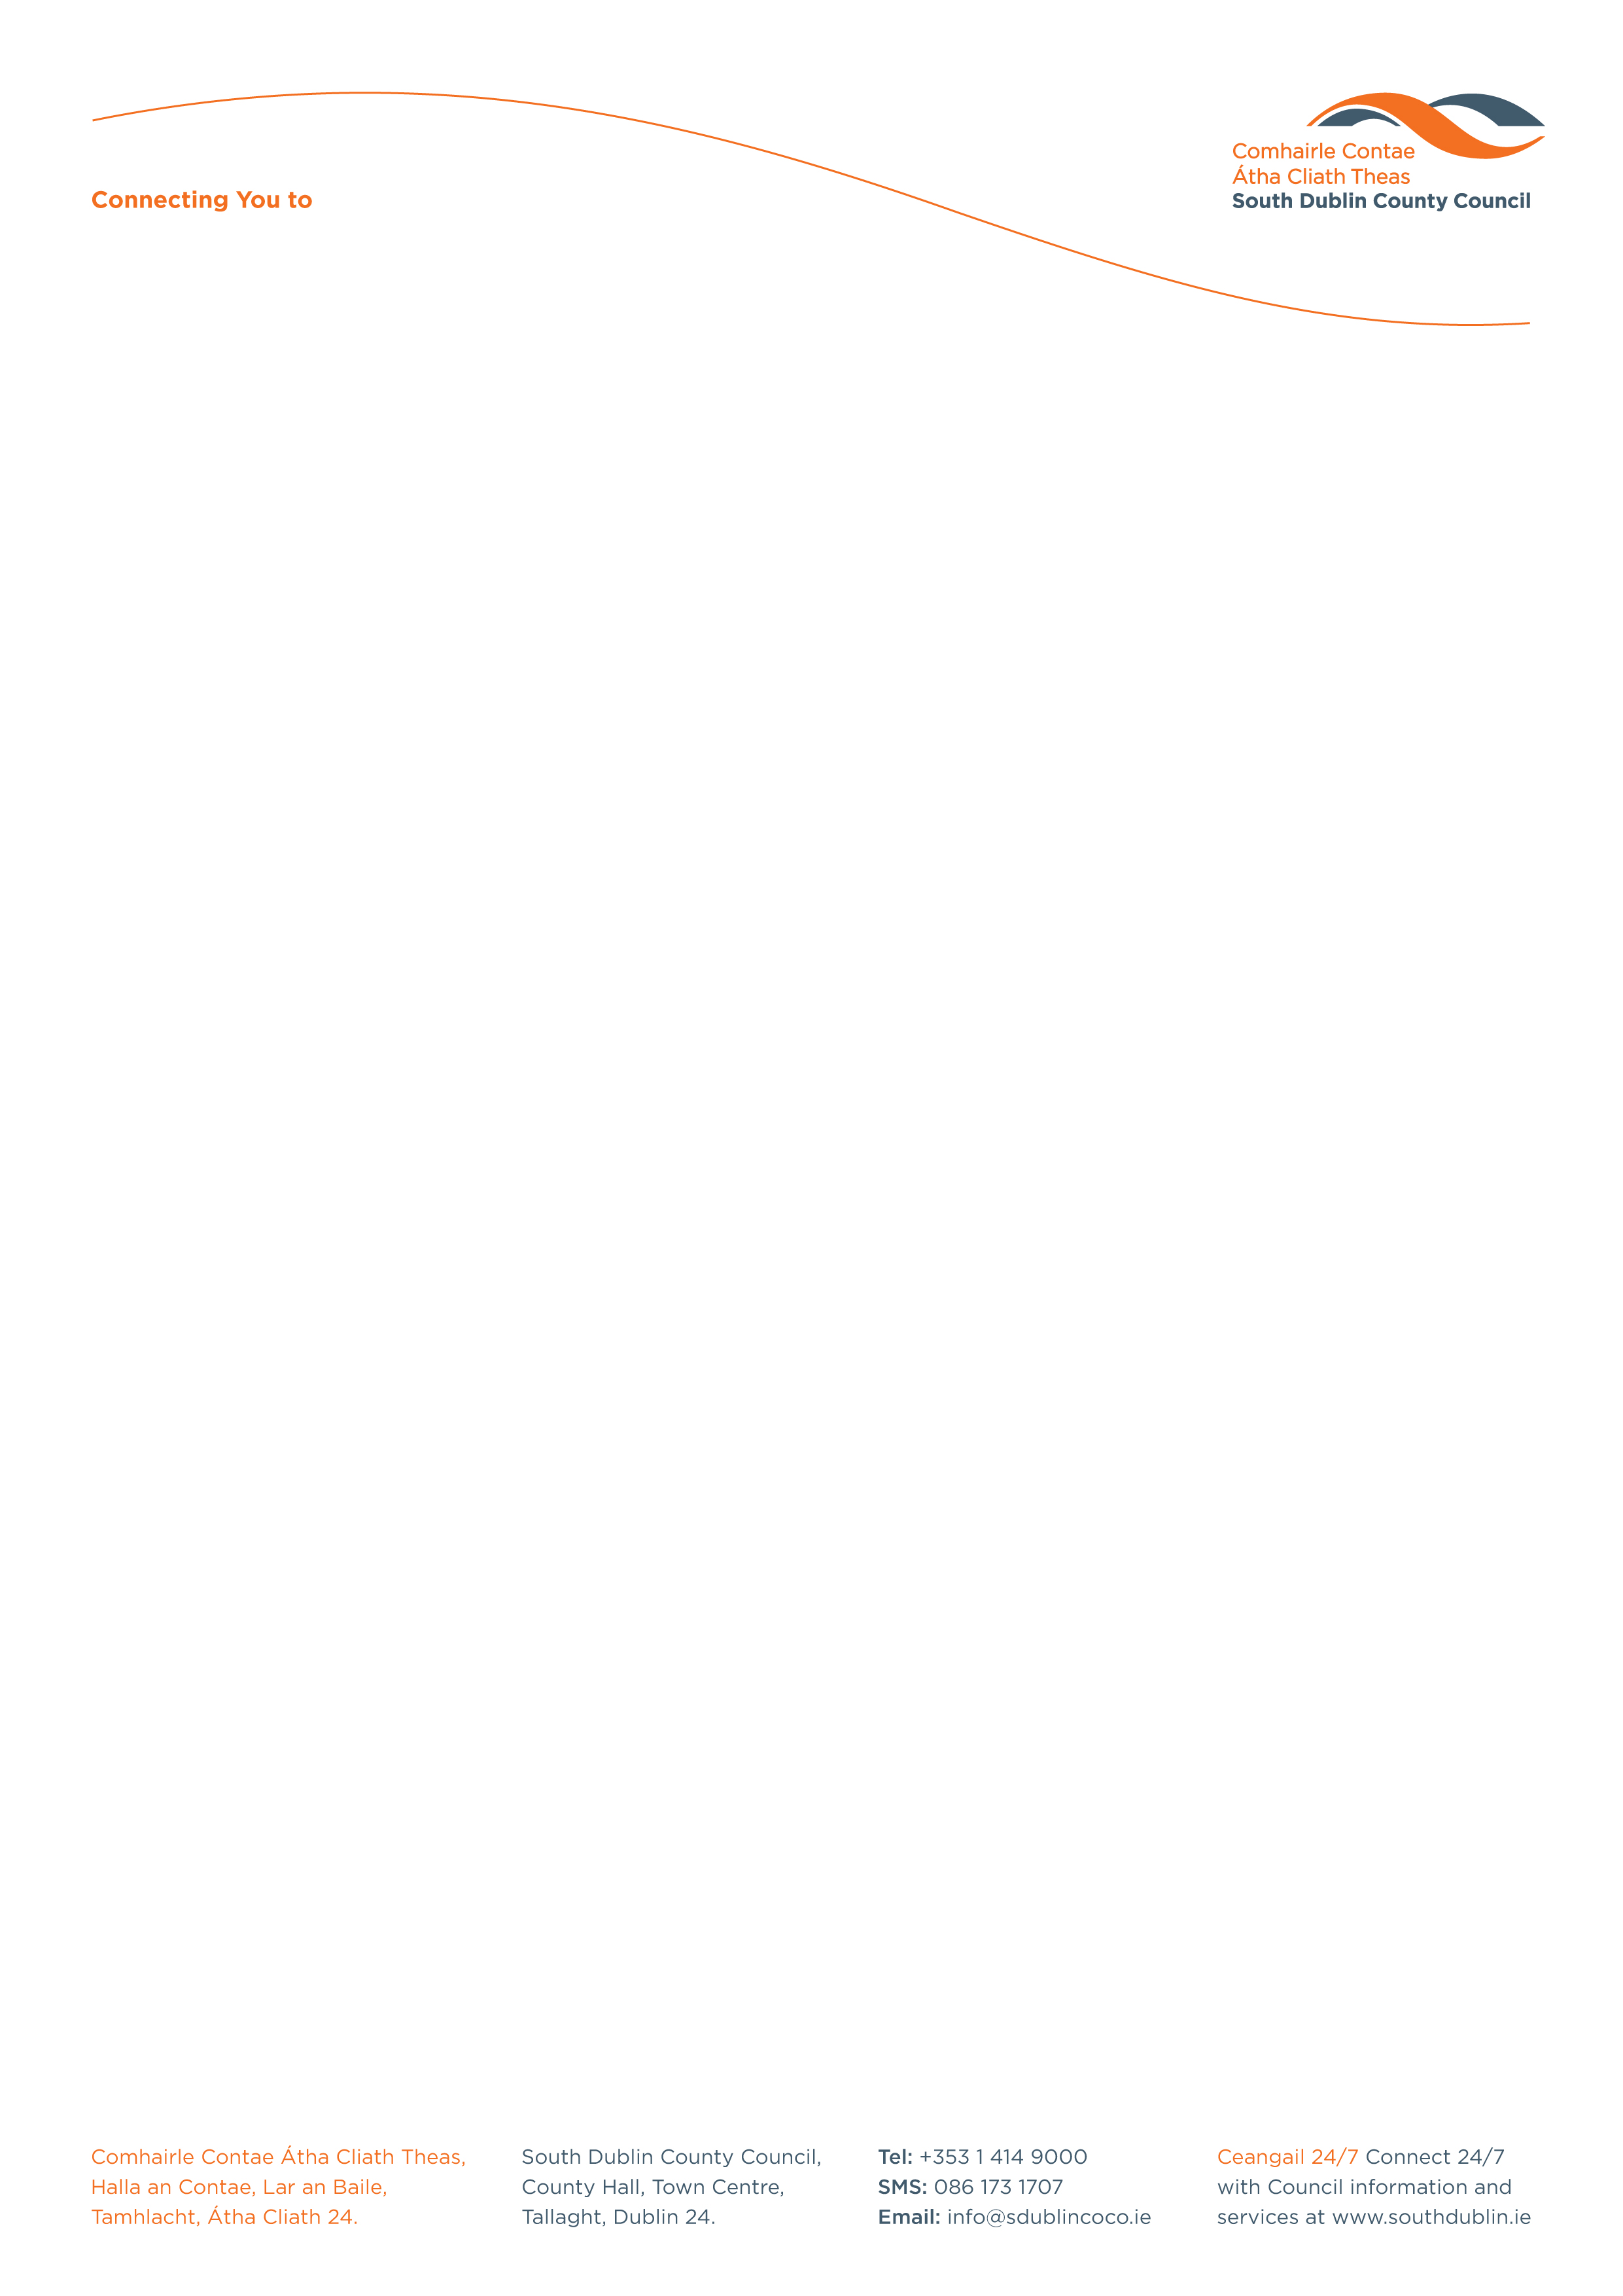

Halla an Chontae, Lár an Bhaile County Hall, Town Centre
Tamhlacht, Baile Átha Cliath 24 Tallaght, Dublin 24
Telefon: 01-4149052 Telephone: 01-4149052

Facs: 01-4149332 Fax: 01-4149042
www.southdublin.ie

John Lahart T.D.
Leinster House,
Kildare Street,
Dublin 2.
1st June, 2016

RE: Tallaght Area Committee Meeting – 23rd May, 2016

Dear Deputy Lahart,

At South Dublin County Council’s Tallaght Area Committee Meeting, held on 23rd May, 2016, the following Motion was passed:
“That this Tallaght Area Committee seeks the support of the 5 local TD’s to review the policing arrangements for Tallaght, Dublin 24 given that our major population centre has suffered much crime in recent times and asking them to confirm plans to allocate additional manpower, vehicles and resources to the station and also when the long promised re-development of the current Garda station will be undertaken.”
I should be obliged if you would let me have a reply on this matter at your earliest convenience.

Thanking you in anticipation,

Yours sincerely,

__________________
Amanda Mills,
A/ Senior Staff Officer,
Housing Administration.

Housing Administration

