COMHAIRLE CHONTAE ÁTHA CLIATH THEAS

SOUTH DUBLIN COUNTY COUNCIL



MEETING OF TERENURE/RATHFARNHAM AREA COMMITTEE (2)

TUESDAY 10TH JANUARY 2006

Question No. 5

Aranleigh

QUESTION: Councillor C. Keane

"To ask the Manager for a map showing the exact location of the proposed new pathway along the desire line at Aranleigh and to state when it is expected that this pathway will be constructed?"

REPLY:

A desire line exists across the open space at Aranleigh between Grange Downs and Stonepark Abbey as indicated by the red line on the attached illustration.

A sum of €10,000 has been allocated under the 2006 Parks Works Programme to construct a pedestrian pathway along this desire line. It is expected to commence this work in late spring/early summer when ground conditions are favourable.

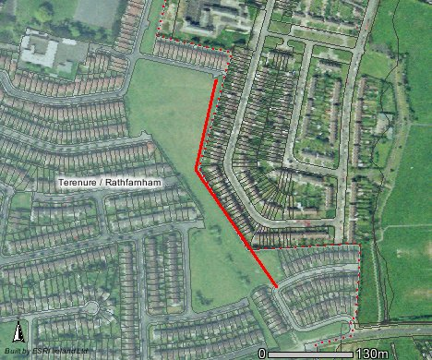
Grange Downs
Stonepark Abbey

