COMHAIRLE CHONTAE ATHA CLIATH THEAS

SOUTH DUBLIN COUNTY COUNCIL

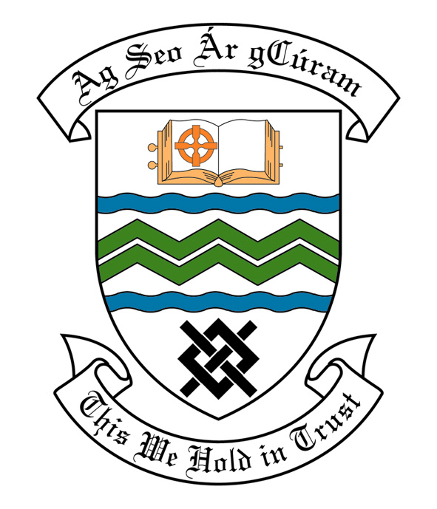

MEETING OF SOUTH DUBLIN COUNTY COUNCIL

MONDAY 9TH JANUARY, 2006

MEETING OF THE LUCAN/ CLONDALKIN AREA COMMITTEE(2)

Tuesday 19th December, 2005

HEADED ITEM NO 2(f)

Application for Grants

Application for grants under the Council’s Community Grants Scheme have been received from the organisations listed below. Payment of these grants to these organisations, in accordance with the conditions of the scheme, in the amounts set out hereunder, is recommended for approval:-

Ref: | Group | Type of Application | Date of Application | Amount
SCRA 1542/ GF 1367 | Bawnogue Youth & Community Centre,  Bawnogue Community Centre,  Clondalkin, Dublin 22. | Community Centre IT Based Infrastructure towards the purchase of Computers. | 30/11/2005 | €5,000

A Contribution is being made to the following :

Ref: | Name | Type of Application | Date of Application | Amount
 | Bawnogue Youth & Family Support Group,  Unit 11 Bawnogue | Contribution towards a Christmas Party | 02/12/05 | €100

It was proposed by Councillor F. Mc Carthy, seconded by Councillor D. Keating and RESOLVED:

“That this Committee recommends that South Dublin County Council APPROVE payment of the above grants as recommended in the foregoing report.”

