COMHAIRLE CHONTAE ATHA CLIATH THEAS

SOUTH DUBLIN COUNTY COUNCIL
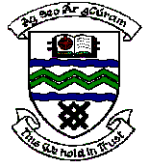

MEETING OF SOUTH DUBLIN COUNTY COUNCIL

MONDAY 9TH JANUARY, 2006

MEETING OF TALLAGHT AREA COMMITTEE MEETING (1)

Wednesday, 7th December, 2005

Headed Item No: (2) (c)

A Contribution is being made to the following group:

Group | Type of Application | Amount
Juvenile Liaison Officer,  An Garda Síochána,  Tallaght Garda Station,  Tallaght,  Dublin 24. | Contribution towards the cost of organising Christmas Parties in National Schools in disadvantage areas within Tallaght Station District. | €1,500

It was proposed by Councillor E. Maloney, seconded by Councillor J. Hannon and RESOLVED:

“That this Committee recommends that South Dublin County Council approve payment of the above grant recommended in the foregoing report”.

