COMHAIRLE CHONTAE ATHA CLIATH THEAS
SOUTH DUBLIN COUNTY COUNCIL

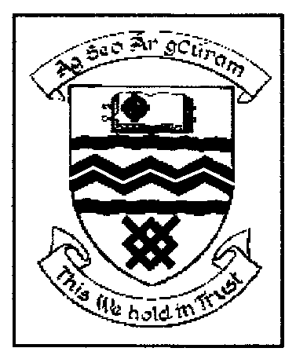

MEETING OF SOUTH DUBLIN COUNTY COUNCIL

MONDAY 9th January 2006

QUESTION NO. 10.

QUESTION: Councillor F. McCarthy

“To ask the Manager to make a statement on what steps are being taken by the Council to ensure that the recently announced plans for Metro and Luas within the county will be facilitated in relation to the County Development Plan?”

REPLY:

The Council proposes to have discussions as soon as possible with the Department of Transport in relation to the proposals listed in Transport 21 as they affect this County.

It is envisaged that following these discussions consideration can be given to determining the extent and nature of variations that will be necessary to the County Development Plan.

