Tallaght
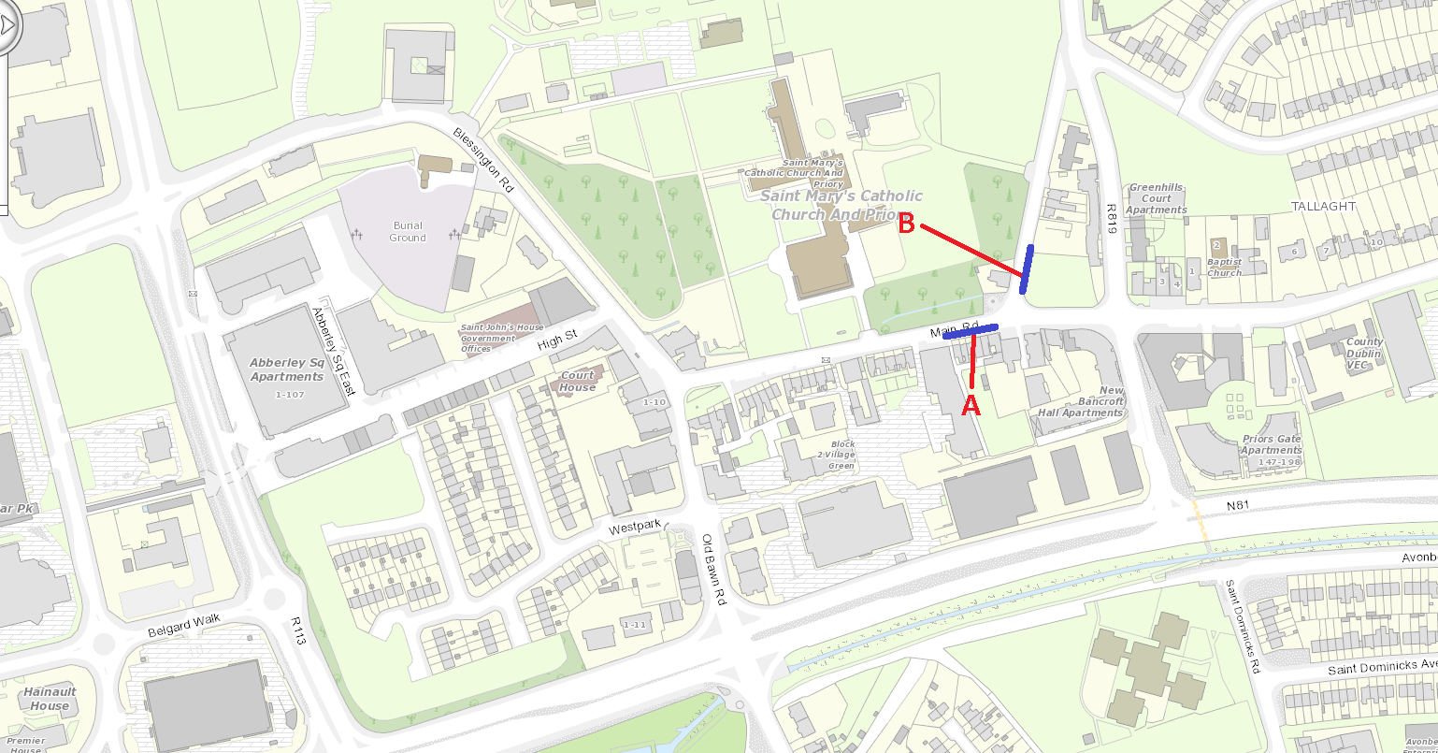
Proposed Location | Road Name | Street type | Day / night/ 24hr
A | Main Street | Restaurant Shops Bank Pubs | 24hr
B | Old Greenhills Road | Restaurant Shops Bank Pubs | Night

