SIGN W 142

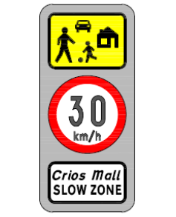

Slow Zone sign

