COMHAIRLE CONTAE ÁTHA CLIATH THEAS  
SOUTH DUBLIN COUNTY COUNCIL



MEETING OF LUCAN AREA COMMITTEE

Tuesday, November 24, 2015

HEADED ITEM NO. 18

In January 2015 a [report](http://intranet/cmas/documents/Lucan%20Area%20Committee/2015/January/LucanAreaCommitteeMeeting27thJanuary2015/42273_M2%2042273%20Christmas%20Tree%20Recycling.doc) was presented to the Lucan Area Committee Meeting on the 2015 Christmas tree recycling programme with specific emphasis on the collection site at Beech Park. This report provides the background to the existing recycling programme, the reason behind the location of the Beechpark site and the various options that are available for the future use of this site.

The Council provides a Christmas tree recycling service which generally runs from the 6th of January each year for a period of 10 days. There were 6 official locations in the Lucan/Palmerstown area in 2015 where trees could be left. These locations were as follows:

1. Beechpark Open Space
2. Sarsfield Park Open space
3. Haydens Lane Car Park in Griffeen Valley Park
4. Foxborough Park Open space
5. Glenaulin Park
6. Woodfarm Acres

The locations chosen provide a convenient area where residents can safely stop in their cars and dispose of their tree. This distribution of locations is primarily geographically based to ensure maximum uptake on recycling facilities.

In 2015 the Beechpark site was the second busiest site in the area and account for 26% of all trees recycled. Haydens Lane was the busiest with 30%. Despite the fact that the recycling facility is provided at no additional cost to the user, individuals still abuse it by burning trees. On average there are 2 fires each year at the Beech Park site. Fires are unfortunately are not limited to this site and all other sites have suffered from fires in the past with the exception of Sarsfield Park. There are a number of options available for this site and these are listed below.

1. Continue to use the site with no change.
2. Continue to use this site but relocate the collection point within the site.
3. Continue to use the site and hire security personnel to prevent fires.
4. Discontinue using this site.
5. Identify a suitable alternative site in the area.

**1. Continue to use the site with no change**

Will not resolve the problem as fires are likely to continue.

**2. Continue to use this site but relocate the collection point within the site**

The Beech Park side of the open space is the most accessible by cars to drop off trees. The collection area on the open space is the flattest area available. There is no other location with similar attributes.

**3. Continue to use the site and hire security personnel to prevent fires.**

On a pilot basis security could be hired to patrol the area from 17:00 to 01:00 on Friday, Saturday and Sunday evenings to prevent fires. The cost of hiring security is likely to be in the region of €250 per night.

**4. Discontinue using this site.**

Erect signage to direct users to alternative recycling locations. High probability that the site will still continue to be used. 11% of trees collected in 2015 were on unofficial sites at Hillcrest and Weston estates. Residents only stopped dumping trees at the unauthorised site at Esker Depot in 2015 when the Department of Education constructed a school on the site during 2014.

**5. Identify a suitable alternative site in the area.** The most suitable alternative site is at Esker Lawns. The recycling location will be set back from the roadside centrally within the open space and enclosed by a sheep wire fence for the duration of the programme. However the high probability that the Beech Park site will be used still exists. See map below for location of alternative site.

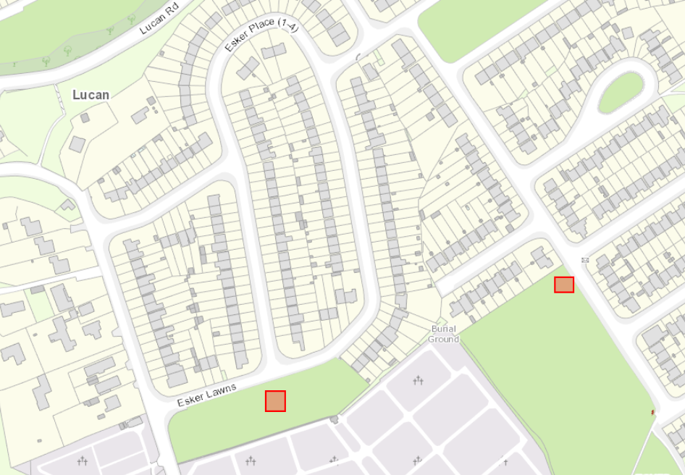

Existing Site

Proposed Site

The recommendation of the report is that option 3 should be pursued. That is to continue to use the site and hire security personnel to prevent fires. Subject to the members approval, arrangements will be made to implement this option on a pilot basis for the 2016 Christmas Tree Recycling Programme.