COMHAIRLE CONTAE ÁTHA CLIATH THEAS  
SOUTH DUBLIN COUNTY COUNCIL



MEETING OF TALLAGHT AREA COMMITTEE

Monday, November 23, 2015

HEADED ITEM NO. 14

**Gaelic Pitch for Scoil Aonghusa**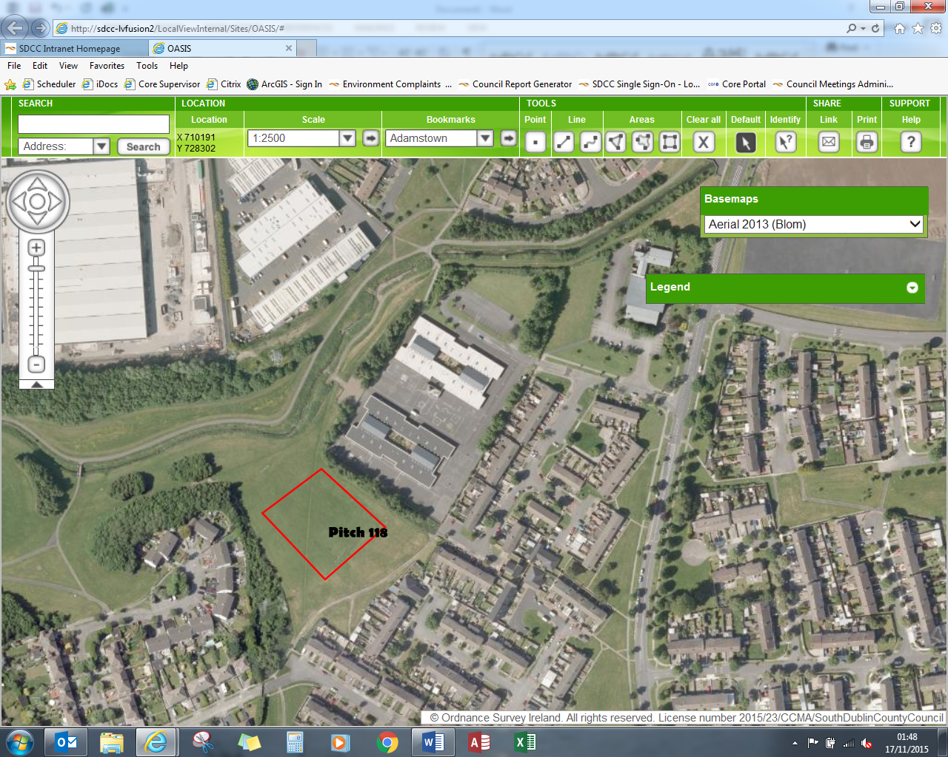

As advised at the September Area Committee Meeting, the pitch immediately adjacent to Scoil Aonghusa Senior School in Balrothery (Pitch no 118) has been let for the 2015/ 2016 Season to St Maelruans FC.

However, following discussions, Gaelic goalposts will be erected on the pitch in early 2016. The pitch will then be freely available to the school to use as a Gaelic Pitch. This has been agreed with St Maelruan’s FC.