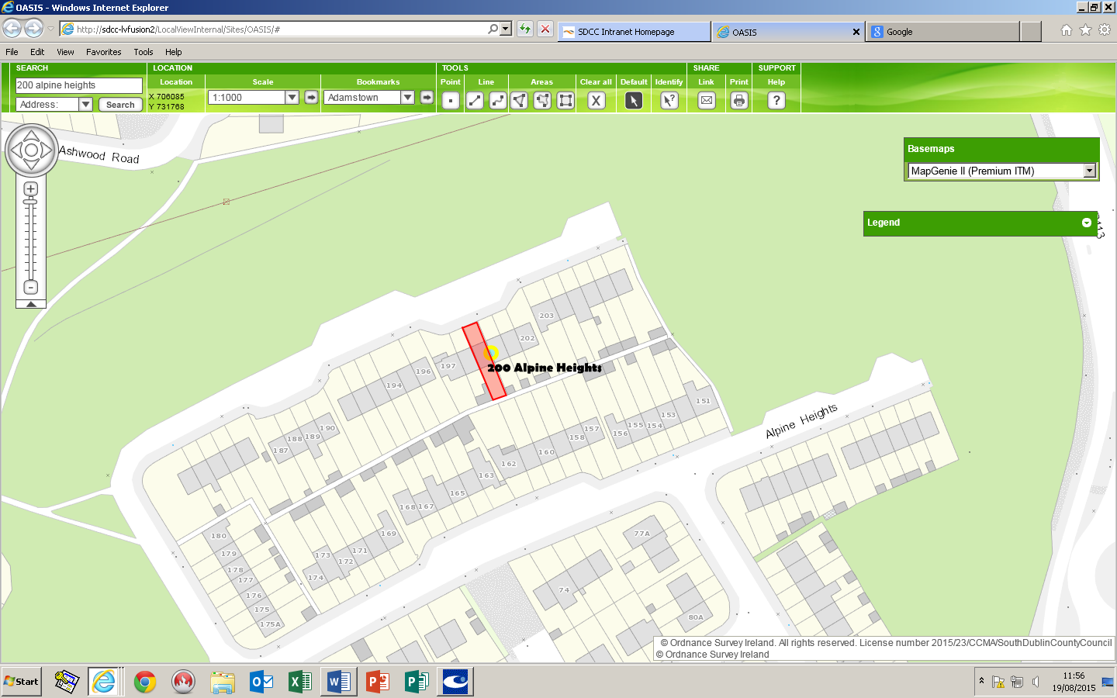


Department:  Economic Enterprise and Tourism Development | Small Builders Scheme-  Shaded in Red
House No:200 | Address:  Alpine Heights
Townland : Clonburris | Owners: Mr. Thomas Whelan

