COMHAIRLE CHONTAE ATHA CLIATH THEAS

SOUTH DUBLIN COUNTY COUNCIL
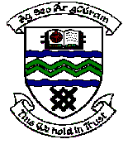

MEETING OF TALLAGHT AREA COMMITTEE MEETING (1)

Monday 7th December, 2005

Headed Item No: H ~I (8)

A Contribution is being made to the following group:

Group | Type of Application | Amount
Juvenile Liaison Officer,  An Garda Síochána,  Tallaght Garda Station,  Tallaght,  Dublin 24. | Contribution towards the cost of organising Christmas Parties in National Schools in disadvantage areas within Tallaght Station District. | €1,500

