COMHAIRLE CONTAE ATHA CLIATH THEAS

SOUTH DUBLIN COUNTY COUNCIL

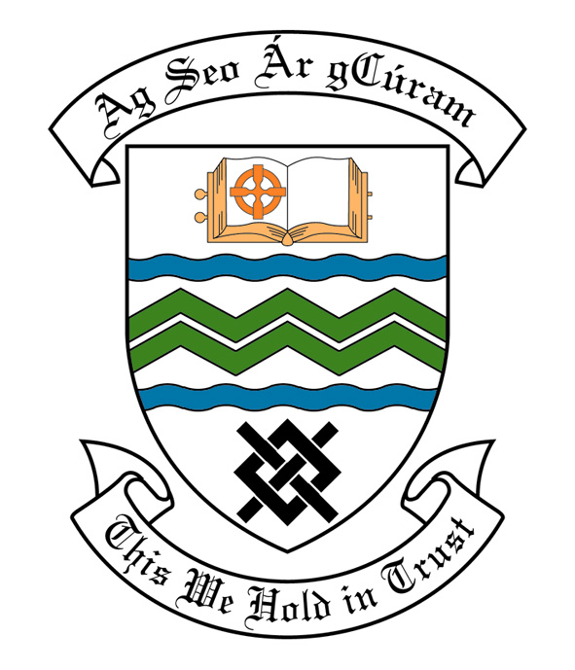

MEETING OF SOUTH DUBLIN COUNTY COUNCIL

Monday 8th June, 2015

Headed Item No: H I 2(b)

MEETING OF CLONDALKIN AREA COMMITTEE

Wednesday 20th May, 2015

HEADED ITEM NO: H- I ()

Report on Summer Projects 2015

Summer Projects are aimed at providing a supervised programme of recreational and educational activities for young people over a consecutive number of weeks in the summer period. Emphasis is placed on community involvement and the development of resources and groups within localities. A wide range of activities are encouraged such as arts & crafts, sports, educational trips, drama, films, games etc. The use of available community facilities (schools, community centres, halls, open spaces) is also encouraged.

South Dublin County Council assists Summer Projects in the County area by way of grant-aid, assistance in kind, organised activities and staff support. In 2015, it is estimated that approximately 6,000 young people in the Council’s administrative area will participate in projects.

Crosscare provides insurance cover for Summer Projects.

It should be noted that in some cases the necessary insurance cost will be deducted from the grant provided by South Dublin County Council and will be paid directly to Crosscare.

Name of Project: Duration of Project Grant Amount

Rowlagh/ Neilstown
Summer Project 2 Weeks €1,000

Clondalkin Youth Service
Village Project 4 Weeks €2,000

Sruleen Summer Project 3 Weeks €1,500

Knockmitten Summer Project 3 Weeks €1,500

Bawnogue Summer Project 3 Weeks €1,500

St. Ronan’s/ Deansrath
Summer Project 3 Weeks €1,500

Bawnogue Youth & Community
Centre Summer Festival 2 Weeks €1,000

Summer Bratz 3 Weeks €500

Quarryvale Summer Project 2 Weeks €1,000
Knockmitten Youth & Community
Centre 2 Weeks €500

It was proposed by Councillor E. O’ Broin and seconded by Councillor F. Timmons:

“That this Committee recommends that South Dublin County Council APPROVE the grants as recommended in the foregoing report”

