COMHAIRLE CHONTAE ATHA CLIATH THEAS

SOUTH DUBLIN COUNTY COUNCIL

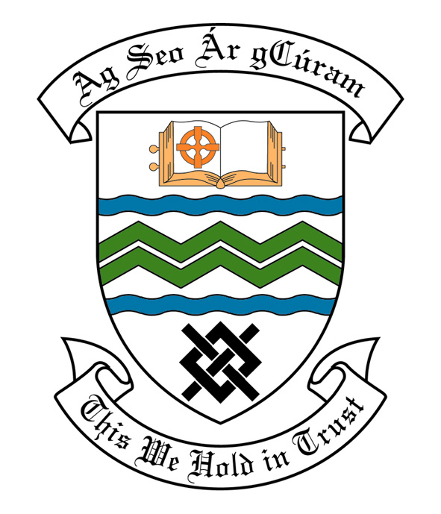

MEETING OF SOUTH DUBLIN COUNTY COUNCIL

Monday 12th December, 2005

MEETING OF THE LUCAN/ CLONDALKIN AREA COMMITTEE(2)

Tuesday 22nd November, 2005

HEADED ITEM NO: H-I 2 (f)

Application for Grants

Application for grants under the Council’s Community Grants Scheme have been received from the organisations listed below. Payment of these grants to these organisations, in accordance with the conditions of the scheme, in the amounts set out hereunder, is recommended for approval:-

Ref: | Group | Type of Application | Date of Application | Amount
Ref: 384 | Esker Celtic Football Club,  Hermitage Park,  Lucan,  Co. Dublin. | Single Interest Grant towards construction of dressing rooms. | 20/10/05 | €40,000
GF 1356 | Neilstown Parish Community Centre,  Neilstown,  Dublin 22. | Upgrading of existing Community Centre towards the provision of double doors, new Customer Counter and replacement of 2 windows. | 02/11/05 | €10,000
SCRA 1645/ Gf 1327 | Lucan Active Retirement Association,  Tubber Lane,  Lucan,  Co. Dublin. | Start Up Grant | 02/08/05 | €1,000
SCRA 1660/ GF 1363 | Rowlagh Village Centre,  St. Mark’s Lane,  Rowlagh,  Dublin 22. | Adaptation of Existing Building towards the cost of flooring. | 14/11/05 | €6,000

Arts Grants

Application for a grant under the Council’s Arts Grant Scheme has been received from the organisation listed below. Payment of this grant to this organization, in accordance with the conditions of the Scheme, in the amount set out hereunder, is recommended for approval.

Ref: | Group | Type of Application | Date of Application | Amount
SCRA 262/ AGF 510 | Áras Chrónain  Irish Cultural Centre,  Clondalkin,  Dublin 22. | Arts grant towards the cost of presenting a dramatized live crib in Áras Chrónain | 14/11/05 | €600

Arts contribution is being made to the following groups

Ref: | Group | Type of Application | Date of application | Amount
 | Deansrath Community College  New Nangor Road  Clondalkin  Dublin 22 | Production of a SC of Music and Song | 29/8/05 | €1,000
 | Clondalkin Camera Club | Annual Photographic exibtition | 11/11/05 | €400

A Contribution is being made to the following :

Ref: | Name | Type of Application | Date of Application | Amount
 | Kenneth Byrne,  44 Alpine Heights,  Clondalkin,  Dublin 22. | Contribution -towards participating in a race “Yukon Artic Ultra” 100 mile race. | 20/08/05 | €200

It was proposed by Councillor F. Mc Carthy, seconded by Councillor D. Keating and RESOLVED:

“That this Committee recommends that South Dublin County Council approve payment of the above grants recommended in the foregoing report”.

