South Dublin County Council
Pavilion Construction Programme 2015 – 2017.

Introduction

SDCC’s commitment to the Health and Wellbeing of its citizens
Health and Wellbeing is one of the major challenges faced by society. Healthy minds and bodies are essential to enjoying physical, mental and social wellbeing. Local authorities play a critical role in supporting and promoting wellbeing at local level. South Dublin County Council recognises its role in this regard, and continues to maintain the well being of its citizens as a priority objective of service delivery.

In light of the Council’s commitment to the Health and Wellbeing of its citizens, this documents sets out the programme for construction of 7 sports pavilions over the period 2015-2017.

South Dublin County Council has provided over 1,750ha of parks and open spaces throughout the county. The larger parks, in particular, provide space for a wide range of active and passive recreation facilities. The benefits of these facilities contribute to the Government’s vision of an active and healthy society as detailed in the 2013 Healthy Ireland document – A Framework for Improved Health and Wellbeing 2013 – 2025. This Council will actively participate in the vision and actions outlined in the document.

As clubs grow and develop, facilities such as changing rooms, first aid posts, and secure storage areas become essential to a club’s sustainability and success.
In the 1980s the then Dublin County Council commenced a programme of providing converted shipping containers for use as changing rooms. These were basic facilities and usually did not include showers or toilets. Subsequently, due to financial constraints the Council was unable to continue this programme and some clubs raised money to provide their own containers. This continued into the new South Dublin County Council. When Government commenced a programme of Sports Capital Grants, submissions were made for permanent dressing room facilities and some of these received funding and were constructed.

The aim of this Pavilion Construction Programme is to set out the location for the construction of each of the agreed seven no. pavilions and also to set out the order of construction over the life of the Construction Programme.

South Dublin County Council currently provides 163 playing pitches for various sporting codes such as Gaelic Football, Hurling, Soccer, Rugby, Cricket, Rounders, and Softball. Some 59 clubs with a total of 850 teams use our pitches on a weekly basis.

Current Position
There are 163 pitches provided by the Council. There are currently 46 temporary container style dressing rooms and 14 Council provided and 18 privately provided permanent dressing room facilities located in our parks and open spaces. The number of temporary structures is often changeable and dependent on the state of repair of the structures as well as the viability of particular clubs from time to time.

The table below illustrates the 10 biggest Sporting Clubs who have a Council pitch allocation;

 | Club name | Location of Pitch Allocations | No of Teams | Sport
1 | Ballyboden St Enda's GAA | Ballycullen/Cherryfield | 81 | GAA
2 | Lucan Sarsfield GAA | GVP/Willsbrook | 51 | GAA
3 | Knocklyon Utd FC | Delaford/Castlefield/Tymon Park & Kennedy's Field | 43 | Soccer
4 | Esker Celtic FC | Hermitage Park | 42 | Soccer
5 | Round Towers GAA | Clondalkin Community Centr & Corkagh park | 36
6 | Lucan Utd FC | Dodsborogh o/s/Hillcrest | 24 | Soccer
7 | Faughs GAA | Tymon Park | 23 | GAA
8 | Firhouse Carmel FC | Ballycragh Park | 19 | Soccer
9 | Kilnamanagh FC | Kilnamanagh O/S & Tymon | 19 | Soccer
10 | Liffeyvalley Rangers FC | Ballyowen Park | 16 | Soccer

The following tables illustrate the breakdown of permanent and private structures in our parks and open spaces to date.

In Appendix 1 there are some illustrations of the temporary and permanent facilities.

PAVILIONS – PERMANENT STRUCTURES LOCATED IN PARKS AND OPEN SPACES
LOCATION | COUNCIL PROVIDED | PRIVATELY PROVIDED
North of the Naas Road
Airlie Park, Lucan |  | Lucan United FC
Ballyowen Park, Lucan |  | South Dublin Football League
Corkagh Park | MAAN Dressing Rooms
Clondalkin Park | Clondalkin Sports and Leisure Centre  (Clondalkin Celtic  Boot Road Celtic  Roundtowers GAA)
Collinstown Park | Collinstown Community College Sport Centre – a project from URBAN (dressing rooms only partly used)
Glenaulin Park |  | St Patricks GAA  Palmerstown Utd FC
Griffeen Valley |  | Lucan Sports Association (a joint project between 3 soccer, athletics and hockey clubs)
Hermitage Park, Lucan |  | Esker Celtic FC
Knockmitten Park | Knockmitten Utd (in Community Centre)
Stewart’s Hospital Park, Liffey Valley | Palmerstown United FC
Quarryvale Park | S.C.V (Quarryvale Community and Leisure Centre)
South of the Naas Road
Allenton |  | St Anne’s GAA (use own adjacent club house)
Bancroft Park | St Maelruan’s FC
 | Tallaght AC
Ballymount Park | St Killians GAA  St Marks GAA  Kingswood FC  Kingswood Castle  (Facility provided as part of cemetery development)
Beechfield Park, Walkinstown | Cherryfield Utd FC  Castle Celtic FC
 | Kit Kat Tennis League
Castlefield Park, Knocklyon | Knocklyon Utd FC
Delaford Park, Knocklyon |  | Knocklyon Utd FC
Dodder Valley
- Cherryfield Park |  | Ballyboden GAA (on adjoining private land)
- Knocklyon Park |  | Ballyboden St Enda’s GAA
Firhouse Park |  | Firhouse Carmel FC
Greenhills Park |  | Greenhills Boys FC (adjoining Community Centre on own land)
Greentrees Park |  | Manortown Utd
Jobstown Park | Brookfield Celtic FC  Jobstown Celtic FC  (use Tallaght Leisure Centre)
Killinardan Park |  | An Croí Ró Naofa
Kilnamanagh Park |  | Kilnamanagh FC
Seán Walsh Park | Shamrock Rovers FC  (in Tallaght Stadium)
Tymon Park | TASC pavilion  (Templeogue FC  Working Trial Club of Ireland  Terenure FC  Limelkiln Rounders)
 |  | St. Judes GAA
 |  | Fág a Bhealach GAA
 |  | National Basketball Arena
Total number of permanent pavilions | 14 | 18

TEMPORARY DRESSING ROOM FACILITIES (CONTAINERS) LOCATED IN PARKS AND OPEN SPACES – the majority owned by clubs
LOCATION | COUNCIL PROVIDED | PRIVATELY PROVIDED
North of Naas Road
Ballyowen Park, Lucan |  | Liffey Valley Rangers (5)  Collinstown FC (1)  Rowlagh FC (1)
Castle Park, Clondalkin |  | Castle Park FC (1)
Clondalkin Park |  | Roundtowers GAA (1)
Collinstown Park |  | Collinstown FC (2)  Oatfield FC (1)
Griffeen Valley |  | Model Car Club and  Lucan Sarsfields GAA (1)  Beechpark FC (2)  Ballyowen Celtic FC (4)
Hillcrest, Lucan |  | Lucan Utd FC (2)
Lett’s Field, Clondalkin |  | (1)
St Cuthbert’s Park, Deansrath |  | (0)
Willsbrook Park, Lucan |  | Lucan Sarsfield (2)
South of Naas Road
Aylesbury Open Space |  | Thomas Davis GAA  Newtown Rangers FC  Shamrock Rovers FC  (0)
Ballycragh Park |  | Firhouse Carmel (0)
Brady’s Field, Old Bawn |  | Tymon Bawn FC (2)
Butler McGee Park |  | St Marks GAA  Old Court Celtic FC  Marks Celtic FC  (0)
Elkwood, Knocklyon |  | Terenure FC (0)
Greenhills Park |  | Greenhills Bowls Club (1)
Greentrees Park |  | Manortown Utd (3)
Dodder Valley
- Cherryfield Park |  | Bros Pearse AC (2)
- Kennedy’s Field |  | Knocklyon Utd FC (2)
- Kilnamanagh Park |  | Kilnamanagh FC (1)  St Kevin’s St Killian’s GAA (1)
Old Bawn Park |  | Thomas Davis GAA  Shamrock Rovers FC(2)  Scoil Seanta GAA  Knocklyon Utd FC (2)
Rathcoole Park |  | (0)
Tymon Park |  | (6)
Total number of temporary dressing rooms |  | 46

Pavilion Construction Programme
The construction programme will be funded through the annual provision of €300,000 made in the Council’s Capital Programme 2015-2017, along with funding from the Department of Transport, Tourism, and Sport through the Sports Capital Programme.

The design of the and positioning of each pavilion will be approved through the Part 8 process in compliance with the Planning and Development Regulations, 2001 (as amended).
The construction of the pavilions will be carried out by a contractor to be procured through the Public Procurement Process. One of the positive outcomes of the construction of the TASC pavilion was the community area and which serves both the sports clubs but also the wider community. Such a facility will also be considered in the proposed programme where the facility will be located in proximity to a residential area. The exact number of dressing rooms in each location will be determined by consideration of the number of clubs that are allocated pitches currently and also the advice of the Sports Officers and the Sports Facilitator.
It is intended to provide a storage unit as part of the build.

Procurement process
It is proposed that a restricted two-stage Procurement Process, Expressions of Interest followed by Tender for a Single-Operator Framework is initiated as follows;

STAGE 1: - Expressions of Interest: (Selection)
Submissions would be invited from manufacturers of prefabricated structures now currently used over very long periods on construction sites, school extensions and medical facilities. The submissions would confirm experience, capacity, financial viability and compliance with Statutory and Fiduciary requirements. Based on these a short list would be prepared of firms to be invited to tender for a Framework for the supply, installation and certification of completed partition buildings.

STAGE 2: - TENDER (Award)
Layout Drawings and a performance-specification (structural, environmental, performance, durability, locking and mechanical/electrical control systems) would be prepared for a number of pavilion types – 4-room, 6-room, 8-room. Tenderers would be invited to submit design proposals addressing the performance-requirements in a report with drawings and pricing a schedule of the elements of the buildings involved. The selection criteria would be a balance of Quality: Cost ratio. The cost criterion would be lowest tender. The quality selection criteria would address a number of design and performance issues including overall design quality, durability, flexibility, and energy-efficiency.

Criteria for the identified locations
Following an audit of the Council’s pitches and facilities within the County and having regard to the level of mixed usage at each location, the following areas have been identified for inclusion in the Pavilion Construction Programme. The selection criteria was based on the clustering of pitches at particular locations so that this initial programme would provide the facilities for the maximum number of pitches and the clubs that use them.

Locations identified
Following an audit of the Council’s pitches and facilities within the County and having regard to the level of mixed usage at each location, the following areas have been identified for inclusion in the Pavilion Construction Programme;

Dodder Valley Old Bawn
Dodder Valley Old Bawn currently has 6 pitches (4 Soccer and 1 full size and 1 junior Gaelic Football), serving 10 teams.

Doddervalley Park Old Bawn  2014/2015 Pitch Allocations | Club Name | No of Teams
 | Shamrock Rovers FC | 8
 | Thomas Davis GAA | 1
 | Scoil Seanta GAA Jnr | 1

Griffeen Valley Park (Sports Centre)
The Park, comprising over 200 acres, is formed from a series of public open spaces, each of which has an identifiable character. The first and oldest section is the popular little town park in the middle of Lucan Village. The second section known as Vesey Park can be entered at Adamstown / Newcastle Road; it winds its way around the Vesey housing estate and ends at the Lucan Bypass. The third section is an open space on the southern side of the bypass ending at Lynch's Lane. The enclosed section of Griffeen Valley Park starts on the other side of Lynch's Lane and extends along the rear of the Arthur Griffith housing estate to Griffeen Avenue.
There are 5 Soccer Pitches in this area which are allocated to two separate clubs.
GVP 2014/ 2015 Pitch Allocations | Club Name | No of Teams
 | Ballyowen Celtic FC | 9
 | Beechpark FC | 14

Corkagh Park
Corkagh Park is located near the Naas Road and connects to Clondalkin. This Regional Park was opened to the public in 1986. It consists of 120 hectares and was formerly part of Corkagh Demesne. There are many amenities in Corkagh Park including a Playground, Pet Farm, Fishery, Rose Garden, Cycle Track, Allotments, Sports & Playing Pitches for various codes of sport.

There are 9 pitches located in the north of Corkagh Park alongside the Outer Ring Road. These 9 pitches currently serve 6 sports clubs (Soccer, Rugby, Gaelic Football, and Baseball) who jointly have 54 teams availing of the pitches at this location.

Corkagh Park  2014/ 2015 Pitch Allocations | Club Name | No of Teams
 | Ashwood FC | 5
 | Alpine FC | 2
 | AZ Alpine FC | 1
 | Boot Road Celtic FC | 4
 | Cloncastle United F.C. | 1
 | Newlands Celtic FC | 2
 | Round Towers GAA | 36
 | Clondalkin Rugby Club | 2
 | Corkagh Baseball | 1

Tymon Park South
Tymon Park is a Regional Park and as such is a valuable resource for the local communities and the surrounding hinterland. It provides opportunities for a wide range of outdoor active and passive recreational activities for all age groups including walking, jogging and participation in active sport, principally field sports. It is a popular venue for many public events such as tournaments, band recitals,
film/television shoots, family festivals in the summer, cross country races
and circus performances.

Currently, there are three pitches and an Archery Range in Tymon Park South. It is intended that two of the pitches will be upgraded in the coming months to deal with drainage issues. An application to the Sports Capital Grant scheme has been made for this drainage project.

Dodder Valley Mt Carmel
Located adjacent to the Firhouse Road and to the rear of Mount Carmel school proposals are currently being drawn up to provide an Athletics Track, BMX Track, and soccer pitches in this location.

Griffeen Valley Park (Arthur Griffith Park)
It is proposed to construct a Dressing Room Unit within the enclosed section of Griffeen Valley Park between Lynch’s Lane and the rear of Arthur Griffith housing estate to serve the pitches located in this area on which 98 teams currently play.

GVP (Arthur Griffith Park)  2014/ 2015 Pitch Allocations | Club Name | No of Teams
 | Arthur Griffith FC | 5
 | Esker Celtic | 42
 | Lucan Sarsfield | 51

Collinstown Park
Currently, there are 5 pitches in this park which are allocated to four Soccer Clubs.

Collinstown Park  2014/ 2015 Pitch Allocations | Club Name | No of Teams
 | Clondalkin FC | 1
 | Collinstown FC | 11
 | Oat Field FC | 1
 | Woods United FC | 3

Plans are being drawn up for the reconfiguration of the existing pitches in this Park. In line with these plans, it is proposed to construct a Dressing Room Pavilion at this location with a secure storage area.

Order of construction

1st - Dodder Valley Old Bawn
2nd - Griffeen Valley Park
3rd - Corkagh Park ORR
4th - Tymon Park South
5th - Dodder Valley Mt Carmel
6th - Griffeen Valley – Arthur Griffith Park
7th - Collinstown Park

Conclusion
A project implementation team will ensure the delivery of the pavilion construction programme as agreed.
It is recommended that the proposed locations and the order of construction be agreed.

Next steps
Draft Part 8 proposals in respect of the Corkagh Park and Griffeen Valley Park (Sports centre) locations will be brought to the relevant June Area Committees for noting.

The finalised draft Part 8 proposals will then be presented to the July meeting of the County Council.

Once the tendering process has been completed, construction will commence on a phased basis over a three year period.

__________________________

Appendix 1: illustrations of some temporary and permanent structures

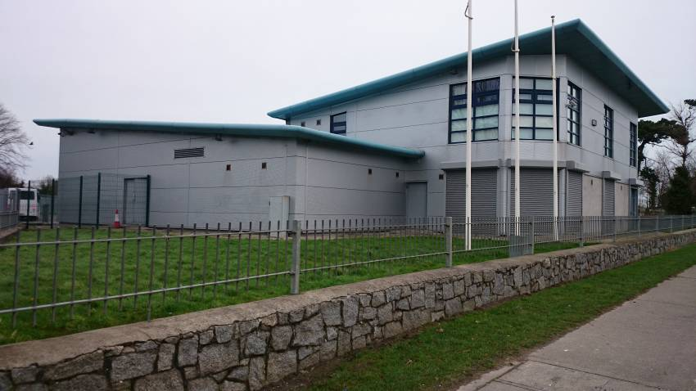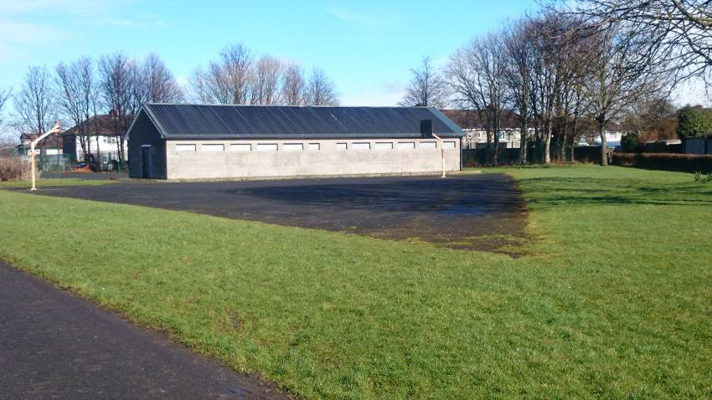
Ballyowen Park Lucan Beechpark Walkinstown
South Dublin Football League
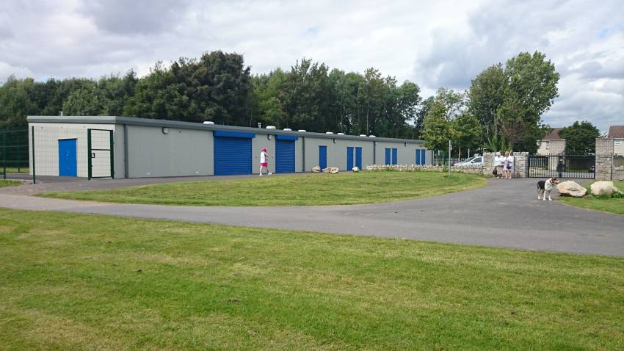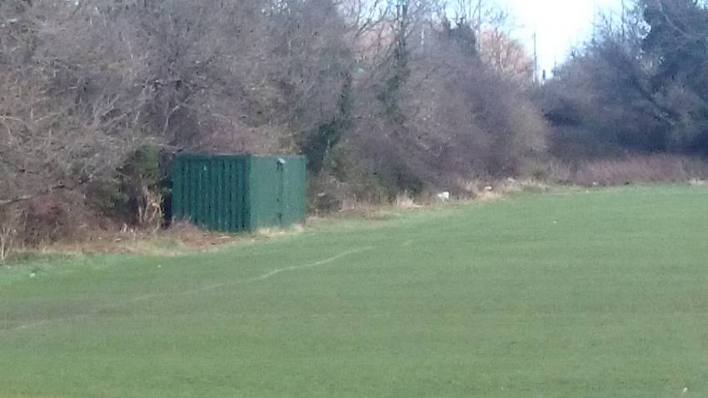
TASC pavilion Tymon Park Kenndedy’s Field
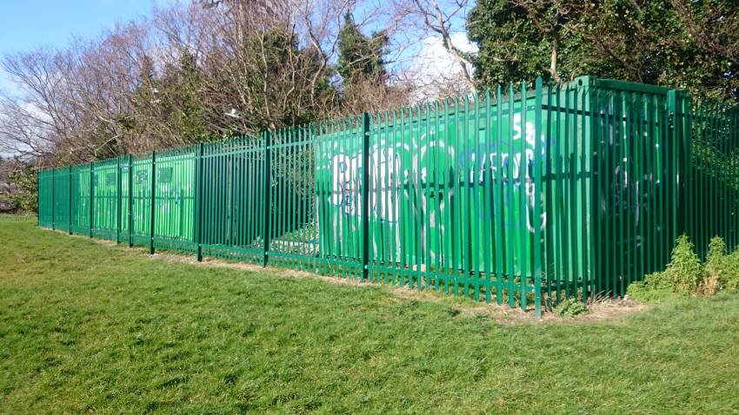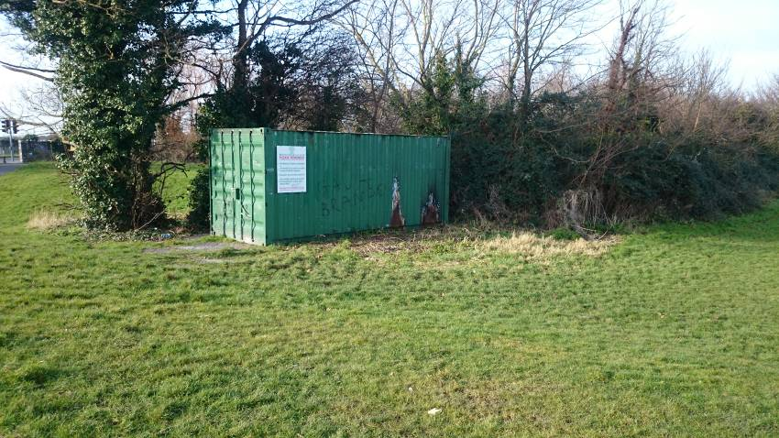
Old Bawn Park Dodder Valley Clondalkin Park

