 | COUNTY ARCHITECTS REPORT – Part 8 Consultation April 2015
Project Title: | Tallaght Village Improvement works, Tallaght, Dublin 24
County Architect:  Senior Architect:  Architects: | Eddie Conroy FRIAI  Máire O Sullivan MRIAI  Architectural Services Department, South Dublin County Council
Description of Project for Part 8 Consultation Notice and Site Notice: | Proposed New Works  Notice Under Planning and Development Act 2000 to 2011  Public Consultation Procedure & under Part VIII of the Planning and Development Regulations 2001 - 2013  Pursuant to the requirements of the above, notice is hereby given of the proposal to construct:  Alterations and improvements to paving, kerbing, parking, trees, public lighting and bollards at the following locations  In front of the commercial premises along the West side of the Old Blessington Road from the junction with Main Street to the junction with High Street and along the old Greenhills Road from the junction with Main Street to the junction with the new Greenhills Road in  Tallaght, Dublin 24  Works to include:  New paving layouts and upgraded kerbing  New trees, public lights and bollards  Revised on street car-parking spaces  These sites are within the Tallaght Architectural Conservation Area. Tallaght Village is a zone of Archeological Potential.  Drawings of the proposed works will be on public display at the:  South Dublin County Council, County Hall, Tallaght, Dublin 24  (between the hours of 9:00am – 5:00pm Monday to Thursday and 9.00am - 4.30pm on Friday) and on http://www.sdcc.ie/  during the period from 12th January 2015 to 23rd February 2015.  Submissions or observations with respect to this matter dealing with the proper planning and sustainable development of the area in which the development would be situated may be made in writing to:  The County Architect  Architectural Services Department  South Dublin County Council  County Hall  Tallaght  Dublin 24  The latest date for the receipt of submissions or observations is 5pm on Monday 9th March 2015.  It should be noted that the Freedom of Information Act applies to all records held by South Dublin County Council.
Context: | Tallaght Village is included in the 9 traditional villages of South Dublin County Council identified for the Villages Initiative. The works which are the subject of this Part VIII are part of this programme of design and works intended to improve the villages in social, economic and environmental performance.  The Village Initiative intends to encourage and grow community involvement and partnership to complement and energise Council environmental and maintenance programmes and develop new projects. These new projects will help to develop the villages as the accessible focus of walking and amenity networks for their adjoining communities.  The village and town centres can become more open and accessible, facilitating walking and cycling, increasing footfall and encouraging social and community encounters and interaction in festivals, performances and open-air markets.  The promotion of quality, choice and diversity in goods, services and recreation in a lively, well-maintained setting, will attract more locals and visitors alike adding to the vibrancy and vitality of successful urban life.  Village surveys and a SWOT analysis of 9 Villages have identified a number of key areas requiring attention in order to build on the villages existing strengths. These include the need for improved landscaping, prioritisation of open spaces, greater legibility and ease of access.  Works contracts are being rolled out to address these short comings to aid in the revitalisation of the villages from the point of view of improving public realm and green infrastructure, removing clutter and improving accessibility and safety for pedestrians.  The environmental activity of landscape, public realm and quality of buildings and shopfronts will be improved through design, capital projects and grant-aid. Support is available for Tidy Towns, community projects and festivals, to grow community support.  The implementation of this programme will be led by the Architectural Services Department but will involve a multidisciplinary approach and a steering group involving all of the key staff covering public realm, planning, heritage, community has now been established.
Project Description | The works include alterations and improvements to paving, kerbing, parking, trees, public lighting and bollards at the following locations:  - In front of the commercial premises along the West side of the Old Blessington Road from the junction with Main Street to the junction with High Street.  The proposal aims to create a coherent pedestrian plaza to the front of these units, which will contain uniform paving, bollards, lighting and trees. This will link up with the public realm improvement works in High Street and the plaza in the village centre. Improved separation of vehicular and pedestrian traffic will result in a safer more accessible environment for pedestrians.  - Along the old Greenhills Road from the junction with Main Street to the junction with the new Greenhills Road  The proposal here will link the Main Street with a new pedestrian plaza at the junction of the old and new Greenhills Road. The area around the Dancing Children sculpture will be upgraded and improved. A regular pattern of trees will be planted along a newly paved path with improved on street carparking.  Works to include:  New paving layouts and upgraded kerbing  New trees, public lights and bollards  Revised on street car-parking spaces  Please refer to the attached drawings for details:
Statutory Protections | (1) The proposed works in front of the commercial premises along the west side of the Old Blessington Road from the junction with Main Street to the junction with High Street, Tallaght are within the Tallaght Architectural Conservation Area (A.C.A.) as defined in the South Dublin County Council Development Plan 2010 – 2016. The proposed works consist of:  - New paving layouts and upgraded kerbing  - New trees, public lights and bollards  - Revised on street car-parking spaces  The proposed works are sympathetic to the special character and amenity of Tallaght village and will not adversely impact on the significance of the buildings within the village Architectural Conservation Area.  In addition to the above statutory protection, Tallaght village is a Zone of Archaeological Potential and is therefore subject to statutory protection in the Record of Monuments and Places, established under Section 12 of the National Monuments (Amendment) Act 1994. This is referred to in the Council’s Record of Monuments and Places (R.M.P.) (Recorded Monument Reference No. DU021-037) under the South Dublin County Development Plan 2010 - 2016 – Schedule 1, Record of Monuments and Places, referred to as a “Town”. Any proposals to develop and excavate the site would require a license, applied for by an archaeologist, predevelopment testing and supervision of all sub-surface site works by an archaeologist.  (2) The proposed works along the old Greenhills Road from the junction with Main Street to the junction with the new Greenhills Road, Tallaght, Dublin 24 are within the Tallaght Architectural Conservation Area (A.C.A.) as defined in the South Dublin County Council Development Plan 2010 – 2016. The proposed works consist of:  - New paving layouts and upgraded kerbing  - New trees, public lights and bollards  - Revised on street car-parking spaces  The proposed works are sympathetic to the special character and amenity of Tallaght village and will not adversely impact on the significance of the buildings within the village Architectural Conservation Area.  The proposed works are also beside the curtilage of the following Protected Structures on the Record of Protected Structures in the South Dublin County Development Plan 2010 – 2016:  - St. Basil’s Training Centre, Greenhills Road, Tallaght, described as a "Detached Ten-Bay Single-Storey Building", Map Reference Number 268.  - The Priory, Tallaght, described as a " Tallaght Castle Gate (also a Recorded Monument)", Map Reference Number 269.  - St. Mary’s Dominican Priory, Tallaght Gothic Revival Priory, described as a " Detached Multiple-Bay Three-Storey With Attic", Map Reference Number 270.  - St. Mary’s Dominican Church, Tallaght, described as a " Detached Gable-Fronted Gothic Revival Church", Map Reference Number 273.  The proposed works will not materially affect the external appearance of these structures or the character of the structures so as to render the appearance inconsistent with the character of the structures.  In addition to the above statutory protections, Tallaght village is a Zone of Archaeological Potential and is therefore subject to statutory protection in the Record of Monuments and Places, established under Section 12 of the National Monuments (Amendment) Act 1994. This is referred to in the Council’s Record of Monuments and Places (R.M.P.) (Recorded Monument Reference No. DU021-037) under the South Dublin County Development Plan 2010 - 2016 – Schedule 1, Record of Monuments and Places, referred to as a “Town”. Any proposals to develop and excavate the site would require a license, applied for by an archaeologist, predevelopment testing and supervision of all sub-surface site works by an archaeologist.
Development Plan | 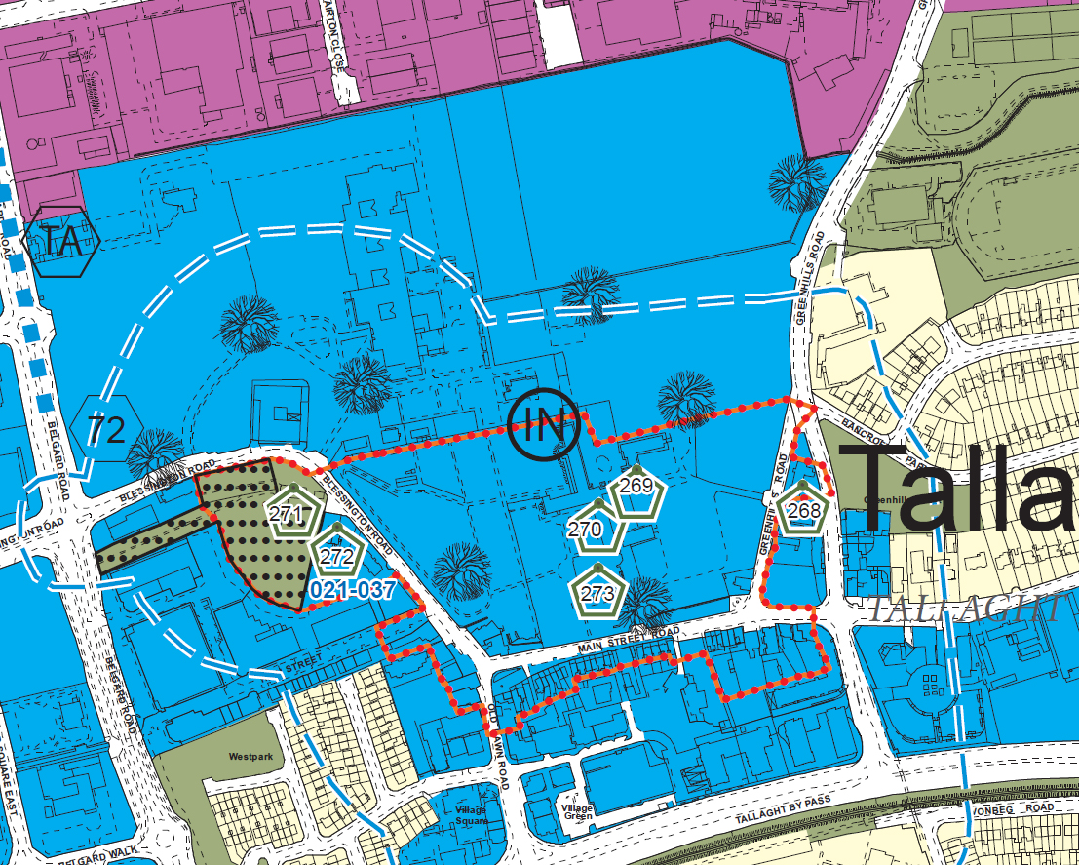  An extract from the South Dublin County Council Development Plan 2010-2016.  The proposed development sites are coloured blue and are therefore zoned to “protect, improve and provide for the future development of the County Town of Tallaght”.  The Architectural Conservation Area is shown surrounded by a beaded red line. The protected structures are identified by a number within a green hexagon, numbers 268, 269, 270 and 273 being the relevant numbers  The Zone of Archaeological Potential is indicated by a white and blue dashed line.  The tree symbol refers to a Specific Objective: to protect and preserve trees and woodlands.
Project Partners | Department of Land Use Planning and Transportation  Department of Economic, Enterprise and Tourism Development  Local Community and residents  Tidy Towns Group
Site / Services Constraints: | All major existing services runs have been identified for the design.
Schedule of Part 8 Submissions  Received | The following is the list of the parties submitting formal written observations or submissions under the provisions of the Part VIII Consultation, as provided for in the legislation. [ see Site Notice / Public Notice text as displayed above ]. Observations made during the consultation process have also been included.  1. Tallaght Community Council  2. Dept of Arts Heritage and the Gaeltacht
Part 8 Submissions  & Commentary | Summary of observations and submissions made under Part VIII  Request for new village signage at Greenhills Plaza:  We will include information signage at this location.  Possibility of improving traffic flow by creating a left only turn on the Greenhills Road:  This will be investigated further.  8th Century hedge monastery rampart, all buildings on the High St. and The Old Cycle Inn building are National Monuments and need appropriate street setting:  These comments and ideas will be considered.  Maps and new Signage points:  Will be installed as part of the Village Improvement plan.  Planting and flower bed at Totem Pole:  Issue of plant maintenance has been referred to our public realm maintenance division.  Drainage in parking bays:  Are being investigated and improvements will be carried out to alleviate flooding.  Priory Walls at the Dragon:  Removal of render to expose stone will be considered.  Archaeological Monitoring shall consist of the following:  SDCC will employ a qualified archaeologist to monitor groundworks.  Should archaeological material be found, works on site may be stopped pending a decision on how best to deal with the archaeology and SDCC will notify Dept of Arts Heritage and the Gaeltacht.  The Planning Authority and Dept of Arts Heritage and the Gaeltacht shall be furnished with a report describing the results of monitoring.  Observations and Submissions – summary  The issues raised by the above parties were largely supportive of proposed development and the detailed concerns will be addressed as reported above.

/tmp/in/input.doc

