Lucan
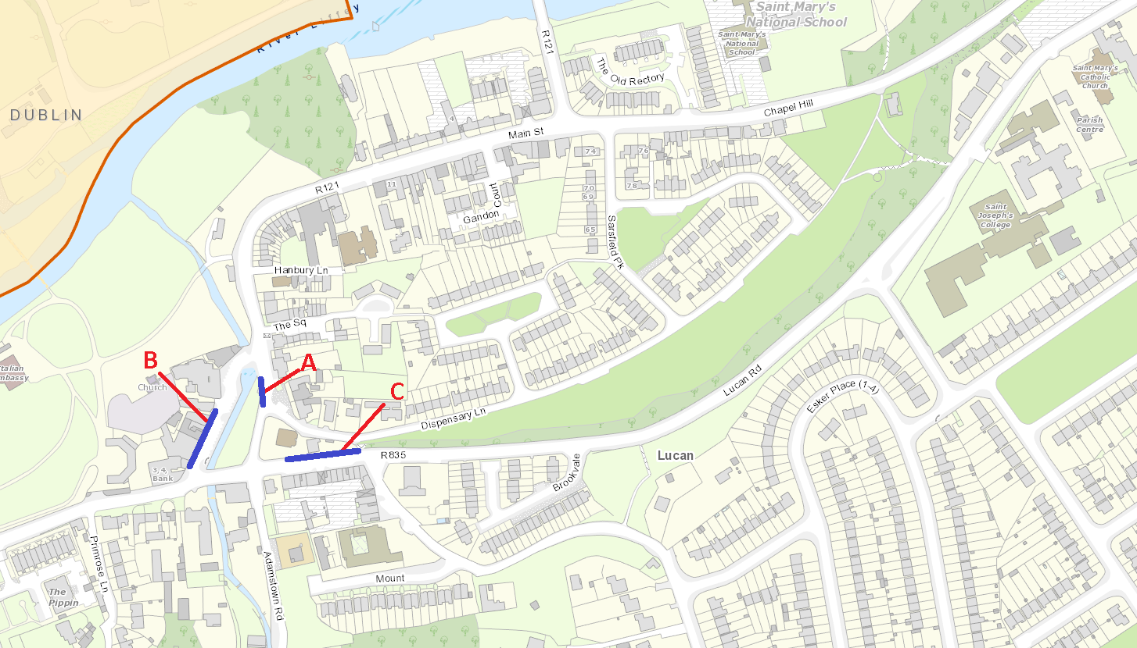
Proposed Location | Road Name | Street type | Day / night/ 24hr
A | Dispensary Lane | Restaurant Shops Bank Pubs | 24Hr
B | Main Street | Shops Bank Pubs | Night
C | Lucan Road | Restaurant Shops Pubs | Night

