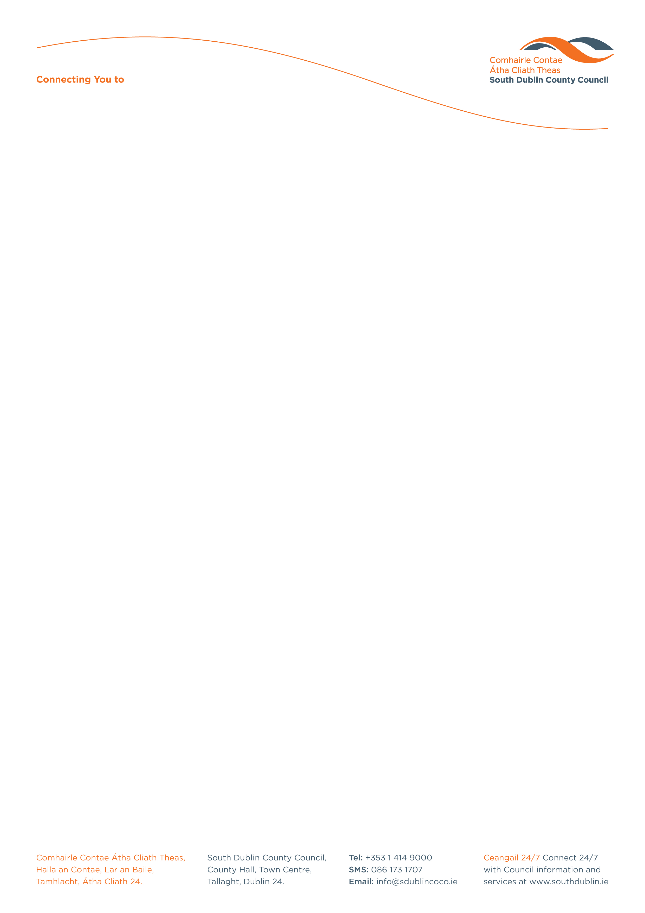

Halla an Chontae, Lár an Bhaile County Hall, Town Centre
Tamhlacht, Baile Átha Cliath 24 Tallaght, Dublin 24
Telefon: 01-4149052 Telephone: 01-4149052
www.southdublin.ie
Jan O’Sullivan, T.D.
Minister for Education
Department of Education
Marlborough Street
Dublin 1
31st March, 2015

RE: Tallaght Area Committee Meeting – 23rd March, 2015

Dear Minister O’Sullivan,

At South Dublin County Council’s Tallaght Area Committee Meeting, held on 23rd March, 2015, the following Motion was passed:
“That This Committee agrees that city wise education in Jobstown has been ignored financially by department of Education and that this Committee make contact with the Minister for Education to ask for this project to be assisted with more funding to provide for the service for this education center.
This center has had to cut back in services in education due to the present cut backs from the department.
City wise is a great asset to the community in West Tallaght and this needs to be addressed to assist the children to receive vital education in West Tallaght”.
I should be obliged if you would let me have a reply on this matter at your earliest convenience.

Thanking you in anticipation,

Yours sincerely,

__________________
Marie Kavanagh
Senior Staff Officer
Housing Administration

Housing Administration

