COMHAIRLE CONTAE ÁTHA CLIATH THEAS
SOUTH DUBLIN COUNTY COUNCIL

MEETING OF LUCAN AREA COMMITTEE
Tuesday, April 28, 2015
QUESTION NO. 15
QUESTION: Councillor P. Gogarty
"To ask the Chief Executive to outline the legal situation regarding large bins placed to the front of commercial premises that have a noticeable foul smell; if a premises (Address Supplied) can be investigated regarding same, as the smell was reported to be very strong at one stage; and if she will make a statement on the matter?"
REPLY:
The matter was referred to the Environmental Health Office.

The Senior EHO called to the (Address Supplied) and observed four large lidded wheelie bins situated within the commercial boundary of the business known as the (Address Supplied). The four wheelie bins all had their lids firmly closed, there was no odour detectable on the public foot path.

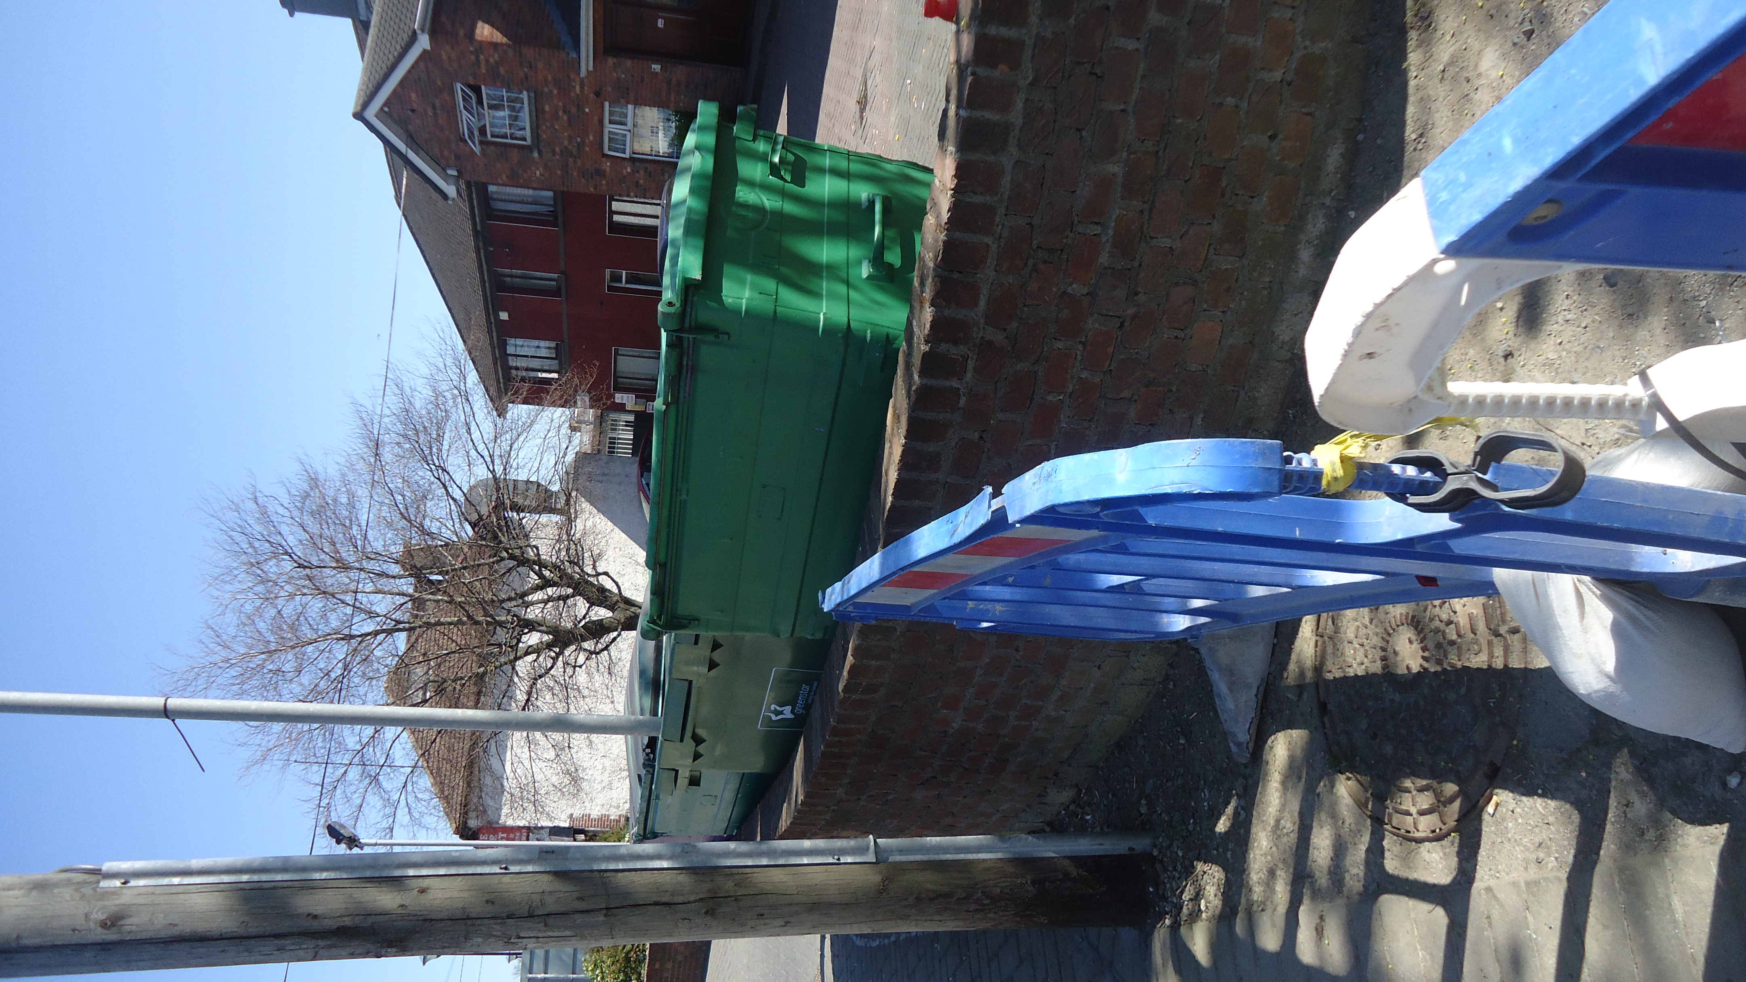

Two photos were taken from the public footpath to show the bins within the confines of private property, in a clean condition and with their lids tightly shut.

