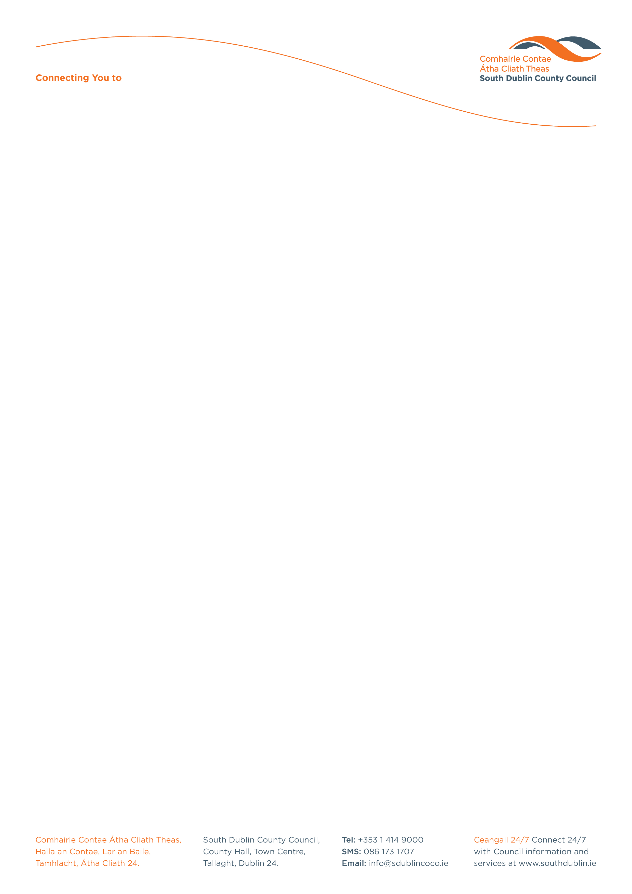

Halla an Chontae, Lár an Bhaile County Hall, Town Centre
Tamhlacht, Baile Átha Cliath 24 Tallaght, Dublin 24
Telefon: 01-4149052 Telephone: 01-4149052

Facs: 01-4149332 Fax: 01-4149042
www.southdublin.ie

Frances Fitzgerald T.D.
Minister for Justice & Equality
94 St. Stephen’s Green
Dublin 2.
24th February, 2015

RE: Tallaght Area Committee Meeting – 23rd February, 2015

Dear Minister Fitzgerald,

At South Dublin County Council’s Tallaght Area Committee Meeting, held on 23rd February, 2015, the following Motion was passed:

“That this Tallaght Area Committee calls on the Minister for Justice to assign additional resources, personnel and vehicles to Tallaght Garda Station to respond to the challenges facing the Gardai in respect of crime and anti social behaviour in Tallaght.

I should be obliged if you would let me have a reply on this matter at your earliest convenience.

Thanking you in anticipation,

Yours sincerely,

__________________
Katherine Nicholls
A/ Senior Staff Officer,
Housing Administration

Housing Administration

