 | COUNTY ARCHITECTS REPORT – Part 8 – Consultation April 2015
Project Title: | Rathcoole Villiage Improvement works, Rathcoole, Co. Dublin
County Architect:  Senior Architect:  Architects: | Eddie Conroy FRIAI  Máire O Sullivan MRIAI  Architectural Services Department, South Dublin County Council
Description of Project for Part 8 Consultation Notice and Site Notice: | Proposed New Works  Notice Under Planning and Development Act 2000 to 2011  Public Consultation Procedure & under Part VIII of the Planning and Development Regulations 2001 - 2013  Pursuant to the requirements of the above, notice is hereby given of the proposal to construct:  Alterations and improvements to paving, kerbing, parking, trees, radii of road junctions, public lighting and bollards at the following  Various locations along Main Street, including in front of the Church of Ireland, the Health Centre and the Garda Station, in front of the School and Bank of Ireland and at the village green in front of the Poitin Stil in  Rathcoole, County Dublin  Rathcoole Village is a zone of Archeological Potential.  Works to include:  New paving and upgraded kerbing  New trees, public lights and bollards  Revised on street car-parking spaces and reduced radii junctions  Drawings of the proposed works will be on public display at the:  South Dublin County Council, County Hall, Tallaght, Dublin 24  (between the hours of 9:00am – 5:00pm Monday to Thursday and 9.00am - 4.30pm on Friday) and on http://www.sdcc.ie/  during the period from 12th January 2015 to 23rd February 2015.  Submissions or observations with respect to this matter dealing with the proper planning and sustainable development of the area in which the development would be situated may be made in writing to:  The County Architect  Architectural Services Department  South Dublin County Council  County Hall  Tallaght  Dublin 24  The latest date for the receipt of submissions or observations is 5pm on Monday 9th March 2015.  It should be noted that the Freedom of Information Act applies to all records held by South Dublin County Council.
Context: | Rathcoole Village is included in the 9 traditional villages of South Dublin County Council identified for the Villages Initiative. The works which are the subject of this Part VIII are part of this programme of design and works intended to improve the villages in social, economic and environmental performance.  The Village Initiative intends to encourage and grow community involvement and partnership to complement and energise Council environmental and maintenance programmes and develop new projects. These new projects will help to develop the villages as the accessible focus of walking and amenity networks for their adjoining communities.  The village and town centres can become more open and accessible, facilitating walking and cycling, increasing footfall and encouraging social and community encounters and interaction in festivals, performances and open-air markets.  The promotion of quality, choice and diversity in goods, services and recreation in a lively, well-maintained setting, will attract more locals and visitors alike adding to the vibrancy and vitality of successful urban life.  Village surveys and a SWOT analysis of 9 Villages have identified a number of key areas requiring attention in order to build on the villages existing strengths. These include the need for improved landscaping, prioritisation of open spaces, greater legibility and ease of access.  Works contracts are being rolled out to address these short comings to aid in the revitalisation of the villages from the point of view of improving public realm and green infrastructure, removing clutter and improving accessibility and safety for pedestrians.  The environmental activity of landscape, public realm and quality of buildings and shopfronts will be improved through design, capital projects and grant-aid. Support is available for Tidy Towns, community projects and festivals, to grow community support.  The implementation of this programme will be led by the Architectural Services Department but will involve a multidisciplinary approach and a steering group involving all of the key staff covering public realm, planning, heritage, community has now been established.
Project Description | The proposed works include alterations and improvements to paving, kerbing, parking, trees, radii of road junctions, public lighting and bollards at the following locations:  - In front of the Church of Ireland, the Health Centre and the Garda Station  It is proposed to enhance the public realm here to include a new public plaza with stone kerbs and a regular pattern of trees and bollards  - In front of the School and Bank of Ireland  It is proposed to provide new public plazas here complimented with trees to create a network of good quality public spaces and to improve the laneway link with the pedestrian crossing at the school  - At various locations along the Main Street  The proposal is for repairs and improvements to tie in with the existing paving and to increase the size of the pedestrian areas at the junctions by reducing the radii of these. This will improve accessibility and safety for pedestrians walking along main Street  - At the village green in front of the Poitin Stil  The proposal here is to separate pedestrian and vehicular traffic by raising the level of the path from the laneway and providing a new tree lined walkway through the green to link with two new raised table crossings. The radius of the junction with Main Street will be reduced which will slow vehicular traffic in this area.  Works to include:  New paving and upgraded kerbing  New trees, public lights and bollards  Revised on street car-parking spaces and reduced radii junctions  Please refer to the attached drawings for details:
Statutory Protections | The proposed works are alterations and improvements to paving, kerbing, parking, trees, radii of road junctions, public lighting and bollards at the various locations along Main Street, including in front of the Church of Ireland, the Health Centre and the Garda Station, in front of the School and Bank of Ireland and at the village green in front of the Poitin Stil in Rathcoole, County Dublin. The works include:  - New paving and upgraded kerbing  - New trees, public lights and bollards  - Revised on street car-parking spaces and reduced radii junctions  The proposed works are beside the curtilage of the following Protected Structures on the Record of Protected Structures in the South Dublin County Development Plan 2010 – 2016:  - Rathcoole House, Main Street, Rathcoole, described as a "House, & Adjacent Underground Passage", Map Reference Number 305.  - Church Of Ireland, Rathcoole, described as a "Church, Graveyard & Walled Enclosure (also a Recorded Monument)", Map Reference Number 310.  - Rathcoole Health Centre, Rathcoole, described as a "Detached Five Bay Two Storey House", Map Reference Number 316.  - Rathcoole Garda Station, Rathcoole, described as a "Detached Five-Bay Two-Storey Garda Station", Map Reference Number 311.  - Main Street, Rathcoole, described as a " Terraced Three Bay Two Storey With Commercial Units To Ground Floor", Map Reference Number 317  - Main Street, Rathcoole, described as a "Detached Five Bay Two Storey House", Map Reference Number 323  - The Rathcoole Inn, Main Street, Rathcoole, described as a "Two Storey Thatched Public House", Map Reference Number 326  - Hillview, Main Street, Rathcoole, described as a " Semi Detached Three Bay Two Storey House", Map Reference Number 318  - Main Street, Rathcoole, described as a " Detached Six Bay Single Storey Former National School", Map Reference Number 324  - Rathcoole (Near Main Street), described as a " Detached Three Bay Single Storey House With Dormer Attic", Map Reference Number 329  - An Poitin Stil, Rathcoole, Rathcoole, described as a " Detached Three Bay Two Storey Public House", Map Reference Number 321  The proposed works will not materially affect the external appearance or the character of these structures.  In addition to the above statutory protection, Rathcoole village is a Zone of Archaeological Potential and is therefore subject to statutory protection in the Record of Monuments and Places, established under Section 12 of the National Monuments (Amendment) Act 1994. This is referred to in the Council’s Record of Monuments and Places (R.M.P.) (Recorded Monument Reference No. DU021-030) under the South Dublin County Development Plan 2010 - 2016 – Schedule 1, Record of Monuments and Places, referred to as a “Village”. Any proposals to develop and excavate the site would require a license, applied for by an archaeologist, predevelopment testing and supervision of all sub-surface site works by an archaeologist.
Development Plan | 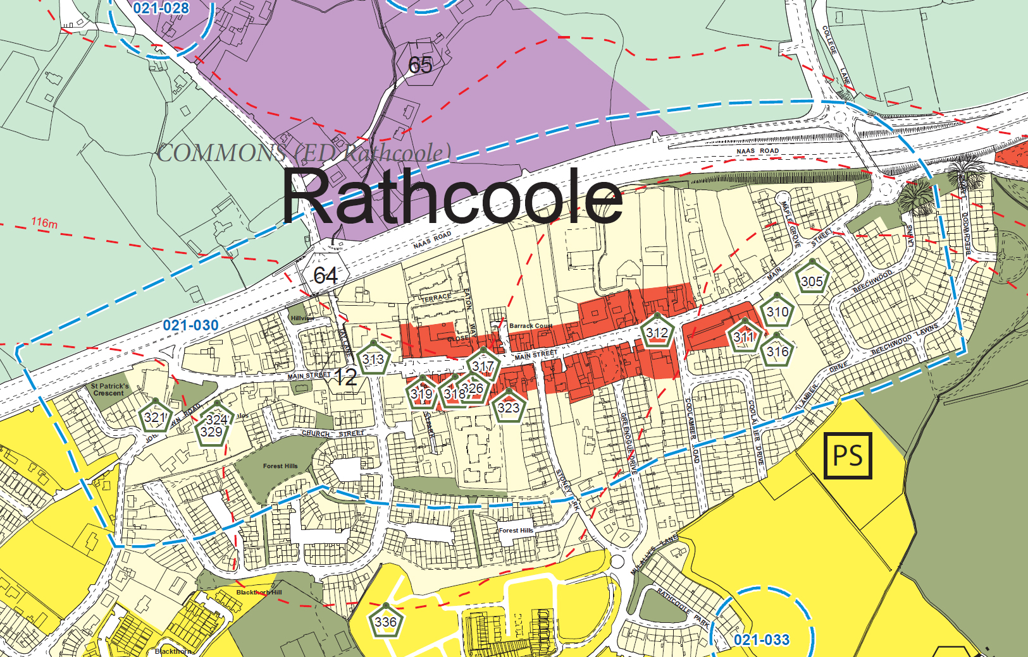  An extract from the South Dublin County Council Development Plan 2010-2016  The proposed development sites are beside red and yellow coloured areas, respectively zoned to “protect, provide for and/or improve Local Centre facilities”, and to “protect and/or improve Residential Amenity”.  The protected structures are identified by a number within a green hexagon, numbers 305, 310, 311, 316, 317, 318, 321, 323, 324, 326, 329 being the relevant numbers  The Zone of Archaeological Potential is indicated by a white and blue dashed line.
Project Partners | Department of Land Use Planning and Transportation  Department of Economic, Enterprise and Tourism Development  Local Community and residents  Tidy Towns Group
Site / Services Constraints: | All major existing services runs have been identified for the design.
Schedule of Part 8 Submissions  Received | The following is the list of the parties submitting formal written observations or submissions under the provisions of the Part VIII Consultation, as provided for in the legislation. [ see Site Notice / Public Notice text as displayed above ]. Observations made during the consultation process have also been included.  1. Rathcoole Community Council  2. Collins Maher Martin on behalf of Ciaran and Aisling Reilly  3. Four Districts Day Care Centre  4. Greenogue Drive Residents Association  5. Dept of Arts Heritage and the Gaeltacht  6. Rathcoole Church of Ireland Parish
Part 8 Submissions  & Commentary | Summary of observations and submissions made under Part VIII  Entrance to Health Centre, Day care centre and Church of Ireland request for removable bollards here and wider entrance to allow two way traffic:  Removable bollards will be provided and a key given to stakeholders.  The stone walls at the Chuirch yard are of great significance to the Church and it is felt that a widened entrance will increase speeds here. We wish to improve the balance of pedestrians and cars in this sensitive location and wider radii at the entrance will increase speeds and mitigate against pedestrian safety and activity here.  Junction of Main St and Johnstown/Kilteel road request for review of recent works here which are providing difficulty for larger vehicles:  This review is being carried out by our Roads Department.  Provision of off street parking:  3No on street parking spaces are to be removed in total as part of the works. An audit of parking provision in the village is in progress  Provision of parking for people with limited mobility:  An audit has been carried out and additional accessible parking will be provided as a result.  Facilitate use of mobility scooters/wheelchairs and tactile paving at dropped kerbs in line with the age friendly status of village:  Improved accessibility will be provided and is central to the proposed works.  Review of parking at Main St. and Church of the Holy Family of large vehicles:  This area is not effected by the Part VIII and no proposals have been made in relation to the entrance to the Church.  Ducting for Christmas lights in paths where paving is being replaced:  This will be examined and provided if not cost prohibitive, however the location of existing utilities in the area show that this may not be possible. A suitable serviced location will be provided in agreement with the local committees for a village Christmas tree as part of this process.  Community Notice Board and Village Directory Sign:  A suitable location for these will be provided as part of the detailed signage strategy which is underway.  Choice of Trees should not obscure visibility:  The choice of trees will be carefully considered as part of the design.  Liaise with Rathcoole Tidy towns for timing of works and planting:  This will be done.  Requesting that access on west and east of protected structure on Main St be maintained:  This area will be redesigned and an entrance will be maintained here.  Request that concrete path linking Greenogue Drive with Main St be replaced with same paving as proposed:  The paving at the main Street end will be upgraded as part of the works. The private laneway is not part of the proposed Part VIII.  Pedestrian crossing at School – request that pedestrian lights 78m up Main St be moved to here:  Following on from initial discussions with our traffic Dept, it is deemed that the existing crossing is working well at school times and that moving the lights is not part of this Part VIII proposal.  Confirmation that new bollards will be positioned to stop cars using passageway:  This will be maintained.  Archaeological Monitoring shall consist of the following:  SDCC will employ a qualified archaeologist to monitor groundworks.  Should archaeological material be found, works on site may be stopped pending a decision on how best to deal with the archaeology and SDCC will notify Dept of Arts Heritage and the Gaeltacht.  The Planning Authority and Dept of Arts Heritage and the Gaeltacht shall be furnished with a report describing the results of monitoring.  Observations and Submissions – summary  The issues raised by the above parties were largely supportive of proposed development and the detailed concerns will be addressed as reported above.
Schedule of Part 8 Submissions  Received | The following is the list of the parties submitting formal written observations or submissions under the provisions of the Part 8 Consultation, as provided for in the legislation. [ see Site Notice / Public Notice text as displayed in County architects Report ]. Observations made during the consultation process are have also been included.  1. Rathcoole Community Council  2. Collins Maher Martin on behalf of Ciaran and Aisling Reilly  3. Four Districts Day Care Centre  4. Greenogue Drive Residents Association  5. Dept of Arts Heritage and the Gaeltacht  6. Rathcoole Church of Ireland Parish

/tmp/in/input.doc

