In addition to the report here are two sample photos.

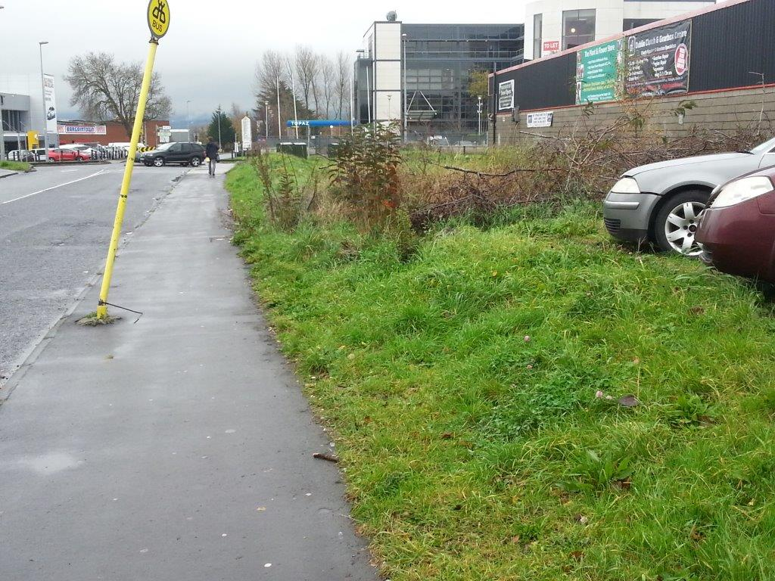
Photo 1: Old Belgard Road – Off Belgard Luas Station – Entrance road into Cookstown Industrial Estate

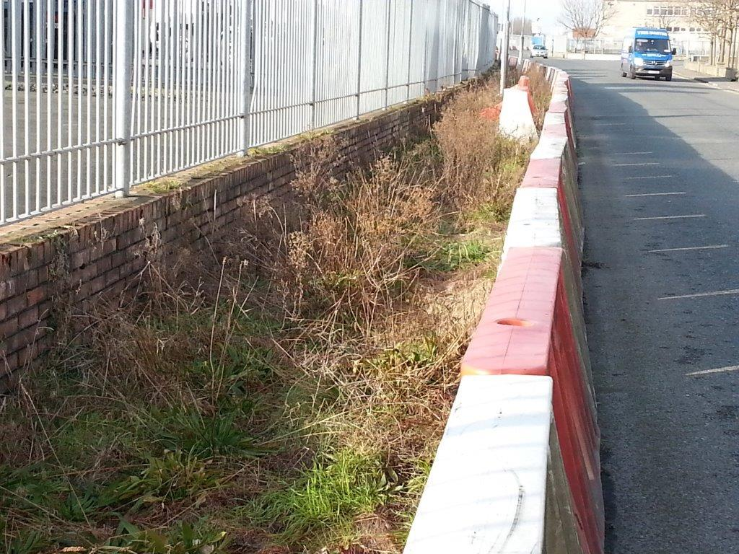
Photo 2: JFK Drive – Temporary Plastic Bollards protecting the Camac Culvert

