Draft Report – Countywide Taxi Ranks Proposal
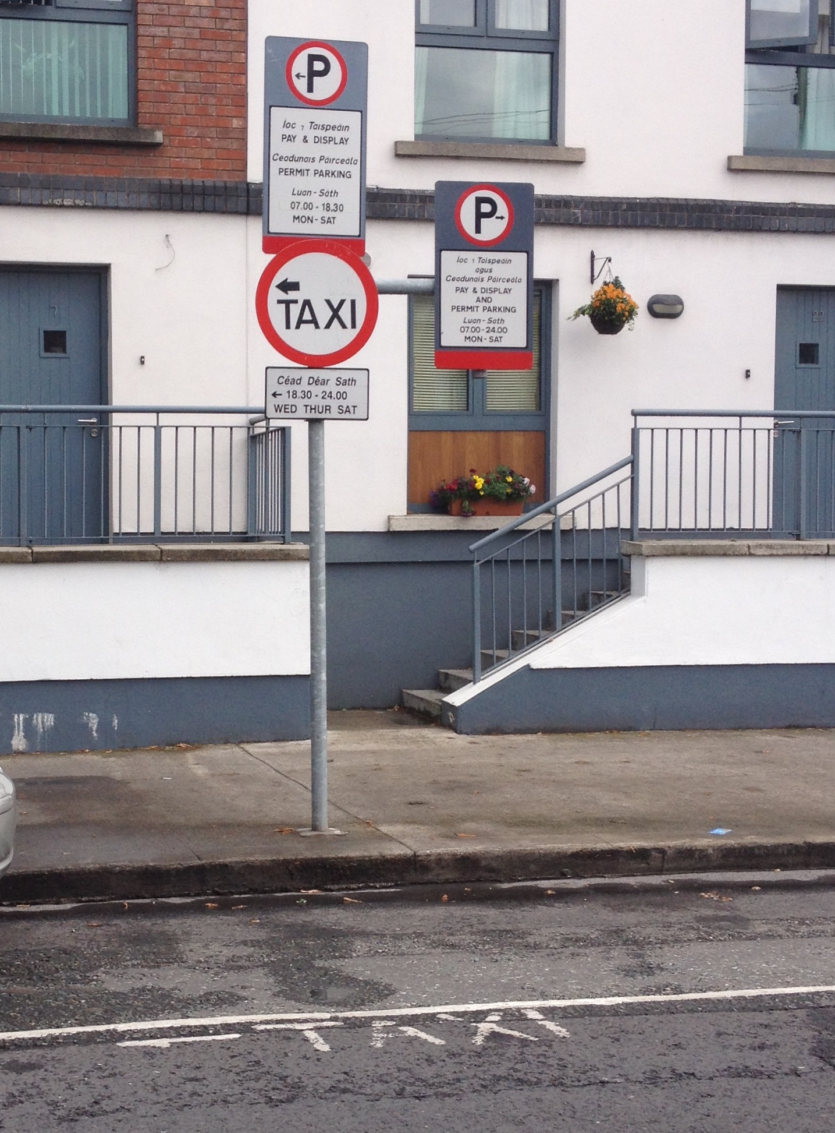
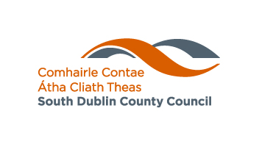
December 2014

Land Use Planning and Transportation Traffic Section

List of possible appointed stands (street service vehicles) in South Dublin County Council
[Taxi ranks]
To be read in conjunction with Draft Bye-Laws

Clondalkin
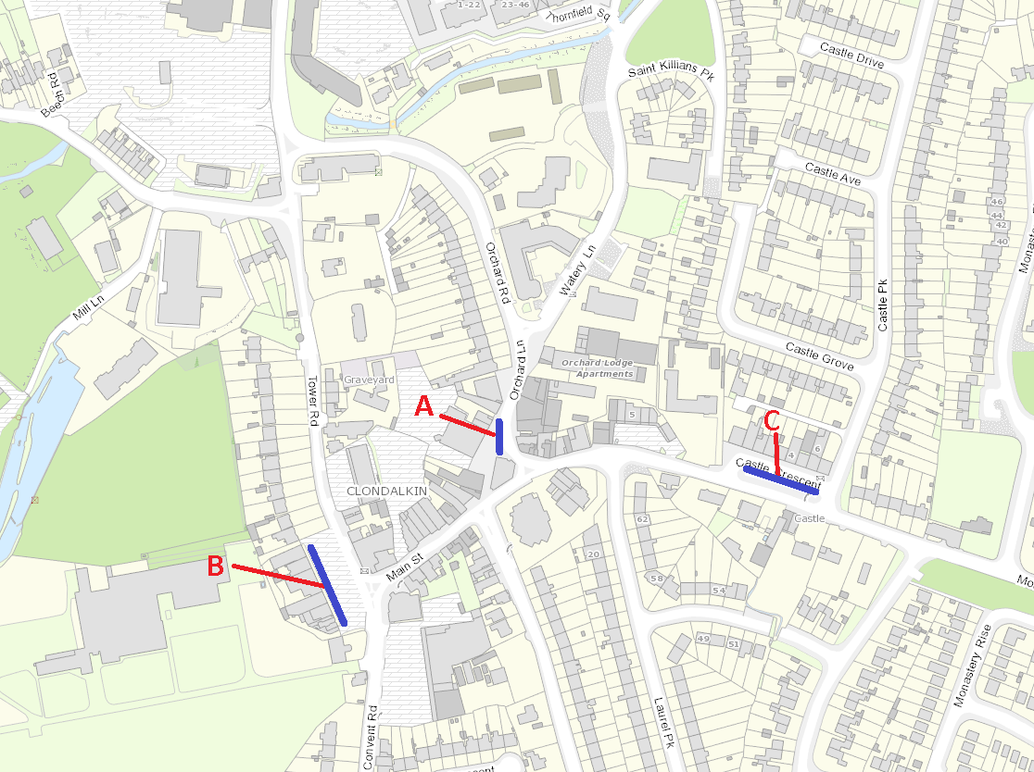
Proposed Location | Road Name | Street type | Day / night/ 24hr
A | Orchard Lane | Pubs Shops | 24hr
B | Tower Road (Service Road) | Restaurant Shops Bank | Night
C | Castle Cresent | Shops | Night

Lucan
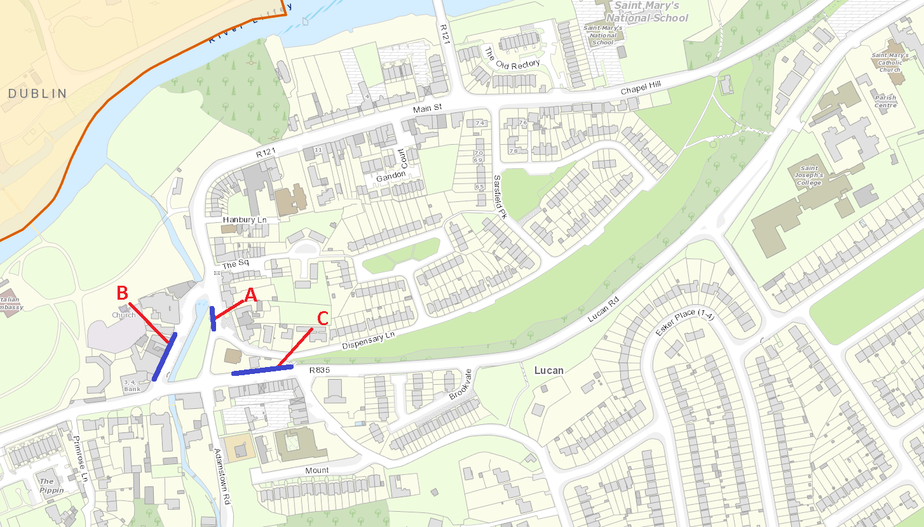
Proposed Location | Road Name | Street type | Day / night/ 24hr
A | Dispensary Lane | Restaurant Shops Bank Pubs | 24Hr | Existing 4 car rank
B | Main Street | Shops Bank Pubs | Night
C | Lucan Road | Restaurant Shops Pubs | Night

Palmerston
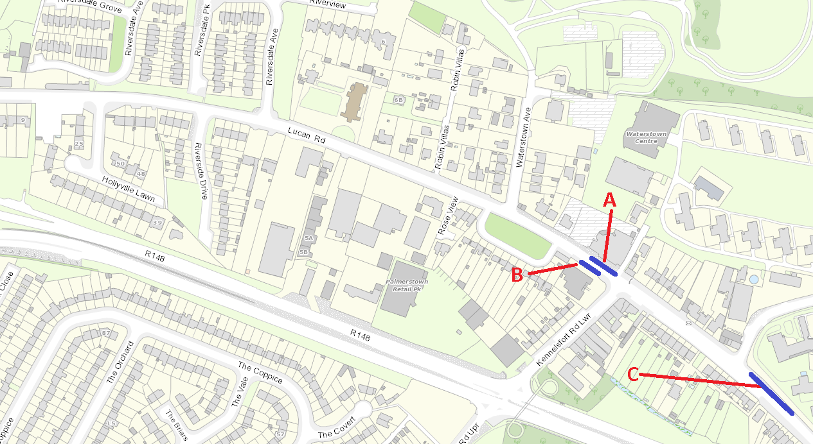
Proposed Location | Road Name | Street type | Day / night/ 24hr
A | Old Lucan Road | Restaurant Shops Bank Pubs | Night
B | Old Lucan Road | Restaurant Shops Bank Pubs | 24hr
C | Old Lucan Road | Restaurant Shops Bank Pubs | Day time only

Rathcoole
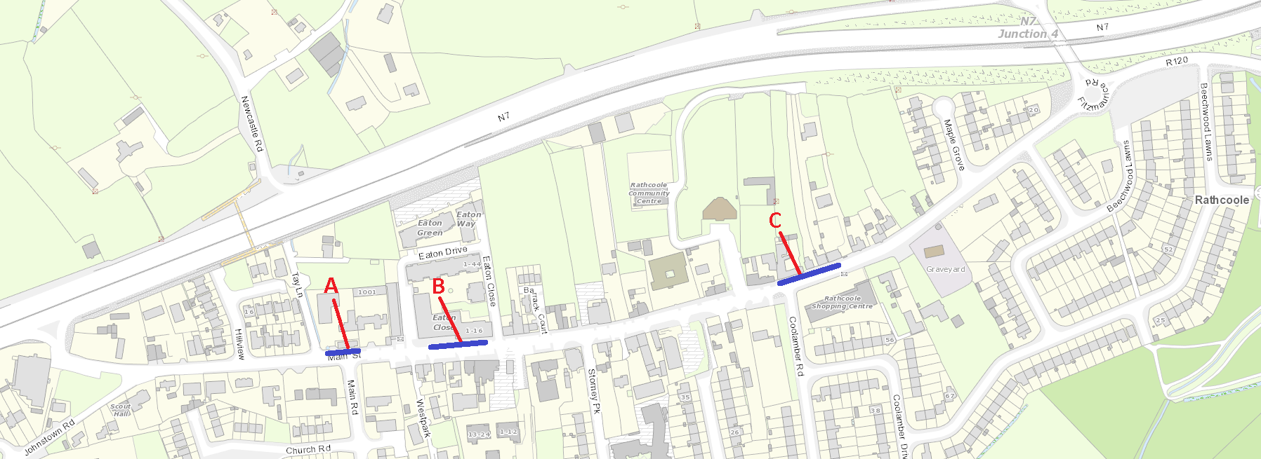
Proposed Location | Road Name | Street type | Day / night/ 24hr
A | Main Street | Restaurant Shops Bank Pubs | 24hr
B | Main Street | Restaurant Shops Bank Pubs | Night
C | Main Street | Restaurant Shops Bank Pubs | Night

Rathfarnham
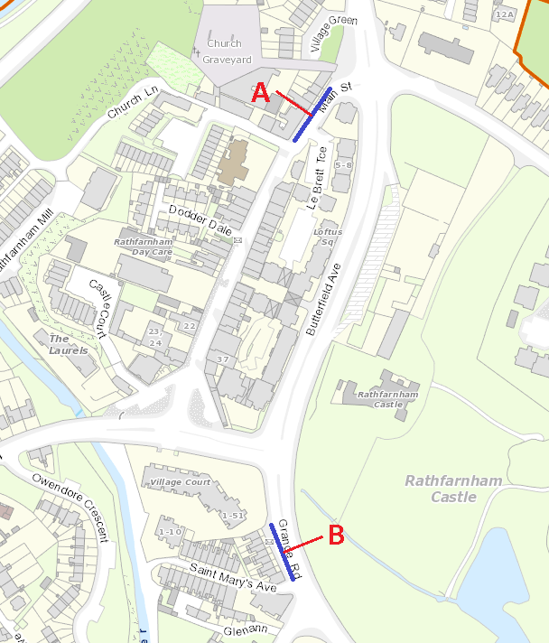
Proposed Location | Road Name | Street type | Day / night/ 24hr
A | Main Street | Restaurant Shops Bank Pubs | 24hr
B | Grange Road | Restaurant Shops Bank Pubs | Night

Tallaght
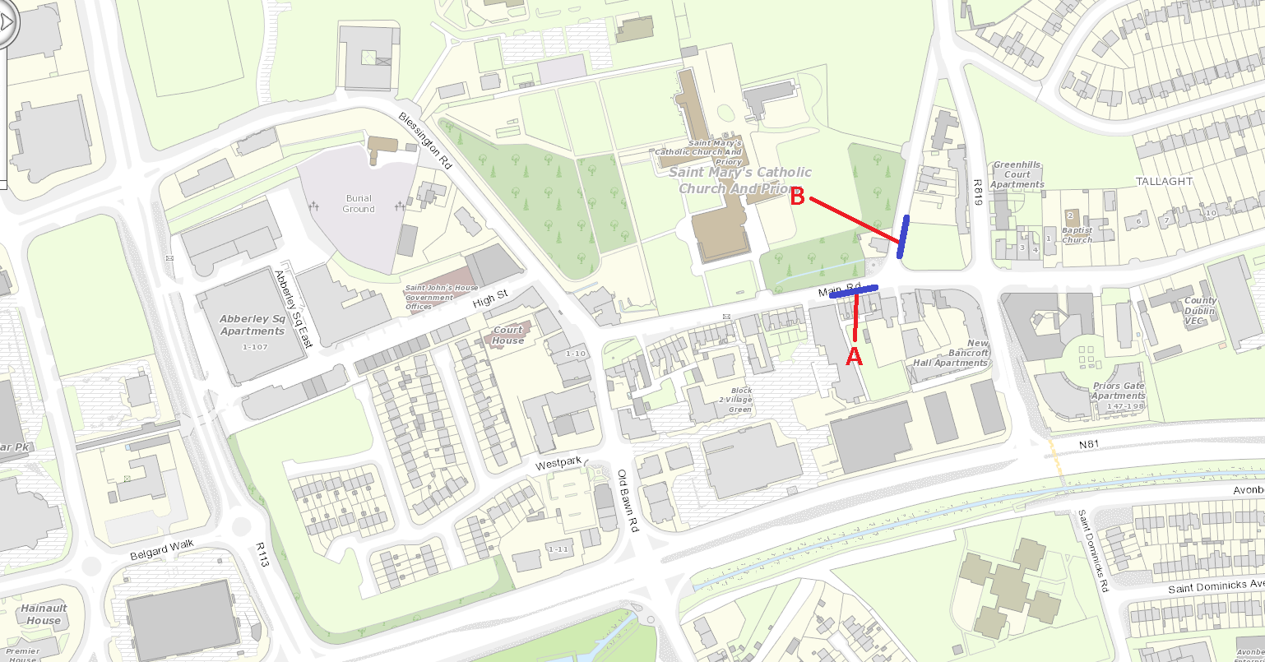
Proposed Location | Road Name | Street type | Day / night/ 24hr
A | Main Street | Restaurant Shops Bank Pubs | 24hr
B | Old Greenhills Road | Restaurant Shops Bank Pubs | Night

Templeogue
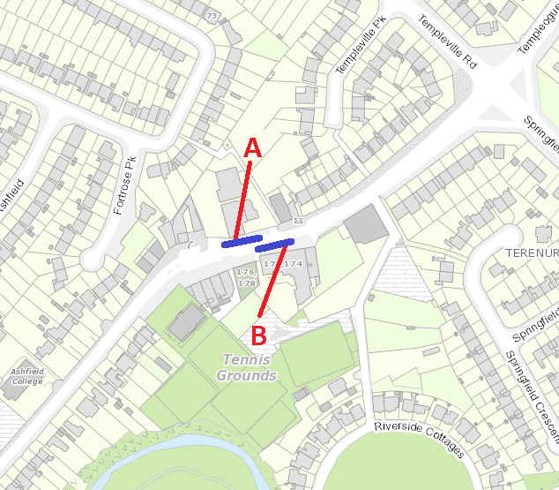
Proposed Location | Road Name | Street type | Day / night/ 24hr
A | Main Street | Restaurant Shops Bank Pubs | 24 hr
B | Main Street | Restaurant Shops Bank Pubs | 24hr

