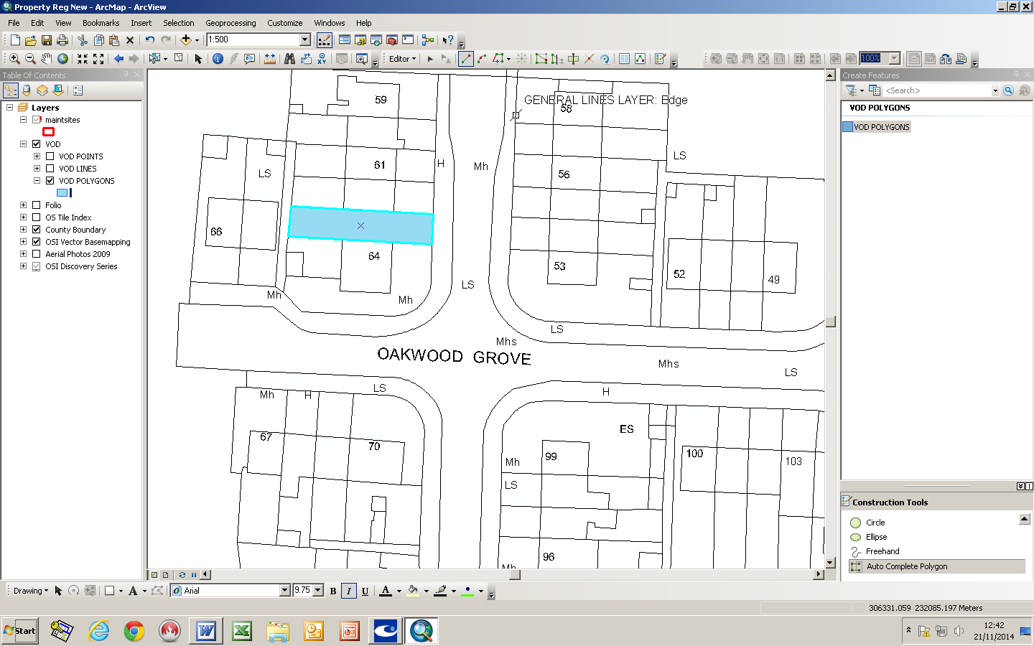
63 Oakwood Grove


Department:  Economic Enterprise and Tourism Development | Small Builders Scheme-  Shaded in Blue
House No:63 | Address:  Oakwood Grove
Townland :  Clonburris Great | Owners:  Sean and Francis O’Connor

