COMHAIRLE CONTAE ÁTHA CLIATH THEAS
SOUTH DUBLIN COUNTY COUNCIL

Meeting of Lucan Area Committee
Tuesday, 28 October 2014
Headed Item No. 6
South Dublin County Council
Procedures for the Execution of Winter Maintenance Operations in the Roads Department of South Dublin County Council
Winter Maintenance System WMS 2014-2015

1. Table of Contents

1. Table of Contents Page 2
1.1 Document Management 3
1.2 Glossary of Terms 3
1.3 Purpose and Scope 4
1.4 Precautionary Gritting 5
1.5 Emergency Scenarios 5
1.6 Trial Run of Salt Bins ....................................................................................................5
1.7 Road Weather Information System Arrangements 6
2. Depots 7
3. Health & Safety………………………………………………………………………………………………………………7
3.1 Drivers Daily Defect Report 7
3.1 Lone Working 7
4. Responsible Persons 8
4.1 Duty Engineers 8
4.2 Depot Inspectors 8
5. Procedures and Rosters 9
5.1 Duties of the duty Engineer 9
5.2 Monday – Friday Procedure 9
5.3 Weekend (Sat. - Sun.) and Bank Holidays Procedure 10
5.4 Winter Maintenance Duty Engineers’ Roster 10
5.5 Rates of Spread for Precautionary Salting 10
5.6 Treatment of snow already on the road after Precautionary Salting 11
5.7 Treatment of Hard-Packed Snow and Ice 11
6. Appendices …………………………………………………………………………………………………………………..12
6.1 Appendix 1 Salting Routes…………………………………………………………………………………………….12
6.2 Appendix 2 Priority Routes……………………………………………………………………………………………13
6.3 Appendix 3 Salt Bin Locations …………………………………………………………………………………….14
6.4 Appendix 4 Risk Assessments……………………………………………………………………………………..15-20
6.5 Appendix 5 Driver Checklist……………………………………………………………………………………..21-24
6.6 Appendix 6 Safe Working Alone System………………………………………………………………………..…25
6.7 Appendix 7 Winter Maintenance Roster 2013-14……………………………………………………………..26

1.1 Document Management

Date | Version | Author
01/09/2010 | DRAFT | V. Dennan
13/10/2011 | 2011 Rev01 | G. Walsh
14/10/2011 | 2011 Rev02 | G. Walsh
19/10/2011 | 2011 Rev03 | V. Dennan
04/10/2012 | 2012 Rev01 | G. Walsh
05/10/2012 | 2012 Rev02 | G. Walsh
03/10/2013 | 2013 Rev01 | S. Tsang
17/12/2013 | 2013 Rev02 | S. Tsang
11/09/2014 | 2014 Rev01 | S. Tsang

1.2 Glossary of Terms

N | N.P | National Primary
 | N.S | National Secondary
S | S.D.C.C | South Dublin County Council
W | WMS | Winter Maintenance System

1.3 Purpose and Scope

South Dublin County Council (SDCC)’s road network consists of
- 73km National Roads
- 144km Regional Roads
- 785km Local Roads
Winter maintenance is confined to National, Regional and Local routes. National Primary routes are gritted by the NRA; National Secondary, Regional and Local routes are gritted by SDCC. The percentages of roads gritted by SDCC are summarized below in Table 1.

 | Gritted  (km) | Total  (km) | %
National Secondary | 13 | 13 | 100%
Regional | 144 | 144 | 100%
Local | 189 | 785 | 24.1%

Table 1

There are 7 Salting routes in SDCC. These Salting Routes can be seen in Appendix 1.

The purpose of this document is to identify the processes, procedures and control measures employed by South Dublin County Council, to ensure that Winter Maintenance works are carried out in accordance with procedural and Health and Safety requirements. All members of staff involved with Winter Maintenance shall be fully acquainted with this Winter Maintenance Strategy and will have access to copies of it.

1.4 Precautionary Gritting

The primary aim is to keep these roads safe and as free as possible from winter hazards.

In order to do this, SDCC Roads Department spreads salt/grit on these roads before ice or snow is expected (called Precautionary Gritting), this operation of pre-salting is timed to be completed before the onset of freezing or snowfall.

 | Road | Length (km)
Route 1 | Lucan | 41.91
Route 2 | Clondalkin | 58.83
Route 3 | Saggart | 27.18
Route 4 | Tallaght | 47.83
Route 5 | Kimmage | 44.43
Route 6 | Ballyboden | 50.16
Route 7 | N81 | 53.52
Table 2

1.5 Emergency Scenarios
If snow or ice settles, snowploughing, salting and gritting is put into action. South Dublin County Council is constantly striving to improve the winter maintenance service.

Priority routes have been prepared to deal with emergency scenarios such as sudden snow storms or prolonged periods of freezing temperatures. S.D.C.C has also prepared specific routes to deal with; reduced driver numbers, low salt and heavy snowfall.

Priority Routes can be seen in Appendix 2.

1.6 Salt Bins for Public Use
In the 2011-2012 season, a trial was carried out which involved leaving Salt Bins at 15 specified locations throughout the county (3 per electoral area). These locations are in local estates and areas with severe slopes that are not on our salting routes but have been identified as problem areas during icy conditions. For the 2013-2014 season this trial will been extended to include a further 2 Salt Bins in each electoral area.

These Salt Bins will be kept stocked with rocksalt so that members of the public can treat a road if they deem it required. Instructions on spread rate will be provided. The salt bins have a lock on them and the local residents association nominates a member of the public as a keyholder.

Salt Bin locations can be seen in Appendix 3.

1.7 Road Weather Information System Arrangements
The Ice Prediction System is supplied by:
Vaisala TMI Ltd
Vaisala House
349 Bristol Road
Birmingham

Tel No: 0044 (0) 121 683 1200 Fax No: 0044 (0)121 683 1299

Vaisala in conjunction with Met Eireann issue forecasts daily. The server for the network Ice Prediction System is housed at the Vaisala office in Birmingham.

The Ice Prediction System polls the outstations on the network at maximum intervals of one hour. This may be reduced to shorter intervals depending on conditions during the winter season.

The weather station for SDCC is located on the N81 at the Mahons Lane junction.

2. Depots

SDCC currently operates Winter Maintenance operations from Ballymount and Palmerston Depots. The Ballymount Depot Salt Barn is our largest and is in close proximity to the M50. A new Salt Barn was constructed in the Palmerston Depot, adjacent to the N4. This Salt Barn came into operation in November 2011.

3. Health & Safety
SDCC will ensure so far, as is reasonably practicable:
- Safe and healthy working conditions,
- Safe equipment and systems of work,
- Provision of appropriate information, instruction, training and supervision,

This procedural document should be read in conjunction with
- Roads Maintenance Ballymount – Risk Assessments (Mounting and Loading Gritter, Gritting Roads and Snow Plough)
- Roads Maintenance Palmerston – Risk Assessments (Mounting and Loading Gritter, Gritting Roads and Snow Plough)
A copy of which is attached in Appendix 4 below.

3.1 Drivers Daily Defect Report
Before any driver can leave a depot to carry out a salting run they must carry out a checklist on the vehicle to ensure that there are no obvious defects with it.
This checklist can be seen in Appendix 5.

3.2 Lone Working
Where Lone working occurs, the procedures outlined in Appendix 6 below shall be utilised.

4. Responsible Persons

Winter Maintenance coordinator:
Michael Glynn, Senior Executive Engineer, Road Maintenance

4.1 Duty Engineers 2014

Name | Position | Contact Numbers
Name | Position | Mobile
Tony O’Grady | Senior Engineer | 086 8560552
Gary Walsh | Assistant Engineer | 086 0479609
Michael Glynn | Senior Executive Engineer | 086 1723274
Padhraic McGillycuddy | Area Engineer | 086 2346174
Caitriona Lambert | Senior Executive Engineer |  | 086 8506771
Sally Tsang | Assistant Engineer |  | 086 0431469

The 2014-2015 roster for Duty Engineers can be seen in Appendix 7.

4.2 Depot Inspectors 2013

Name | Depot | Routes | Contact Numbers
Name | Depot | Routes | Mobile
Paddy Hearns | Palmerston | 1, 2, 3 | 086 8509993
Tony Murphy | Ballymount | 5, 6 | 086 6087029
Mick Redmond | Ballymount | 4, 7 | 087 1984649

5. Procedures and Rosters

A roster of Duty Engineers to give 24-hour coverage has been agreed to manage information from Met. Eireann and Vaisala. The Duty Engineer will have authority to instruct treatment as required. Consultation with the Winter Maintenance Coordinator will be carried out as necessary.

The Duty Engineer will also ensure plant and personnel are mobilised. The Duty Engineer will instruct the Inspector when a decision to treat has been made. The Inspector will ensure the drivers are instructed and ready to treat the road at the time required. The Inspector will take instruction from the Duty Engineer.

5.1 Duties of the duty Engineer
The Pre-salting Phase will be activated by the Duty Engineer in the event of ice or adverse weather prediction from the Vaisala Netvigator service. This is normally issued before 2.30pm in the afternoon.
Pre-salting shall commence at the time determined by the Duty Engineer to ensure the completion of routes before the onset of icy conditions. As the Vaisala Netvigator forecast and data is available at 2.30 pm therefore it is expected that the callout is given as early as possible particularly on a Friday in order that arrangements can be made before personnel finish work.

5.2 Monday – Friday Procedure
- The Duty Engineer checks the Vaisala Netvigator and forecast at or before 2.30pm each day.
- In the event of the forecast of ice conditions the Duty Engineer notifies the Inspector on call before 3.30pm, of routes to be pre-salted and time of commencement.
- The Inspector then notifies the drivers and the Machinery Yard Foreman on call for that week.
- The Duty Drivers proceed to their parking depots at the end of their normal working day and fit the salt spreaders.
- The Inspector notifies the loader driver, proceeds to the salt depot at the end of normal working time, and prepares the depot for loading of salt.
- At the designated time, the drivers will collect their machines, load salt and pre-salt their prearranged routes, on completion the driver will return the spreader to its parking location.
- The Inspector will be on standby in the event of breakdown.
- From the call out time, the Inspector will monitor the operations and in the event of breakdown will call out a fitter, or activate the standby salt spreader whichever he feels appropriate.

5.3 Weekend (Sat. - Sun.) and Bank Holidays Procedure
The pre-salting duty roster is as above
- The Duty Engineer checks the Vaisala Netvigator and forecast at or before 2.30pm each day.
- In the event of the forecast of ice conditions he notifies the Inspector on call before 3.30pm, of routes to be pre-salted and time of commencement.
- The Inspector notifies the drivers and Machinery Yard Foreman on call for that week, of the time of callout.
- The Inspector notifies the loader driver, proceeds to the salt depot at the time appointed and prepares the depot for loading of salt.
- The Duty Drivers proceed to the depot at the appointed time, load salt, proceeds to complete assigned routes, and on completion the driver will return the salt spreader to its parking location.

5.4 Winter Maintenance Duty Engineers’ Roster
The 2013-2014 roster for Duty Engineers can be seen in Appendix 7.

5.5 Rates of Spread for Precautionary Salting

It is intended that Precautionary Action forms the major part of winter operations.

For frost and road surface temperatures at or above -2ºC, salt shall be spread at 10-20 g/m² dependant on local conditions and the immediate forecast.

If freezing conditions are expected after rain or frost and the road surface temperature is below -2ºC, spread rates will be increased to 20-30 g/m² according to the amount of moisture present and the temperature expected. Unless freezing conditions coincide with rainfall, salting shall be delayed as long as possible to reduce loss of salt by run-off.

If continuous snow is forecast, salt shall be spread at 30-40 g/m² according to the anticipated severity of the snowfall. Every effort will be made to ensure enough salt is applied before snow starts to stick to the road to melt the initial snowfall and to provide a wet surface.

The spread rates for precautionary salt treatments are summarized below.

Weather Conditions | Definition | Salt Spread Rate (gram/square metre)
Light | Frost and/or light snow | 10
Moderate | Freezing conditions after rain | 20 to 30
Severe | Continuous snow | 30 to 40

For a single precautionary treatment on all Priority 1 and 2 routes at a spread rate of 10 g/m², the tonnage of salt required would be 19t. This would be on a night when a hoar frost is expected, and the road surface temperature will be at or above -2°C.

5.6 Treatment of snow already on the road after Precautionary Salting

Snow ploughing will commence on major routes as shown in Appendix 2 as directed by the Duty Engineer. Each pass of the plough shall be supplemented by an application of salt at a rate as per the table above. Special salting may be necessary to deal with melted water from snow, which may freeze at night, and a watch will be kept for such conditions.

5.7 Treatment of Hard-Packed Snow and Ice

If the previous procedures are carried out successfully then the formation of hard-packed snow should be prevented. However, in cases where hard-packed snow and ice occur and provided that the ice is no more than 20mm thick and the air temperature is below -5ºC, then removal shall be carried out by successive salt applications of 20-40 g/m².

6. Appendices

6.1 Appendix 1 - Gritting Routes

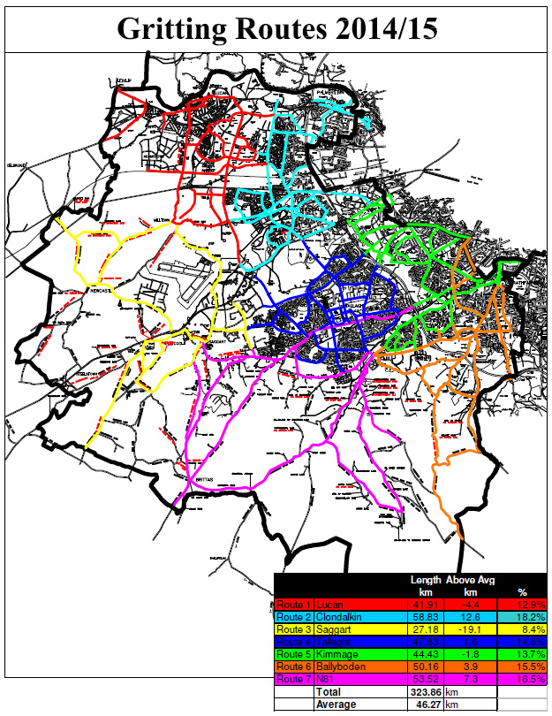

6.2 Appendix 2 - Priority Routes

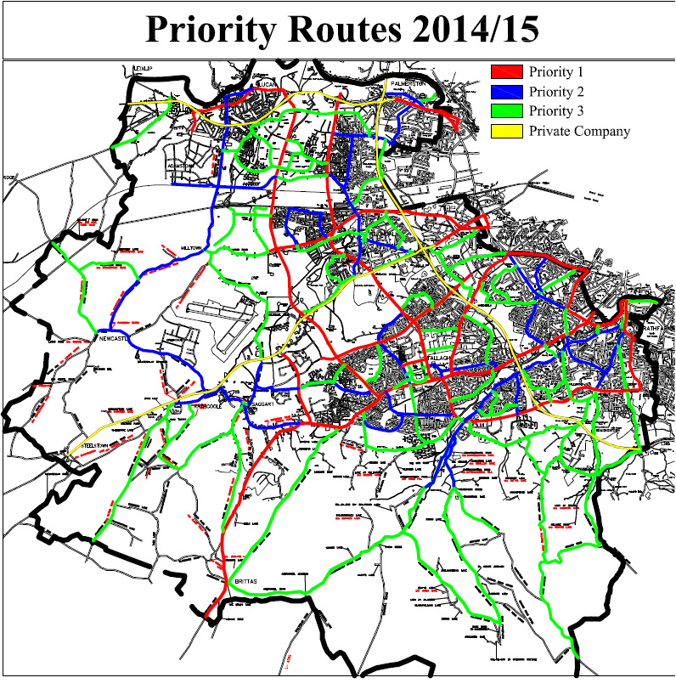

6.3 Appendix 3 - Salt Bin Locations during Trial Run

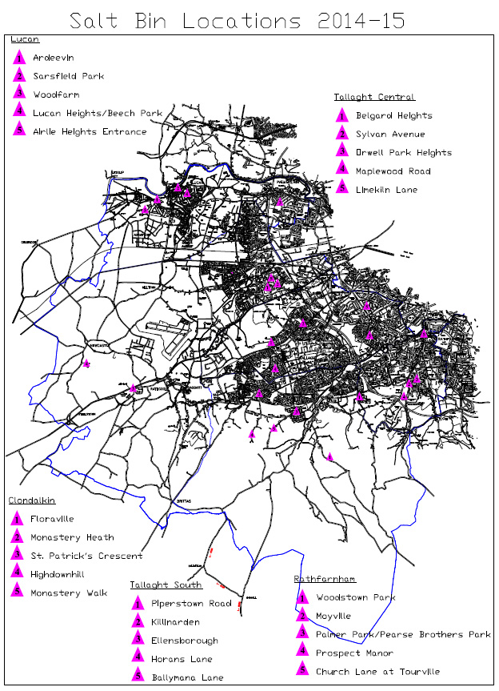

6.4 Appendix 4 – Risk Assessments



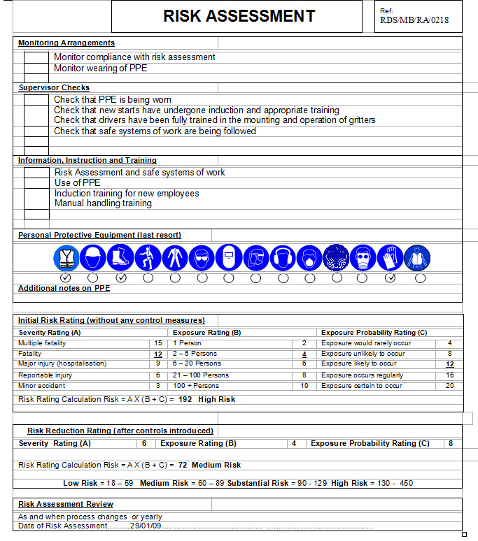
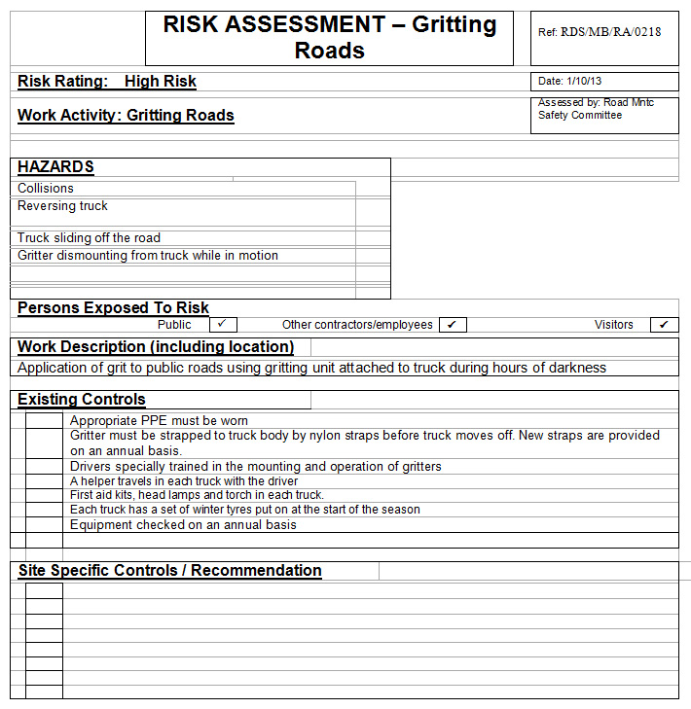
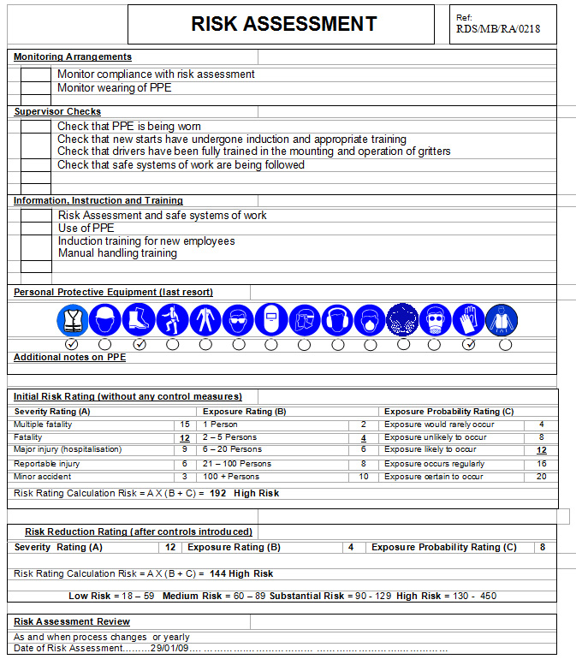
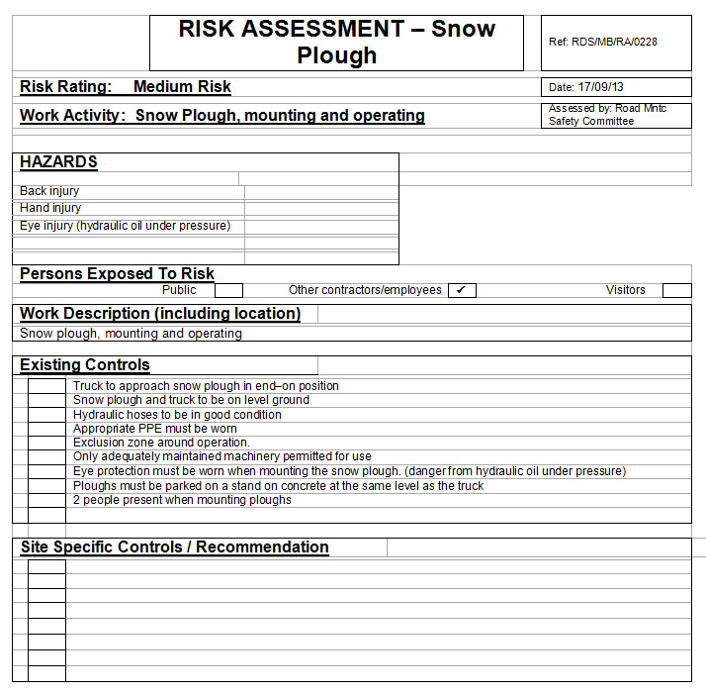
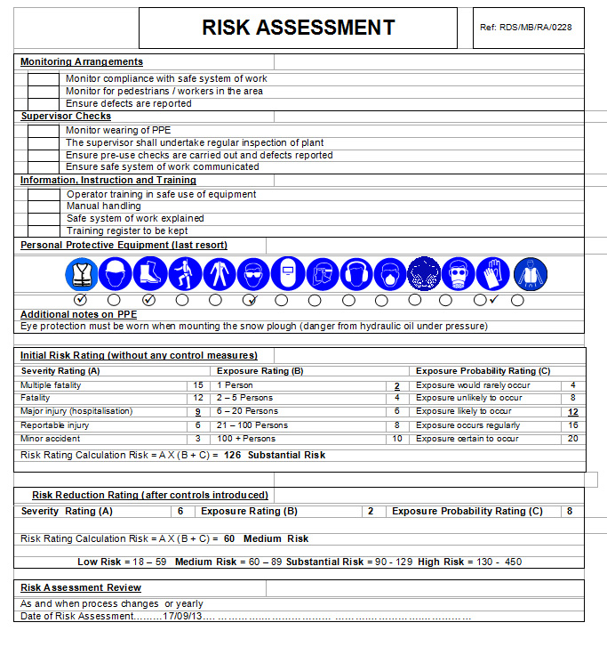

6.5 Appendix 5 – Driver Checklist

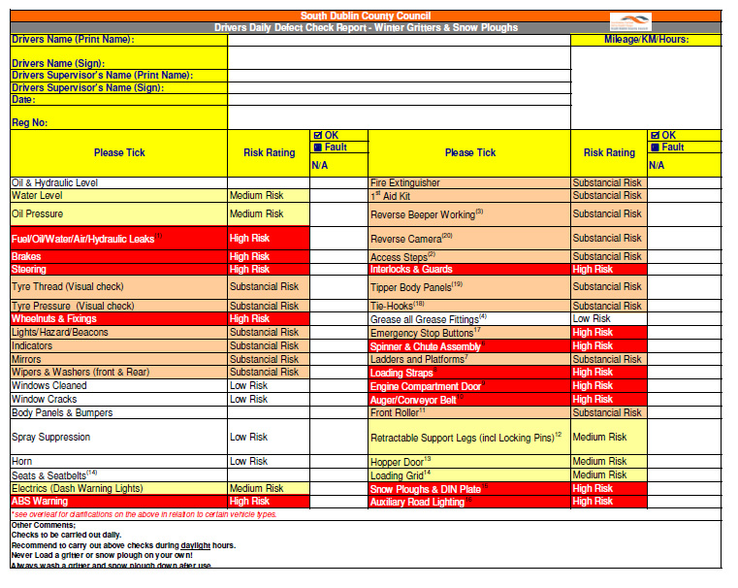
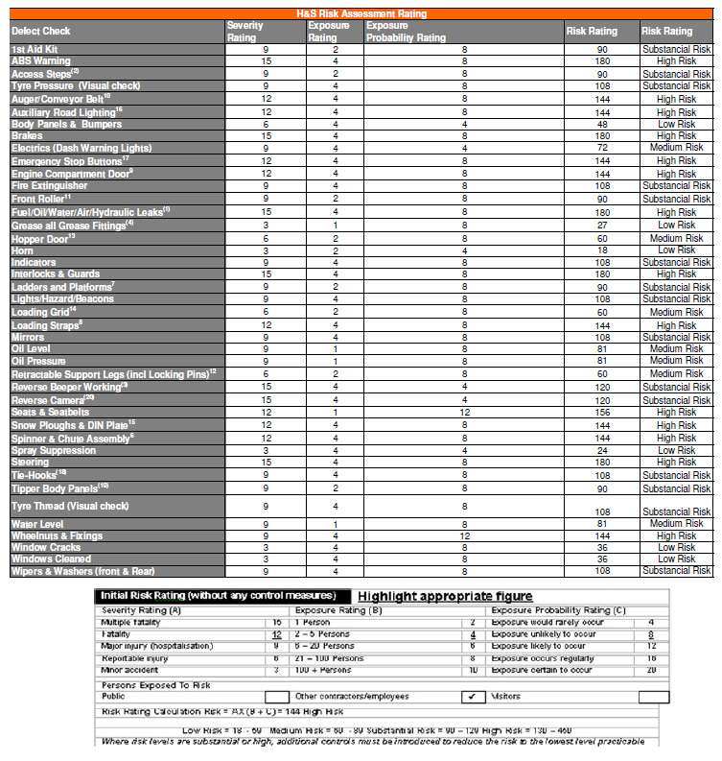
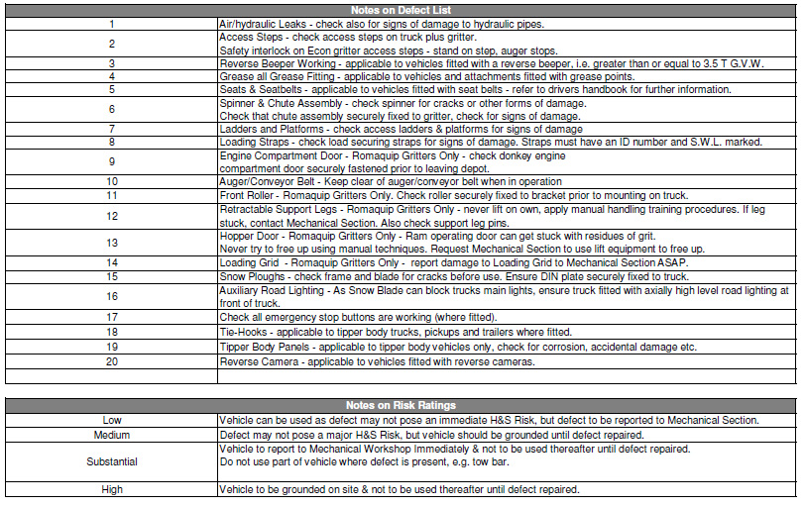
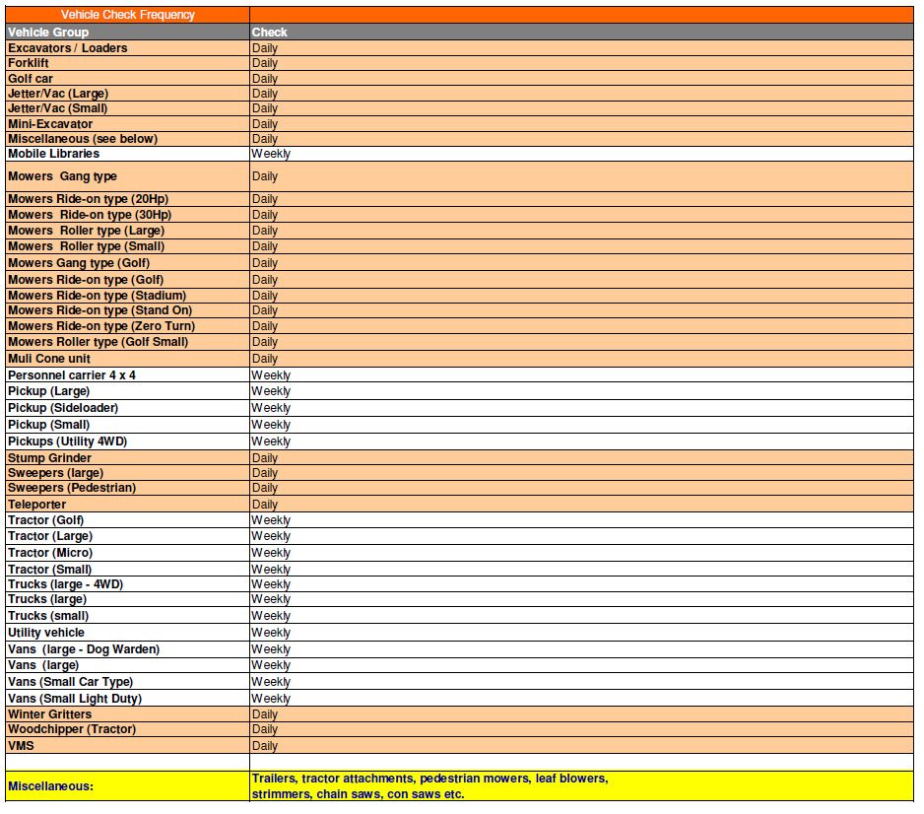

6.6 Appendix 6 - Safe Working Alone System

The Salt Spreading Operations are carried to prevent the occurrence of icy conditions on roads, the main period of activity is from November 1st to March 31st, but it is not exclusive to this period.
The operation when activated is scheduled each night to finish approximately two hours before the onset of icy conditions on the road. The equipment consists of a truck and a gritter mounted on the truck. The gritters are located in the Machinery Yard and the Salt used is stored in the salt barns.

Hazards
The Risk Assessments of the winter salting activity refers to the activity of lone working and lists the controls as follows.
- In the event that a driver operates the Salt Spreading Unit without an attendant, a Safe Working Alone System must be put in place.
- A communication procedure and an emergency procedure must form part of the system.
- An arrangement for periodic checks must be included.

Safe Working Alone System
The following is the lone working procedure to comply with these controls
- Before leaving the depot
  - Complete check of machine
  - Complete check of controls
  - Complete communications check with designated contact

- During Route
  - Check in with designated contact at approximately 30 minute intervals or agreed timing
(Specific check in locations and timings should be agreed with the supervisor and recorded to coincide with specific points on the route e.g. end of specific section of road, suitable stop point, etc)
  - Check in with designated contact on completion of route

Stop Procedure
In the event of stopping during the route, the following shall be the procedure
- Park in a safe location
- Communicate with the designated contact
(When leaving the cab, inform the designated contact that you are leaving the cab, for what purpose and how long you expect to be out of the cab)
- Contact your designated contact on return to the cab
- Personnel Should never mount the Bridge of the Salt Spreader unattended

Breakdown Procedure
- In the event of breakdown during the route, the following shall be the procedure
Park in a safe location
- Communicate with the designated contact
- Remain in the cab and await instructions from your supervisor
6.7 Appendix 7 – Duty Engineer Roster 2014-2015
Winter Maintenance Duty Engineer’s Roster for the period Monday 13th October 2014 to Thursday 30th April 2015

Local Authority: South Dublin County Council

Week starting  Monday | Duty Engineer’s Initials | Week starting Monday | Duty Engineer’s Initials | Week starting Monday | Duty Engineer’s Initials | Week starting Monday | Duty Engineer’s Initials
13/10/2014 | TOG | 1/12/2014 | PMcG | 19/1/2015 | MG | 09/3/2015 | ST
20/10/2014 | TOG | 8/12/2014 | GW | 26/1/2015 | MG | 16/3/2015 | ST
27/10/2014 | TOG | 15/12/2014 | GW | 2/2/2015 | MG | 23/3/2015 | CL
3/11/2014 | TOG | 22/12/2014 | GW | 9/2/2015 | MG | 30/3/2015 | CL
10/11/2014 | PMcG | 29/12/2014 | GW | 16/2/2015 | ST | 06/4/2015 | CL
17/11/2014 | PMcG | 05/1/2015 | GW | 23/2/2015 | ST | 13/04/2015 | CL
24/11/2014 | PMcG | 12/1/2015 | MG | 2/3/2015 | ST | 20/04 and 27/04 | MG/TOG

Duty Engineer’s Name & Initials | Office Phone No | Office Fax No | Office E-mail Address
Padhraic McGillycuddy PMcG | 01 451 9514 | 01 462 7736 | pmcgillycuddy@  sdublincoco.ie
Michael Glynn MG | 01 414 9000 | 01 414 9158 | mglynn@  sdublincoco.ie
Gary Walsh GW | 01 414 9000 | 01 414 9158 | garywalsh@  sdublincoco.ie
Tony O’Grady TOG | 01 414 9000 | 01 414 9158 | togrady@  sdublincoco.ie
Caitríona Lambert CL | 01 414 9000 | 01 414 9158 | clambert@  sdublincoco.ie
Sally Tsang | 01 414 9000 | 01 414 9158 | stsang@  sdublincoco.ie

Send to (E-mail preferable): CAFO, Met. Éireann, Glasnevin Hill, Dublin 9. Attention: Duty SMO E-mail: forecasts@met.ie
Copy to: Ms. Margaret Claffey, National Roads Authority, St. Martin’s House, Waterloo Road, Dublin 4. E-mail: mclaffey@nra.ie

