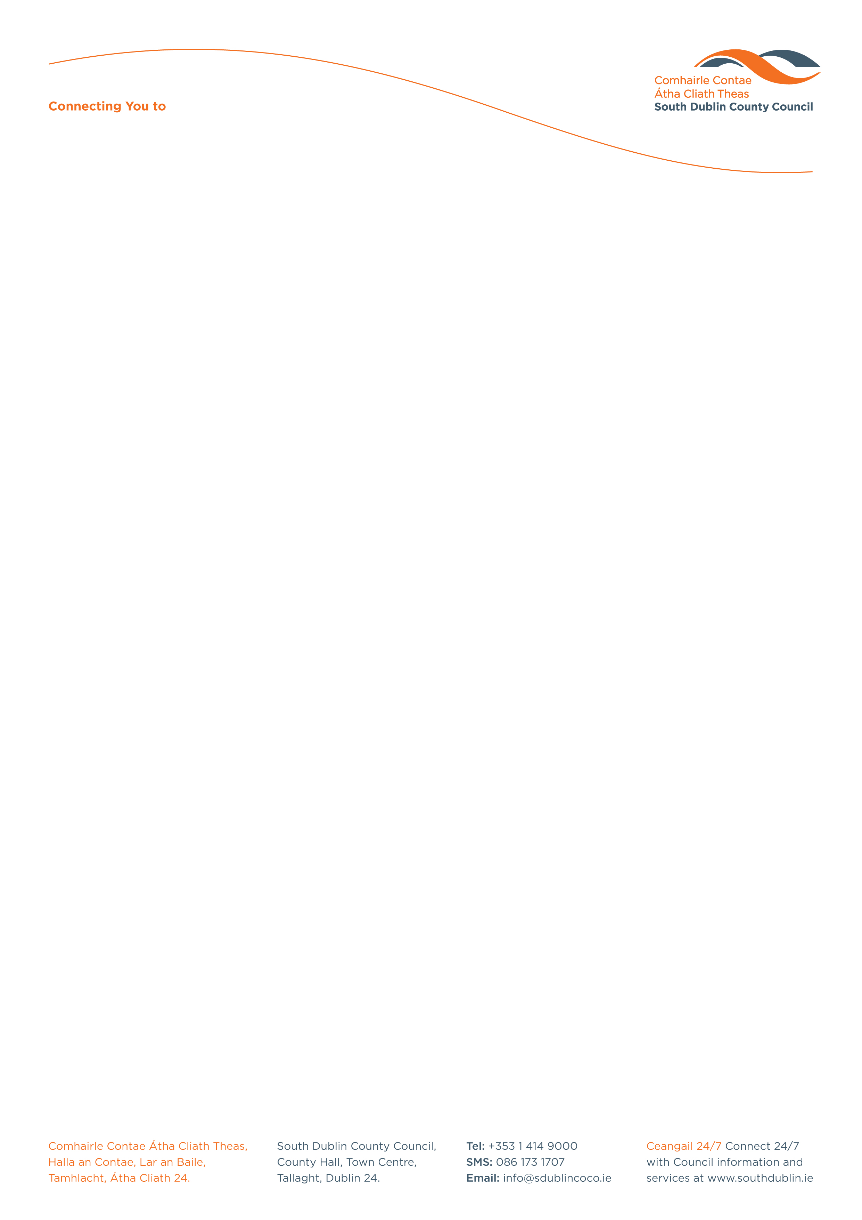

Halla an Chontae, Lár an Bhaile County Hall, Town Centre
Tamhlacht, Baile Átha Cliath 24 Tallaght, Dublin 24
Telefon: 01-4149052 Telephone: 01-4149052

Facs: 01-4149332 Fax: 01-4149332
www.southdublin.ie

Mr. Paddy Doherty,
Chief Executive,
Dublin Bus,
O’Connell Street,
Dublin 1.
April 30th, 2014

RE: Tallaght Area Committee Meeting – 28th April, 2014

Dear Mr. Doherty,

At South Dublin County Council’s Tallaght Area Committee Meeting, held on 28th April, 2014, the following Motion was passed:
“That this Committee reiterates its longstanding call for Dublin Bus to consider the extension of the 123 bus route to the Greenhills area to facilitate linkages with the Luas, Walkinstown Post Office, St James' Hospital and other areas.”

I should be obliged if you would let me have a reply on both matters at your earliest convenience.

Thanking you in anticipation,

Yours sincerely,

Leona Maher,
A/ASSISTANT STAFF OFFICER,
HOUSING ADMINISTRATION.

Housing Administration

