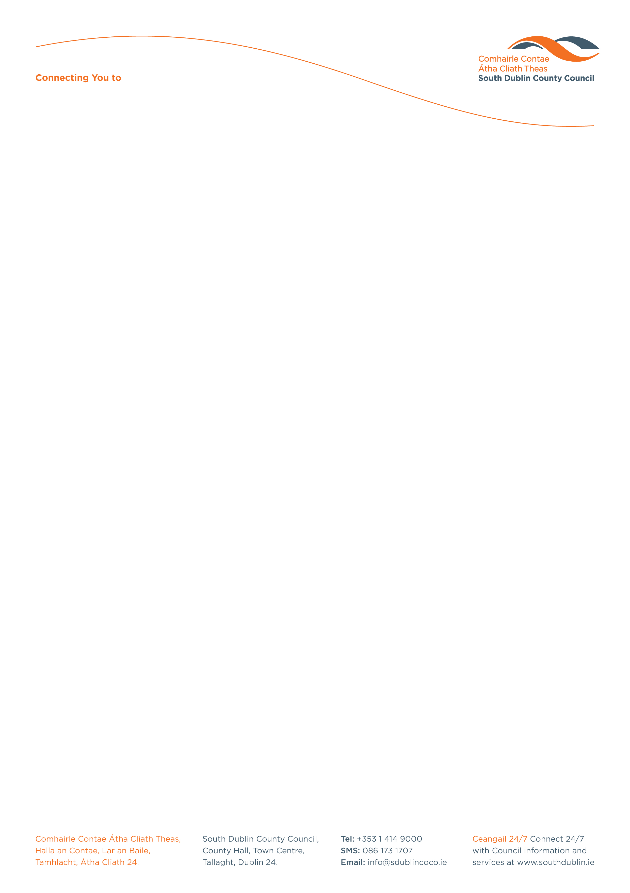

Halla an Chontae, Lár an Bhaile County Hall, Town Centre
Tamhlacht, Baile Átha Cliath 24 Tallaght, Dublin 24
Telefon: 01-4149052 Telephone: 01-4149052

Facs: 01-4149332 Fax: 01-4149332
www.southdublin.ie

Revenue Commissioner,
Plaza Complex,
Belgard Road,
Tallaght,
Dublin 24.
March 25th, 2014

RE: Tallaght Area Committee Meeting – 24th March, 2014

Dear Sir/Madam,

At South Dublin County Council’s Tallaght Area Committee Meeting, held on 24th March, 2014, the following Motion was passed:

“That this Area Committee calls on the Revenue Commissioner to restore normal opening hours to the Dublin Region South County District office, on High Street, to facilitate the growing numbers of customers requiring the service.”

I should be obliged if you would let me have a reply on this matter at your earliest convenience.

Thanking you in anticipation,

Yours sincerely,

Allyson Rooney,
SENIOR STAFF OFFICER,
HOUSING ADMINISTRATION.

Housing Administration

