COMHAIRLE CONTAE ATHA CLIATH THEAS

SOUTH DUBLIN COUNTY COUNCIL

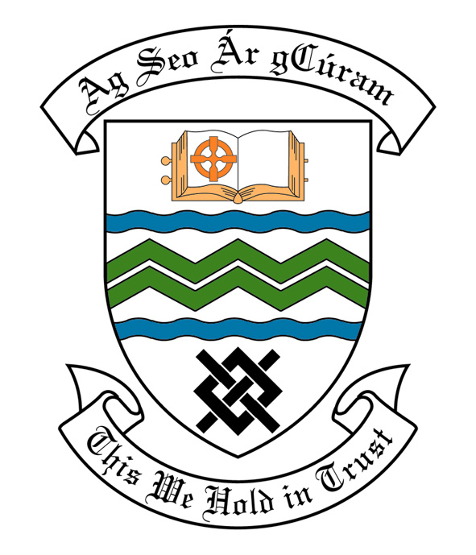
MEETING OF SOUTH DUBLIN COUNTY COUNCIL
MONDAY, 10th March, 2014
HEADED ITEM NO. 2b)

MEETING OF CLONDALKIN AREA COMMITTEE

Wednesday 19th February 2014

HEADED ITEM NO: H- I .(9)

Application for Arts Grants

Applications for Arts Grant under Section 6 of the Arts Act 2003, has been received from the organisations listed below. Payment of this grant, in accordance with the conditions of the Scheme and in the amount set out hereunder, is recommended for approval:-

Ref: | Name of Group | Type of Application | Date Received | Amount
Agf808 | Ronanstown CDP | Grant towards the cost of a drama project for Diversity 55 – an active aging group | 7/02/2014 | €1,000
Agf809 | Clondalkin Art Group | Grant towards the cost of art classes for an active aging group. | 10/2/2014 | €480

It was proposed by Councillor E. Ó’Broin and seconded by Councillor G. Kenny:

“That this Committee recommends that South Dublin County Council APPROVE the grants as recommended in the forgoing report.”

