

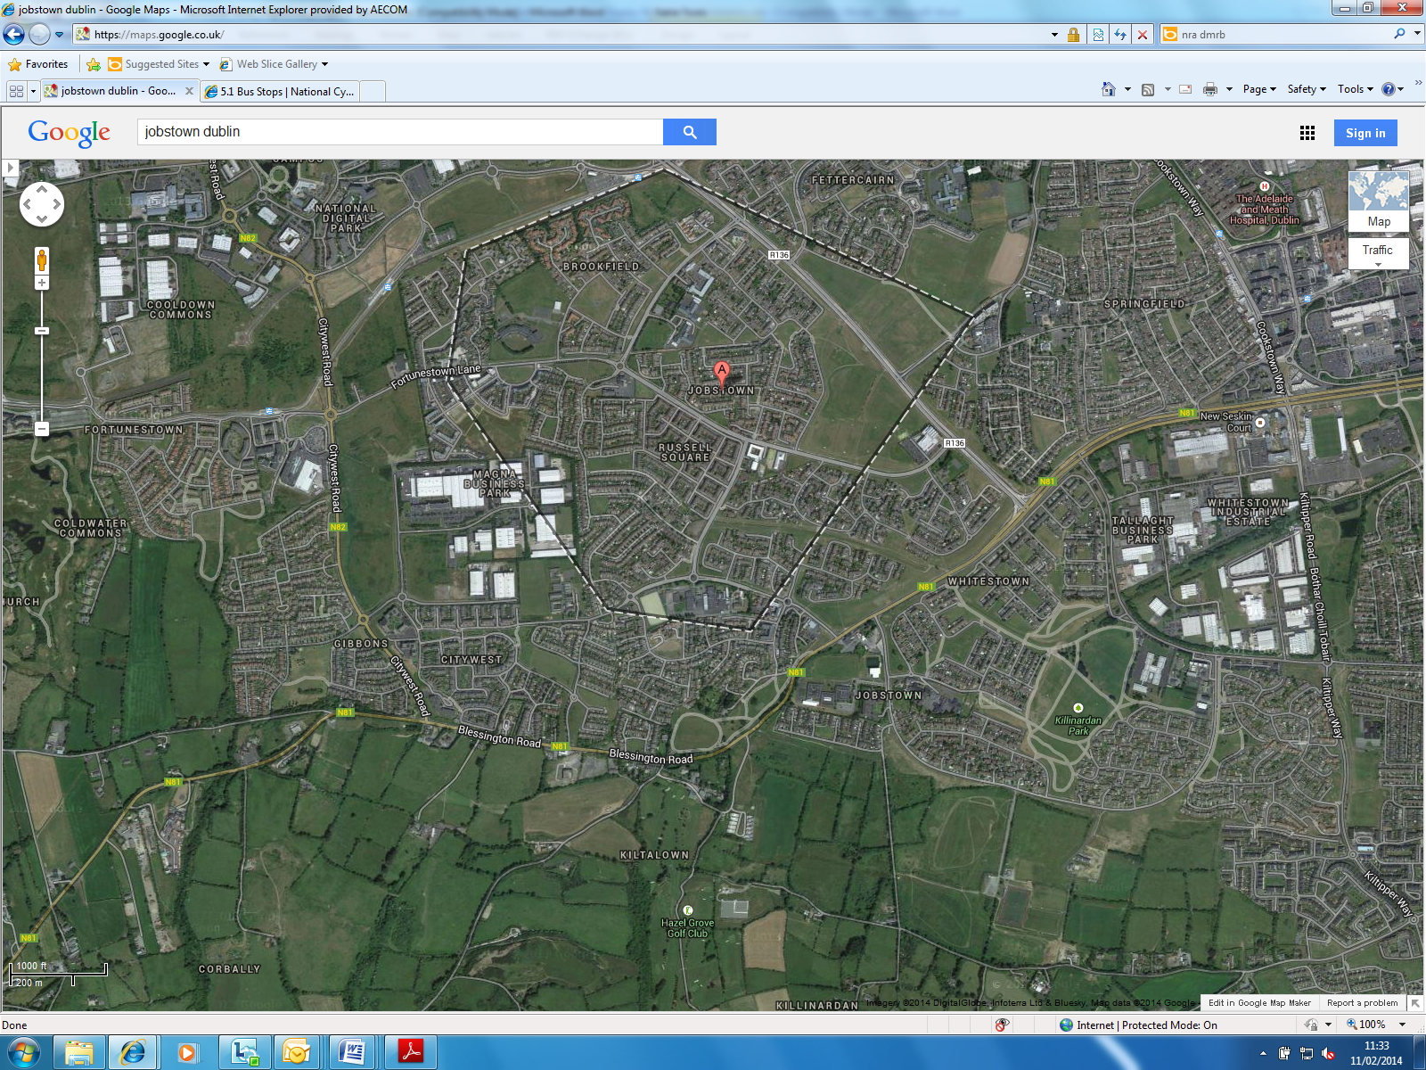
N81 (FORTUNESTOWN to Citywest Road formerly N82)

Part 8 Public Display – Report on Submissions

February 2014

Table of Contents

Table of Contents 1
1. Introduction 2
2. Public consultation 2
3. Description of the Nature and Extent of the Proposed Development and the Principal Features thereof 2
3.1 Merits of the Scheme 3
3.2 Proposed Scheme 4
3.3 Evaluation of the likely implications, if any, of the proposed development with respect to the proper planning and sustainable development of the area in which the development would be sustained 4
4. List of persons or bodies who made submissions or observations with respect to the proposed development 5
5. Summary of the issues with respect to the proper planning and sustainable development of the area raised by persons or bodies who made submissions or observations and the response of the South Dublin County Council thereto: 5
5.1 Submission 1 5
5.2 Submission 2 5
5.3 Submission 3 9
5.4 Submission 4 10
5.5 Submission 5 11
6. Recommendations based on the submissions received 12

Introduction

As part of a 5 year programme of schemes funded by the National Transport Authority (NTA), SDCC has prepared a design for the development and improvement of facilities for pedestrians, cyclists and bus users along the N81 from Blessington Road near Knockmore Gardens to the junction with the Citywest Road (formerly N82).

Public consultation

Pursuant to the requirements of the Planning and Development Act, 2000 and Part 8 of the Planning and Development Regulations, 2001, Public Notice of the availability for public inspection of plans and particulars of the proposed scheme were published in the public press on Wednesday the 25th of July 2012.

The Scheme was on public display between Thursday 5th December and Friday 27th January 2014 at the following locations:

- County Hall, Tallaght
- County Library, Tallaght

Submissions or observations with respect to the proposed development of the area in which the development would be situated were invited to be made in writing to the County Council up to Monday 10th February 2014. A total of 5 submissions in relation to the proposed scheme were received. Accordingly, the following report has been prepared.

Description of the Nature and Extent of the Proposed Development and the Principal Features thereof

South Dublin County Council seeks to provide enhancements to the road corridor for cyclists, pedestrians and bus users of the N81 over the extents described above while maintaining current vehicular capacity throughout. The proposed scheme will provide an unbroken route for cyclists and pedestrians over the extent of the scheme (some 2km) in a safer fashion, as well as providing safer links to recognised destinations along the route.

The primary aim of the project is to provide a safe and attractive environment to encourage greater use of sustainable travel modes for trips to work, education, and for recreation. With this in mind, the key objective was to prepare a scheme that improves the quality of service offered to pedestrians and cyclists along the N81 road corridor. This is broadly in line with modern design standards which aim to design for pedestrians and cyclists first, rather than motor vehicles, and offering improved pedestrian and cyclist links within the existing road network.

It is anticipated that the scheme will deliver a modal shift among younger people travelling from the local residential areas along the route to schools, recreational facilities and local parks. It is also expected that the scheme will provide a safer connection to outlying areas beyond the urban conurbations for leisure cyclists looking to venture into the Wicklow Mountains.

It is proposed to take part of the route through the existing Kiltalown Park with a view to avoiding the unsafe interaction of pedestrians and cyclists with motorised traffic through this precarious stretch of the N81 road alongside the park. The width of the N81 at this location is spatially constrained by the existing heritage wall to the north and a stream to the south. The additional benefits of taking the route through the park will also provide improved connectivity for local residential areas to the north of the park.

In addition to the provision of a clear route running east west, a major component of the scheme is the provision of improvements to the existing pedestrian/cyclist crossing facilities running north to south at several key locations along the route. The aim here is to link safely those residential areas on both sides of the N81 with public amenities on the opposite side.

Bus users will also be better served by improved facilities including Real Time Passenger Information on inbound routes, better landing points and footpath connections. Enhancements to controlled crossings and the addition of safer uncontrolled crossing points will also provide safer destination connectivity.

3.1 Merits of the Scheme

The general benefits to be achieved from the scheme are:

- A high-quality ‘unbroken’ route that provides linkage to key local trip attractors and strategic cycle routes with a minimum Quality of Service of Level B in accordance with the Nation Cycle Manual;
- Modal shift for school pupils, members of sports clubs, etc. ;
- Improved cyclist and pedestrian safety at busy junctions including the N81 Jobstown Road Kiltalown Heights;
- Safe transition of pedestrians and cyclists from existing facilities;
- Provision of sustainable transport in line with government policies and funding criteria, as part of a network of cycling facilities being currently developed;
- Clearance of overgrown vegetation to provide improved visibility
- Enhanced public lighting along the route in particular through the park;
- Enhancements to landscaping along the route with minimal tree removal (5 maximum with direct replacement within 20 metres);
- Adjustment of the Blessington Road Hazel Hill junction to improve visibility and alignment;
- Enhanced and clear pedestrian cycle signage and markings throughout the scheme with improved/new white lining;
- Speed reduction of vehicular traffic through the study area

3.2 Proposed Scheme

The proposed works will comprise of the following key elements:

The construction of:
- 400 metres of new independent footpath;
- 1110 metres of new dedicated 2 way cycleway;
- 500 metres of shared pedestrian cycle path through a park;
- 600 metres of improved shared pedestrian cycle path alongside the existing N81;
- 2 raised tables at existing priority junctions to improve pedestrian’s crossing and speed reduction on approach

The enhancement of
- 8 existing bus stops with new or improved footpath waiting areas and provision for real-time information for inbound buses;
- 3 existing junctions at Citywest Road, Jobstown Road and Hazel Hill Road with all round provision for cyclists and pedestrians as well as maintaining current levels of capacity.
- Public lighting along the route
- Landscaping along the route
- New controlled and uncontrolled crossing facilities to enhance access north to south as well as improved linkage with existing bus stops;
- All round controlled pedestrian facilities at 3 existing signalised junctions;

The addition of
- A clear signage strategy
- Road drainage and associated works where required;
- A new toucan crossing at Knockmore Gardens.

3.3 Evaluation of the likely implications, if any, of the proposed development with respect to the proper planning and sustainable development of the area in which the development would be sustained

The proposed scheme will involve the delivery of a clear unbroken pedestrian cycle route extending existing routes and offering improved connectivity with residential areas and key trip attractors and public amenities. (Schools/College, Sports Clubs, local shops etc.). This will offer a more attractive environment for vulnerable road users encouraging a modal shift among the local population to walking, cycling or public transport usage as a safe and convenient means of making local trips.

The implementation of the proposed scheme is identified in the South Dublin County Development Plan (2010 – 2016) where it is an objective of the Council to establish a cycle route network in the County within the time period of the Plan.

List of persons or bodies who made submissions or observations with respect to the proposed development

The following submissions were received with regard to the displayed scheme:

- Tara Spain, Nation Roads Authority, St Martin’s House, Waterloo Road, Dublin 4 (31st January 2014)
- Mairead Forsythe, Dublin Cycling Campaign, PO Box 10295, Dublin 3 (7th February 2014)
- Cormac Deane, email (7th February 2014)
- Aine Hickey (9th February 2014)
- Gordon White, c/o Fahy Fitzpatrick Consulting Engineers,2057 Castle Drive, Citywest Campus, Naas Road, Dublin 24

Summary of the issues with respect to the proper planning and sustainable development of the area raised by persons or bodies who made submissions or observations and the response of the South Dublin County Council thereto:

5.1 Submission 1

Observation

It is generally noted that the National Roads Authority broadly welcomes the implementation of this scheme and merely provides a reminder to the Local Authority that all proposed structures alongside the route must be approved by the Bridge Management Section of the NRA in accordance with the requirements of BD 2 Technical Approval of Road Structures on Motorways and Other National Roads.

Council's response:

The Council notes the comments submitted by the NRA.

5.2 Submission 2

It is generally noted that the Dublin Cycling Campaign broadly welcomes the implementation of this scheme and make the following general observations:

Observation 1

We recommend that the design is complemented by the installation of directional signage to encourage the use of the cycle paths as many cyclists and potential cyclists are unaware of cycle routes in their area.

Council's response:

A signage strategy will be prepared in full accordance with current policy and guidelines as part of the detailed design process and will reflect the interconnectivity of the surrounding cycle network.

Observation 2

We expect that many experienced leisure cyclists travelling from Tallaght towards Blessington will continue to use the main road. Has any consideration been given to signage so that motorists continue to expect cyclists on the main road?

Council's response:

Every effort has been made, and will continue to be made through the detail design process, to ensure the route is signed, geometrically direct and as accessible as possible to meet the needs of the majority of cyclists, both leisure and those more proficient.

It is appreciated that the more accomplished cyclist may well prefer to use the road to avoid conflict with pedestrians and the slow moving leisure cyclist. However, this stretch of road is precarious in places and particularly alongside Kiltalown Park. There are also many junction and access interfaces throughout the study area. Consequently the Local Authority will endeavour to direct the majority of cyclists onto the newly developed route by improving the physical geometry of the route, installation of toucan controlled crossings at key interface locations and make use of high visibility signage to ensure priority is clear. It is also worthy of note that the proposed route, while redirected, is no longer in length.

Notwithstanding the above, those cyclists that still favour remaining on road will be accounted for. The detailed design process will include provision for additional warning signage and markings in road along the extents of the road clearly indicating the presence of cyclists and pedestrians along the route. It is further noted that the Local Authority, in consultation with the National Roads Authority, will make every effort to seek the reduction of speed limits through the study area to provide further protection.

Observation 3

The proposed scheme will deliver cyclists to the CITYWEST ROAD junction at Citywest where they rejoin roads with speed limits of 60kph (both the CITYWEST ROAD and the N81 westbound). There are (almost) no segregated facilities for cyclists, and many roundabouts to negotiate in the Citywest Business Campus. We would like to see speed limits reduced to 50kph throughout the Campus as the current speed of traffic is unsafe and threatening to cyclists. While this may be outside the scope of the scheme, the uptake on the proposed cycling facilities will be considerably reduced if cyclists travelling to Citywest do not have safe facilities when they arrive at the Campus. This has unfortunately been exemplified by the recent cyclist fatality at the Brownsbarn roundabout near Citywest.

Members of the Dublin Cycling Campaign would be happy to cycle the route with the design team (consultants and Local Authority engineers) at a mutually agreeable time, so as to discuss the points raised in this submission

Council's response:

We fully acknowledge the vulnerability of cyclists both within the study area and on its periphery. It is also correctly observed that the scope of this particular scheme does not extend to include the areas highlighted. However, the Local Authority, in consultation with the National Roads Authority, will make every effort to seek the reduction of speed limits through the study area and will give the necessary consideration to the issues raised as further extensions to this study, also ensuring that interfaces with the study area are fully considered and connected safely and motorists made fully aware of the likelihood of cyclists and pedestrians in the area.

It is worthy of note that both this scheme and the Citywest Road form part of the adopted Greater Dublin Area Cycle Network. Hence detailed linkages to the CITYWEST ROAD and beyond will form key components of this scheme to ensure continuity. The Citywest Road is likely to form part of the development plans in the short term future to realise the objectives of the cycle network.

The Local Authority also welcomes the opportunity to cycle the route with members of the Dublin Cycling Campaign to discuss the issues raised to ensure the detail design meets the majority of the scheme objectives.

Observation 4

Bus Stops at 200, 600 and 850 (inbound)

There is potential for conflicts between cyclists and people waiting for the bus at these bus stops. Island bus stops would be preferable if there is sufficient room (see Cycle Manual (http://www.cyclemanual.ie/manual/detailsright/busstops/).

Council's response:

Space is at a premium between boundaries in the cross section throughout the study area. However, the cyclist pedestrian interaction at the bus stops highlighted has been considered as part of the preliminary design and reflects the requirements of the National Cycle Manual. Nonetheless, if further opportunities arise through the detail geometrical design, due consideration of this observation will be made and further enhancements made.

Observation 5

Newhall Court Junction

We recommend clarity on priority for cyclists travelling along the Main Road from west to east be provided by inclusion of a Yield line for exiting cars. It is not clear from the existing drawings.

Council's response:

The large scale of the drawing and level of detail may not have made the eastbound cyclists priority clear. The detail design drawings will clearly illustrate the yield line and cyclist priority at the Newhall Road junction and De Selby Road junction.

Observation 6

Kiltalown Park

We note the shared use proposals in Kiltalown Park and, while we recognise that this is a major step forward in improved cycle provision, we suggest that usage levels and possible conflicts be monitored post-construction.

Council's response:

The detail design, in consultation with the NTA, will call for covert cycle counters to monitor usage levels through the park. Post Construction Stage Road Safety Audits are also proposed as part of the design process to monitor ongoing interactions.

5.3 Submission 3
It is generally noted that the Cormac Deane welcomes the implementation of this scheme and makes the following general observations.

Observation 1

I would like to make a plea for as much segregation as possible between pedestrians and cycles at bus stops, and especially between cars and cycles in general.

Council's response:
The cyclist bus pedestrian interaction at the bus stops have been considered as part of the preliminary design and reflects the requirements of the National Cycle Manual.

The proposed cycle route is generally segregated from motorised vehicular traffic through the entire study area and has achieved a Quality of Service Level B in accordance with the National Cycle Manual.

Observation 2

Reduction of speed limits is essential in making cycle routes usable, particularly for school children, whose parent will not allow them into fast traffic. Signage such as happy face indicators for correct speed can be very helpful in this regard.

Council's response:
The proposed cycle route is generally segregated from motorised vehicular traffic through the entire study area and has achieved a Quality of Service level B in accordance with the National Cycle Manual. Toucan controlled crossing facilities are also proposed for larger junctions and key interfaces.

Nevertheless, the Local Authority, in consultation with the National Roads Authority, will make every effort to seek the reduction of speed limits through the study area and will give due consideration to the issues raised as further extensions to this study.

Furthermore, a signage strategy will be prepared in full accordance with current policy and guidelines as part of the detailed design process reflecting the interconnectivity of the surrounding cycle network and taking into account the suggestions made.

5.4 Submission 4

It is generally noted that the Aine Hickey welcomes the implementation of this scheme and comments that ‘it will be a great improvement’ and making the following general observations.

Observation 1

The bus stops. From the plans it looks like there will be a conflict between cyclist/buses/passengers. These need to be clearly designed to minimise this.

Council's response:
The cyclist bus pedestrian interaction at the bus stops have been considered as part of the preliminary design and reflect the requirements of the National Cycle Manual..

Observation 2

Cycle access. There are a number of points where pedestrians can access the road, but cars cannot ( Eg Belfy Grove). Does this plan take into account if these access pints are also to be bike friendly? In many locations there are kerbs. Replacing these with ramps can make a big difference to cyclists and anyone with a pram. There is no use building great cycling facilities if it is hard to access them.

Council's response:

All pedestrian cycle access points along the route will be considered individually and where possible, within the scope of the proposed scheme, will be improved to allow ease of access onto the new route for cyclists, mobility restricted and those with prams.

It should be noted however, that many of these access points are not in charge with the Local Authority and would require agreement with local land owners to implement. Nevertheless, the Local Authority will make every effort to ensure that all accesses are considered.

5.5 Submission 5

It is generally noted that the Fahy Fitzpatrick, on behalf of their clients Place Properties and Citywest Limited, generally welcome the proposed improvements scheme but would have some reservations and make the following general observations.

Observation 1

Place Properties Ltd are the registered owners of folio no. DN92893F, within which part of the works (at the western end, around the junction of the Citywest Road) are to take place.
Citywest Limited are the developers of Citywest Campus and of Citywest Road. Whilst the carriageway of Citywest Road is in the charge of South Dublin County Council the verges are not and are maintained by Citywest Ltd. In particular the open area between Corbally Way, Citywest Road the Blessington Road as shown hatched in green on the attached extract from your drawing forms part of the Place Properties folio and is maintained by Citywest Limited. The County Council will need the assent of these parties to carry out the proposed works

Council's response:
The Local Authority acknowledges the extents of ownership of Place Properties and Citywest Ltd. Every effort has been made to avoid impact on lands not in charge with South Dublin County Council, however, some additional space in this area may be required to maximise the benefits of the scheme and ensure that traffic capacity is not reduced.

Notwithstanding the above, the Local Authority will continue to consult, through Fahy Fitzpatrick, with Place Properties and Citywest Ltd, to ensure that where additional land is required to achieve the objectives for the scheme, full written consent will be obtained before procurement of any works commences.

Recommendations based on the submissions received

Following consideration of all the submissions received it appears that the scheme is broadly welcomed by all. Consequently, it is not proposed to change the core design philosophy for the scheme as the generally positive observations made will form part of the detailed design process.

The following key elements will be given specific consideration through the detailed design process together with follow up consultation with those groups submitting observations to ensure that all concerns are addressed and taken into consideration.

- All structures proposed as part of the scheme will be submitted and discussed with the NRA Bridge Management section in accordance with BD2

- A detailed signage and marking strategy will be applied to the scheme in line with current policy and guidelines

- Consideration, where space allows, to provide island based bus stops.

- Consideration of speed reductions in Citywest Campus and N81, subject to extension of the scope of this study and consultation with the National Roads Authority.

- The inclusion of cycle counters at discrete locations in consultation with the NTA

- The consideration of all pedestrian access points along the scheme to ensure bike/mobility/pram friendly, subject to consultation and agreement with private land owners as necessary

- Continued consultation with Fahy Fitzpatrick, on behalf of Place Properties and Citywest Ltd, with regard to spatial requirements and consents to maximise the benefits of the scheme.

