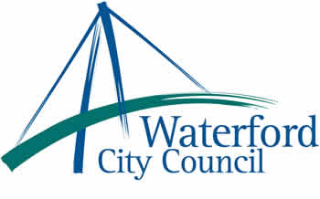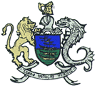

21 November, 2013

To: The Meetings Administrator

The following motion was unanimously adopted by Waterford City Council at its monthly meeting held on the 11th November, 2013:.

“Waterford City Council urgently requests the Government to have a total review of legislation in the area of Anti-Social Behaviour with the objective of strengthening the powers of the Gardaí and Local Authorities to tackle this issue in an effective manner.”

Yours sincerely,

Billy Duggan
Meetings Administrator

