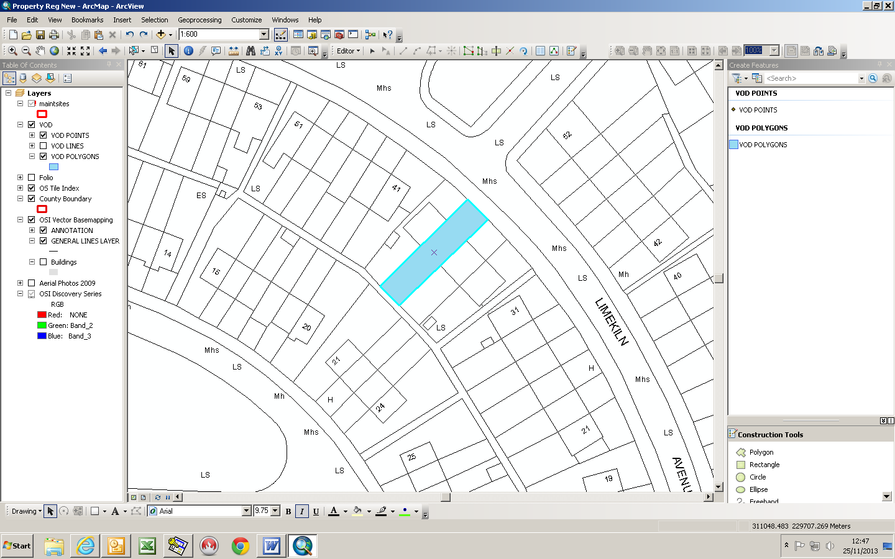
37 Limekiln Avenue


Department:  Development, Economic and Transport Planning | Small Builders Scheme-  Shaded in Blue
House No:  37 | Address:  Limekiln Avenue
Townland : Limekiln Farm | Owners:  Louise and David Murphy

