COMHAIRLE CONTAE ÁTHA CLIATH THEAS
SOUTH DUBLIN COUNTY COUNCIL

MEETING OF CLONDALKIN AREA COMMITTEE
Wednesday, November 20, 2013
HEADED ITEM NO. 7

Controlled parking across South Dublin County Council

Following the October 2013 County Council meeting it was agreed to present the review of the parking bye laws to the upcoming Transportation SPC. For the attention of the members the report will also be presented to each Area Committee for their consideration.
Controlled parking commenced in South Dublin County Council in 2003 in Lucan Village and was extended county wide in 2006 to cover the other major commercial village centres.
South Dublin County Council is the smallest of the four Dublin LA’s and we now collaborate to achieve operational savings.

Legal framework
In exercising the powers vested in them by Section 36 of the Road Traffic Act 1994 (public roads) as amended and Section 101 of the Road Traffic Act 1961 (car parks), and having consulted with the Commissioner of the Garda Síochána The Mayor and Members of South Dublin County Council may make Bye-Laws controlling parking on roads and in car parks in their charge. The full text of the sections is at the end of this report.
Public consultation is required under Section 36 of the Road Traffic Act 1994,
(3) Before making bye-laws under this section (other than bye-laws relating to the fees to be paid in respect of the parking of vehicles), a road authority shall—
(a) consult with the Commissioner;
(b) publish a notice in one or more newspapers circulating in the area to which the bye-laws relate—
(i) indicating that it is proposed to make bye-laws under this section,
(ii) indicating the times at which, the period (being not less than one month) during which and the place (being a place within their functional area) where a copy of the draft bye-laws may be inspected,
(iii) stating that representations may be made in writing to the road authority in relation to the draft bye-laws before a specified date (which shall be not less than 2 weeks after the end of the period for inspection), and
(iv) stating that a copy of the draft bye-laws may be purchased on payment of a fee not exceeding the reasonable cost of making such copies; and
(c) before deciding whether to make the bye-laws and determining their content, consider any observations made to them by the Commissioner or any representations made to them pursuant to paragraph (b)(iii).

Public consultation is not required for bye-laws relating to the fees to be paid in respect of the parking of vehicles.
Public consultation is not stipulated under Section 101 of the Road Traffic Act 1961 (car parks).

Reason for managed parking
The goal from managed parking is maximise footfall arising from use of parking spaces within our villages.
To support this goal the aims for managed parking are
- High Turnover
- Good Availability
- Good Occupancy
- Protecting adjoining areas from inappropriate overspill parking.
A notional economic value can be placed on a parking space:
Value of a space €20 of trade per hour x 8 hours x 6 days x 50 weeks = €48,000
50 busy spaces may contribute €2.4 million to the local economy each year.
The value of a parking space to a locality is significant and must be correctly managed.
As part of the overall review parking surveys have been carried out across the county to assess the utilisation of spaces. The surveys recorded and identified vehicles present at hourly intervals and analysed the duration, turnover and space availability.

Tariff structure
For simplicity a time based tariff is used in all areas. A period of ten minutes is permitted to ‘get change’ during which any brief message can also be completed. For any parking in excess this of period the time based charge applies. There is no bias towards either short or long duration parking.
Given the pressures on the commercial businesses it is important that on completion of a motorists business in the village that the space is then made available for the next customer. An extended free period, such as an hour free, introduces a disincentive to leave within the period and makes ‘gaming the system’ easy. An appropriate charge is therefore applied.
The parking duration profile at several sites across the county is shown below:
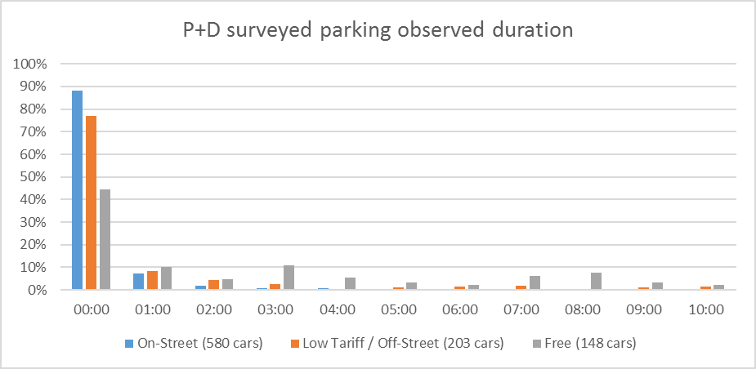

Observed duration hours | <1 hour | 1 | 2 | 3 | 4 | 5 | 6 | 7 | 8 | 9 | 10
On-Street (580 cars) | 88% | 7% | 2% | 1% | 1% | 1% | 0% | 0% | 0% | 0% | 0%
Low Tariff / Off-Street  (203 cars) | 77% | 8% | 4% | 2% | 0% | 1% | 1% | 2% | 0% | 1% | 1%
Free (148 cars) | 45% | 10% | 5% | 11% | 5% | 3% | 2% | 6% | 7% | 3% | 2%

It is evident from above that 88% of on-street parking is less than one hour.

On-Street surveys at Rathfarnham, Templeogue and Tallaght
148 cars at the Courthouse Square, Tallaght
Charging for parking succeeds in significantly improving the utility of valuable parking spaces.

Scale and scope
There are approximately 600 on street and 200 off-street parking spaces in South Dublin County Council where council Pay + Display operates. Additional residential areas are covered for the prevention of overspill parking but are not considered as contributing to parking space availability.
Number of spaces are shown for each area
 | Total number of spaces | Normal tariff | Reduced tariff
Rathfarnham  €1.50/hr Mon - Sat | 181 | 81 | 100
Lucan  €1/hr Mon - Fri | 167 | 152 | 15
Rathcoole  €1/hr Mon - Fri | 100 | 90 | 10
Clondalkin  €1/hr Mon - Fri | 89 | 89 | -
Tallaght  €1.50/hr Mon - Sat | 79 | 33 | 46
Palmerston  €1.50/hr Mon - Sat | 77 | 62 | 15
Templeogue  €1.50/hr Mon - Sat | 75 | 20 | 55

Reduced tariff is €0.75 per hour.

Income
The income for each village is shown, for the periods indicated and the share of income for the most recent 12 month period.
12 month period | 09/12 - 08/13 | Share | 09/11 - 08/12 | 09/10 - 08/11 | 09/09 - 08/10
Lucan  €1/hr Mon - Fri | €259,764 | 40% | €263,760 | €262,452 | €213,840
Rathfarnham  €1.50/hr Mon - Sat | €202,932 | 31% | €215,964 | €191,316 | €120,000
Clondalkin  €1/hr Mon - Fri | €56,820 | 9% | €58,704 | €62,136 | €62,028
Tallaght  €1.50/hr Mon - Sat | €45,324 | 7% | €48,372 | €43,080
Rathcoole  €1/hr Mon - Fri | €36,132 | 6% | €47,616 | €45,996 | €40,980
Templeogue  €1.50/hr Mon - Sat | €28,764 | 4% | €29,940 | €27,756
Palmerston  €1.50/hr Mon - Sat | €21,216 | 3% | €19,596 | €25,488 | €21,396

Tariff ‘A’ (€1.50/hr Mon - Sat) and ‘A1’ (€1/hr Mon - Fri) cover 89% of income, the remainder comes from car parks and low tariff streets. The car parks and low tariff streets are charged at half the ‘A’ tariff and are included in the totals shown in the table above.

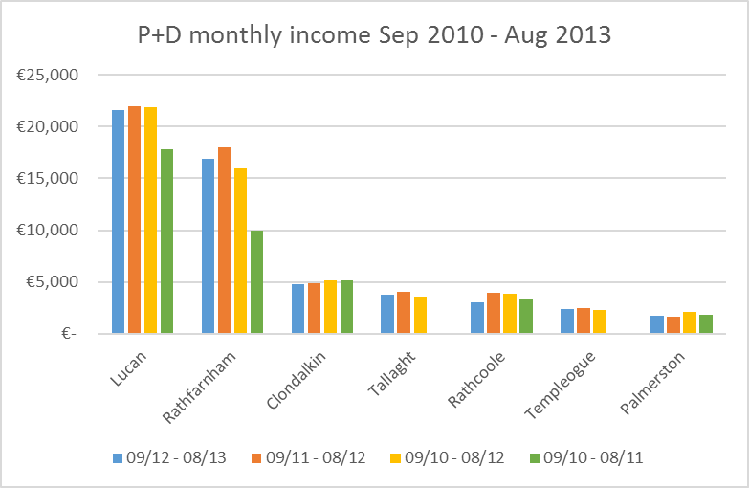

Current customer operation
A straight forward pay and display system is operated. A driver arriving purchases a parking duration on a ticket on arrival and displays the ticket in the car. Grace periods are applied as described above.
Additionally, Parking Tag was recently expanded to South Dublin County Council in conjunction with the other local authorities in Dublin. A driver purchases a parking duration by mobile phone and the parking secession cost is electronically transferred to South Dublin County Council.
In either case the driver is able to extend their parking secession by repeating the process. Parking tag has the added advantage of not having to return to the car and not requiring change.

Costs
In both on-street and off-street parking for 2012 the enforcement, permit issue, cash collection and machine maintenance contracts in South Dublin County Council cost €626,467 the income in the same period was €980,355 (coin, fine and permits). There was a VAT liability of €8,800 for the off-street parking. This leaves a net income of €345,000.

Parking survey findings and proposals
Parking in Lucan and Clondalkin will be examined as part of the NTA studies and no precise data on space occupation, turnover or availability is available at this time. It should be noted that parking in both Lucan and Clondalkin is generally very busy and good turnover is experienced. In Rathcoole sections of parking where commercial activity occurs are busy.
Arising out of the surveys a number of proposals have come back.

Rathfarnham
Parking in Rathfarnham Village was surveyed in June. Sample areas were examined for their occupancy during the day and the type of parking i.e. long or short term parking. In order to get a full picture both a week day and a weekend were surveyed
During the weekday survey parking was observed on a Thursday. It is observed that occupancy for on-street parking areas is well used with maximum occupancy between 60% and 90%. Parking is typically short term with long term parking confined to residential areas.
In Village Court car park (60 spaces) maximum occupancy on the Thursday survey was 30% and parking was predominately short term
At weekends maximum occupancy for on street parking was observed at 80% to 90% however more long term parking was observed. In Village court car park, where parking is free on Saturday, occupancy was 90% with a mix of long and short term parking.
The parking areas in Rathfarnham Village are effectively fully occupied during both weekdays and weekends and good parking turnover has been achieved with the exception of weekday use of Village Court car park. The current tariff is appropriate as there is no general requirement to either to increase use or turnover, as the parking is delivering close to its maximum vehicles parked and the turnover delivers short term parking.
The Village Court car park could be better utilised on weekdays as up to 40 spaces may be available. Currently parking is charged at ½ the Main Street rate to encourage better use option for motorists visiting the village and permits for workers are available at €25 per month including VAT.
In order to prevent the Village Court car park reverting to a park and ride site for the city bound trips controlled parking should be retained. To promote better use of the car park in a way that benefits the village area the provision of permits limited to workers of the village at the reduced rate should be retained and made available for annual and monthly periods. Additional 'low tariff parking' signage is now in place for the car park.
There is no proposal to make any modification to the system of residents parking permits.
The parking Tag is now operational in Rathfarnham Village.

Tallaght
Parking in Tallaght village was surveyed to ascertain the level of parking in and adjacent to the controlled parking zones. This survey was undertaken both on a Thursday and Saturday.
Of most interest are the fringe areas as the effect of controlled parking are most apparent here and this is where any modification can be first made.
The car park on Oldbawn Road at Mountain Park was observed to have low use on both occasions (33% max occupancy on Thursday and 25% on Saturday). A reduced tariff operates in the car park, however it is a considerable walking distance from the commercial centre of the village. A possible solution would be that the pay and display operation be removed as this car park is of limited value and enforce the remaining parking regulations (double yellow lines etc.) as necessary.
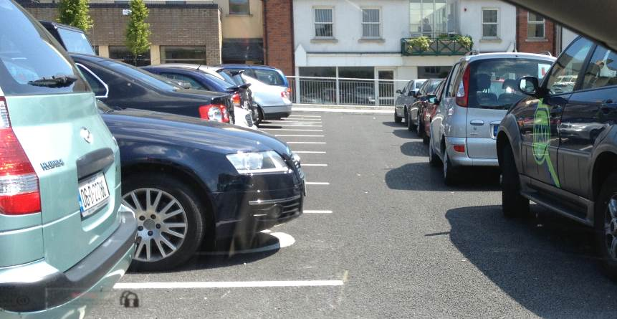
The car park at the Court House was improved in 2012 and now provides 71 spaces and 2 disabled spaces. This car park is busy and was observed to be full during the day with 94% occupancy. It provides parking for the court and village activities and is connected to the commercial centre of the village by two walkways. Demand for space has exceeded supply from time to time with casual parking occurring between parking aisles. The turnover of space in the car park is poor with more than 60% long term parking (44 of 71 spaces). To support the commercial activity in the village much of this long term parking should be dissuaded from using a prime parking location. A possible solution here is to introduce pay and display parking.

Tallaght Main Street was observed to be well used and had good turnover during the week and at weekends with a maximum occupancy of 85% during the week and 63% on Saturday. There is a good balance between occupancy, availability and space turnover. Adjacent to Main Street parking is available on Old Greenhills Road. It provides reduced tariff parking and is free on Saturdays. This arrangement supports access to Main Street as an option for drivers and mitigates the less convenient location.
As some space is available on Old Greenhills Road (maximum occupancy of 30%), this may be improved by the provision on if an improved long stay parking facility based on commercial permits at €300 per year paid monthly.
Westpark is operated with permits for residents and is achieving the protection of the residential area from overspill parking.
Some on street parking exists around the square shopping centre. Controlled parking is applied to public parking areas to protect from inappropriate long-term parking.

Templeogue
Templeogue village was also surveyed on a Thursday and Saturday
Parking on Main Street provides 19 public spaces, maximum occupancy was recorded at 70% during the week and 80% on Saturday. The public off street car park on the road approaching Riverside Cottages (opposite the piggery site) had a maximum occupancy of less than 30% of its 31 spaces both during the week and at the weekend. In all cases parking was predominately short term within the Templeogue pay and display area. The parking in the village operates with good availability and space turnover. Occupancy is at a good level on Main Street
Despite the lower tariff for parking in the off-street car park (opposite the piggery site) requires further promotion and signs have now been installed. A members led initiative to maximise the use of these 31 spaces for working staff in the village at a reduced rate would free up on-street parking in the village.

Palmerston
Palmerston village was surveyed in May to ascertain the level of parking in and adjacent to the controlled parking zone. Here again the survey was undertaken on both a Thursday and Saturday.
Of most interest are the fringe areas as the effect of controlled parking are most apparent here.
Waterstown Avenue and Mill Lane were surveyed as they are adjacent to the Pay and Display areas (parking is free on these roads) and indicate the demand for free parking within the village. These locations were observed to accommodate 40 parked vehicles, primarily long-stay. Any change in paid parking will see a redistribution of these vehicles. The changes must be made in a structured approach to keep the correct balance between occupancy, accessibility and space turnover.
The Old Lucan Road at the small green area (Horseshoe area) was surveyed, it was generally unused for pay and display parking. A possible solution would be to exclude this location from controlled parking and only enforce the existing double yellow lines.
The area of Old Lucan Road to the east of Mill lane provides for long term parking however little use is made of this area by non-residents as residential parking is accommodated with permits. It would not appear necessary to include this area beyond the enforcement of existing double yellow lines. Any spill over parking from Mill Lane is expected to be accommodated on the unused long term area.
Upper Kennelsfort Road car park adjacent to the pedestrian bridge is remote from the village and is little used. A possible solution would be to remove this area from pay and display.
Parking is still prevalent at weekends but at a lower level than weekdays. With the reduction in the extent of the parking zone the free parking will be available at all times a short distance from the shopping area, but space availability and space turn over will continue to be protected at the shopping area.

Enforcement
Each year approximately 10,000 fines are issued. Fines are issued for noncompliance with pay and display (expired parking) and parking orders (DYL’s and disabled spaces etc.)
The following protocols are applied to issuing of a fixed charge offence notice:

Issuing a Parking Fine
When a warden encounters an illegally parked vehicle they record the following details into their (firstly) Pocket Books and (secondly) electronic hand held units:
- Registration Number.
- Location of Vehicle.
- Offence.
- Make and Colour.
- Authorisation Time.
- Taxation Class e.g. Private or Goods Vehicle (for loading bay offences).
- Details of any Pay & Display Ticket or Parking Permit on the vehicle.

The majority of fines are preceded with a grace period. This allows the driver the opportunity to obtain a Ticket from the Pay & Display Machine or to load or unload from their vehicle.
The Parking Fine ticket is placed under the windscreen wiper.
4/5 Digital Photographs are taken of the vehicle.
(Evidence of no P&D Ticket, P&D Ticket has expired, road signs and lines and any other relevant information.)

OFFENCE | AUTHORISATION | GRACE PERIOD
Vehicle parked at a Disabled parking space | IRL, EU Badge, only accepted  Double check for badge, wheelchair and modification on controls and be extra vigilant, record observations in pocket book. | Instant (no grace period)
Vehicle parked at a Disabled parking space | Expired Disabled Badges  If the badge has expired by less than 3 months issue a warning notice | Issue Warning Notice
Vehicle parked at a Pay & Display Area | With no Pay & Display ticket | 10 minutes
Vehicle parked at a Pay & Display Area | With expired Pay & Display ticket (photos to include clear image of expired ticket) | 10 minutes post ticket expiry
Vehicle parked at a Loading Bay | Vehicles displaying Goods or Private & Goods tax disc must be actively loading and unloading  Observe 5 minutes. If not seen to be loading/unloading issue ticket after 25 minutes.  If loading /unloading more than 30 minutes, use discretion before you authorise. | Observe 5 minutes, then 30 minutes grace
Vehicle parked at a Loading Bay | Private Vehicles | Instant (no grace period)
Vehicle parked on a Footpath | In commercial areas, All Vehicles | Instant (no grace period)
Vehicle parked at a Taxi Rank | Taxi if unattended | 10 minutes
Vehicle parked at a Taxi Rank | All other vehicles | Instant (no grace period)
Vehicle parked at a Bus Stop | Ticket vehicles inside bus stop markings except large public service vehicle (Bus) | Instant (no grace period)
Vehicle parked on a Cycle Tracks | Non-Mandatory Cycle Track (broken line)  Ticket all vehicles unless actively loading/unloading. If loading/unloading no tickets to be issued but record observation time in pocket book. | 10 minutes
Vehicle parked on a Cycle Tracks | Mandatory Cycle Tracks (continuous line)  All vehicles | Instant (no grace period)
Vehicle parked on a Yellow Lines DYL & SYL | All Vehicles, Observe for loading/unloading activity | Instant (no grace period) unless active loading/unloading, observe and allow 15 minutes grace period subject to traffic being able to pass

Reminder Sent
Any fine that is unpaid is sent a reminder notice, 10 days after the ticket has issued.
The letter includes the following:
- Name and address of registered owner.
- Date of fine issue.
- Registration Number.
- Reference Number.
- Amount of fine.
- Days remaining before increase of Fixed Charge Notice. A fine issued for €40.00 will increase to €60.00 if unpaid after a period of 28 days. A fine issued for €80.00 will increase to €120.00 if unpaid after 28 days.

Increase in Fine
At midnight on the 28th day an unpaid fine will automatically increase by 50%.

Legal Proceedings
In accordance with the Local Authorities (Traffic Wardens) Act 1975 as amended, legal proceedings should be brought by South Dublin County Council against the driver of the vehicle through the District Court for all unpaid fines after 56 days.

Appeals
South Dublin County Council receives written appeals from drivers who wish to dispute the issue of a parking fine. Once an appeal has been received the disputed parking fine is placed on hold. This stops the entire process, pending a decision by the Council.
- A rejected appeal will result in the process resuming at the point it was placed on hold.
- An appeal that is upheld by the Council will result in the fine being cancelled.

General Rules
- Diplomatic cars are not exempt from any category of parking regulations.
- Ensure signs and lines are in order.
- If seemingly contradictory markings are observed do not enforce. Take photos and inform your team leader/supervisor.
- At specific locations exceptions to the general rules may be made, for instance geometry of road

Road traffic acts sections
Section 36 of the Road Traffic Act 1994:
Parking of vehicles in parking places on public roads. | 36.—(1) A road authority may make bye-laws for the control and regulation of the parking of vehicles in places specified in the bye-laws (in this section referred to as parking places) on public roads within their functional area and shall in the bye-laws provide for the payment of fees in respect of such parking.
 | (2) Bye-laws under this section may, in particular and without prejudice to the generality of subsection (1), provide for all or any of the following matters:
 | (a) the specification of parking places;
 | (b) the payment of fees, including the manner and proof of payment (whether by means of a parking meter, the purchase and exhibition of a document, or otherwise) in respect of the parking of vehicles;
 | (c) the specification of the amount of any fees payable pursuant to bye-laws under paragraph (b);
 | (d) the specification of the maximum periods for which vehicles may be parked in specified parking places;
 | (e) the prohibition of the parking of vehicles in a parking place for a period for which a fee is chargeable without the appropriate fee having been paid in the manner specified;
 | (f) the prohibition of the parking of vehicles in a parking place for a longer period than that in respect of which a fee was paid;
 | (g) the specification of the classes of vehicles which may use a parking place in respect of which a fee is payable;
 | (h) the exemption of specified classes of vehicles from the payment of fees in respect of parking, the conditions under which specified classes of vehicles may be so exempted and the identification of exempted vehicles;
 | (i) that indications given by parking meters shall be treated as evidence until the contrary is shown of such facts and for such purposes as may be specified in the bye-laws.
 | (3) Before making bye-laws under this section (other than bye-laws relating to the fees to be paid in respect of the parking of vehicles), a road authority shall—
 | (a) consult with the Commissioner;
 | (b) publish a notice in one or more newspapers circulating in the area to which the bye-laws relate—
 | (i) indicating that it is proposed to make bye-laws under this section,
 | (ii) indicating the times at which, the period (being not less than one month) during which and the place (being a place within their functional area) where a copy of the draft bye-laws may be inspected,
 | (iii) stating that representations may be made in writing to the road authority in relation to the draft bye-laws before a specified date (which shall be not less than 2 weeks after the end of the period for inspection), and
 | (iv) stating that a copy of the draft bye-laws may be purchased on payment of a fee not exceeding the reasonable cost of making such copies; and
 | (c) before deciding whether to make the bye-laws and determining their content, consider any observations made to them by the Commissioner or any representations made to them pursuant to paragraph (b)(iii).
 | (4) Different bye-laws may be made under this section—
 | (a) in respect of different areas within the functional area of a road authority,
 | (b) in respect of different classes of vehicles,
 | (c) for different circumstances, and
 | (d) in respect of different periods of time.
 | (5) The making of bye-laws under this section and the consideration of observations or representations under subsection (3)(c) shall be reserved functions.
 | (6) As soon as may be after the making of bye-laws under this section notice of their making and of the place where copies thereof may be purchased or inspected shall be published in Iris Oifigiúil and in one or more newspapers circulating in the area to which the bye-laws relate.
 | (7) The Minister may issue general guidelines to road authorities relating to the content of bye-laws under this section and may amend or cancel any guidelines under this subsection and, where any such guidelines are in force for the time being, bye-laws under this section shall be made by road authorities in accordance with the guidelines.
 | (8) (a) A person who contravenes a bye-law under this section shall be guilty of an offence.
 | (b) Where, in relation to a mechanically propelled vehicle, there is a contravention of a bye-law under this section, each of the following persons shall be guilty of an offence—
 | (i) the registered owner of the vehicle,
 | (ii) if the vehicle is the subject of a hire-drive agreement on the occasion in question, the person to whom the vehicle is hired under the agreement, and
 | (iii) if the person who parked the vehicle is not its registered owner or the person to whom it is hired under a hire-drive agreement, the first-mentioned person.
 | (9) (a) Where a person charged with an offence under subsection (8) of this section is the registered owner of the vehicle concerned, it shall be a defence for him to show that the vehicle was being used on the occasion in question by another person and that—
 | (i) such use was unauthorised, or
 | (ii) the vehicle was on that occasion the subject of a hire-drive agreement.
 | (b) Where a person charged with an offence under subsection (8) of this section is a person to whom the vehicle concerned stood hired at the time of the commission of the offence, it shall be a defence for him to show that the vehicle was being used on the occasion in question by another person and that such use was unauthorised.
 | (10) In this section “parking meter” means an apparatus for collecting fees at a parking place and for indicating payment of such fees and the periods that have elapsed since they were paid.
 | (11) (a) Subject to paragraph (b), any fees under this section shall be disposed of in such manner as the road authority concerned may by resolution determine.
 | (b) The Minister may issue general guidelines to road authorities relating to the disposal of fees under this section and may amend or cancel any such guidelines and, where any such guidelines are in force for the time being, fees under this section shall be disposed of by road authorities in accordance with the guidelines.
 | (c) The making of a resolution pursuant to paragraph (a) shall be a reserved function.
 | (12) In any prosecution for an offence under this section, a parking meter at a parking place shall be presumed, until the contrary is shown by the defendant, to have been duly placed there under this section and to have been accurate and in good working order.
 | (13) The performance by a road authority of their functions under this section or under any bye-law thereunder shall not render the authority subject to any liability in respect of loss of or damage to any vehicle in a parking place or the contents of such vehicle.

Section 101 of the Road Traffic Act 1961:
Provision of car parks by local authorities. | 101.—(1) In this section—
 | “local authority” means a sanitary authority within the meaning of the Local Government (Sanitary Services) Acts, 1878 to 1952;
 | “car park” means a place (not being part of a public road) for the parking of mechanically propelled vehicles.
 | (2) A local authority may provide such one or more car parks (and access thereto) as they consider desirable in order to relieve or prevent traffic congestion.
 | (3) A local authority may, with the consent of the Minister, assist any person providing a car park, and the assistance may consist either of a contribution of money or the execution of works or the grant or lease of land.
 | (4) For the purposes of subsection (2) or subsection (3) of this section, a local authority may, with the consent of the Minister, purchase or take on lease any land or any easement in, to or over the land or use any land which they have acquired for another purpose.
 | (5) Sections 203, 214 and 215 of the Public Health (Ireland) Act, 1878, as amended by section 8 of the Public Health (Ireland) Act, 1896, and section 68 of the Local Government Act, 1925 , shall apply to the acquisition of land by a local authority under this section, but with the modification that the advertisements mentioned in subsection (2) of section 203 of the Public Health (Ireland) Act, 1878, may be published in any month, and that the notices mentioned in that subsection shall be served in the next succeeding month.
 | (6) Subsection (2) of this section shall be construed as conferring on a local authority—
 | (a) power, subject to the consent of the Minister, to erect a building used wholly or mainly for parking mechanically propelled vehicles,
 | (b) power, subject to the consent of the Minister, to erect waiting rooms, cloak rooms and similar facilities for any car park provided by them,
 | (c) power to adapt land for use as a car park.
 | (7) A local authority may make bye-laws as to the use of any car park provided by them under this section, and, in particular, in relation to all or any of the following matters:
 | (a) restricting the classes of vehicles which may be admitted to the car park;
 | (b) specifying the charges to be made for the use of the car park;
 | (c) specifying the periods for which vehicles may remain in the car park.
 | (8) Sections 219 to 223 of the Public Health (Ireland) Act, 1878, shall apply to bye-laws under this section in like manner as they apply to bye-laws under that Act.
 | (9) Where a local authority become of opinion that the land used for a car park provided by them under this section should be used for a different purpose for which they may lawfully use land, the local authority may terminate the use of the land for a car park.
 | (10) A local authority who have provided under this section a car park may, with the consent of the Minister, sell or lease the car park or any part thereof to any person subject to such conditions as they think proper.
 | (11) The Minister may, with the consent of the Minister for Finance, make grants from the Road Fund towards the expenses incurred under this section by a local authority.

