COMHAIRLE CONTAE ATHA CLIATH THEAS

SOUTH DUBLIN COUNTY COUNCIL

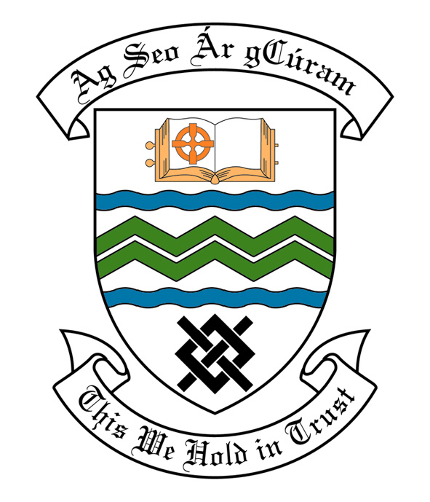
MEETING OF SOUTH DUBLIN COUNTY COUNCIL
MONDAY, 11th November, 2013
HEADED ITEM NO. H-I (2)(b)

MEETING OF CLONDALKIN AREA COMMITTEE

Wednesday 16th October, 2013

HEADED ITEM NO: H- I (5)

APPLICATION FOR GRANTS
“Application for grants under South Dublin County Council’s Community Grants Scheme have been received from the organizations listed below. Payment of these grants, in accordance with the conditions of the Scheme and in the amounts set out hereunder, is recommended for approval:-“

Ref: | Name of Group | Type of Application | Date Received | Amount
Agf799 | Knockmitten Youth Action Project – Clondalkin Skater group | Contribution towards cost of engaging filmmaker to work with Clondalkin Skater group | 27.8.2013 | €200

It was proposed by Councillor B. Bonner and seconded by Councillor T. Ridge:

“That this Committee recommends that South Dublin County Council APPROVE the grants as recommended in the forgoing report.”

