

South Dublin County Council
Ambient Sound Monitoring Network
Annual Report 2012

Document Information

Authors
 | Name | Company
Key author | Paul McDonald | Sonitus Systems
Reviewed | David O’Brien | South Dublin County Council

Revision History
Version | Date | Description
1.0 | April 2013 | Initial draft
1.1 | May 2013 | Final Version (internal document
1.2 | May 2013 | Final Version (approved, public)

Status
Draft Version | x
Final Version (Internal document) | x
Final Version (approved, public) | x

Table of Contents
1 Introduction 4
1.1 Sound and Noise 4
1.2 Noise Indicators 6
2 Monitoring Network Description 6
3 Data Reporting and Collection 9
4 Sound Sources 10
5 Guideline Values for Noise Assessment 10
6 Summary Results 11
6.1 Average Daily Trends 12
6.2 Sample Data from Monitoring Sites 16
7 Discussion 18
Appendix A 20
Appendix B 24
Appendix C Error! Bookmark not defined.

List of Figures
Figure 1: The level of typical common sounds on the dB(A) scale (NRA Guidelines for the Treatment of Noise and Vibration in National Road Schemes, 2004) 5
Figure 2: Sensitivity to changes in the loudness of a sound 5
Figure 3: Map indicating approximate location of monitoring stations 7
Figure 5: EM2010 Sound Level Monitoring Kit 1
Figure 4: EM2010 Sound Level Monitoring Unit 1
Figure 6: Microphone Assembly with Bird Spike 1
Figure 7: Microphone with Outdoor Weather Protection 1
Figure 8: L_{DEN} and L_{NIGHT} for all Sites in the Monitoring Network 12
Figure 9: Averaged Hourly Values at St. Colmcille's School 12
Figure 10: Averaged Hourly Values at Cheeverstown Centre 13
Figure 11: Averaged Hourly Values at Deansrath 13
Figure 12: Averaged Hourly Values at Tallaght Leisure Centre 14
Figure 13: Averaged Hourly Values at Saggart Park 14
Figure 14: Averaged Hourly Values at County Hall 15
Figure 15: Averaged Hourly Values at Esker Park 15
Figure 16: Sound Levels for May 2012 at St. Colmcille's School 16
Figure 17: Sound Levels for May 2012 at Cheeverstown Centre 17
Figure 18: Sound Levels for May 2012 at Deansrath Depot 17
Figure 19: Sound Levels for May 2012 at Tallaght Leisure Centre 17
Figure 20: Sound Levels for May 2012 at Saggart Parks Depot 18
Figure 21: Sound Levels for May 2012 at County Hall 18
Figure 22: Sound Levels for May 2012 at Esker Parks Depot 18
Figure 23: Averaged Hourly Values for Weekdays at St. Colmcille's School 20
Figure 24: Averaged Hourly Values for Weekdays at Cheeverstown Centre 20
Figure 25: Averaged Hourly Values for Weekdays at Deansrath 21
Figure 26: Averaged Hourly Values for Weekdays at Tallaght Leisure Centre 21
Figure 27: Averaged Hourly Values for Weekdays at Saggart Park 22
Figure 28: Averaged Hourly Values for Weekdays at County Hall 22
Figure 29: Averaged Hourly Values for Weekdays at Esker Park 23

List of Tables
Table 1: Description of Measured Parameters 9
Table 2: Data capture rates for sound monitoring network 9
Table 3: Summary results for all sites for 2012 11

Introduction
South Dublin County Council installed an ambient sound monitoring network in 2011. This network of monitors continuously records the sound levels at 7 individual locations with a view to providing an accurate reflection of the quality of the acoustic environment at sites that are characteristic of those found with the functional area of the Council. This initiative is complementary to the Council’s efforts to assess and manage exposure to environmental noise in the locality. This report provides an overview of the performance of the network and an analysis of the sound levels recorded by the long term monitoring stations.

Sound and Noise
The difference between sound and noise can often depend on the perspective of the listener. A sound that is considered bothersome by one individual may not even be noticed by another. Whether it disrupts speech or simply reduces the enjoyment of a garden, noise is almost always undesirable. But how exactly is noise classified and measured? The human ear perceives sound by detecting pressure changes in the air caused by propagating sound waves. Sound, and noise, is measured on a logarithmic scale, to account for the fact that people can detect sounds over a wide range of pressures. These range from approximately 20μPa (Micropascals) known as the Threshold of Hearing, to upwards of 100Pa (Pascals), commonly known as the Threshold of Pain. The ratio between the two is over a million to one. It is for this reason that sound pressure levels (SPLs) are measured in decibels, dB(SPL). The SPL is a logarithmic measure of the average sound pressure, relative to the Threshold of Hearing.
The scale in Figure 1 indicates the range of sound pressure levels which humans can hear and shows some examples of scenarios where they might be experienced.
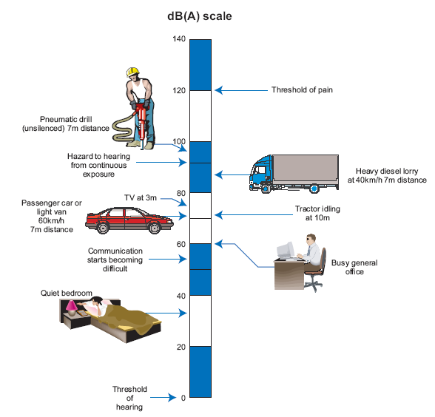
Figure 1: The level of typical common sounds on the dB(A) scale (NRA Guidelines for the Treatment of Noise and Vibration in National Road Schemes, 2004)
Within the range of audible sound, one must also consider the perception of sound. A doubling of the sound pressure results in a 6dB increase in sound pressure level, however, this does not mean that the sound appears twice as loud. But what level can be considered loud or annoying? The subjective nature of noise annoyance makes defining a specific value a complex task. Figure 2 gives an indication of the perception of changes in the loudness of a sound.
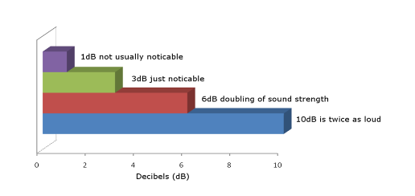
Figure 2: Sensitivity to changes in the loudness of a sound
Furthermore, not all types of sound are perceived in the same manner. The ear does not have a uniform response to all sounds and it is more responsive to certain frequencies. The frequency of the sound is similar to the pitch, low frequency sounds has a bass sound while very high frequency sound is high pitched. Humans can hear sounds with frequencies in the range 20Hz (Hertz) to 20kHz (kilohertz) approximately, but can hear some frequencies better than others. When measuring sound levels this is usually accounted for using frequency weighting. The most commonly used weighting filter is the A-weighting filter. A-weighting of noise levels accounts for the fact that the human ear is more responsive to certain types of sound than others. The A-weighting process applies weightings to different types of noise to better approximate the human perception of sounds. A-weighted sound pressure levels are measured in decibels, dB(A).

Noise Indicators
In order to standardise noise measurements and assessment methods a common noise indicator is required. Various statistical indicators exist to define noise levels depending on the manner and duration of the noise in question.
The European Environmental Noise Directive specifies two noise indicators to be used when preparing environmental noise maps. These are the L_{DEN} indicator and the L_{NIGHT} which is used to assess sleep disturbance. The L_{DEN} is the day, evening and night time rating level, with weightings applied to noise pollution for the different periods.

L_{DAY} is the A-weighted long-term average sound level measured between 07.00 and 19.00
L_{EVENING} is the A-weighted long term-average sound level measured between 19.00 and 23.00
L_{NIGHT} is the A-weighted long-term average sound level measured between 23.00 and 07.00

The average day, evening and night values are determined over all the respective periods of a year, making the L_{DEN} a yearly average. A 5dB weighting is added to the evening noise value and a 10dB weighting added to the night time level. This is to account for the fact that the same noise level may be more annoying at different times of the day. Consider road works in a residential area at four in the afternoon or four in the morning. The same noise level will be far more annoying during the night time period. The formula used to calculate L_{DEN} is presented in Appendix B

Monitoring Network Description
The monitoring network currently comprises 7 sites within the functional area of South Dublin County Council. The sites chosen were readily available to the Council i.e. public buildings, and were also instances of representative locations where monitoring of the sound levels is relevant for determining the quality of the acoustic environment. The process for site selection included a review of the strategic noise maps produced under the Environmental Noise Regulations, S.I 140 of 2006.

The sites chosen were:
- St. Colmcille’s Community School, Knocklyon
- Cheeverstown Centre, Templeogue
- Deansrath Depot, Clondalkin
- Tallaght Leisure Centre, Tallaght
- Saggart Parks Depot, Saggart
- County Hall, Tallaght
- Esker Parks Depot, Lucan

Figure 3 displays a map showing the location of the monitoring sites.

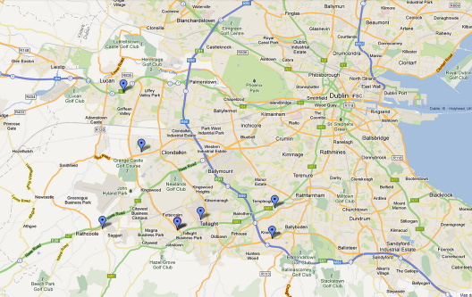
Figure 3: Map indicating approximate location of monitoring stations
A permanent sound level monitoring station is installed at each site. The equipment is a Sonitus Systems EM2010 Sound Level Monitor, capable of continuous, unattended sound level measurement and logging. The network is maintained through periodic recalibration of the equipment. Maintenance procedures also involve replacement of any parts which have degraded due to prolonged exposure, such as microphone capsules, wind screens and rain protectors. The equipment used is displayed below in Figure 5 to Figure 7.
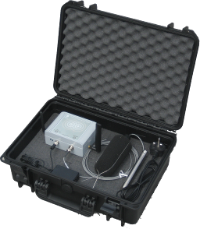
Figure 4: EM2010 Sound Level Monitoring Kit

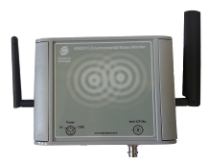
Figure 5: EM2010 Sound Level Monitoring Unit

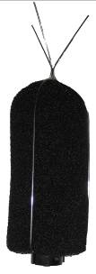
Figure 6: Microphone Assembly with Bird Spike

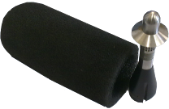
Figure 7: Microphone with Outdoor Weather Protection

Data Reporting and Collection
The monitoring stations record a number of sound level values and statistics on an ongoing basis. These parameters are relevant for the assessment of the impact of environmental noise from any given source and for comparison with predicted noise levels produced during the strategic noise mapping process. The information recorded at each site is described in Table 1.

Measured Parameters
Parameter | Description | Note
L_{EQ}A | Equivalent continuous level or average | A-weighted
L₁₀A | Level exceeded 10% of the time (peak) | A-weighted
L₉₅A | Level exceeded 95% of the time (background) | A-weighted
L_{EQ}C | Equivalent continuous level or average | C-weighted (for peak noise)
L₁₀C | Level exceeded 10% of the time (peak) | C-weighted (for peak noise)
L₉₅C | Level exceeded 95% of the time (background) | C-weighted (for peak noise)
Table 1: Description of Measured Parameters
Readings are logged every 5 minutes, providing detailed information across the day. These readings are remotely uploaded to a centralized online database for access by South Dublin County Council staff. The database is updated daily to include the latest readings from all sites.

At certain times of the year the monitoring stations are removed for routine maintenance work, resulting in periods where data is not captured. Additionally, due to the nature of unattended monitoring equipment, various circumstances occur when equipment may be powered down. The data capture rates for each of the monitoring sites for 2012 are shown in Table 2. These are calculated by comparing the number of recorded measurements to the number of measurements which would be logged if the equipment was operating without interruption for an entire year. The average data capture rate across the network is 85%, with one site at Saggart Park performing considerably below this level and two sites at Tallaght Leisure Centre and County Hall performing extremely well.

Data Capture Rates
Site Name | % Data Capture in 2012
St. Colmcille’s School | 82.87
Cheeverstown Centre | 72.75
Deansrath | 85.87
Tallaght Leisure Centre | 98.02
Saggart Park | 66.67
County Hall | 98.62
Esker Park | 88.25
Table 2: Data capture rates for sound monitoring network

Sound Sources
The dominant source of environmental noise in Dublin is road traffic. Strategic noise mapping is used to predict the influence of major noise sources e.g. traffic on the sound levels in a given area. However, noise maps do not consider all sound sources and provide only indicate levels attributed to a single acoustic source. The sites chosen for monitoring are in locations where the ambient levels are subject to influence from road traffic, but are not wholly dominated by major roads. This provides a better evaluation of the actual ambient sound levels experienced at these sites and can account for the influence of other sources of noise.

Sound level measurements are influenced by the weather conditions at the time of measurement. In particular high winds can invalidate a measurement, while heavy rain can also influence recorded levels. However, it is also important to note that the weather has a significant impact on the actual sound level emissions from road traffic, with traffic on wet days being significantly louder than in dry conditions.

Guideline Values for Noise Assessment
At present there is no existing legislation that limits environmental noise levels to a particular value. Several difficulties arise when attempting to choose a reasonable value for noise level limits, mainly due to the subjective nature of noise exposure and annoyance. The effects of noise exposure are highly dependent on the perception of the exposed person and the effectiveness of noise reduction can often be dependent as much on relative changes as on absolute levels. Attempting to apply the same limit value to a city centre park and rural country side may be inappropriate, despite the fact that both can be perceived as tranquil areas relative to the surroundings.
The Dublin Agglomeration Noise Action Plan includes guideline values for determining if an area is subject to undesirably high or favourably low environmental noise levels. These are given below.

Onset levels for classification as undesirably high:
- 70dB(A) L_{DAY}
- 55dB(A) L_{NIGHT}

Onset levels for classification as desirably low:
- 55dB(A) L_{DAY}
- 50dB(A) L_{NIGHT}

These levels reflect an annual average 24 hour period.

Summary Results
All available data for 2012 was collated and analysed. This represented the first full year of measurement, providing information across all seasons and weather conditions. The 5 minute readings at each site were averaged across each hour of the day and across the periods outlined in section 1.2. This long term averaging has the effect of mitigating the influence of any fluctuations in readings or short periods of sound level emissions that are uncharacteristic at the site. The calculated noise indicators at each site are presented in Table 3.

 | Location
 | St. Colmcille’s School | Cheeverstown Centre | Deansrath - | Tallaght Leisure | Saggart Park | County Hall | Esker Park
Indicator | dB(A) | dB(A) | dB(A) | dB(A) | dB(A) | dB(A) | dB(A)
LDAY | 61.86 | 57.81 | 56.22 | 60.63 | 67.15 | 65.13 | 58.30
LEVENING | 60.16 | 55.94 | 53.91 | 59.34 | 64.55 | 62.61 | 55.93
LNIGHT | 56.38 | 52.24 | 50.55 | 54.74 | 59.52 | 57.46 | 51.86
LDEN | 64.41 | 60.28 | 58.56 | 63.06 | 68.50 | 66.48 | 60.24
Table 3: Summary results for all sites for 2012
The results indicate that day time levels at all sites are below the upper guideline value for of 70dB(A). There are no sites below the lower limit for L_{DAY} indicating that all sites are between the thresholds and have acceptable day time sound levels.

Calculation of average L_{NIGHT} values for 2012 shows that 4 sites were below the 55dB(A) upper guideline level, indicating acceptable night time noise levels. The remaining sites were above the upper night time guideline level of 55dB(A). The largest exceedance was at the Saggart Parks Depot which was 4.5dB(A) above the threshold. It should be noted that this site also had the lowest data capture rate at just 67%. It is possible that a full year of data here would cause the total overall levels to vary.

The L_{DEN} was also calculated at each site. As expected, the locations follow the trends seen in the day and night time levels, with Deansrath being the quietest and Saggart Park and County Hall showing the highest levels. Figure 8 displays the calculated L_{DEN} and L_{NIGHT} at each location.

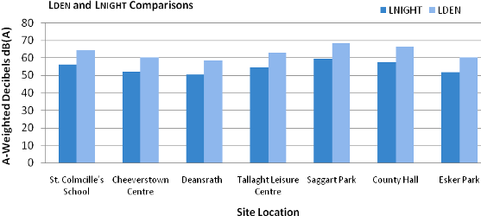
Figure 8: L_{DEN} and L_{NIGHT} for all Sites in the Monitoring Network

Average Daily Trends
In addition to the long term summary averages the daily trends at each location were also evaluated. This analysis provides greater detail of the variation in sound levels across the day by computing the average value per hour for 2012. These plots are displayed in Figure 9 to Figure 15. It can be seen that certain sites exhibit considerable variations in noise levels between the day time and night time periods, with a difference of approximately 10dB observed between peak levels in most locations.

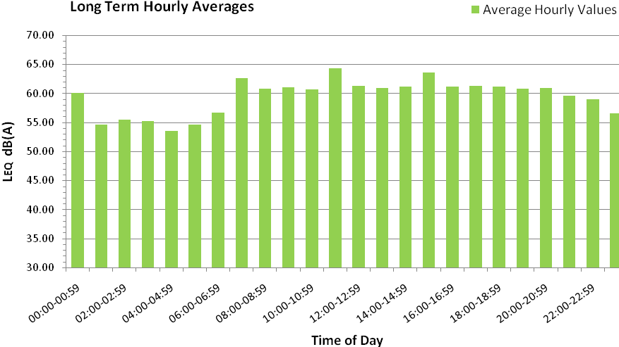
Figure 9: Averaged Hourly Values at St. Colmcille's School

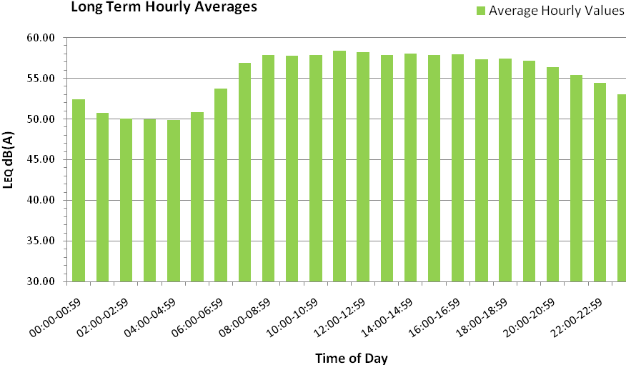
Figure 10: Averaged Hourly Values at Cheeverstown Centre

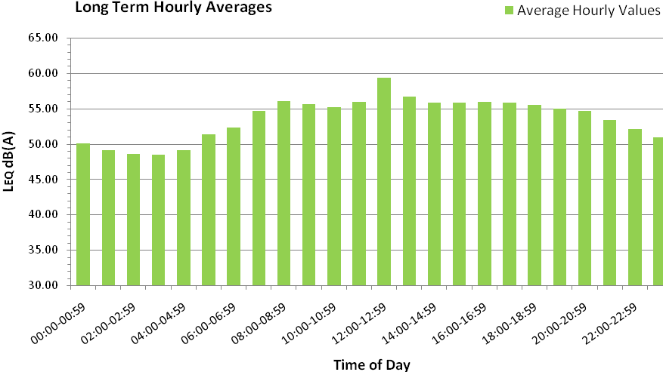
Figure 11: Averaged Hourly Values at Deansrath

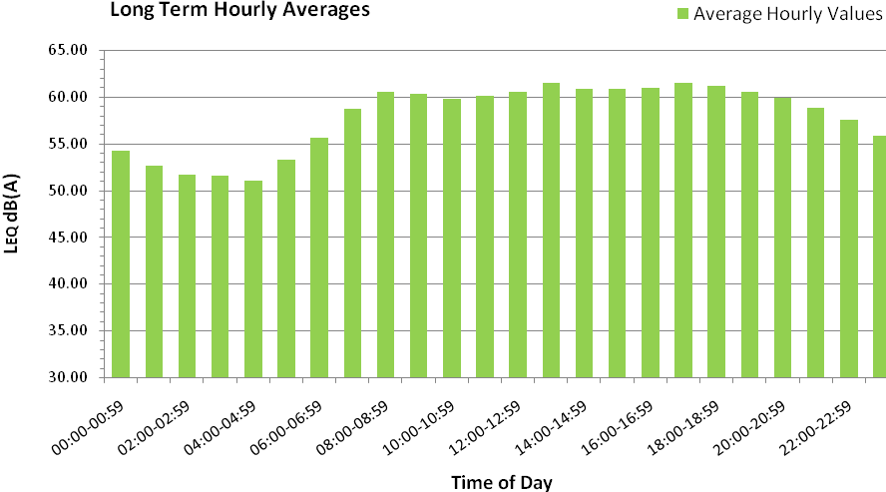
Figure 12: Averaged Hourly Values at Tallaght Leisure Centre

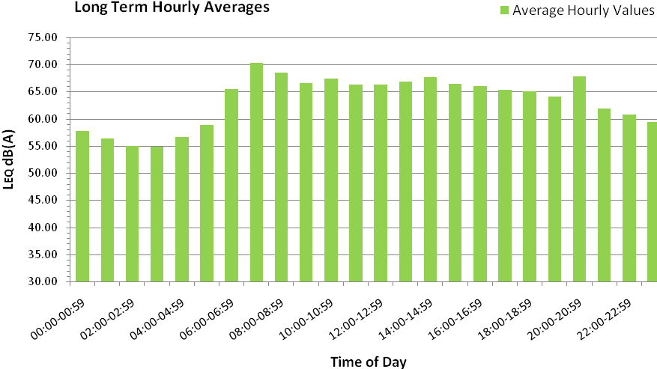
Figure 13: Averaged Hourly Values at Saggart Park

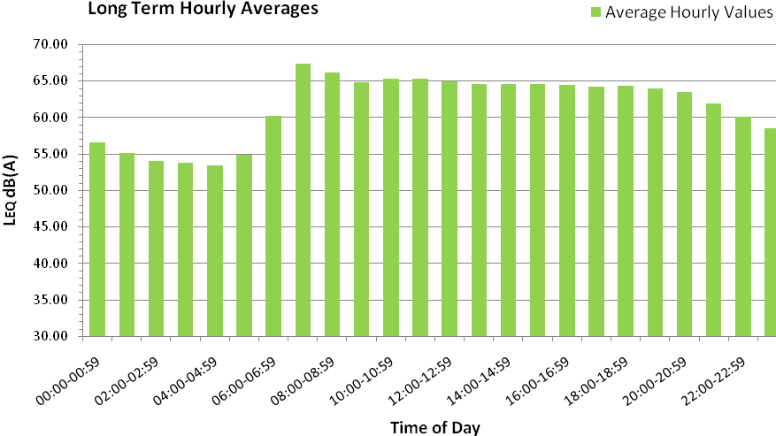
Figure 14: Averaged Hourly Values at County Hall

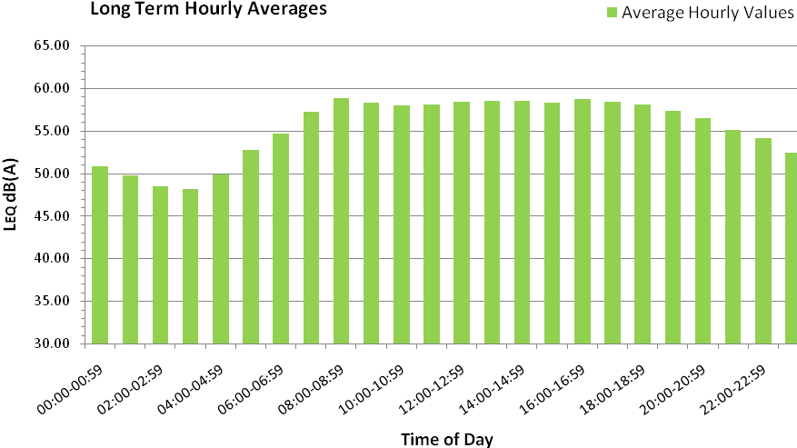
Figure 15: Averaged Hourly Values at Esker Park

In addition to this analysis a further break down was performed in order to evaluate the variation of noise levels at the weekday and weekend. Weekday readings for the year were separated and the average hourly values computed and compared to those for the weekend. The plots of this data can be seen in Figure 23 to Figure 29, presented in Appendix A. The greatest deviation in levels is observed in the early morning, where rush hour traffic would be expected on weekdays. The average reduction in sound levels across all sites between the hours of 6:00am to 9:00am is 6.5%. The peak weekend reduction was 12.58% observed at St. Colmcille’s School, which is explained by the absence of school traffic at the weekend. The monitoring site at County Hall recorded a 10% drop in weekend sound levels in these early hours, most likely attributed to the reduction in industrial and commuter traffic.

Sample Data from Monitoring Sites
It can be seen from the plots in the previous sections that the daily sound level readings follow a diurnal pattern, as is expected for urban and suburban locations. This is due to the notable influence of human activities i.e. traffic, on ambient sound levels. It is also useful to observe longer term patterns in order to assess variations between sites and changes in ambient sound levels caused by factors such as seasonal weather variations, public holidays, school holidays etc.

The continuous monitoring capabilities of the sound monitoring network allow such comparisons to be carried out by providing data at various levels of detail.

The following plots in Figure 16 to Figure 22 display the sound levels recorded at each site at 5 minute intervals for the month of May 2012. These plots highlight the diurnal variation in sound levels mentioned above and illustrate the large range in sound levels experienced at each site. The difference between daily minimums, occurring between 2.00am and 4.00am, and daily peaks, usually between 8.00am and 11.00am are obvious on all monthly plots. The same trends are observed at each of the sites, while the base line sound levels vary between locations.

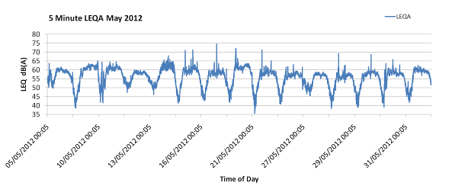
Figure 16: Sound Levels for May 2012 at St. Colmcille's School

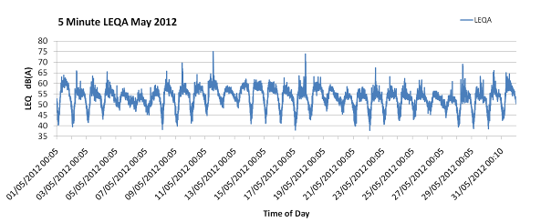
Figure 17: Sound Levels for May 2012 at Cheeverstown Centre

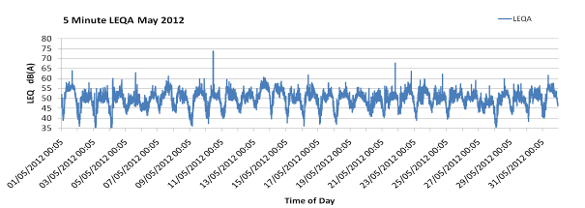
Figure 18: Sound Levels for May 2012 at Deansrath Depot

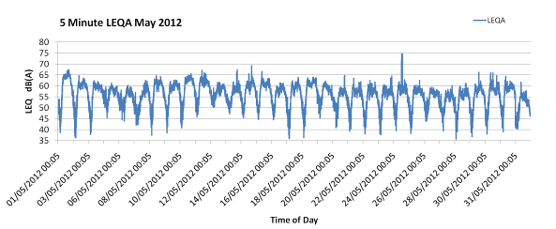
Figure 19: Sound Levels for May 2012 at Tallaght Leisure Centre
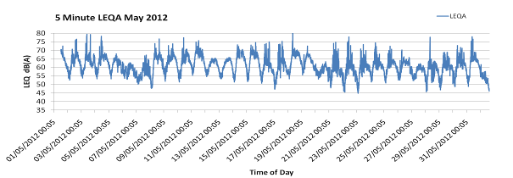
Figure 20: Sound Levels for May 2012 at Saggart Parks Depot

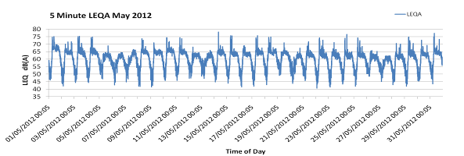
Figure 21: Sound Levels for May 2012 at County Hall

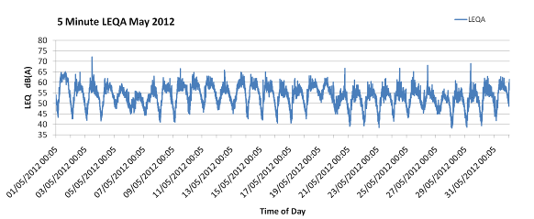
Figure 22: Sound Levels for May 2012 at Esker Parks Depot

Discussion

The monitoring network has performed well at all sites once installed. The data capture rates at two sites were excellent, achieving greater than 95% data availability. The lower rates of data capture at Saggart Park and Cheeverstown, measured over the entire year, were due to delays experienced during installation of the monitoring stations. Data availability has been close to 100% since installation and is expected to remain high in the future.

The sound levels at all sites are within acceptable guideline levels when averaged across the day time period of 07:00am to 19:00am. There were no instances of undesirably high or favourably low day time sound levels. The absence of very low levels is to be expected at sites close to major roads and sources of environmental noise.

The long term average sound levels for the night time period of 11:00pm to 7:00am indicated that three sites were above the guideline value of 55dB(A), suggesting undesirably high levels of environmental noise. The value at St. Colmcille’s School showed a marginal exceedance of the threshold, while the figure of 59.5dB(A) at Saggart Parks Depot suggests consistently higher levels of night time noise. This is likely due to the proximity of the site to the N7 road way. This site is also close to Casement Aerodrome, which may have an influence on the sound levels recorded.

Investigation of the variance in sound levels over the course of a day show the diurnal trend expected at these locations. Sound levels peak in the morning, during morning rush hour through to 11:00am and are at the lowest levels between 2:00am and 5:00am. This characteristic is further highlighted in the sample monthly data. Weekday values show a more pronounced difference between peak sound levels and minimum levels, with weekend values being slightly more uniform throughout the day. The sound levels recorded at weekends were lower than weekdays, with the exception of Saggart Parks Depot where weekend peak levels exceeded weekday values.

In general the quality of the acoustic environment at these sites is good, with the L_{DEN} values at all locations below the European guideline assessment value of 70dB(A).

Appendix A

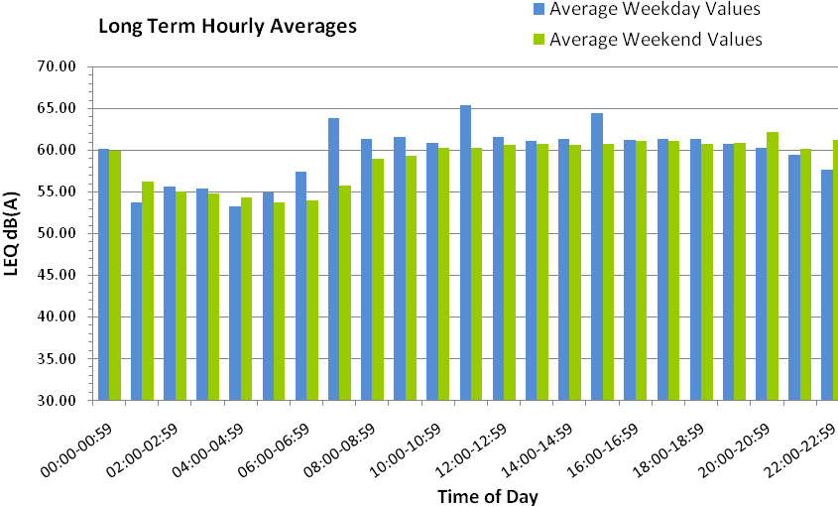
Figure 23: Averaged Hourly Values for Weekdays at St. Colmcille's School

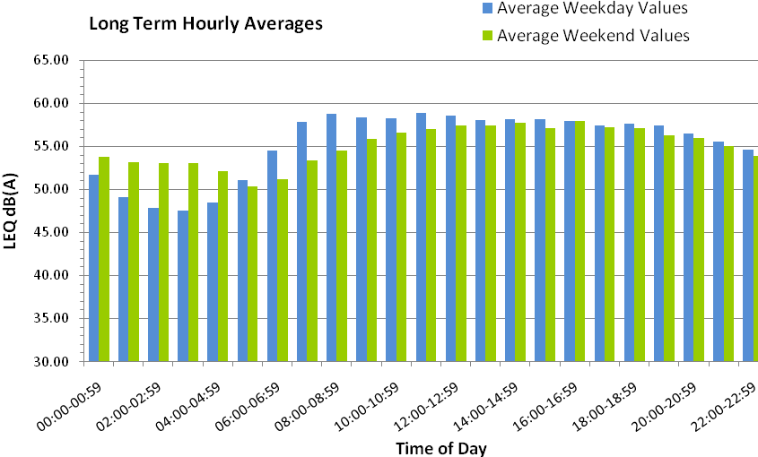
Figure 24: Averaged Hourly Values for Weekdays at Cheeverstown Centre

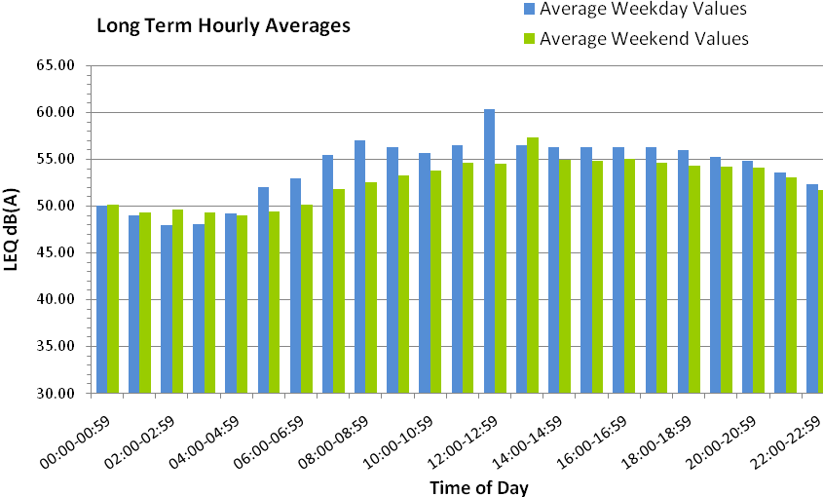
Figure 25: Averaged Hourly Values for Weekdays at Deansrath

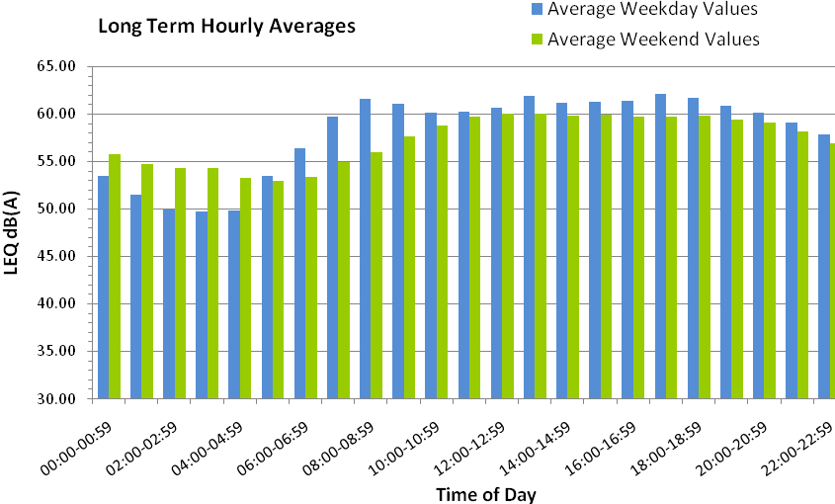
Figure 26: Averaged Hourly Values for Weekdays at Tallaght Leisure Centre

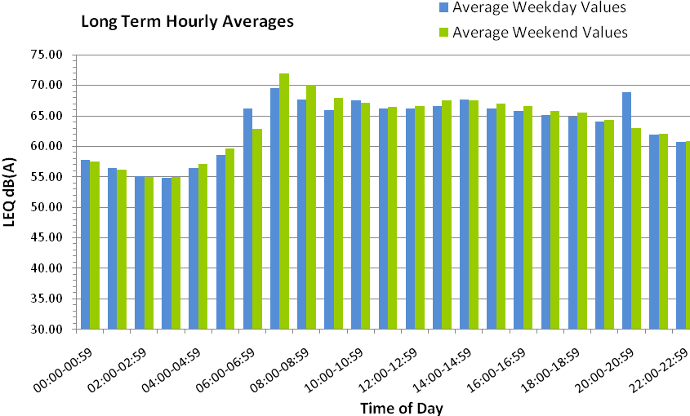
Figure 27: Averaged Hourly Values for Weekdays at Saggart Park

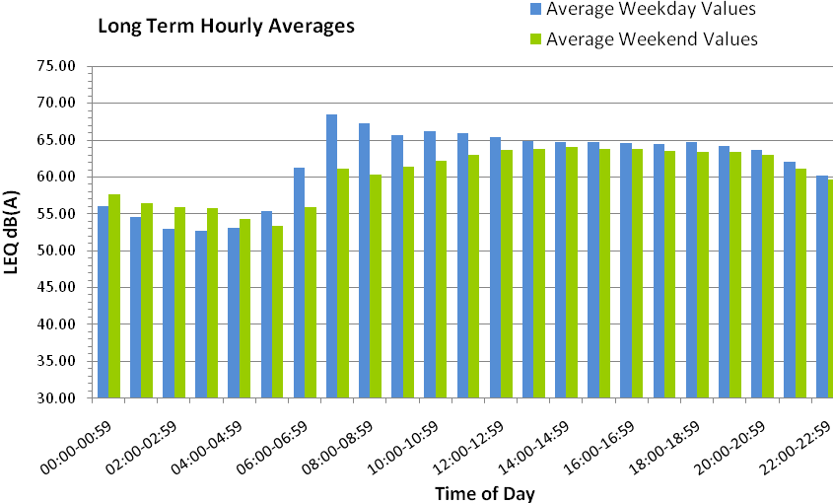
Figure 28: Averaged Hourly Values for Weekdays at County Hall

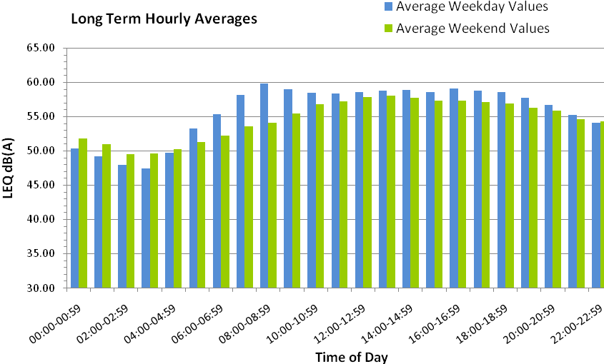
Figure 29: Averaged Hourly Values for Weekdays at Esker Park

Appendix B

Formulae:

L_{DEN} is calculated from:
$$L_{\text{den}}=\text{10}{\text{log}}_{\text{10}}\frac{1}{\text{24}}\left(\text{12}∗{\text{10}}^{\text{Lday}\text{10}}+4∗{\text{10}}^{\text{Levening}+5\text{10}}+8∗{\text{10}}^{\text{Lnight}+\text{10}\text{10}}\right)\text{dB}$$

SPL Calculations:
The Sound Pressure Level (SPL) is a logarithmic measure of the root mean square sound pressure, relative to the threshold of hearing.
$\text{SPL}=\text{20}{\text{log}}_{\text{10}}\left(\frac{p_{\text{RMS}}}{p_{\text{ref}}}\right)$dB $p_{\text{ref}}=\text{20}μ\text{Pa}$

